MOD14
Performing Background Processing by Using Web Workers
Lesson 2: Performing Asynchronous Processing by Using Web Workers

Demonstration: Creating a Web Worker Process
speaker-badge.htm
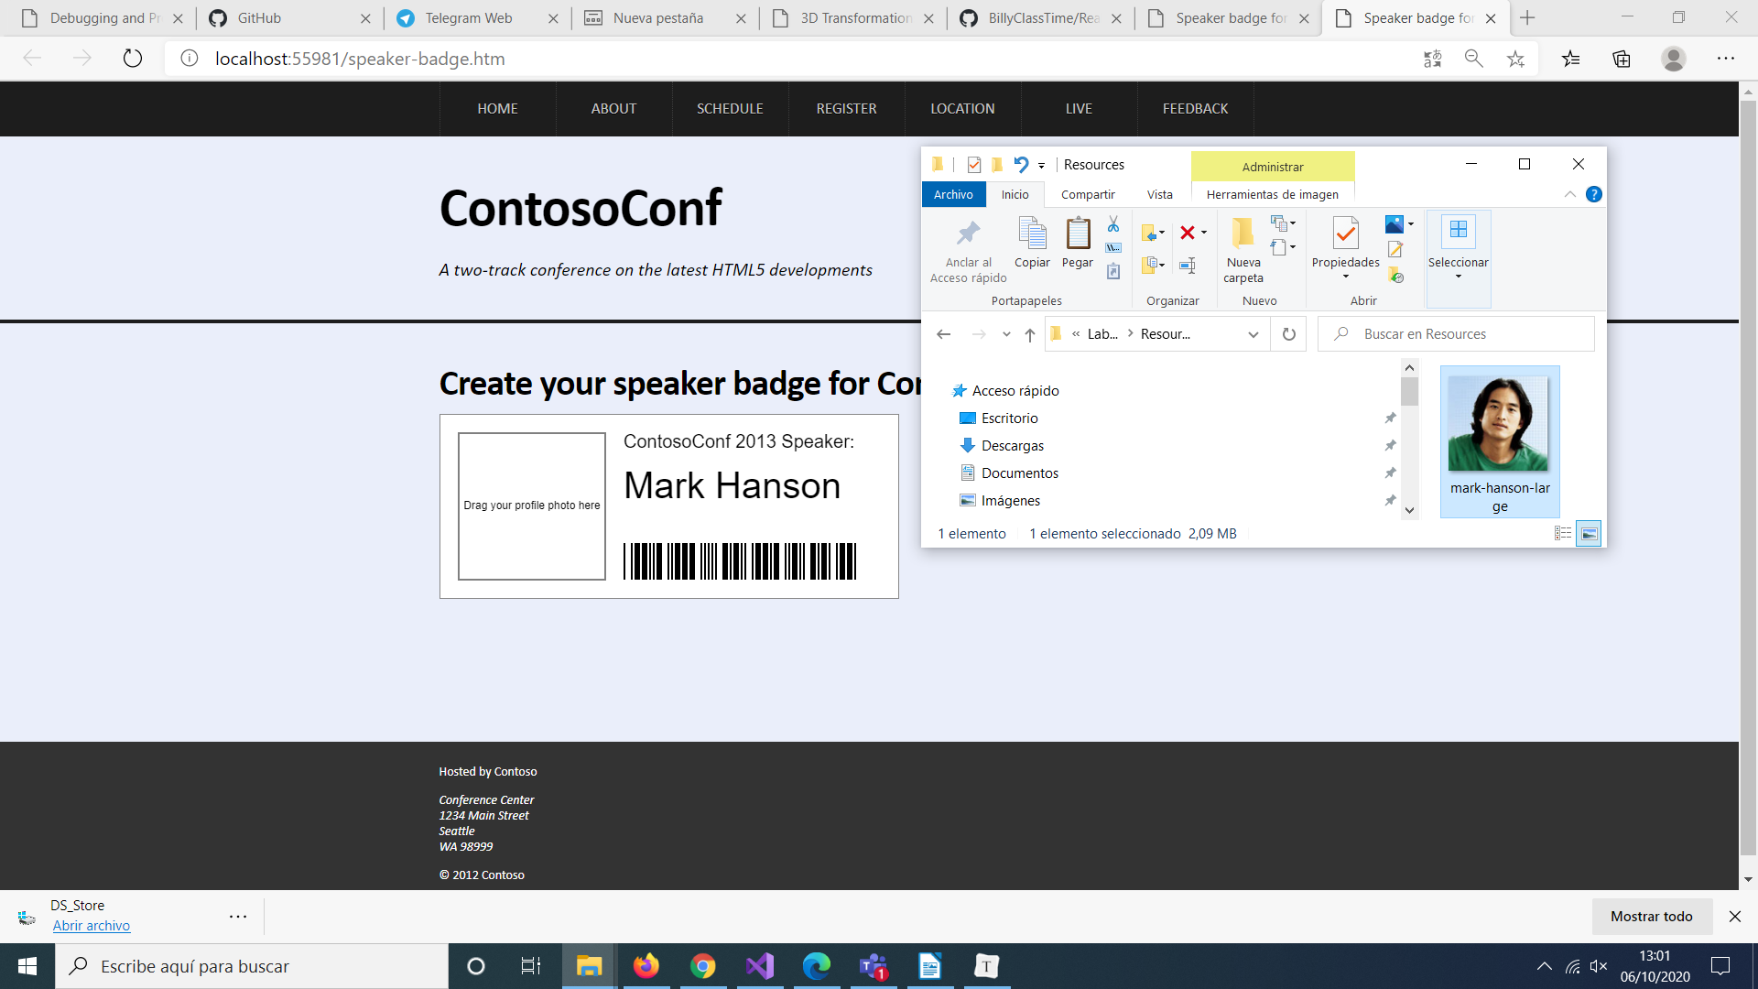
Drag mark-hanson-large.jpg to Internet Explorer and drop it on the canvas with the label Drag your profile photo here.

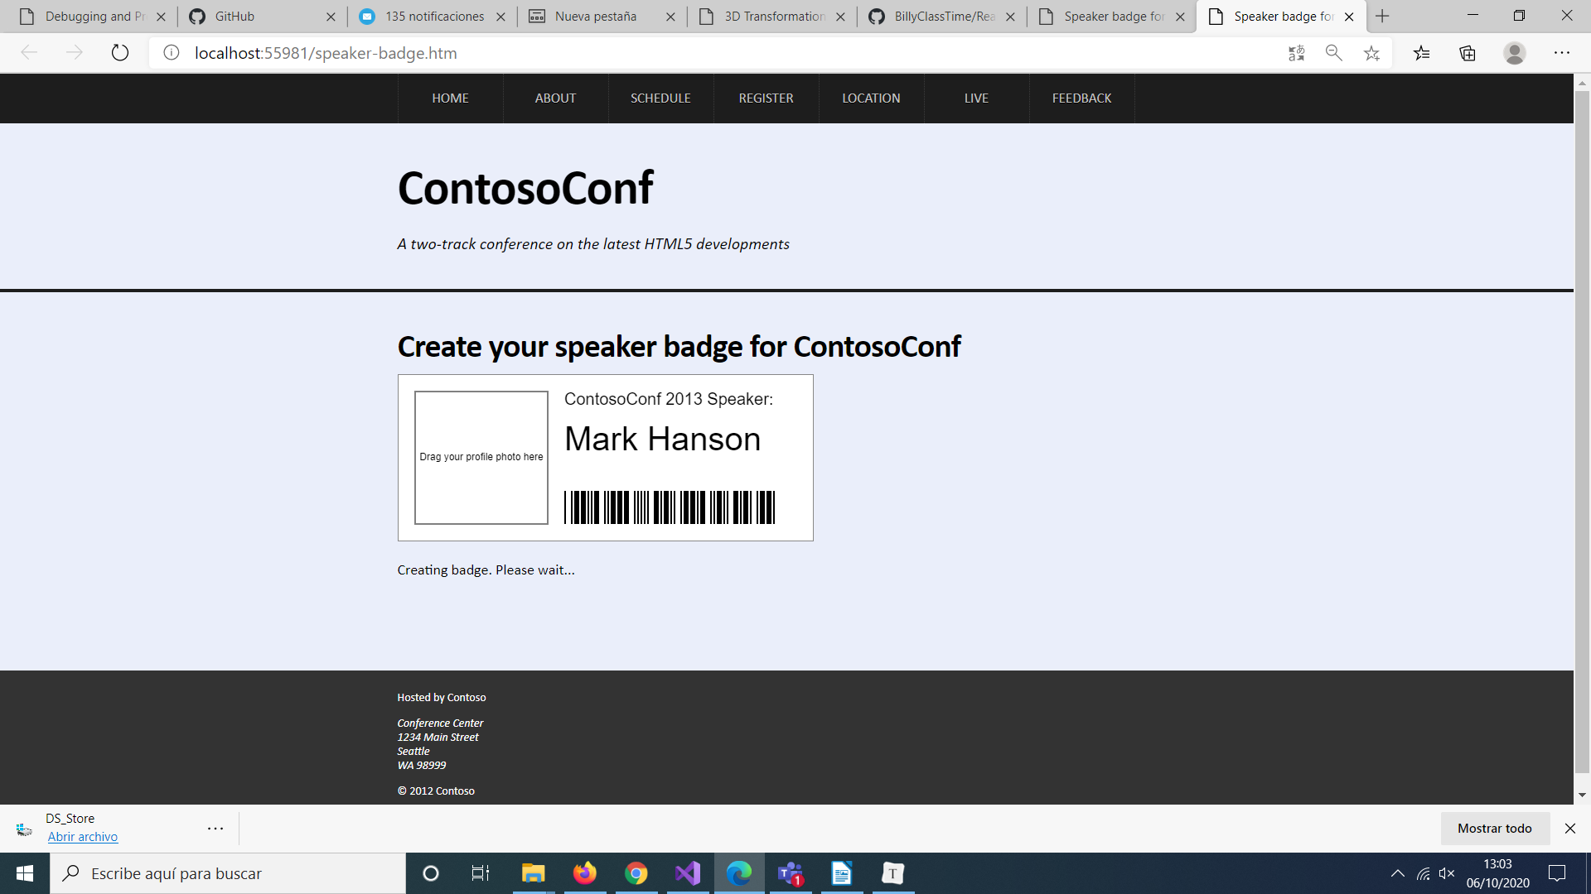

Wait until the grayscale image of the presenter has been generated:

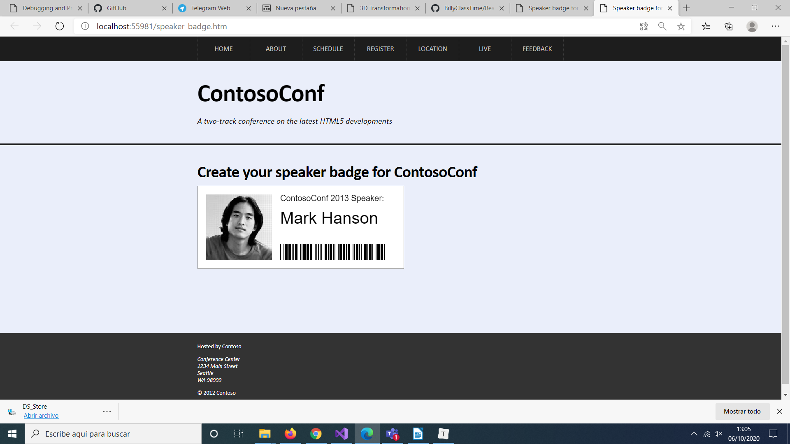

grayscale-worker.js
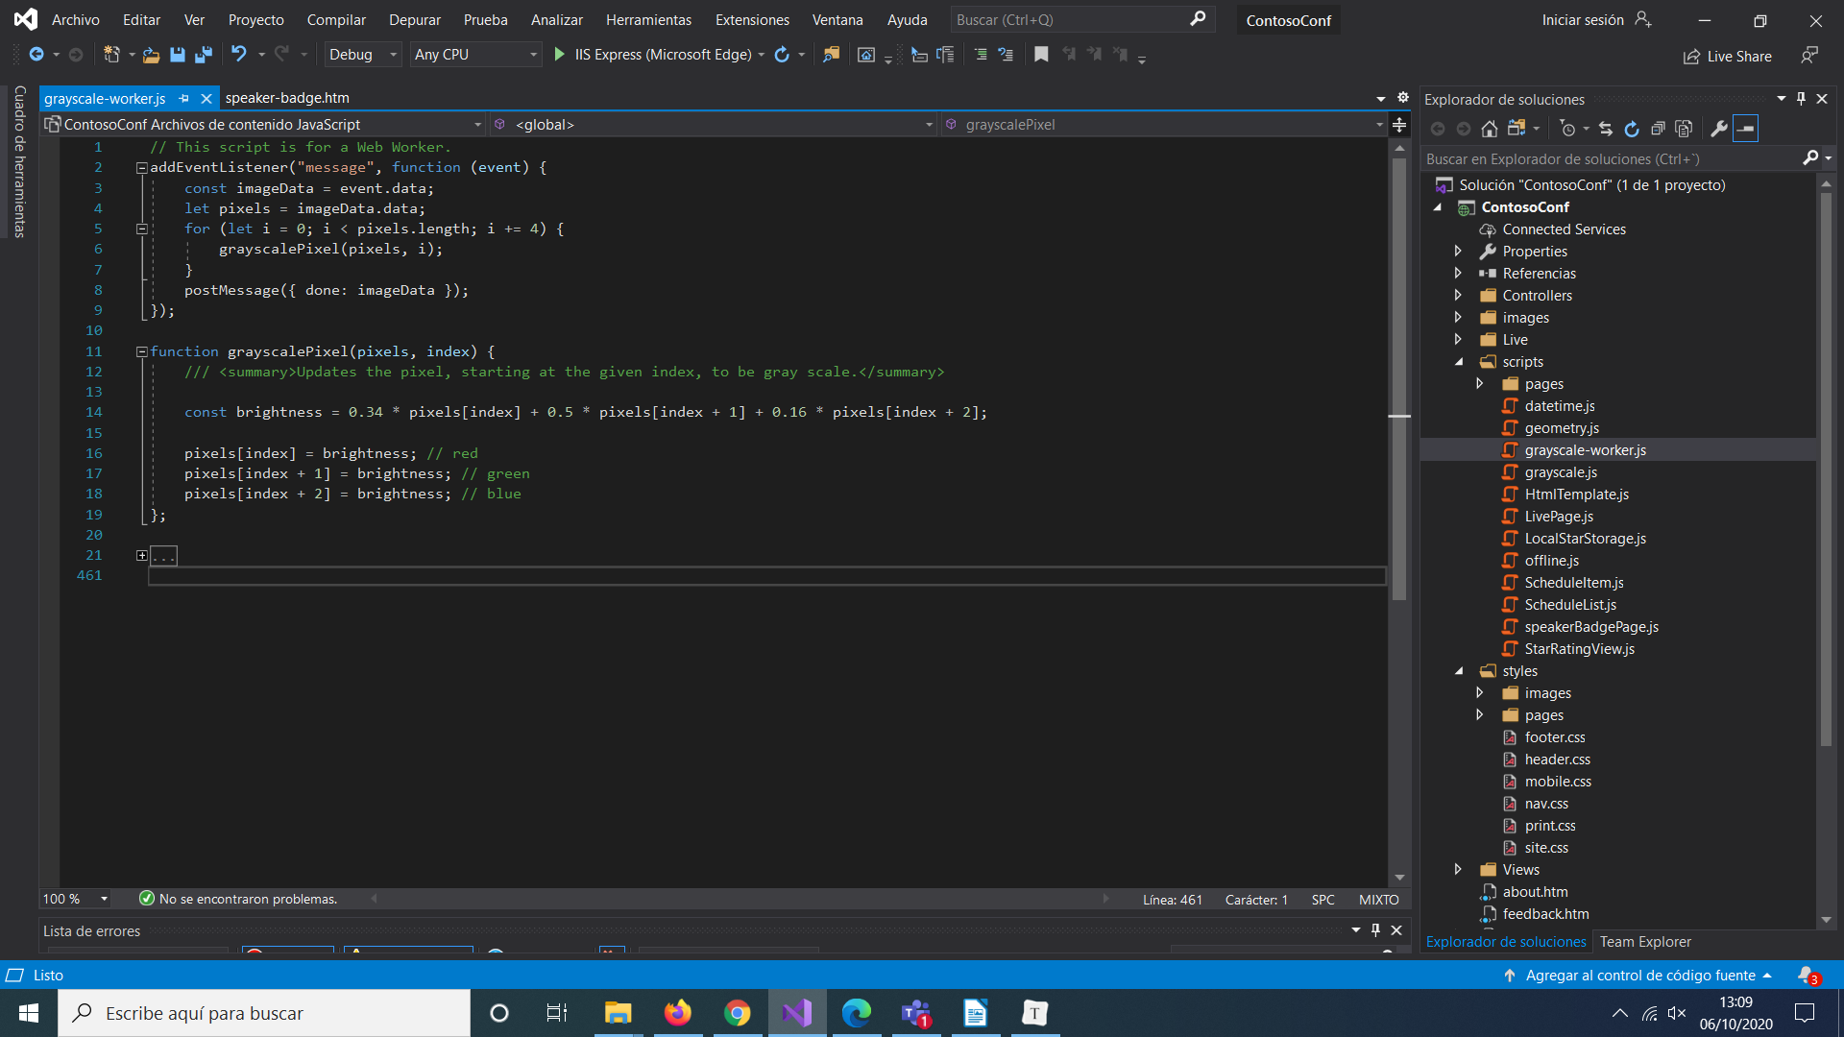
The event handler then calls the grayscalePixel() function to convert each pixel in the image to grayscale, and then posts a message with that grayscale image data.

grayscale.js
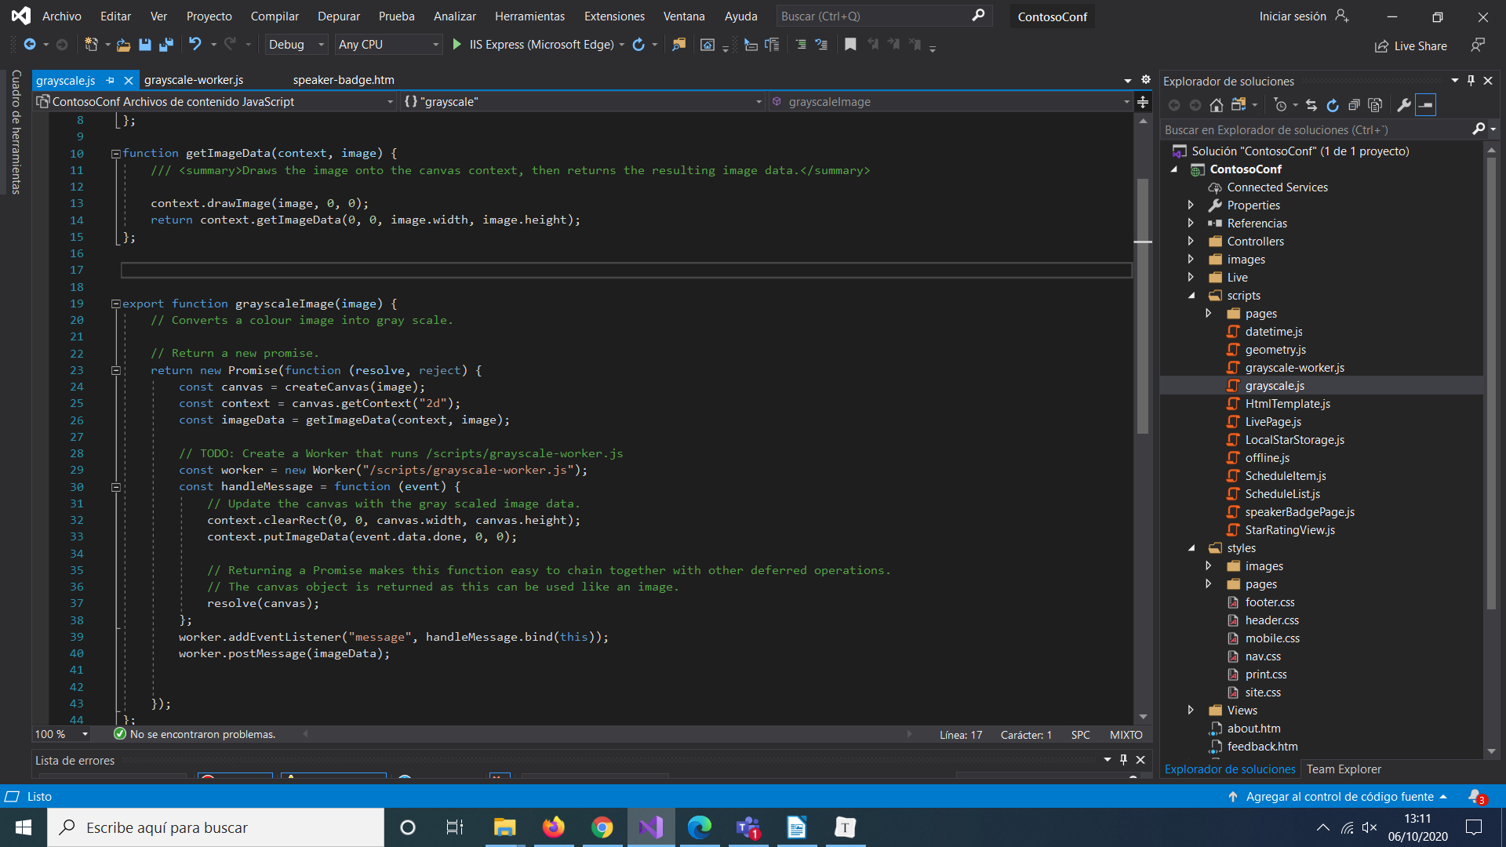

grayscaleImage() function: This function creates a web worker that runs the grayscale-worker.js script, and posts a message to the web worker that contains the data for the image that the user dropped onto the canvas on the form. This function also arranges to catch the message that the web worker posts back, containing the grayscale version of the image, which is displayed on the canvas on the web page.

The code that sets up the message handler for the web worker uses bind(this) to ensure that the anonymous function that handles the event is resolved to the web page and not the web worker variable.

