Book Time Off

An App used to book holidays off from work and clock in and out

Laura Norbury

20071810

# Functionality

## Login & Register

This was created but it did not work in my previous app. This app features a register and login service using an SQLite database. A user can create an account by giving their name, work email and two matching passwords. Once the passwords are confirmed as matching the user is then registered. They can then navigate back to the log in page an log in. The user will only be logged in if the email and password match.

This is persisted meaning it is kept even when the phone is turned off etc.

## Book Time Off

This function was present in the previous version of this app but I changed it from using a base class and adapter to using a database to store data. The previous version kept overwriting each variable. This one is fully working whereby a user can select their three data objects and they all get stored in the database.

There is a spinner in this class. The user can select one of three different options. I managed to store the user selected one in the database by using a switch statement and assigning a String to the result.

I also deleted my two calendar activities from the old app and replaced them with two calendar pop ups. I did this with DataPickerDialog and I then customised it to my needs.

## Time Sheets

I created a new functionality for this app. The timesheets are a clock in and clock out system. There is a thread running of the current system time. There are also two buttons for the user to clock in and out with. The onClick method takes note of the times and they are then stored in the db.

## SplashScreen

This app has a splashscreen. It was really easy to make. I made my logo and added it to the layout with an imageView. Then I created a thread that sleeps for 3 seconds and starts an intent after this. It brings me onto the home page.

## Navigation

I created the navigation by getting rid of the default toolbar and using an actionbar instead. It looked exactly the same but I was able to change the page titles and add back buttons. I set the home screen as the parent of all the classes (except login & signup) and they then navigated back to them.

## Edit

The CRUD is working on my db and I can create and retrieve no problem. I can also edit and delete but I am having problem with a the list view items crashing when I click them so there is no way to see the rest of the CRUD in action even though it all works. I put the edit data section on the home screen so it could be seen how it was going to be done from the listview.

# USECASE

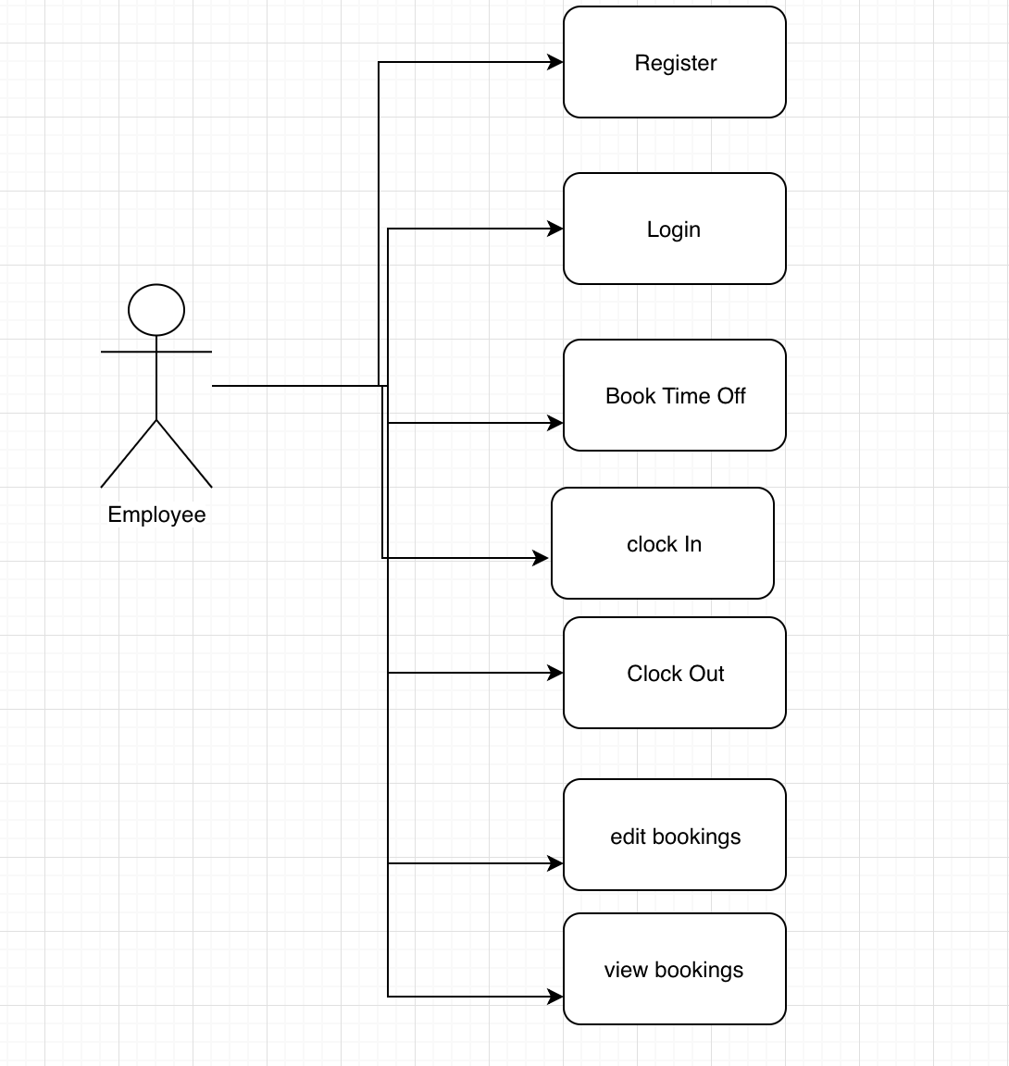

# Persistence

As shown in my video my persistence is fully working. I am able to retrieve data even after the apps are closed and the phone is turned off. The persisted info is user details, user bookings and user timesheets. The user has a unique id so they can only see their own data.

## Database Schema

## 

# GIT

Link: <https://github.com/LauraNorbury/appdevCA2>

# Video:

Link: https://drive.google.com/drive/u/0/folders/1f_fRyejwMtRY5KY3-QiFMgK0nuc6c7Lj

# UX/UD

Design Approaches:

White Background – I have dyspraxia and it’s the only colour I can read off of

Sans Serif Font – Easiest for on screen display

Dark ToolBar Colour – Easy for user to see and read

# References

Making my spinner - https://www.youtube.com/watch?v=urQp7KsQhW8

Taking date from calendar - https://www.youtube.com/watch?v=hHjFIG0TtA0

SQLite database - https://www.youtube.com/watch?v=aQAIMY-HzL8

Database to list view - https://www.youtube.com/watch?v=tzj-SS0cAFk&list=PLzLFqCABnRQf2hEjUJE3Ozg70taTXnZAw&index=2

Access array list from another class - https://social.msdn.microsoft.com/Forums/vstudio/en-US/0a4b96d2-cf43-4249-be9f-50515c8cd47a/acess-an-arraylist-from-another-class?forum=csharpgeneral

Delete and Update CRUD: https://www.youtube.com/watch?annotation_id=annotation_245689227&feature=iv&src_vid=aQAIMY-HzL8&v=nY2bYJyGty8

Time and Date: https://www.youtube.com/watch?v=G6AkbQkfywE

Calendar View:

https://www.youtube.com/watch?v=hwe1abDO2Ag