Act Report

This article features results from a quick analysis of the Twitter account @WeRateDogs. The analysis and data processing has been done using Python and Jupyter Notebooks. For reference, look up the whole analysis on this file ‘[wrangle\_act.ipynb](http://localhost:8888/notebooks/My_Projects/Github%20folder/Project_4-Wrangle_and_analyze_data_no_token/wrangle_act.ipynb" \t "_blank)’.

**How is the activity of tweets overtime in the WeRateDogs twitter account?**

**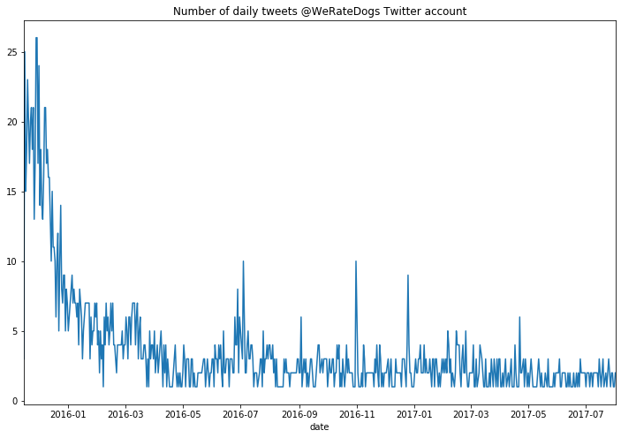**

End of 2015, the tweet activity was quite high, it was the ascendance of WeRateDogs Twitter account popularity! Then there were less tweet daily posts but they became more regular at a daily pace.

**Which is the most retweeted post vs most favorite dog post?**

The most retweeted dog is also the most loved with almost 80k retweets and more than 155k likes. It features a doggo Labrador retriever swimming in a pool for the first time with a rating of 13/10.

Here is his cutie doggo face:



**What makes a good dog rating?**

Facts:

1. ***“A good rating for your dog may lead to more retweets and likes!”***

There is a clear correlation between retweet count and dog ratings. If a dog is given a good rating, there is more chance for it to be retweeted. More retweets is directly correlated with more likes on Twitter @WeRateDogs

1. ***“Your dog rating has nothing to do with its breed”***

There is no pattern or clear distinction of the popularity of a dog breed on a rating @WeRateDogs. Looks like these good boys are rated based on love <3

**So?... Love is what makes a good rating @WeRateDogs**

**How good is the ML prediction of the dog breed?**

The data used for this analysis was run through a ML engine to predict the dog breeds based on pictures of dogs posted in the tweets.

Histogram of confidence level (from 0 to 1) for dog breed predictions

**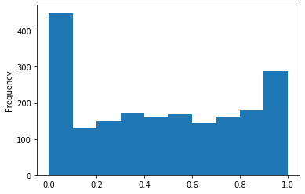**

Breed predictions confidence are spread. A good 20% of the dataset has a very low confidence. All in all, at first glance the prediction confidence is very average and not highly reliable.

However, we tested some samples at 80% confidence level and were pretty pleased by the prediction, but maybe also by these cute little faces. Here’s an example:

'german\_shepherd'

