DISCUSSION: We see several interesting lines of future work including (a) the theoretical analysis of the algorithms proposed in this paper, (b) the study of variants thereof, and (c) the investigation of other particle-based methods obtained by view ing the EM problem ‘jointly over θ and q’ rather than in a coordinate-wise manner.

6. Explain SOUL
gradient based optimisation for mmle

7. Implement SOUL

8. particle algos
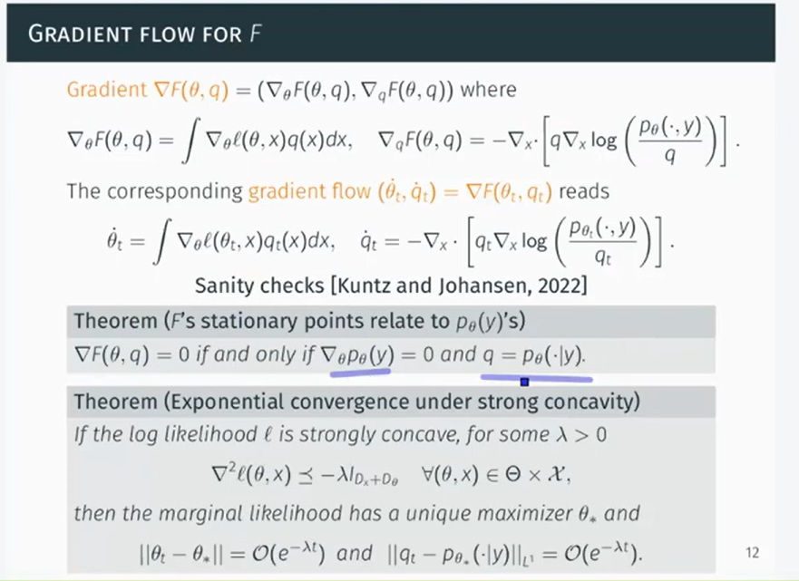
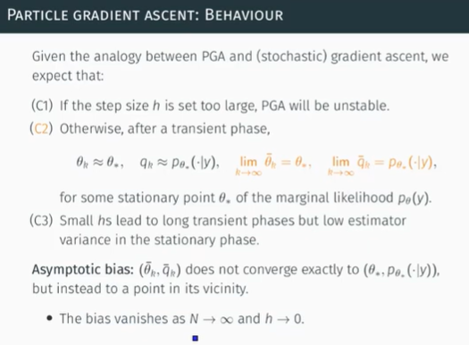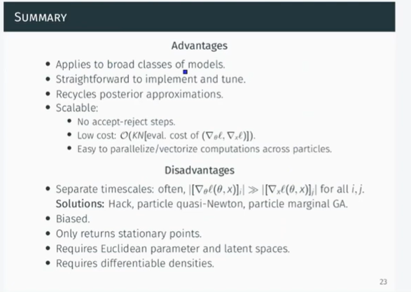

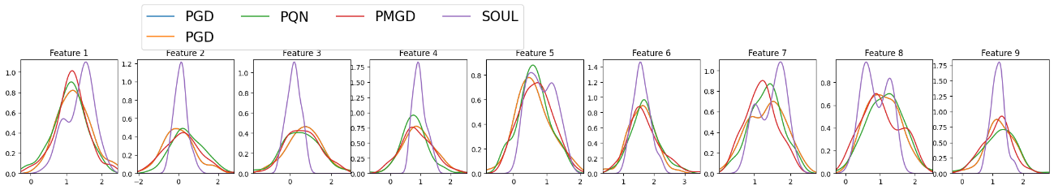
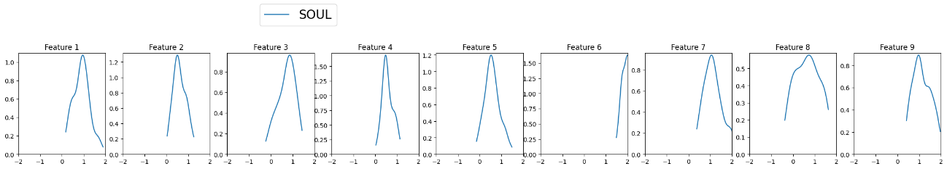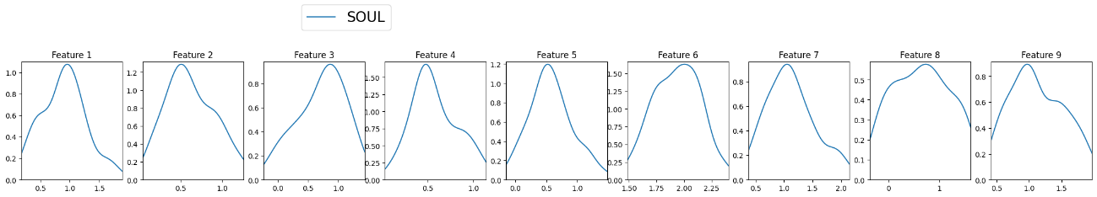

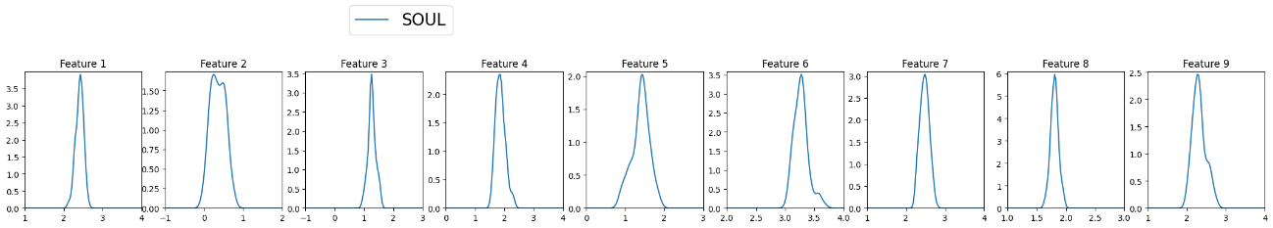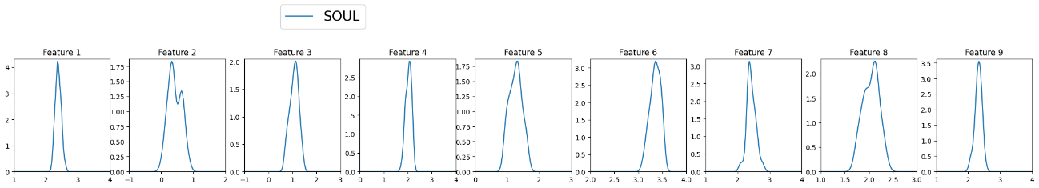
My code below, kuntz on top

Report V2

Introduction: The project plan is to explore/improve SOUL.
MCMC example from https://pmc.ncbi.nlm.nih.gov/articles/PMC3619958/
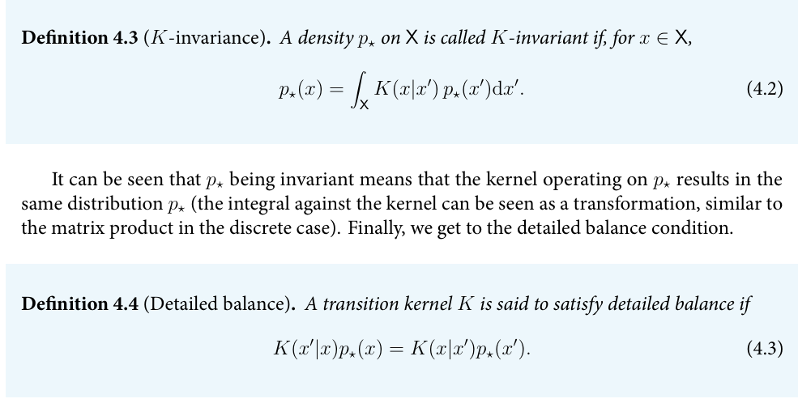
IfKsatisfiesdetailedbalance,thenp⋆is theinvariantdistribution.
MMLE introduction https://www.emergentmind.com/topics/maximum-marginal-likelihood-estimation-mmle

