Team Members: Deepak and Mike

Idea behind the mobile application:: Instead of people saving their videos and files to a random location on their mobile phones. We came up with an idea where any user can save their daily life memories (text, pictures, vidoes) with the help of an application and we name it a Memory Bank. So users can look back and watch the list of memorable activities . If they wish they can even share with their friends and families via social media.

Bellow we have our mockups for the mobile app. We will use ionic frameworks and our own codes. We will use online sources like W3schools, codeschool and so on.

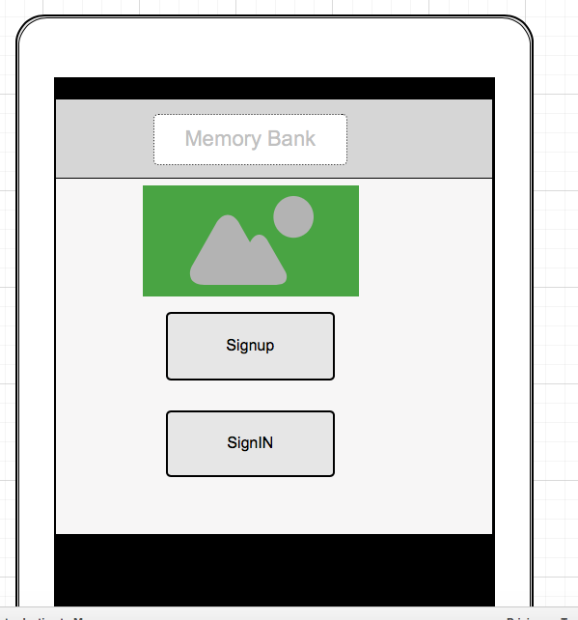

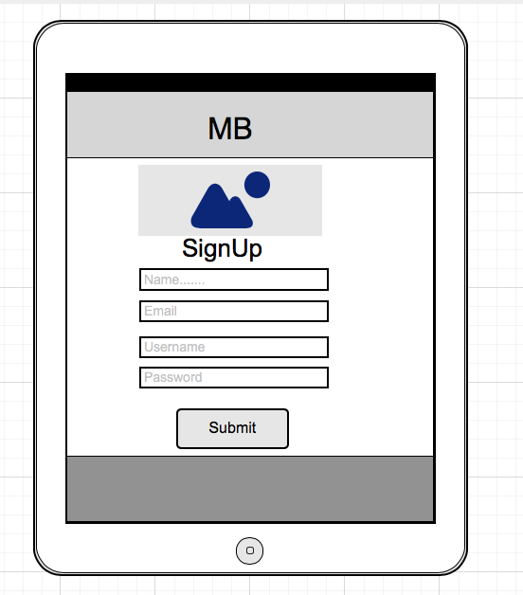

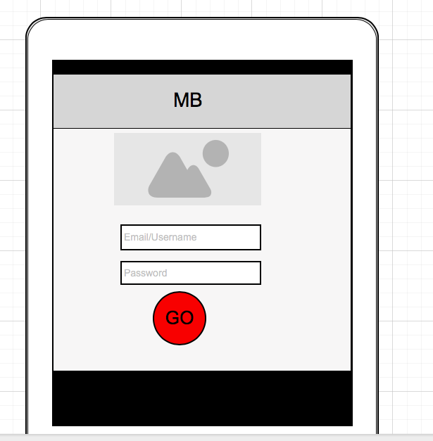

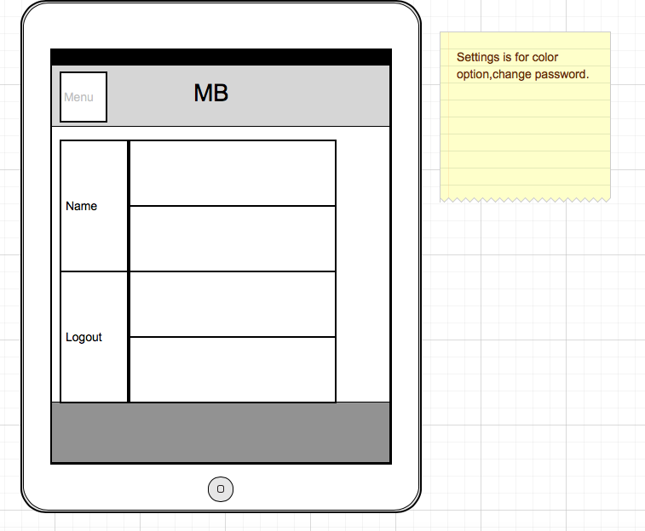Menu button will have several options like settings for color, and share option.