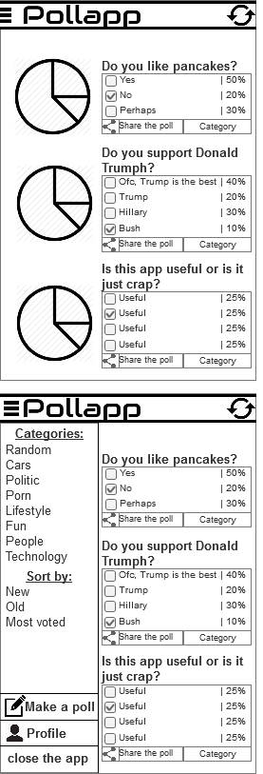App Plan: **POLLAPP**

As the name says it, it's an app where you can browse polls (made by another users) and create your own polls. There will be a lot of polls and users can read & vote as many polls they like. Poll’s subjects varies and therefore there will be a lot of categories. Users can browse e.g. only polls from category of technology if they want. Polls can also be shared with your friends and through social media. Polls have a question and 2-6 answer options that the user can decide. The poll is always a pie chart that will show how the answers divided. You need first vote before you can see the results!

App is very simple, it has only 2 pages. The homepage that includes all the polls that can be sorted by the categories but by default it sorts the polls “newest first”. Homepage is infinite scroll, meaning that it will load more polls as you swipe down. Second page is “Create a poll” that will do exactly the thing it says.

**Questions.**

How hard it is to make pie chart that will change its results after people have voted on it?