**PetLife**

The PetLife app is basically Facebook for pets. It’s meant for crazy cat ladies and other pet crazy people, why not bookies who bet on horses too (assuming the horses have PetLife accounts). I made a picture that should explain how I expect the app to work and what kind of functionality it includes.  
  
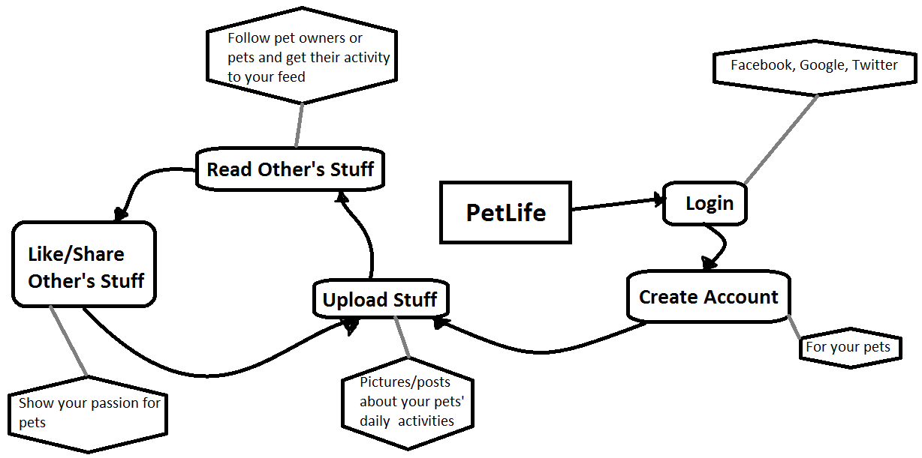

Questions I’m trying to answer:

Simple?

Understandable?

Concrete?

Credible?

Emotional?

Story?

Tommi Lahtinen