Project plan

My project will be fairly small shopping list application. The reason I’m making this application is that I want to make something I really need instead of just an app that nobody would ever use. This app is made for me and my girlfriend so we can easily do our shopping.

My app will be very similar to the tutorials we made in this study unit. I will make a shopping list application that allows users to add items to the shopping list. All items will also belong to groups and user can change between the groups in the sidemenu.

Item will have a checkbox next to it. If the checkbox is checked it means that the user needs to buy it. When user goes to the shop he can just buy all checked items and take the check mark off the item. This way user always has updated shopping list in his pocket.

The app itself will be made with ionic and cordova and will use firebase as a database. I won’t make any kind of users or login to the app because I will only install this application to my own and to my girlfriends’ device.

The layout will be customized from the ionic sidemenu template and will look a bit like the following pictures.

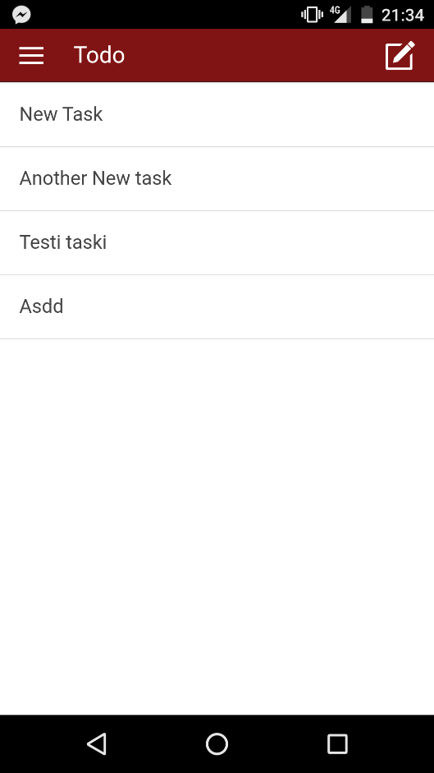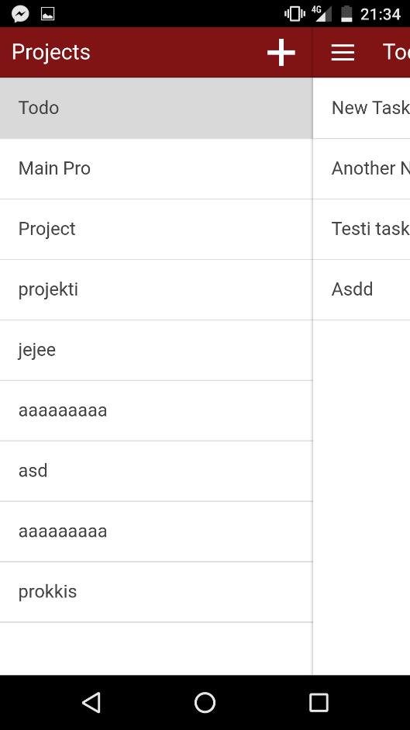

On the left first picture there is todo list. The shopping list will look pretty similar. The groups of my app (for example groceries) can be found from the sidemenu and will look similar to the second pictures’ projects list.