**Sharks Cove HDK – Quick Start Guide**

**Rev0.6**

**Revision History**

|  |  |  |
| --- | --- | --- |
| **Version** | **Changed** | **Editor** |
| 0.5 | Created | D Kannan |
| 0.6 | Updates for FW Driver and OS installations | R Myers |
|  |  |  |

1. **The Sharks Cove Board**

This board is intended as a development platform for IHVs and OEMs (as opposed to a hobbyist board). It is based on current Atom based tablet designs and configured as the core of a tablet design, with the additional devices (cameras, sensors, display) left off so that drivers for new versions of those devices can be developed for x86 compatible, Connected Standby Atom based platform designs.

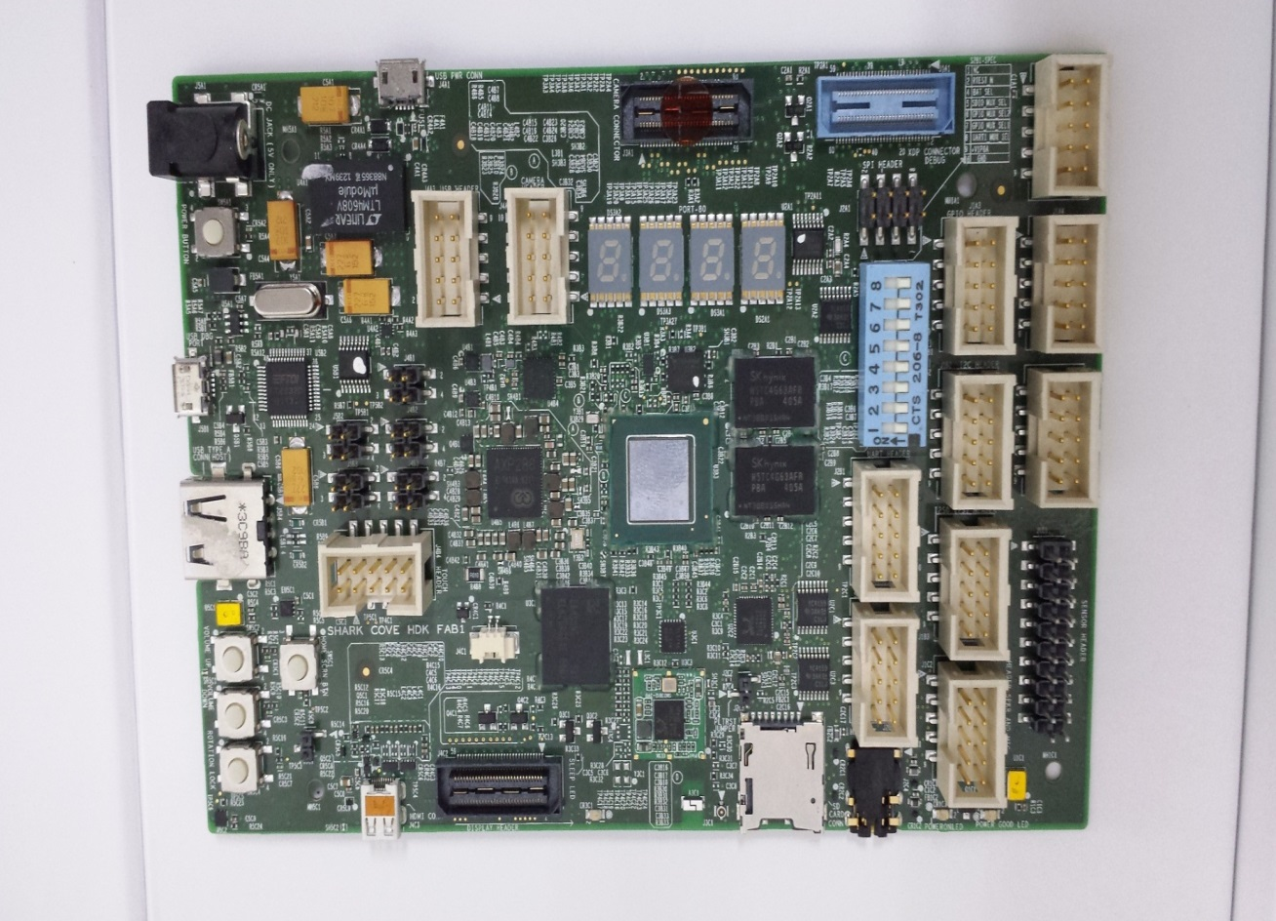

Power using micro USB

(5V)Port

Serial UART signals on USB

USB Type A (to USB hub)

Volume Up/Down Button, Rotation Lock, Home Screen Button

Post Codes

WiFi/BT Module

Camera Connector

uSD Card

3.5mm Audio Jack

Headers

ITP Connector

MIPI Display

Dip Switch for WiFi/BT Select

HDMI

Optional Power

(5V)

Power Button

CMOS Coin Cell Battery Connector

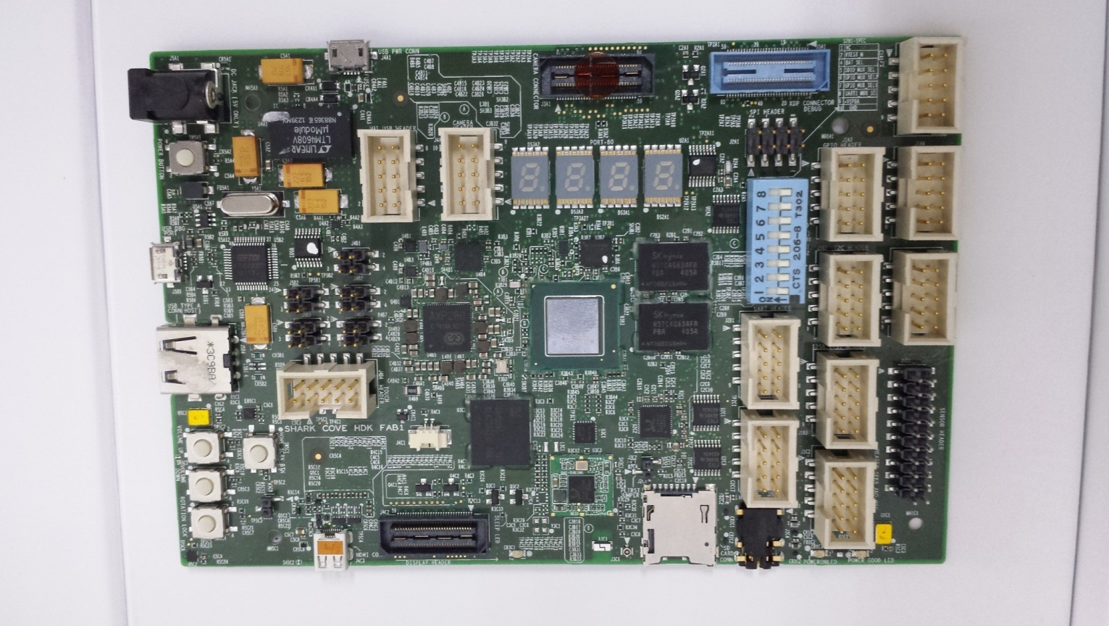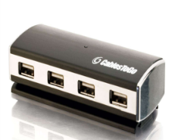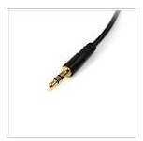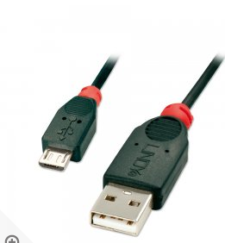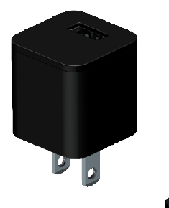

Alternate 5V (**NOT BYT RVP compatible**) power supply

uUSB 2A power supply

UART to uUSB for serial output (BIOS, WinDbg)

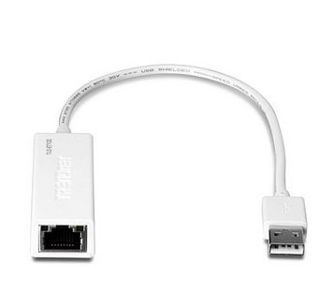

Primary USB 2.0 (to USB hub)

Audio jack

* Power is through a “device only” micro USB OTG port. The power adapter needs to be at 2A adapter.
* Alternately a 5v barrel connector style adapter can be used but **beware, the 12V Baytrail RVP adaptors are not the right voltage.** The 5V Clovertrail adapters are the right voltage.
* Kernel debugging is through the USB UART (your host system will need the same driver for the FTDI chip we have used before <http://www.ftdichip.com/Products/ICs/FT2232H.htm> ). Set up your host system ….
* Display is via HDMI
* A handful of the earliest systems had an incorrectly wired HDMI port that required a modified HDMI cable. These systems can be identified as they have the micro HDMI port (but not necessarily all systems with a micro HDMI port have this problem). If you have one of these systems, use the included cable with visible heat shrink tubing in the middle. Note that these cables may be fragile and **will not work for any other HDMI usages.**

1. **Updating IFWI**

For a brand new system that has no IFWI, the Dediprog and USB flash drive needs to be used following the instructions in the BYT CR Firmware releases. We have been using the FOTA method to update the IFWI. See the BytCRFotaCreatX64_IA32 directory in the Tools directory for information on creating the FOTA image.

* 1. **Updating IFWI with FOTA**
* The board must be able to boot to EFI Internal Shell without any issue.
  + Some of the earliest shipped systems did not have the EFI partition file system, so you will not see an fs0: file system for the eMMC (you may see one for an attached YSB flash drive though). In that case the FOTA method will not work. To work around this, boot to a WinPE USB flash drive, open a command window and run the create_efi2.bat script.
* Power button will be disabled during firmware update. If an accident hang happens, system will automatically reboot in 300 seconds.
* After updating IFWI via FOTA, if PMC FW version is not updated the system must shutdown to update PMC, such as shutdown -h/shutdown -s in OS, reset -s in Shell or power off forcibly.
* Get FOTA file from IFWI release folder or create it with below steps, and **FOTA file must be renamed to BIOSUPDATE.fv.**
  + Copy FotaCreate folder to Host PC
  + Copy the 4MB IFWI binary to FotaCreate folder.
  + To create IA32 FOTA image, run

CreateFotaIa32.bat <PATH to 4MB IFWI image> 6999 <OUTPUT Directory>

* + To create X64 FOTA image, run

CreateFotaX64.bat <PATH to 4MB IFWI image> 6999 <OUTPUT Directory>

* + BIOSUPDATE.fv is created under output folder.
* FOTA update is one way for FW update not flashing. When use FOTA update, the **below items will not be changed**, compared with context of system before updating.
  + The flash descriptor
  + The variable of BIOS
  + The status of TXE

**Steps:**

1. Put BIOSUPDATE.fv to USB flash disk root folder.
2. Boot to EFI Internal Shell with this USB flash disk connected.
3. Copy BIOSUPDATE.fv to the root folder of fs0:
4. Restart system.
5. Upon restart, check the IFWI update behavior.

*During restart, IFWI will be updated. The update progress log is showed. After update completely, system restarts automatically.*

1. Boot to BIOS setup. Check the versions of BIOS and TXE FW.
2. *The versions of BIOS and TXE FW are updated to correct ones wanted*
3. **Programming IFWI with DediProg + USB flash disk**

**Steps:**

1. Power off SUT
2. Connect DediProg to SUT
3. Power on the SUT
4. Connect Dediprog USB port to Host PC
5. Open ‘DediProg’ icon on the PC host, Select ‘Detect’ button to detect device on board and display the window. Select ‘Erase’ button to erase the device and display the operation completed (skip this step if the device is already blank).

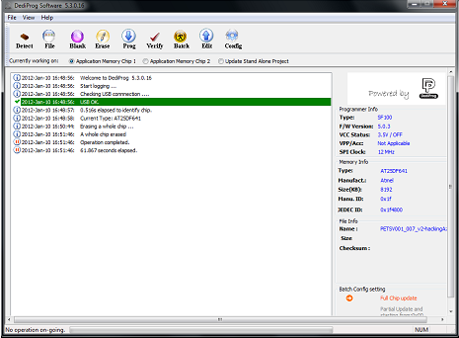

1. Click on ‘File’ button in menu to load 4MB IFWI file from the Host PC, select Data Format as ‘Raw Binary’ and check the item of ‘Truncate file to fit in the target area’, then click ‘OK’ to proceed.

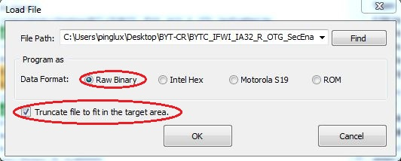

1. Go to Config menu and do the settings as shown below

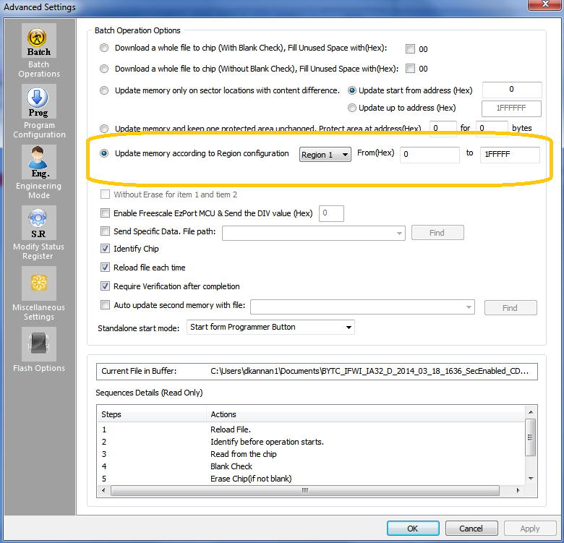

1. Select ‘Prog’ button to program device, and display the message after completing the programming.

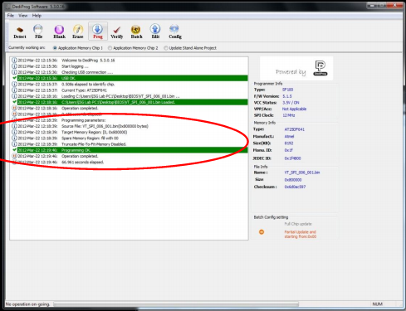

1. Click ‘Verify’ button to check and verify the programming.

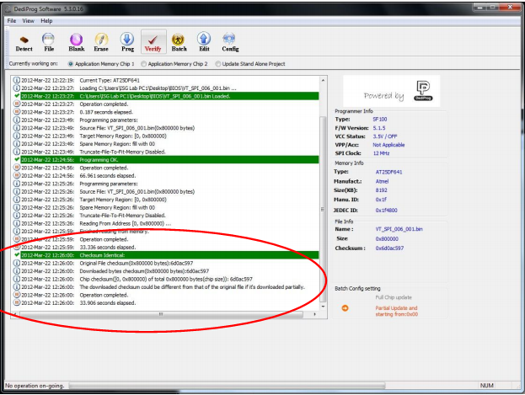

1. Power off the system and Remove the dediprog connection
2. Connect the USB Flash disk having firmware.bin file to the TYPE A USB connector
3. Power on SUT with USB flash disk connected.

*Then SUT processes normal boot along with progress bar without any issue, completing recovery of 2nd stage BIOS binary from USB flash disk seamlessly.*

1. Remove the USB flash disk.
2. Reboot to BIOS setup, check the versions of BIOS and TXE FW.

*The versions of BIOS and TXE FW are flashed to correct ones wanted.*

1. **Post IFWI Update Setup**

After updating the IFWI, make sure that the following BIOS settings are set correctly, by entering the BIOS setup screen by pressing the F2 key during boot

* BIOS version
* Device Manager, System Setup, South Cluster Configuration, Audio Configuration, Audio Controller to **Enable**
* Device Manager, System Setup, Thermal, DPTF to **Enable**
* Device Manager, System Setup, Boot, UEFI Security Boot set to **Disable** if you want to enable the kernel debugger and load unsigned drivers

1. **Operating System**

* We have been using a fresh install of the S14 Win8.1 release. Copy the ISO to a USB flash drive, and boot from that to complete the install
* We expect that the Single Language Release will be the typical install for development, but the Pro version has been shown to work as well
* Twice during OS install the system gets stuck. To workaround this we pull power and it resumes. We have not had time to debug this yet.

1. **Drivers**

* There are updated drivers that are not the same as the BYT CR distribution for Audio (due to a chance in the I2C channel), I2C and PMIC (due to the Xpower PMIC and I2C semaphore driver) in this file
* We are manually installing the drivers using the **drivers.bat** batch file. The batch file describes the order we were applying these. Note that some of the drivers are manually installed as described by that batch file.

1. **Known Issues**

* Twice during OS install the system gets stuck. To workaround this we pull power and it resumes. We have not had time to debug this yet
* Power button does not work in the OS
* Rotation lock does not work
* When last we checked, SVIDs were not changing
* Link to the Sharks Cove platform sightings (BYT CR HDK platform type) : <https://vthsd.fm.intel.com/hsd/tablet_platform/default.aspx#search/criteria.aspx?reloadf=1&focus=sighting&usr_query_id=5452651&qSaved=1>