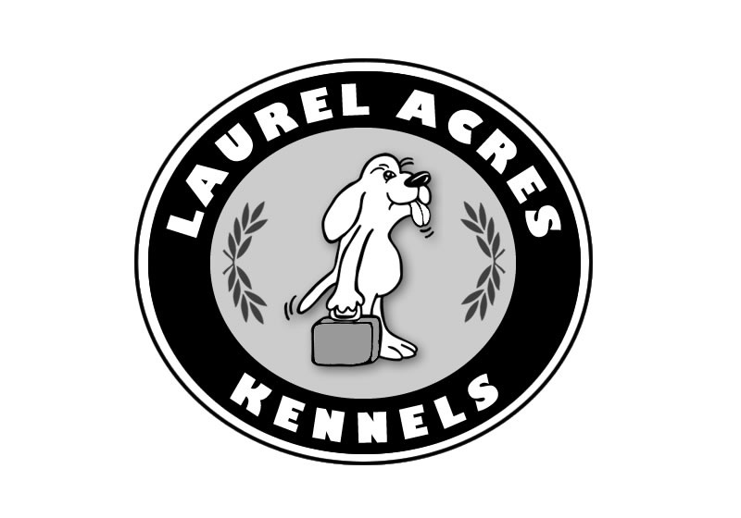
LAUREL ACRES KENNELS: OUR POLICIES

Laurel Acres Kennels will conduct business during normal hours.

All pet guests will be charged for the first day of boarding, regardless of arrival time. Dogs and cats can more easily adjust to the kennel environment if they arrive early in the day (particularly for the first time visitor). If your pet is picked up before 12:00 PM (noon) on the day of departure, you will not be charged for that day. Please take note of the 2013 holiday schedule and make your reservations early. If your plans change and you have to cancel, please give us at least 72 hours notice so that someone else can be accommodated.

Don't be disappointed! RESERVE EARLY FOR THE HOLIDAYS. They include: Spring Break, Memorial Day, Fourth of July, Labor Day, Thanksgiving, Christmas/New Years.

For your pet's safety and the safety of our other pet guests, all dogs must be kept on leash.All vaccinations must be current before pets will be checked in. Please ask your veterinarian to fax this information to us at (503) 628-4251. Please follow your veterinarian's recommendations regarding the vaccinations your pet should have prior to boarding.

GUESTS WILL NOT BE CHECKED IN UNTIL SHOTS ARE CURRENT

Please leave your pet in the car until check-in is complete. We will verify the dates your pet will be with us and make sure that all requested services such as walks, play yard, bathing, etc. are properly noted in your pet's record. You will also be asked to sign a contract for your pet's stay. Bedding and toys from home may make your dog's stay more comfortable so please mark your pet's name on all items. Although we can provide blankets for your dog's stay, the plain, easily washed ones, which you may choose to bring, would be best. Your dog will be given his very own "locker" for his personal possessions while he is here and we make every effort to return them to you. Please understand that occasionally these items are lost or destroyed. (Just like kids going to camp.) Do not bring items that are especially important to you as we cannot be responsible for them.Click here to view is an example contract that we will require you sign during your pets stay.

Changes to this StatementLaurel Acres Kennels will occasionally update this Statement to reflect company and customer feedback. Laurel Acres Kennels encourages you to periodically review this Statement to be informed of how Laurel Acres Kennels is protecting your information.

Contact UsLaurel Acres Kennels welcomes your comments. Please contact us at info@laurelacreskennels.com.

© Laurel Acres Kennels Last updated: November 2014

