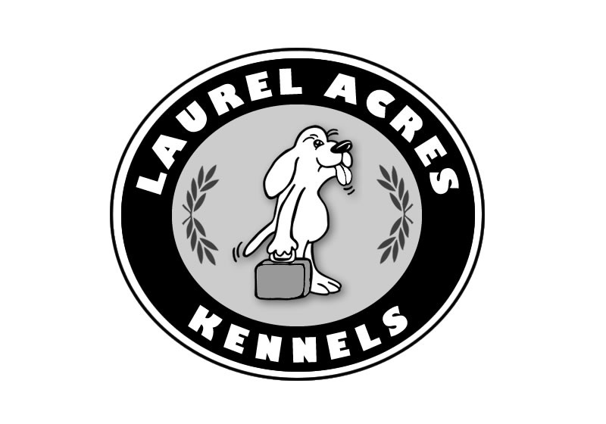
LAUREL ACRES KENNEL POLICIES and SECURITY

Laurel Acres Kennels will conduct business during normal hours.
All pet guests will be charged for the first day of boarding, regardless of arrival time. Dogs and cats can more easily adjust to the kennel environment if they arrive early in the day (particularly for the first time visitor). If your pet is picked up before 12:00 PM (noon) on the day of departure, you will not be charged for that day. Please take note of the 2013 holiday schedule and make your reservations early. If your plans change and you have to cancel, please give us at least 72 hours notice so that someone else can be accommodated.

OUR HOLIDAY SCHEDULE WILL CHANGE. See website for dates. They include: Spring Break, Memorial Day, Fourth of July, Labor Day, Thanksgiving, Christmas/New Years

For your pet's safety and the safety of our other pet guests, all dogs must be kept on leash.All vaccinations must be current before pets will be checked in. Please ask your veterinarian to fax this information to us at (503) 628-4251. For dogs, these shots are Rabies, DHLPP and Bordetella. For cats, these shots are Rabies, FVRCP and FELV. GUESTS WILL NOT BE CHECKED IN UNTIL SHOTS ARE CURRENT

Please leave your pet in the car until check-in is complete. We will verify the dates your pet will be with us and make sure that all requested services such as walks, play yard, bathing, etc. are properly noted in your pet's record. You will also be asked to sign a contract for your pet's stay. Bedding and toys from home may make your dog's stay more comfortable so please mark your pet's name on all items. Although we can provide blankets for your dog's stay, the plain, easily washed ones, which you may choose to bring, would be best. Your dog will be given his very own "locker" for his personal possessions while he is here and we make every effort to return them to you. Please understand that occasionally these items are lost or destroyed. (Just like kids going to camp.) Do not bring items that are especially important to you as we cannot be responsible for them.Click here to view is an example contract that we will require you sign during your pets stay.

Laurel Acres Kennels is committed to protecting your privacy and developing technology that gives you the most powerful and safe online experience.This Statement of Privacy applies to the Laurel Acres Kennels Web site and governs data collection and usage. By using the Laurel Acres Kennels website, you consent to the data practices described in this statement.

Collection of your Personal InformationLaurel Acres Kennels collects personally identifiable information, such as your e-mail address, name, home or work address or telephone number. Laurel Acres Kennels also collects anonymous demographic information, which is not unique to you, such as your ZIP code, age, gender, preferences, interests and favorites. There is also information about your computer hardware and software that is automatically collected by Laurel Acres Kennels. This information can include: your IP address, browser type, domain names, access times and referring Web site addresses. This information is used by Laurel Acres Kennels for the operation of the service, to maintain quality of the service, and to provide general statistics regarding use of the Laurel Acres Kennels Web site.

Please keep in mind that if you directly disclose personally identifiable information or personally sensitive data through Laurel Acres Kennels public message boards, this information may be collected and used by others. Note: Laurel Acres Kennels does not read any of your private online communications.

Laurel Acres Kennels encourages you to review the privacy statements of Web sites you choose to link to from Laurel Acres Kennels so that you can understand how those Web sites collect, use and share your information. Laurel Acres Kennels is not responsible for the privacy statements or other content on Web sites outside of the Laurel Acres Kennels and Laurel Acres Kennels family of Web sites.

Use of your Personal InformationLaurel Acres Kennels collects and uses your personal information to operate the Laurel Acres Kennels Web site and deliver the services you have requested. Laurel Acres Kennels also uses your personally identifiable information to inform you of other products or services available from Laurel Acres Kennels and its affiliates. Laurel Acres Kennels may also contact you via surveys to conduct research about your opinion of current services or of potential new services that may be offered.

Laurel Acres Kennels does not sell, rent or lease its customer lists to third parties. Laurel Acres Kennels may, from time to time, contact you on behalf of external business partners about a particular offering that may be of interest to you. In those cases, your unique personally identifiable information (e-mail, name, address, telephone number) is not transferred to the third party. In addition, Laurel Acres Kennels may share data with trusted partners to help us perform statistical analysis, send you email or postal mail, provide customer support, or arrange for deliveries. All such third parties are prohibited from using your personal information except to provide these services to Laurel Acres Kennels, and they are required to maintain the confidentiality of your information.

Laurel Acres Kennels does not use or disclose sensitive personal information, such as race, religion, or political affiliations, without your explicit consent.Laurel Acres Kennels keeps track of the Web sites and pages our customers visit within Laurel Acres Kennels, in order to determine what Laurel Acres Kennels services are the most popular. This data is used to deliver customized content and advertising within Laurel Acres Kennels to customers whose behavior indicates that they are interested in a particular subject area.

Laurel Acres Kennels Web sites will disclose your personal information, without notice, only if required to do so by law or in the good faith belief that such action is necessary to: (a) conform to the edicts of the law or comply with legal process served on Laurel Acres Kennels or the site; (b) protect and defend the rights or property of Laurel Acres Kennels; and, (c) act under exigent circumstances to protect the personal safety of users of Laurel Acres Kennels, or the public.

Use of CookiesThe Laurel Acres Kennels Web site use "cookies" to help you personalize your online experience. A cookie is a text file that is placed on your hard disk by a Web page server. Cookies cannot be used to run programs or deliver viruses to your computer. Cookies are uniquely assigned to you, and can only be read by a web server in the domain that issued the cookie to you.

One of the primary purposes of cookies is to provide a convenience feature to save you time. The purpose of a cookie is to tell the Web server that you have returned to a specific page. For example, if you personalize Laurel Acres Kennels pages, or register with Laurel Acres Kennels site or services, a cookie helps Laurel Acres Kennels to recall your specific information on subsequent visits. This simplifies the process of recording your personal information, such as billing addresses, shipping addresses, and so on. When you return to the same Laurel Acres Kennels Web site, the information you previously provided can be retrieved, so you can easily use the Laurel Acres Kennels features that you customized.

You have the ability to accept or decline cookies. Most Web browsers automatically accept cookies, but you can usually modify your browser setting to decline cookies if you prefer. If you choose to decline cookies, you may not be able to fully experience the interactive features of the Laurel Acres Kennels services or Web sites you visit.Security of your Personal InformationLaurel Acres Kennels secures your personal information from unauthorized access, use or disclosure. Laurel Acres Kennels secures the personally identifiable information you provide on computer servers in a controlled, secure environment, protected from unauthorized access, use or disclosure. When personal information (such as a credit card number) is transmitted to other Web sites, it is protected through the use of encryption, such as the Secure Socket Layer (SSL) protocol.

Changes to this StatementLaurel Acres Kennels will occasionally update this Statement of Privacy to reflect company and customer feedback. Laurel Acres Kennels encourages you to periodically review this Statement to be informed of how Laurel Acres Kennels is protecting your information.

Contact InformationLaurel Acres Kennels welcomes your comments regarding this Statement of Privacy. If you believe that Laurel Acres Kennels has not adhered to this Statement, please contact Laurel Acres Kennels atmailto:info@laurelacreskennels.com. We will use commercially reasonable efforts to promptly determine and remedy the problem.

© Laurel Acres Kennels Last updated: March 2014

