Chapter 46 Problems

1, 2, 3 = straightforward, intermediate, challenging

Section 46.1 The Fundamental Forces in Nature
Section 46.2 Positrons and Other Antiparticles

1. A photon produces a proton–antiproton pair according to the reaction 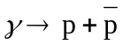. What is the minimum possible frequency of the photon? What is its wavelength?

2. Two photons are produced when a proton and antiproton annihilate each other. In the reference frame in which the center of mass of the proton–antiproton system is stationary, what are the minimum frequency and corresponding wavelength of each photon?

3. A photon with an energy E_{γ} = 2.09 GeV creates a proton–antiproton pair in which the proton has a kinetic energy of 95.0 MeV. What is the kinetic energy of the antiproton? (m_{p}c² = 938.3 MeV.)

Section 46.3 Mesons and the Beginning of Particle Physics

4. Occasionally, high-energy muons collide with electrons and produce two neutrinos according to the reaction 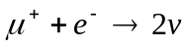. What kind of neutrinos are these?

5. One of the mediators of the weak interaction is the Z⁰ boson, with mass 93 GeV/c². Use this information to find the order of magnitude of the range of the weak interaction.

6. Calculate the range of the force that might be produced by the virtual exchange of a proton.

7. A neutral pion at rest decays into two photons according to

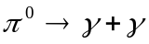

Find the energy, momentum, and frequency of each photon.

8. When a high-energy proton or pion traveling near the speed of light collides with a nucleus, it travels an average distance of 3 × 10^{–15} m before interacting. From this information, find the order of magnitude of the time interval required for the strong interaction to occur.

9. A free neutron beta decays by creating a proton, an electron and an antineutrino according to the reaction 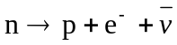. What If? Imagine that a free neutron decays by creating a proton and electron according to the reaction

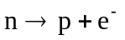

and assume that the neutron is initially at rest in the laboratory. (a) Determine the energy released in this reaction. (b) Determine the speeds of the proton and electron after the reaction. (Energy and momentum are conserved in the reaction.) (c) Is either of these particles moving at a relativistic speed? Explain.

Section 46.4 Classification of Particles

10. Identify the unknown particle on the left side of the following reaction:

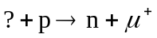

11. Name one possible decay mode (see Table 46.2) for 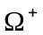, 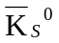, 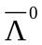 and .

Section 46.5 Conservation Laws

12. Each of the following reactions is forbidden. Determine a conservation law that is violated for each reaction.

(a) 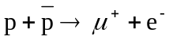
(b) 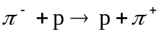
(c) 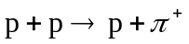
(d) 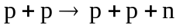
(e) 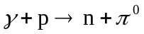

13. (a) Show that baryon number and charge are conserved in the following reactions of a pion with a proton.

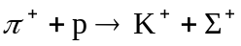 (1)
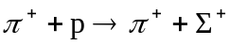 (2)

(b) The first reaction is observed, but the second never occurs. Explain.

14. The first of the following two reactions can occur, but the second cannot. Explain.

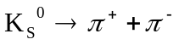 (can occur)
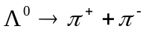 (cannot occur)

15. The following reactions or decays involve one or more neutrinos. In each case, supply the missing neutrino (v_{e}, v_{μ}, or v_{τ}) or antineutrino.

(a) 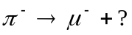
(b) 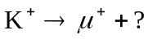
(c) 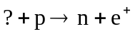
(d) 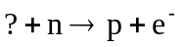
(e) 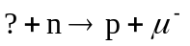
(f) 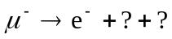

16. A K_{S}⁰ particle at rest decays into a π⁺ and a π–. What will be the speed of each of the pions? The mass of the K_{S}⁰ is 497.7 MeV/c², and the mass of each π is 139.6 MeV/c².

17. Determine which of the following reactions can occur. For those that cannot occur, determine the conservation law (or laws) violated:

(a) 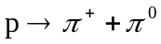
(b) 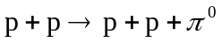
(c)
(d) 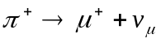
(e) 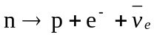
(f) 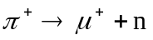

18. (a) Show that the proton-decay reaction

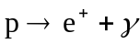

cannot occur, because it violates conservation of baryon number. (b) What If? Imagine that this reaction does occur, and that the proton is initially at rest. Determine the energy and momentum of the positron and photon after the reaction. (Suggestion: Recall that energy and momentum must be conserved in the reaction.) (c) Determine the speed of the positron after the reaction.

19. Determine the type of neutrino or antineutrino involved in each of the following processes:

(a) 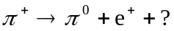
(b) 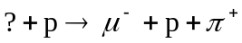
(c) 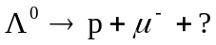
(d) 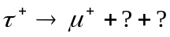

Section 46.6 Strange Particles and Strangeness

20. The neutral meson ρ₀ decays by the strong interaction into two pions: 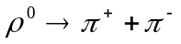, half-life 10^{–23} s. The neutral kaon also decays into two pions: , half-life 10^{–10} s. How do you explain the difference in half-lives?

21. Determine whether or not strangeness is conserved in the following decays and reactions.

(a) 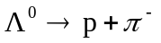
(b) 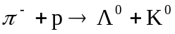
(c) 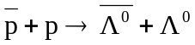
(d) 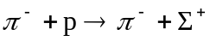
(e) 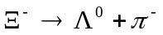
(f) 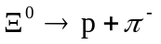

22. For each of the following forbidden decays, determine which conservation law is violated:

(a) 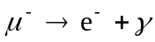
(b) 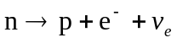
(c) 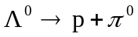
(d) 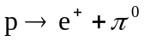
(e) 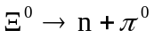

23. Which of the following processes are allowed by the strong interaction, the electromagnetic interaction, the weak interaction, or no interaction at all?

(a) 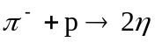
(b) 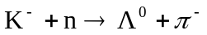
(c) 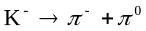
(d) 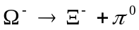
(e) 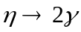

24. Identify the conserved quantities in the following processes:

(a) 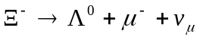
(b) 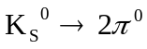
(c) 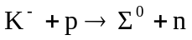
(d) 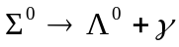
(e) 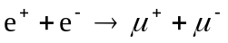
(f) 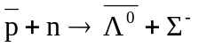

25. Fill in the missing particle. Assume that (a) occurs via the strong interaction and (b) and (c) involve the weak interaction.

(a) 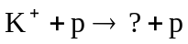
(b) 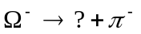
(c) 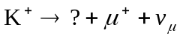

Section 46.7 Making Elementary Particles and Measuring their Properties

26. The particle decay 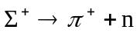 is observed in a bubble chamber. Figure P46.26 represents the curved tracks of the particles Σ⁺ and π⁺, and the invisible track of the neutron, in the presence of a uniform magnetic field of 1.15 T directed out of the page. The measured radii of curvature are 1.99 m for the Σ⁺ particle and 0.580 m for the π⁺ particle. (a) Find the momenta of the Σ⁺ and the π⁺ particles, in units of MeV/c. (b) The angle between the momenta of the Σ⁺ and the π⁺ particles at the moment of decay is 64.5°. Find the momentum of the neutron. (c) Calculate the total energy of the π⁺ particle, and of the neutron, from their known masses (m_{π} = 139.6 MeV/c², m_{n} = 939.6 MeV/c²) and the relativistic energy–momentum relation. What is the total energy of the Σ⁺ particle? (d) Calculate the mass and speed of the Σ⁺ particle.

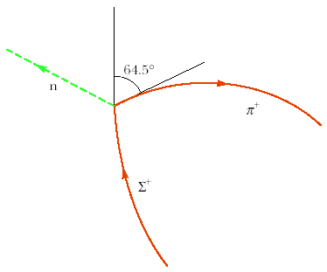

Figure P46.26

27. If a K_{S}⁰ meson at rest decays in 0.900 × 10^{–10} s, how far will a K_{S}⁰ meson travel if it is moving at 0.960c?

28. A particle of mass m₁ is fired at a stationary particle of mass m₂, and a reaction takes place in which new particles are created out of the incident kinetic energy. Taken together, the product particles have total mass m₃. The minimum kinetic energy that the bombarding particle must have in order to induce the reaction is called the threshold energy. At this energy, the kinetic energy of the products is a minimum, so that the fraction of the incident kinetic energy that is available to create new particles is a maximum. This occurs when all the product particles have the same velocity, so that the particles have no kinetic energy of motion relative to one another. (a) By using conservation of relativistic energy and momentum, and the relativistic energy-momentum relation, show that the threshold energy is given by

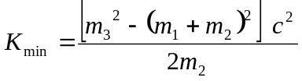

Calculate the threshold energy for each of the following reactions:
(b) 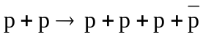
(One of the initial protons is at rest. Antiprotons are produced.)
(c) 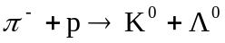
(The proton is at rest. Strange particles are produced.)
(d)
(One of the initial protons is at rest. Pions are produced.)
(e) 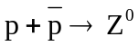
(One of the initial particles is at rest. Z⁰ particles (mass 91.2 GeV/c²) are produced.)

Section 46.8 Finding Patterns in the Particles
Section 46.9 Quarks
Section 46.10 Multicolored Quarks
Section 46.11 The Standard Model
Note: Problem 71 in Chapter 39 can be assigned with Section 46.11.

29. (a) Find the number of electrons and the number of each species of quarks in 1 L of water. (b) Make an order-of-magnitude estimate of the number of each kind of fundamental matter particle in your body. State your assumptions and the quantities you take as data.

30. The quark composition of the proton is uud, and that of the neutron is udd. Show that in each case the charge, baryon number, and strangeness of the particle equal, respectively, the sums of these numbers for the quark constituents.

31. What If? Imagine that binding energies could be ignored. Find the masses of the u and d quarks from the masses of the proton and neutron.

32. The quark compositions of the K⁰ and Λ⁰ particles are 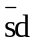 and uds, respectively. Show that the charge, baryon number, and strangeness of these particles equal, respectively, the sums of these numbers for the quark constituents.

33. Analyze each reaction in terms of constituent quarks:

(a)
(b)
(c) 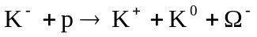
(d) 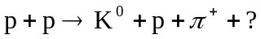

In the last reaction, identify the mystery particle.

34. The text states that the reaction 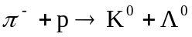 occurs with high probability, whereas the reaction 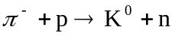 never occurs. Analyze these reactions at the quark level. Show that the first reaction conserves the total number of each type of quark, and the second reaction does not.

35. A Σ⁰ particle traveling through matter strikes a proton; then a Σ⁺ and a gamma ray emerge, as well as a third particle. Use the quark model of each to determine the identity of the third particle.

36. Identify the particles corresponding to the quark combinations (a) suu, (b) 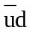, (c) , and (d) ssd.

37. What is the electrical charge of the baryons with the quark compositions (a) and (b) ? What are these baryons called?

Section 46.12 The Cosmic Connection

38. Review problem. Refer to Section 39.4. Prove that the Doppler shift in wavelength of electromagnetic waves is described by

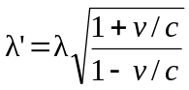

where λ’ is the wavelength measured by an observer moving at speed v away from a source radiating waves of wavelength λ.

39. A distant quasar is moving away from Earth at such high speed that the blue 434-nm H_{γ} line of hydrogen is observed at 510 nm, in the green portion of the spectrum (Fig. P46.39). (a) How fast is the quasar receding? You may use the result of Problem 38. (b) Edwin Hubble discovered that all objects outside the local group of galaxies are moving away from us, with speeds proportional to their distances. Hubble’s law is expressed as v = HR, where Hubble’s constant has the approximate value H = 17 × 10^{–3} m/s · ly. Determine the distance from Earth to this quasar.

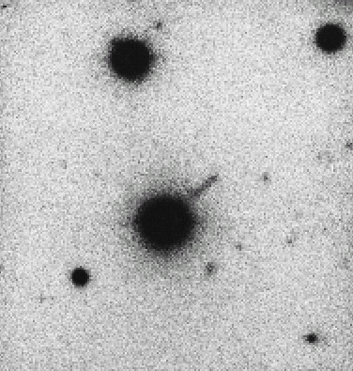
Note: Problem 20 in Chapter 39 can be assigned with this section.

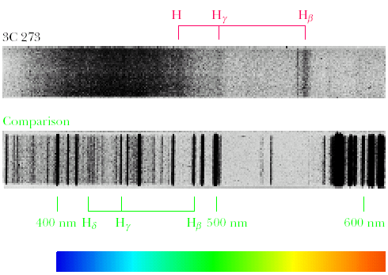
Maarten Schmidt/Palomar Observatory/California Institute of Technology

Figure P46.39: (a) Image of the quasar 3C273. (b) Spectrum of the quasar above a comparison spectrum emitted by stationary hydrogen and helium atoms. Both parts of the figure are printed as black-and-white photographic negatives to reveal detail.

40. The various spectral lines observed in the light from a distant quasar have longer wavelengths λ_{n}’ than the wavelengths λ_{n} measured in light from a stationary source. Here n is an index taking different values for different spectral lines. The fractional change in wavelength toward the red is the same for all spectral lines. That is, the redshift parameter Z defined by

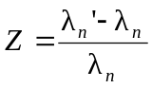

is common to all spectral lines for one object. In terms of Z, determine (a) the speed of recession of the quasar and (b) the distance from Earth to this quasar. Use the result of Problem 38 and Hubble’s law.

41. Using Hubble’s law, find the wavelength of the 590-nm sodium line emitted from galaxies (a) 2.00 × 10⁶ ly away from Earth, (b) 2.00 × 10⁸ ly away, and (c) 2.00 × 10⁹ ly away. You may use the result of Problem 38.

42. Review problem. The cosmic background radiation is blackbody radiation from a source at a temperature of 2.73 K. (a) Use Wien’s law to determine the wavelength at which this radiation has its maximum intensity. (b) In what part of the electromagnetic spectrum is the peak of the distribution?

43. Review problem. Use Stefan’s law to find the intensity of the cosmic background radiation emitted by the fireball of the Big Bang at a temperature of 2.73 K.

44. It is mostly your roommate’s fault. Nosy astronomers have discovered enough junk and clutter in your dorm room to constitute the missing mass required to close the Universe. After observing your floor, closet, bed, and computer files, they extrapolate to slobs in other galaxies and calculate the average density of the observable Universe as 1.20 ρ_{c}. How many times larger will the Universe become before it begins to collapse? That is, by what factor will the distance between remote galaxies increase in the future?

45. The early Universe was dense with gamma-ray photons of energy ~k_{B}T and at such a high temperature that protons and antiprotons were created by the process as rapidly as they annihilated each other. As the Universe cooled in adiabatic expansion, its temperature fell below a certain value, and proton pair production became rare. At that time slightly more protons than antiprotons existed, and essentially all of the protons in the Universe today date from that time. (a) Estimate the order of magnitude of the temperature of the Universe when protons condensed out. (b) Estimate the order of magnitude of the temperature of the Universe when electrons condensed out.

46. If the average density of the Universe is small compared to the critical density, the expansion of the Universe described by Hubble’s law proceeds with speeds that are nearly constant over time. (a) Prove that in this case the age of the Universe is given by the inverse of Hubble’s constant. (b) Calculate 1/H and express it in years.

47. Assume that the average density of the Universe is equal to the critical density. (a) Prove that the age of the Universe is given by 2/3H. (b) Calculate 2/3H and express it in years.

48. Hubble’s law can be stated in vector form as v = HR: Outside the local group of galaxies, all objects are moving away from us with velocities proportional to their displacements from us. In this form, it sounds as if our location in the Universe is specially privileged. Prove that Hubble’s law would be equally true for an observer elsewhere in the Universe. Proceed as follows. Assume that we are at the origin of coordinates, that one galaxy cluster is at location R₁ and has velocity v₁ = HR₁ relative to us, and that another galaxy cluster has radius vector R₂ and velocity v₂ = HR₂. Suppose the speeds are nonrelativistic. Consider the frame of reference of an observer in the first of these galaxy clusters. Show that our velocity relative to her, together with the displacement vector of our galaxy cluster from hers, satisfies Hubble’s law. Show that the displacement and velocity of cluster 2 relative to cluster 1 satisfy Hubble’s law.

Section 46.13 Problems and Perspectives

49. Classical general relativity views the structure of space–time as deterministic and well defined down to arbitrarily small distances. On the other hand, quantum general relativity forbids distances smaller than the Planck length given by L = (ħG/c³)^{1/2}. (a) Calculate the value of the Planck length. The quantum limitation suggests that after the Big Bang, when all the presently observable section of the Universe was contained within a point-like singularity, nothing could be observed until that singularity grew larger than the Planck length. Because the size of the singularity grew at the speed of light, we can infer that no observations were possible during the time interval required for light to travel the Planck length. (b) Calculate this time interval, known as the Planck time T, and compare it with the ultrahot epoch mentioned in the text. (c) Does this suggest we may never know what happened between the time t = 0 and the time t = T?

Additional Problems

50. Review problem. Supernova Shelton 1987A, located about 170 000 ly from the Earth, is estimated to have emitted a burst of neutrinos carrying energy ~10⁴⁶ J (Fig. P46.50). Suppose the average neutrino energy was 6 MeV and your body presented cross-sectional area 5 000 cm². To an order of magnitude, how many of these neutrinos passed through you?

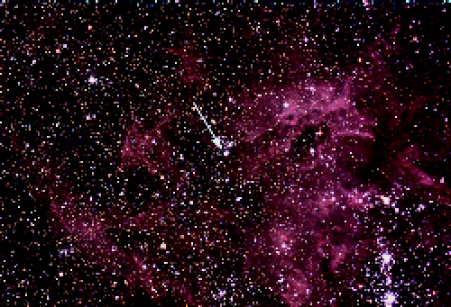

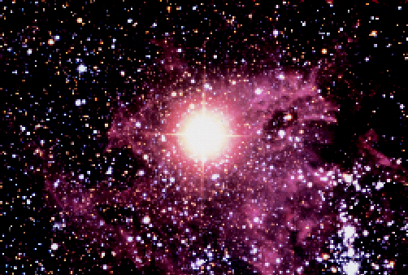
Anglo-Australian Telescope Board

Figure P46.50: The giant star Sanduleak –69:202 in the “before” picture became Supernova Shelton 1987A in the “after” picture.

51. The most recent naked-eye supernova was Supernova Shelton 1987A (Fig. P46.50). It was 170 000 ly away in the next galaxy to ours, the Large Magellanic Cloud. About 3 h before its optical brightening was noticed, two continuously running neutrino detection experiments simultaneously registered the first neutrinos from an identified source other than the Sun. The Irvine–Michigan–Brookhaven experiment in a salt mine in Ohio registered 8 neutrinos over a 6-s period, and the Kamiokande II experiment in a zinc mine in Japan counted 11 neutrinos in 13 s. (Because the supernova is far south in the sky, these neutrinos entered the detectors from below. They passed through the Earth before they were by chance absorbed by nuclei in the detectors.) The neutrino energies were between about 8 MeV and 40 MeV. If neutrinos have no mass, then neutrinos of all energies should travel together at the speed of light—the data are consistent with this possibility. The arrival times could show scatter simply because neutrinos were created at different moments as the core of the star collapsed into a neutron star. If neutrinos have nonzero mass, then lower-energy neutrinos should move comparatively slowly. The data are consistent with a 10-MeV neutrino requiring at most about 10 s more than a photon would require to travel from the supernova to us. Find the upper limit that this observation sets on the mass of a neutrino. (Other evidence sets an even tighter limit.)

52. Name at least one conservation law that prevents each of the following reactions: (a) 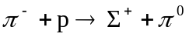 (b) 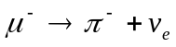 (c) 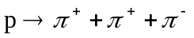

53. The energy flux carried by neutrinos from the Sun is estimated to be on the order of 0.4 W/m² at Earth’s surface. Estimate the fractional mass loss of the Sun over 10⁹ yr due to the emission of neutrinos. (The mass of the Sun is 2 × 10³⁰ kg. The Earth–Sun distance is 1.5 × 10¹¹ m.)

54. Two protons approach each other head-on, each with 70.4 MeV of kinetic energy, and engage in a reaction in which a proton and positive pion emerge at rest. What third particle, obviously uncharged and therefore difficult to detect, must have been created?

55. A rocket engine for space travel using photon drive and matter–antimatter annihilation has been suggested. Suppose the fuel for a short-duration burn consists of N protons and N antiprotons, each with mass m. (a) Assume all of the fuel is annihilated to produce photons. When the photons are ejected from the rocket, what momentum can be imparted to it? (b) What If? If half of the protons and antiprotons annihilate each other and the energy released is used to eject the remaining particles, what momentum could be given to the rocket? (c) Which scheme results in the greater change in speed for the rocket?

56. The nuclear force can be attributed to the exchange of an elementary particle between protons and neutrons when they are sufficiently close. Take the range of the nuclear force as approximately 1.4 × 10^{–15} m. (a) Use the uncertainty principle ΔEΔt ≥ ħ/2 to estimate the mass of the elementary particle. Assume that it moves at nearly the speed of light. (b) Using Table 46.2, identify the particle.

57. Determine the kinetic energies of the proton and pion resulting from the decay of a Λ⁰ at rest:

58. A gamma-ray photon strikes a stationary electron. Determine the minimum gamma-ray energy to make this reaction occur:

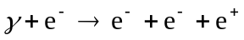

59. An unstable particle, initially at rest, decays into a proton (rest energy 938.3 MeV) and a negative pion (rest energy 139.6 MeV). A uniform magnetic field of 0.250 T exists perpendicular to the velocities of the created particles. The radius of curvature of each track is found to be 1.33 m. What is the mass of the original unstable particle?

60. A Σ⁰ particle at rest decays according to

Find the gamma-ray energy.

61. Two protons approach each other with velocities of equal magnitude in opposite directions. What is the minimum kinetic energy of each of the protons if they are to produce a π⁺ meson at rest in the following reaction?

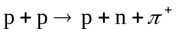

62. A π-meson at rest decays according to 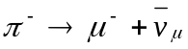. What is the energy carried off by the neutrino? (Assume that the neutrino has no mass and moves off with the speed of light. Take m_{π} c² = 139.6 MeV and m_{μ} c² = 105.7 MeV.)

63. Review problem. Use the Boltzmann distribution function 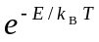 to calculate the temperature at which 1.00% of a population of photons will have energy greater than 1.00 eV. The energy required to excite an atom is on the order of 1 eV. Therefore as the temperature of the Universe fell below the value you calculate, neutral atoms could form from plasma, and the Universe became transparent. The cosmic background radiation represents our vastly red-shifted view of the opaque fireball of the Big Bang as it was at this time and temperature. The fireball surrounds us; we are embers.

64. What processes are described by the Feynman diagrams in Figure P46.64? What is the exchanged particle in each process?

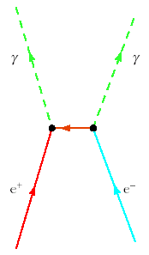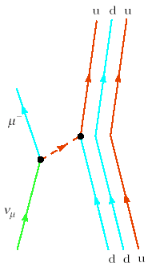

Figure P46.64

65. Identify the mediators for the two interactions described in the Feynman diagrams shown in Figure P46.65.

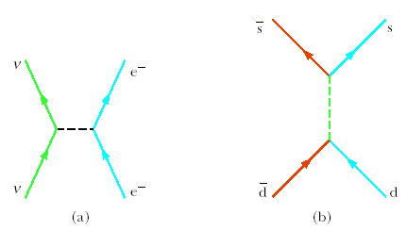

Figure P46.65

66. The cosmic rays of highest energy are mostly protons, accelerated by unknown sources. Their spectrum shows a cutoff at an energy on the order of 10²⁰ eV. Above that energy, a proton will interact with a photon of cosmic microwave background radiation to produce mesons, for example according to

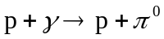

Demonstrate this fact by taking the following steps: (a) Find the minimum photon energy required to produce this reaction in the reference frame where the total momentum of the photon–proton system is zero. The reaction was observed experimentally in the 1950s with photons of a few hundred MeV. (b) Use Wien’s displacement law to find the wavelength of a photon at the peak of the blackbody spectrum of the primordial microwave background radiation, with a temperature of 2.73 K. (c) Find the energy of this photon. (d) Consider the reaction in part (a) in a moving reference frame so that the photon is the same as that in part (c). Calculate the energy of the proton in this frame, which represents the Earth reference frame.

© Copyright 2004 Thomson. All rights reserved.

