**Data Structures Group Project Group Report**

**Group Members**

|  |  |
| --- | --- |
| **Name** | **ID Number** |
| Laurell Seville | 1800746 |
| Marvin Arnett | 1701403 |
| Donrick Jones | 1500745 |

**Application User Manual**

**Player Registration**

This is the first screen. Here you enter the names of the three players.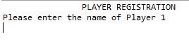

**Gameplay**

In this section the respective round is chosen. The current player’s information is displayed as well as the card the wheel landed on when it was spun. As well as the puzzle to be solved. Here you can enter a guess for a letter

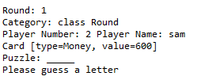

**Incorrect Guess**

If the player guesses incorrectly, he loses his turn and another player gets to guess a letter.

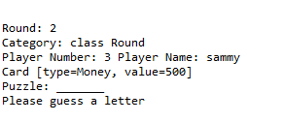

**Correct Guess**

If the player guesses correctly he is presented with three options, spin the wheel to get another guess, buy a vowel or guess the puzzle. The value of his card is also added to his round total.

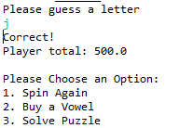

**Spin Again**

If the user chooses 1. The wheel is spun again and he gets to guess another letter.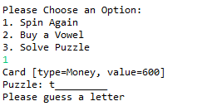

**Buy A Vowel**

Here the user can purchase any vowel, if the vowel he bought is in the word it will be added to the list of letters already guessed if not he loses his turn.

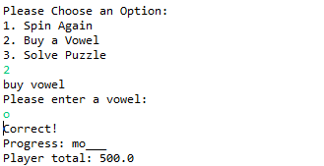

**Solve Puzzle**

Here the user has an option to enter what he thinks the word is.