1a & 1b. Use LucidChart to develop the same ERD Level 0 and Level 1 diagrams discussed in the lectures this week for Rick's Brick & Cue Catering.  ERD Level 0 should include the following entities: CUSTOMER, EVENT, ITEM, DELIVERY LOCATION, GUEST CHECK, and EMPLOYEE.  ERD Level 1 should contain the same entities, along with any association entities added to resolve M:N relationships.

2a & 2b. Use LucidChart to develop ERD Level 0 and Level 1 diagrams for the following business rules:

**1a**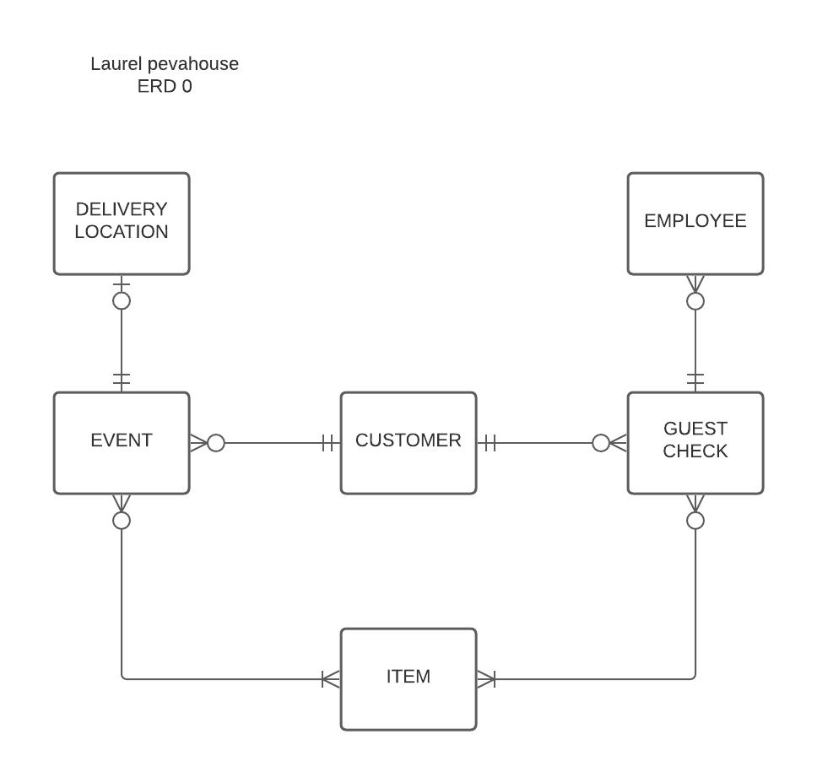

**1b**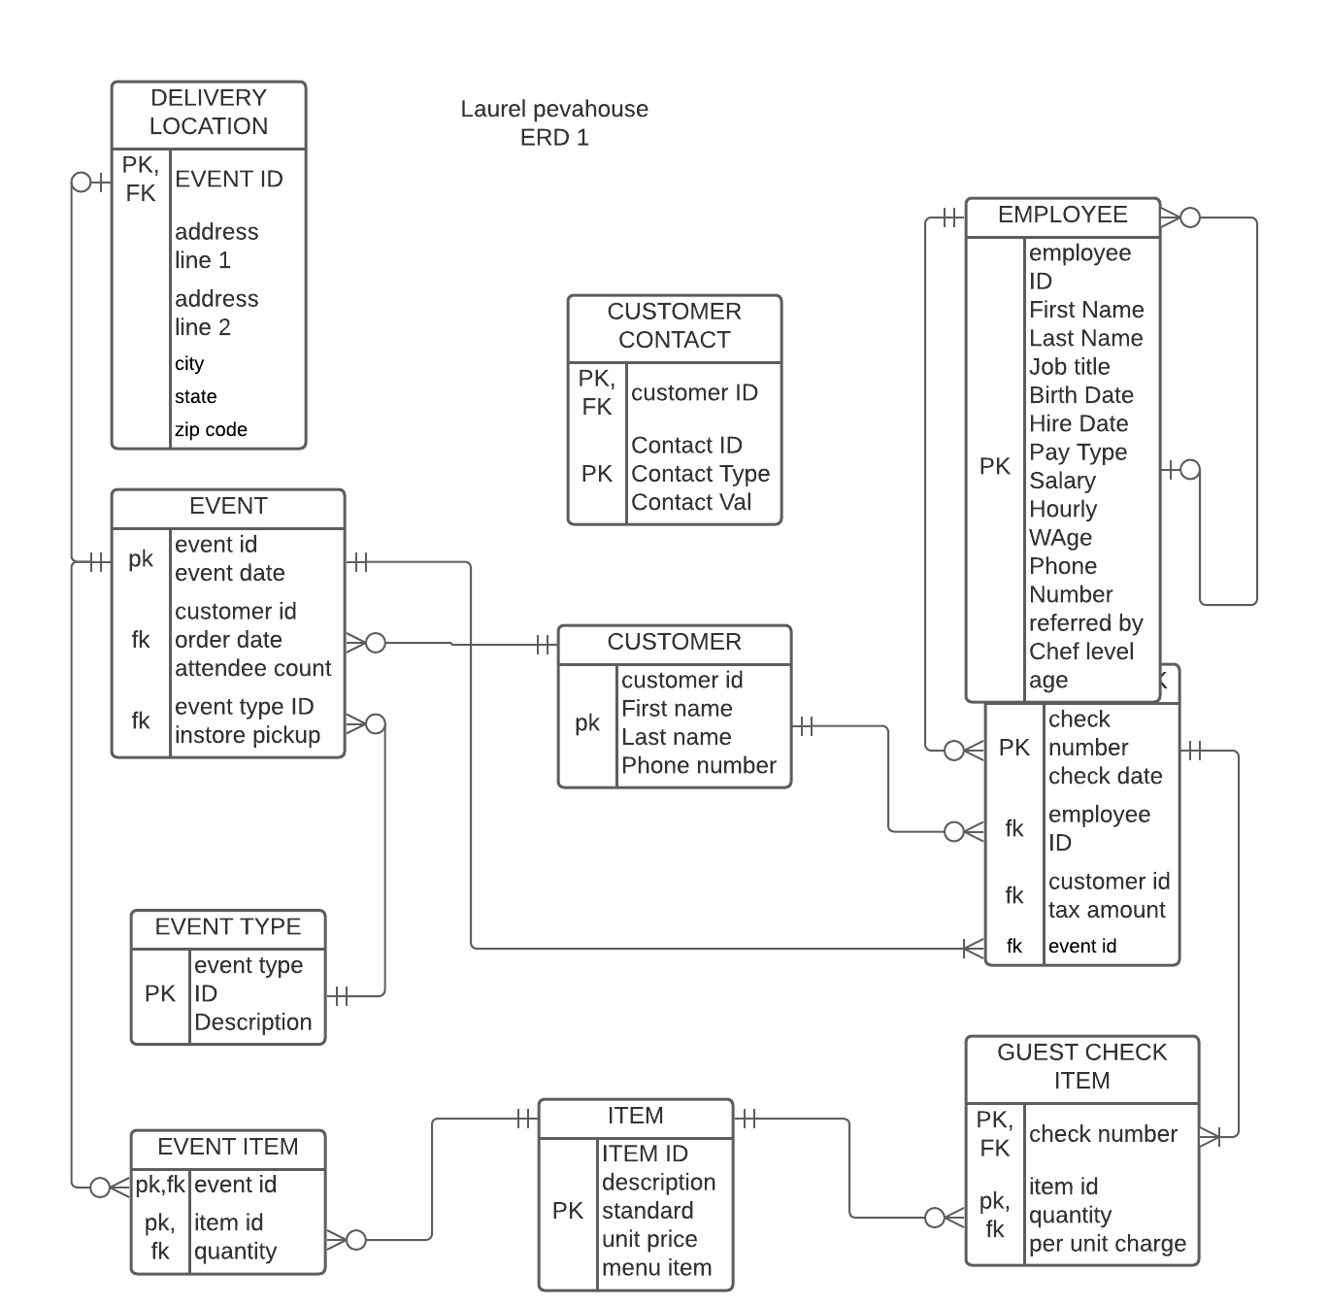

**2A**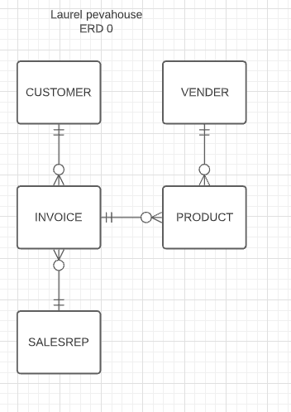

2B