On the origin of citations

Lauren Blake

September 15, 2015

# Load the data

counts_raw <- read.delim("~/altmetrics/counts-raw.txt")  
counts_norm <- read.delim("~/altmetrics/counts-norm.txt")

# Data exploration

What's the distribution of authors in all articles of our data set?

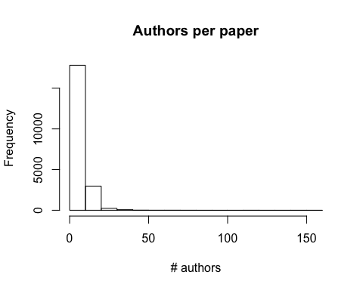

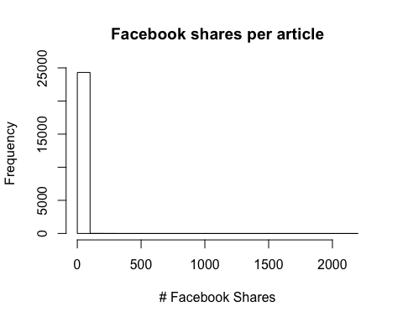

The average number of Facebook shares per paper in the data set is 0.6524187.

## dplyr

library("dplyr")

##   
## Attaching package: 'dplyr'  
##   
## The following object is masked from 'package:stats':  
##   
## filter  
##   
## The following objects are masked from 'package:base':  
##   
## intersect, setdiff, setequal, union

research <- filter(counts_raw, articleType == "Research Article")

research_2006 <- filter(research, year == 2006)  
nrow(research_2006)

## [1] 873

research_2006_tweet <- filter(research_2006, backtweetsCount > 0)  
nrow(research_2006_tweet)

## [1] 10

research_2006_fb_tweet <- filter(research, year == 2006,  
 facebookCommentCount > 0 |  
 backtweetsCount > 0)  
nrow(research_2006_fb_tweet)

## [1] 13