IN605: DATA MODEL ASSIGNMENT



Lauren Parker

9 April 2012

MAIN OBJECTIVE:
The objective of this Database is to provide a junior rugby club with the means to record all their data. This includes Player Registrations – inputting new players and maintaining existing players, subs details, receipts for subs paid, Coach data – inputting new Coaches, maintaining existing Coaches, record their qualifications and when/if they expire, assigning players to Teams according to player weight and age, assigning coaches to each team, plus gear bags and maintaining the items inside each gearbag, along with which team has which bag. It also records each teams game and scores, and awards given out to players. Another function is to record coach reffing duties – according to which teams have a home game, and also shop duties – also according to which teams have a home game.
It will also store the newsletters which are sent out to every player. There is a website for the club which will publish game scores and results, also awards and game times and locations.
Currently the club uses a manual system, so this database will mean they can store their records electronically, which means less risk of data loss and administrators can access the data from multiple locations.
In the future with more development there is the possibility of having public logins to the website where players can update their own details, such as address and phone number, and caregivers can do the same.

USE CASES:
Main Admin Use Case:
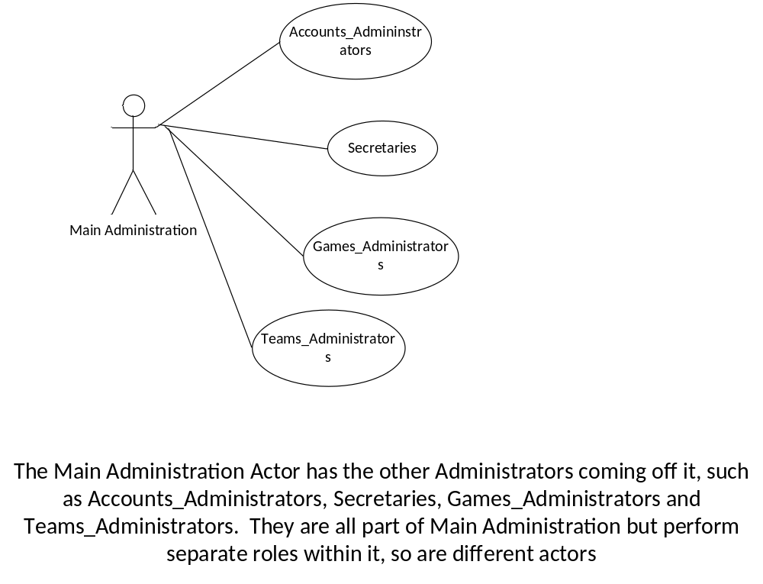

Accounts_Admin Use Case:
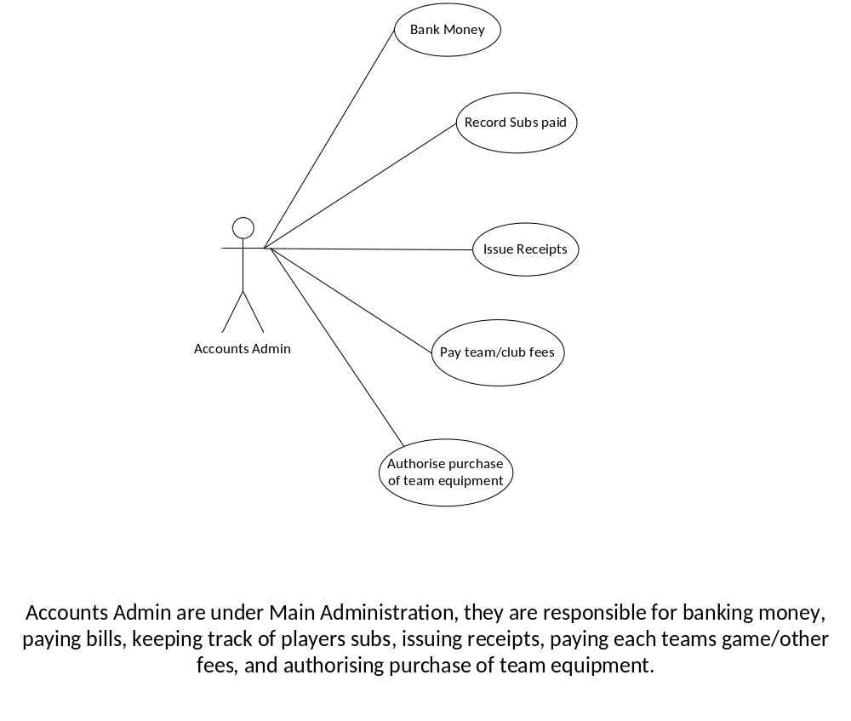

Games_Admin Use Case:
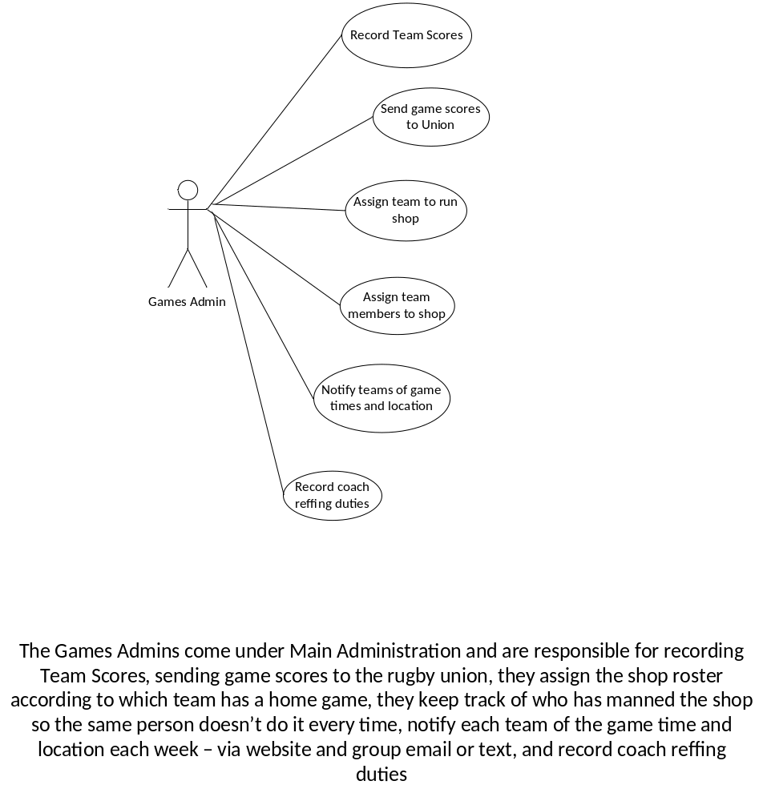

Teams Admin Use Case:

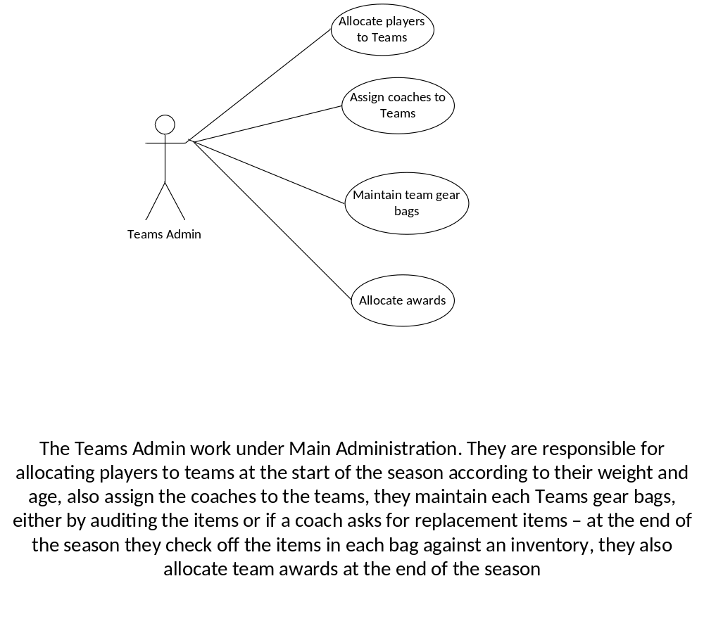

Secretaries Use Case:
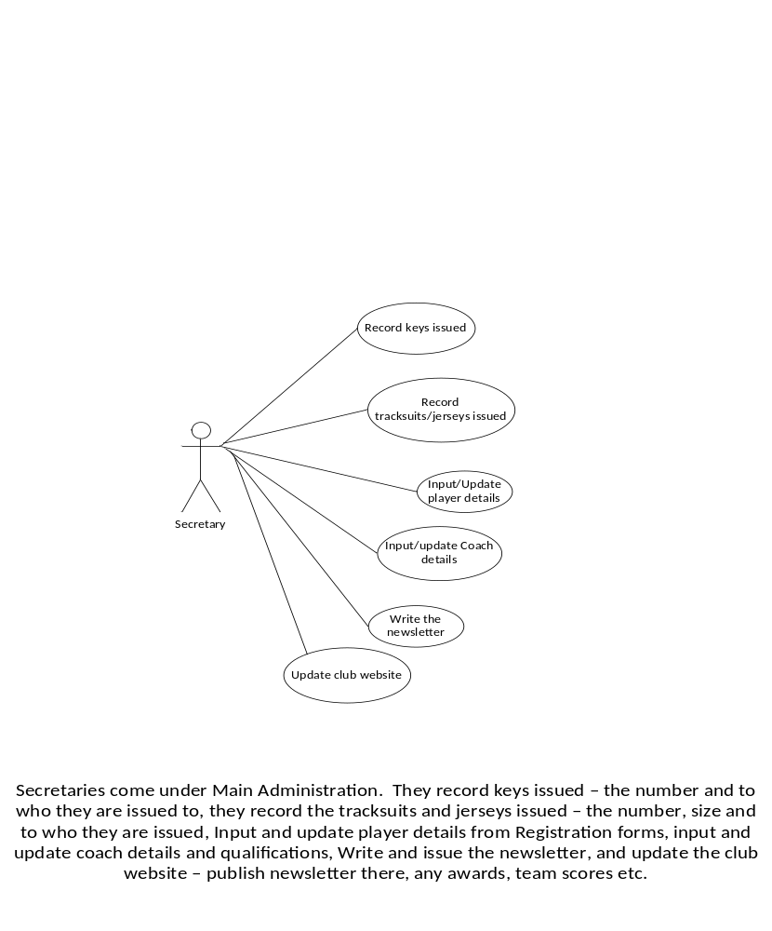

CONCEPTUAL DATA MODEL:
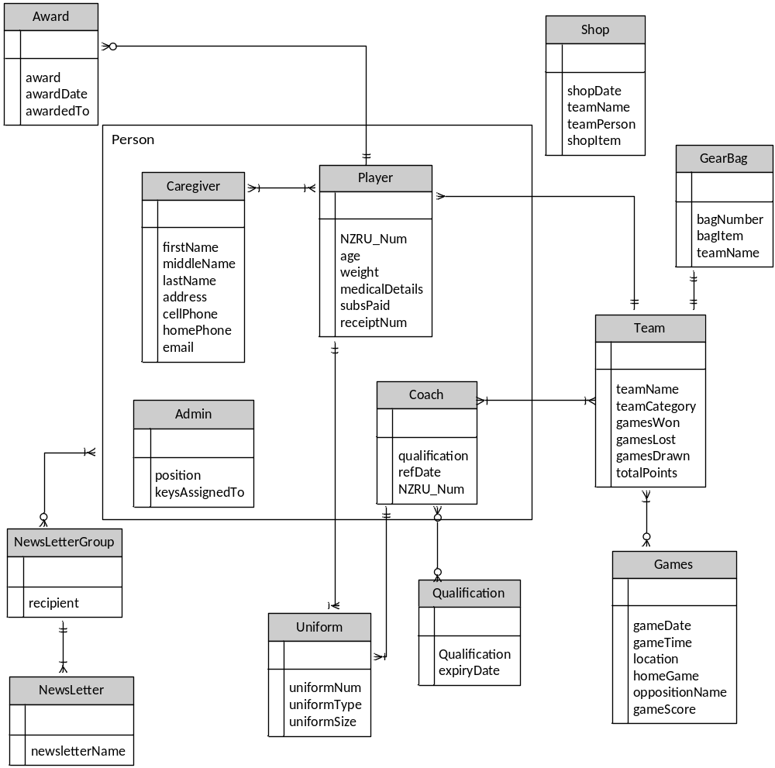

DATA DICTIONARY:
Table | Attribute | Data Type | Description
Player
 | NZRU_Num  age  weight  medicalDetails  subsPaid  receiptNum | Integer  Integer  Integer  String  Boolean  Integer | NZRU Registration Number  Players Age  Players Weight  Players Medical Details  Record if subs paid  Receipt number for subs
Coach
 | qualification  refDate  NZRU_Num | String  Date  String | Record coaches qualifications  Record when each coach refs home game so it stays fair  Number allocated to coach when they are registered
Caregiver
 | firstName  middleName  lastName  address  cellPhone  homePhone  Email | String  String  String  String  String  String  String | Caregivers First Name  Caregivers Middle Name  Caregivers Last Name  Caregivers address  Caregivers Cellphone number  Caregivers Home phone number  Caregivers Email address
Person
 | Address  cellPhone  dateOfBirth  email  firstName  middleName  lastName  homePhoneNum | String  String  String  String  String  String  String  String | Persons address  Cellphone Number for Person  Date of Birth for Person  Contact Email address  First Name for Person  Middle Name for Person  Last Name for Person  Contact landline for Person
Gear Bag
 | bagNumber  bagItem  teamName | Integer  String  String | Number on the bag itself  Each thing in bag, eg balls, cones  Record which team has the bag
Administration
 | position  keysAssignedTo | char  String | Position held, eg Secretary, Treasurer  Person who key is assigned to
Team
 | teamName  teamCategory  gamesWon  gamesLost  gamesDrawn  totalPoints | String  Char  Integer  Integer  Integer  Integer | Name of the Team  What age group/weight category team belongs to  Number games won  Number games lost  Number games drawn  Points team has gained over season
Game
 | gameDate  gameTime  location  homeGame  oppositionName  gameScore | Date  Integer  String  Boolean  String  Integer | Date game played  Time of game  Where game played  If game is at home or not  Name of opposition team  Score of game
Shop
 | shopDate  teamName  teamPerson  shopItem | Date  String  String  String | Date shop open  Name of team who manned shop  Person in team who manned shop  Items in the shop
Awards
 | award  awardDate  awardedTo | Char  Date  Char | Award presented  Date award presented  Person who received award
NewsLetterGroup
 | recipient | char | Person Receiving newsletter
Newsletter
 | newsletterName | Char | Name of newsletter, eg April Newsletter
Uniform
 | uniformNum  uniformType  uniformSize | Integer  Char  Char | Number on item of clothing  Type of clothing issued – tracksuit for coach or jersey for player  Size issued
Qualification
 | Qualification  expiryDate | String  DATE | Qualifications the person holds  Date the qualification expires – can be NULL if it doesn’t expire
Keys
 | keyNumber  keyAllocatedTo  keyReturned | Integer  String  Boolean | Number on the keys  Name of person key is allocated to  Record if returned at end of season

