Summary of Video:

Essentially converting a number to a different base means you are dividing a specified number by the desired conversion base to get the remainder. You repeat the process until your quotient becomes less than the base. I used the method described in the video to test converting some numbers from base 10 to base 8. I found this conversion calculator to be helpful in checking my answers: <https://www.rapidtables.com/convert/number/base-converter.html>

Design documentation:

The idea of building and running a base conversion program relies on having and storing a remainder. We know that if we are converting from base ten to base 8, we are dividing an input by powers of 8 and continuously dividing the remainder by powers of 8.

I wanted to use C++ for this assignment, since I have minimal experience with it and would like some practice, and I also like working in CodeBlocks IDE, which only uses C and C++. I used that to build the converter.

The % operator in C++ gives the remainder of the division of 2 values. That remainder needs to be stored as an integer. The decimal value entered also needs to be stored and an integer.

I found this code online, I cannot claim this as my own. This site was extremely helpful: https://www.programiz.com/cpp-programming/examples/octal-decimal-convert

I did build and run the converter and it was successful every time

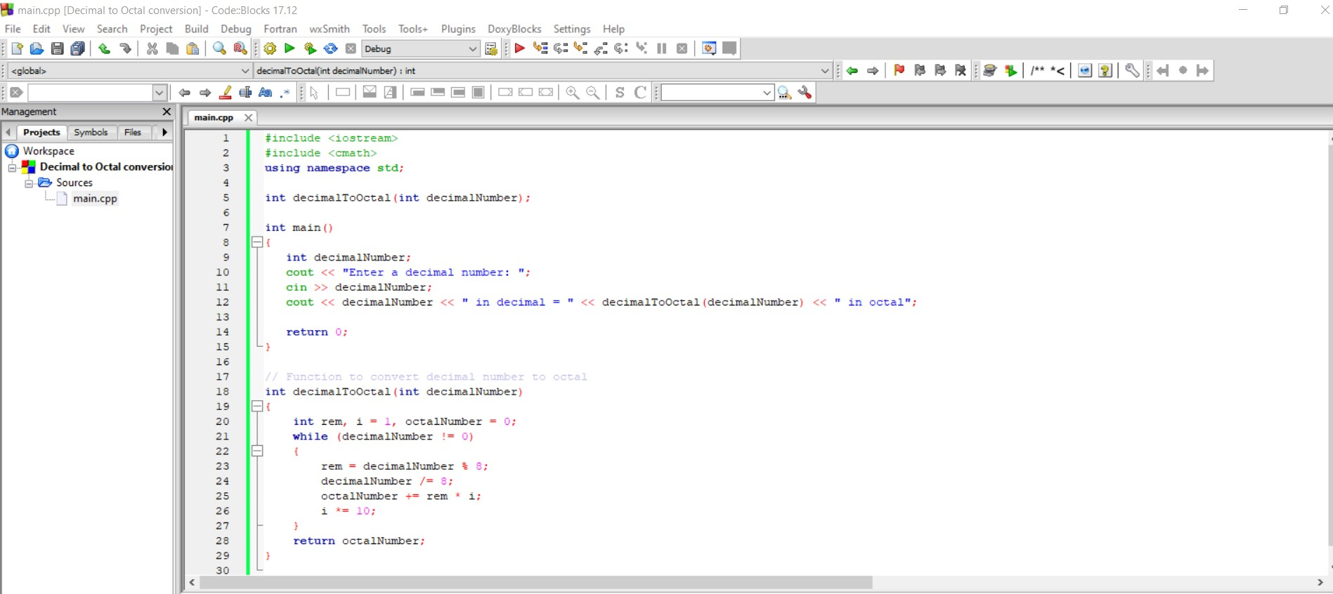

This code will actually ask for your decimal input via cout and cin.

The actual function used for the conversion is

int decimalToOctal(int decimalNumber)

{

int rem, i = 1, octalNumber = 0;

while (decimalNumber != 0)

{

rem = decimalNumber % 8;

decimalNumber /= 8;

octalNumber += rem \* i;

i \*= 10;

}

return octalNumber;

}

This assigns the remainder (rem) as the decimalNumber Input % 8 , meaning the remainder will be whatever input we give, divided by 8’s remainder.

The decimalNumber itself gets divided by 8 and stored, using a compound assignment. octalNumber also gets assigned as the result of the remainder defined as i.

Other resources I used for this include <http://www.cplusplus.com/doc/tutorial/operators/>