The genome sequence of the Southern Maori Wrasse, Ophthalmolepis lineolata (Valenciennes, 1839)

Abstract
We present a genome assembly from a female specimen of Ophthalmolepis lineolata, the Southern Maori Wrasse (Percomorphaceae; Eupercaria; Labriformes; Labridae). The genome assembly includes two haplotypes with total lengths of 728.78 and 731.59 megabases. Both haplotypes are chromosome-level (2n=48) with 99.44% of scaffolds assigned to chromosomes in haplotype 1 and 99.67% assigned in haplotype 2. The mitochondrial genome has also been assembled, with a length of 16.63 kilobases.

Authors
Glen Moore, Lauren Huet, Liam Anstiss, Emma de Jong, Anna Depiazzi, Adrianne Doran, Ibrahim Faseeh, Laura Missen, Tyler Peirce, Georgia M. Nester, Ebony M. Thorpe, Adam J. Bennett, Olivia Nguyen, Tsz Ching Wong, OceanOmics Division Shannon Corrigan

Author information
The following groups contributed to this project.
OceanOmics Division ; Marcelle E. Ayad, Philipp E. Bayer, Michael Bunce, Shannon Corrigan, Matthew W. Fraser, Priscila Goncalves, Eric J. Raes
Western Australia Museum

Key words
Ophthalmolepis lineolata, Southern Maori Wrasse, genome sequence, chromosomal, Labriformes

Main body

Species taxonomy
Eukaryota; Opisthokonta; Metazoa; Eumetazoa; Bilateria; Deuterostomia; Chordata; Craniata; Vertebrata; Gnathostomata; Teleostomi; Euteleostomi; Actinopterygii; Actinopteri; Neopterygii; Teleostei; Osteoglossocephalai; Clupeocephala; Euteleosteomorpha; Neoteleostei; Eurypterygia; Ctenosquamata; Acanthomorphata; Euacanthomorphacea; Percomorphaceae; Eupercaria; Labriformes; Labridae; Ophthalmolepis lineolata (Valenciennes, 1839) (NCBI:txid241325)

Background
The Southern Maori wrasse Ophthalmolepis lineolata, is a species of wrasse endemic to temperate Indian Ocean Coastal waters of Australia. It is distributed from Southern Queensland, around the south of the country to south-western Western Australia. O. lineolata are known to roam large areas, with home ranges varied from 52 m² to 1,660 m² (Kingsford & Carlson 2010). Juveniles and females are red orange above a white band along the mid-sides, and red orange below. Mature males develop a black stripe along the sides, blue spots on each of the body scales and blue scribbles on the head. Mature males reach a max length of 450mm (McGrouther 2019).
O. lineolata is common on rocky reefs and is known to prefer kelp and urchin grazed barren habitats, with juveniles most abundant in habitats rich in algae (Kingsford & Carlson 2010). The species opportunistically feeds on polychaetes, polyplacophorans, marginellid gastropods (especially Austroginella sp.), bivalves and echinoids spotted in a wide variety of habitats, but particularly in sand/rubble (Morton et al. 2008b). It is a protogynous hermaphrodite and sexually dichromatic, sex change occurs at about 295 mm, when individuals transition to the terminal-phase male. (Morton et al. 2008a). The reproductive season of O. lineolata occurs from December to March, with a peak occurring in mid-summer (January) to early autumn (March) (Morton et al. 2008a).
This species is captured in recreational fishing and sold commercially in New South Wales. It is a non-target by-catch species of the rock lobster and giant crab fishery in South Australia, also likely to be a by-catch species of West Coast Demersal Scalefish Fishery in Western Australia. The IUCN red list assessed O. lineolata in 2008 and listed the species as Least Concern (Russell, Fairclough, & Pollard 2010).
Here, we present a chromosome-level, haplotype resolved genome assembly of the Southern Maori Wrasse, Ophthalmolepis lineolata. The sequence was derived from a female specimen (Figure 1), collected from New Year Island, Western Australia.

Methods

Sample acquisition
An adult female Ophthalmolepis lineolata (ToLID fOphLin2) was collected from New Year Island, Western Australia (latitude 33.85066S, longitude 142.13089E) on 2023-03-28. The specimen was collected by Glen Moore from the Western Australia Museum (GIM, WAM) on SCUBA. The specimen was pinned and imaged in fresh colouration by GIM (WAM). The specimen was preserved in formalin in the field by GIM (WAM) and subsequently accessioned into the WAM as O. lineolata voucher ID WAM P35483.001.

DNA extraction, library preparation and sequencing
High molecular weight (HMW) genomic DNA was extracted from approximately 25 mg of gill tissue. Tissue was homogenised using the TissueRuptor II (QIAGEN, Hilden, Germany) and then pelleted as per the PacBio Nanobind tissue kit (PacBio, CA, USA) protocol. Cell lysis, and DNA isolation was performed following the PacBio “Extracting HMW DNA from skeletal muscle using Nanobind” procedure (102-579-200, Dec 2022). The quantity, and fragment length distribution of extracted gDNA were determined using a Qubit 3 Fluorometer with the Qubit dsDNA Broad-Range Assay Kit (Thermo Fisher Scientific, MA, USA), a NanoDrop One (Thermo Fisher Scientific, MA, USA) and a Femto Pulse with the Genomic DNA 165kb kit (Agilent, CA, USA). A PacBio HiFi SMRTbell® library was prepared using the PacBio SMRTbell® prep kit 3.0 according to manufacturer’s instructions. The library was sequenced on a PacBio Sequel IIe.

Hi-C library construction and sequencing
Cryogenic grinding of flash-frozen gill tissue in liquid nitrogen was used to facilitate the construction of a Dovetail Hi-C library, using the Dovetail LinkPrep Module and Dovetail Library Module for Illumina kits (Cantata Bio, CA, USA) as per the manufacturer's protocols. Shallow sequencing of the Hi-C libraries was performed on an Illumina iSeq 100 platform using a 2 × 150 bp paired-end run to assess library complexity. Deep sequencing of Hi-C data was carried out on an Illumina NovaSeq 6000 platform with a 2 × 150 bp paired end run configuration to generate chromosome conformation data.

RNA extraction, library construction and sequencing
Flash-frozen gill and muscle tissue from the same specimen was used for an RNA extraction using the RNeasy® Fibrous Tissue Mini Kit (Qiagen, Germany) according to the manufacturer’s instructions. RNA concentration was quantified using a Qubit™ fluorometer with the Qubit™ RNA High Sensitivity (HS) Assay Kit (Thermo Fisher Scientific, USA) and cross-checked with a NanoDrop™ spectrophotometer (Thermo Fisher Scientific, USA). RNA integrity and fragment size distribution were assessed on an Agilent TapeStation system using the appropriate RNA ScreenTape assay (Agilent Technologies, USA). Total RNA extracted from gill and muscle from the same individual was used as input for the Iso-Seq Express 2.0 Kit (Pacific Biosciences, USA) in separate reactions to generate barcoded full-length cDNA, following the manufacturer’s instructions. The resulting full-length cDNA libraries for each tissue were then processed independently using the PacBio Kinnex™ full-length RNA Kit (Pacific Biosciences, USA) to produce concatenated SMRTbell® libraries for Iso-Seq analysis. Kinnex libraries were sequenced on a PacBio Revio system (Pacific Biosciences, USA).

Genome assembly, curation and evaluation

Assembly
Prior to assembly of the PacBio HiFi reads, a database of k-mer counts (k = 31) was generated from the filtered reads using meryl (Rhie et al, 2020). Genomescope2 (Ranallo-Benavidez et al., 2020) was used to analyse the k-mer frequency distributions, providing estimates of genome size, heterozygosity, homozygosity, and repeat content. The HiFi reads were assembled using Hifiasm (Cheng et al., 2021, 2022) in Hi-C phasing mode, resulting in a pair of haplotype resolved assemblies. Initial assembly quality statistics were generated with Gfastats (Formenti et al., 2022), BUSCO (Manni et al., 2021) and MerquryFK (Rhie et al., 2020).
Hi-C reads were mapped to the primary contigs using the OMNIC pipeline (Cantata Bio, CA, USA). Scaffolding was performed by YaHs (Zhou et al., 2023) using the --no-contig-ec option to prevent over-fragmentation of the input contigs. The scaffolded assemblies were decontaminated using NCBI FCS-GX and tiara for mitochondrion contamination. The resulting decontaminated assemblies were evaluated using Gfastats (Formenti et al., 2022), BUSCO (Manni et al., 2021) and MerquryFK (Rhie et al., 2020). TIDK (Brown et al., 2025) was used to predict telomers in the assemblies and BEDtools (Quinlan & Hall, 2010) was used to generate coverage and gaps tracks to be injected into Pretext Maps (Harry, 2022) to prepare the genome for manual curation. Processing of the assembly was done using the nextflow pipeline OceanOmics-OceanGenomes-ref-genomes.v1.0.0
The mitochondrial genome was assembled using MitoHiFi (Uliano-Silva et al., 2023), which runs MitoFinder (Allio et al., 2020), and uses these annotations to select the final mitochondrial contig and to ensure the general quality of the sequence.

Curation
Manual curation was conducted using PretextView (Harry, 2022), with additional insights provided by BUSCO based synteny plots (chromsyn). Scaffolds were visually inspected and corrected as described by Howe et al. (2021). Any identified contamination, missed joins, and mis-joins were corrected, and duplicate sequences were tagged and removed.

Evaluation of the final assembly
The MerquryFK tool (Rhie et al., 2020) was used to evaluate k-mer completeness and assembly quality for the curated haplotypes, using the k-mer databases (k = 31) computed before genome assembly. The analysis outputs included k-mer plots, assembly QV scores and completeness statistics. Gfastats (Formenti et al., 2022) was used to assess contiguity and BUSCO (Manni et al., 2021) was used to assess completeness of the assemblies.
The final assembly was also analysed with BlobToolKit using the OceanOmics-OceanGenomes-genomenotes pipeline. HiFi and Hi-C reads were aligned to the assemblies using minimap2 (Li, 2018) and SAMtools, generating coverage tracks for regions of fixed size (1kb). BUSCO genes were counted in regions of fixed size (1kb) and stats were calculated per window to assess GC and AT content. In parallel, the assembly was chunked out with Seqkit and split into sliding windows of 100,000kb. The chunks were searched against the NCBI core_nt database using BLASTN v.17.0+ (Camacho et al., 2009) to screen for any additional contamination. The resulting files were used as input to generate a blobdir for visualisation.

Genome sequence report

Sequencing data
The genome of an adult female Ophthalmolepis lineolata was sequenced using PacBio HiFi single molecule long reads, generating a total of 75.62 Gb (gigabases) of HiFi data from 4533111 of reads. Chromosome conformation Hi-C sequencing produced 42.71 GB of data from 70816274 million reads. The raw sequence data obtained is summarised in Table 1.
GenomeScope k-mer profiling (k = 31) of the raw Pacbio HiFi data estimate the haploid genome to be 695,633,824 Gb. Heterozygosity was estimated at 0.77 % and repeat size was 84,809,333. The coverage of the PacBio sequencing was 75x and the Hi-C was 61x.
Table 1. Sequence data information for the genome assembly of Ophthalmolepis lineolata. ToLID refers to the unique identifier assigned to the specimen. BioSample describes the biological source material from which the data were generated, and the run accessions refer to the identifiers assigned to the raw sequencing reads for each dataset.
 | PacBio | Hi-C
ToLID | fOphLin2 | fOphLin2
Tissue | Gill | Gill
Sequencing platform and model | PacBio Sequel IIe | Hi-C Dovetail link prep Illumina NovaSeq 6000
BioSample | SAMN47141674 | SAMN47141674
Run accessions | SRR32639444 | SRR32639442
Read count total | 4533111 | 70816274
Base count total | 75.62 Gb | 42.71 Gb

Assembly Statistics
Haplotype 1 and Haplotype 2 were assembled using Hi-C phasing and scaffolded, the two haplotypes were combined for manual curation. The resulting curated assemblies were processed through OceanOmics post curation pipeline (OceanOmics-OceanGenomes-post-curation) for quality checks.
The final haplotype 1 assembly had a total length of 728.78 Mb, with a scaffold n50 of 50.14 Mb and 164 gaps (Table 2).
A total of 99.44% of scaffolds were assigned to 24 autosomal chromosomes. Chromosome-scale scaffolds confirmed by the Hi-C data are named in order of size (Figure 2; Table 3).
The mitochondrial genome was also assembled and has been submitted as a standalone record to genbank PP897915.
Table 2. Genome assembly information for Ophthalmolepis lineolata showing the assembly metric benchmarks adapted from Rhie et al. (2021) and the Earth BioGenome Project Report on Assembly Standards September 2024 for the chromosome-level assembly haplotype 1 compared with Ophthalmolepis lineolatam assembly results from haplotype one and two.
 | Consortia standards |  | Ophthalmolepis lineolata
 | EBP | VGP | Haplotype 1 | Haplotype 2
Assembly name |  |  | fOphLin2.hap1 | fOphLin2.hap2
Assembly accession |  |  | PRJNA1228108 | PRJNA1228109
Assembly level | chromosome | chromosome | chromosome | chromosome
Total length (Mb) | - | - | 728.78 | 731.594
Contig N50 (Mb) | ≥ 10 Mb | ≥10 | 11.96 | 15.08
Number of scaffolds | - | - | 115 | 83
Number of gaps |  |  | 164 | 151
Scaffold N50 (Mb) | = chr N50 | = chr N50 | 50.14 | 36.65
Consensus quality (QV) | ≥ 40 | 39-43 | 59.82 | 59.80
BUSCO | S > 90%; D < 5% | C ≥ 95 | S 98.6; D 0.5 | S 98.7; D 0.5
Assembly assigned to chromosomes  (%) | (≥ 90%) | > 95 | 99.44 | 99.67
Sex chromosomes | - | - | - | -
Organelles (Kb) |  |  | Mitochondrial genome: 16.63 | -

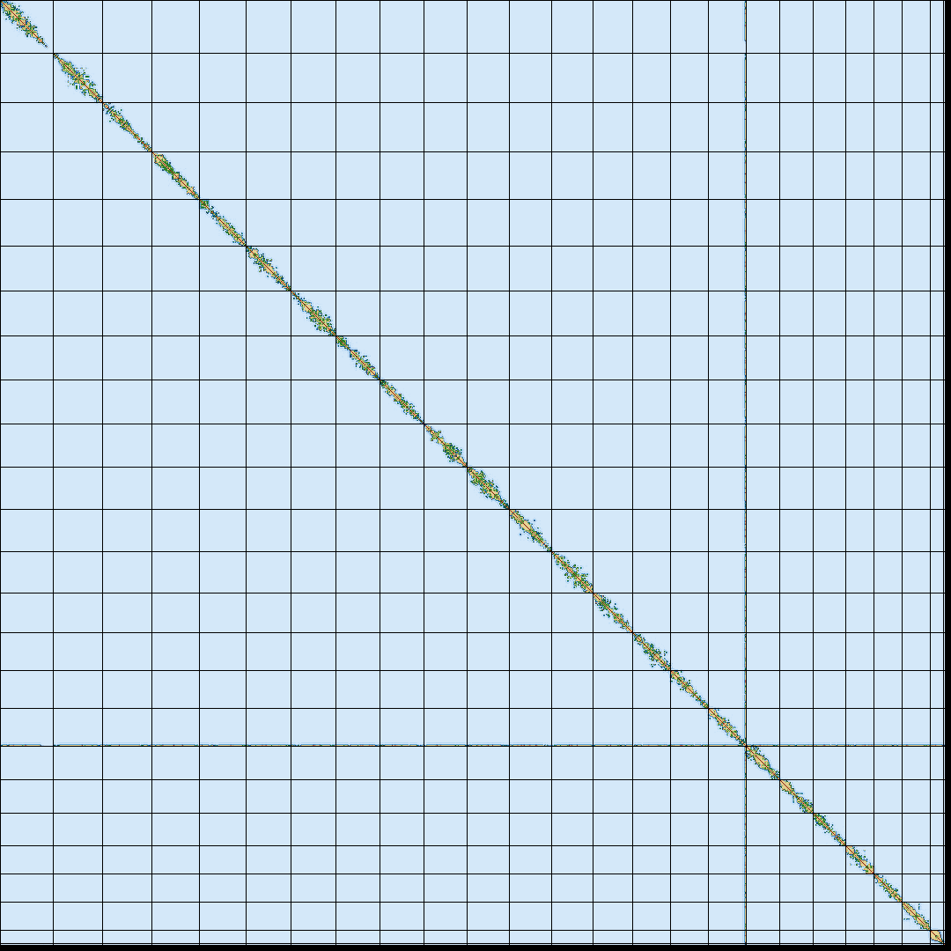
Figure 2. Genome assembly of Ophthalmolepis lineolata fOphLin2.hap1: Hi-C contact map of fOphLin2.hap1 assembly produced by PretextView. Chromosomes are ordered by size from left to right and top to bottom.

Assembly quality metrics
The BUSCO completeness scores, estimated Quality Value (QV) and k-mer completeness metrics were computed for each haplotype and the combined assembly. BUSCO scores provide a measure of completeness based off benchmarking universal single copy orthologs. The QV measures the base-level consensus accuracy of the genome assembly while completeness indicates the proportion of expected k-mers identified in the assembly.
BUSCO analysis performed using the actinopterii_10db reference database identified 99.1% of expected genes in haplotype 1 (single copy 98.6, duplicated 0.5%) and 99.2% in haplotype 2 (single copy 98.7%, duplicated 0.5) (Table 2).
The QV for haplotype one is 59.82, and 59.80 for haplotype 2. Combining both haplotypes yields a QV of 59.81. The k-mer completeness for haplotype 1 is 83.53% and 83.52% for haplotype 2. The combined completeness of both haplotypes is 99.66% (Table 2). Figure 3 shows the frequency distribution of k-mers that are unique to each haplotype (red and blue curves) and shared between the haplotypes (green curve).
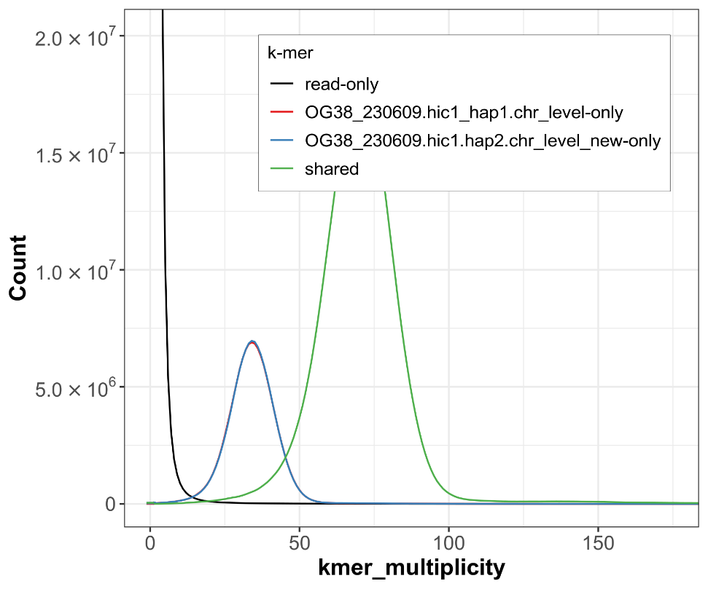

Figure 3: Evaluation of k-mer completeness using MerquryFK. This plot illustrates the recovery of k‐mers from the original read data in the final assemblies. The horizontal axis shows k‐mer multiplicity, and the vertical axis shows the number of k‐mers. The grey curve represents k‐mers that appear in the reads but are not assembled. The green curve corresponds to k‐mers shared by both assemblies (the homozygous peak), and the red and blue curves show k‐mers found only in haplotype 1 or haplotype 2, respectively (the heterozygous peaks).
The snail plot in Figure 4 provides a scaffold-level overview of the assembly. Scaffolds are arranged by length around the circumference, with arcs highlighting the largest scaffold and the N50 and N90 lengths. The plot also displays GC, AT, and N content across scaffold bins, as well as a cumulative count of scaffolds in the centre. The blob plot in Figure 5 visualises GC content on the horizontal axis and coverage on the vertical axis, with each point representing a scaffold sized by length.
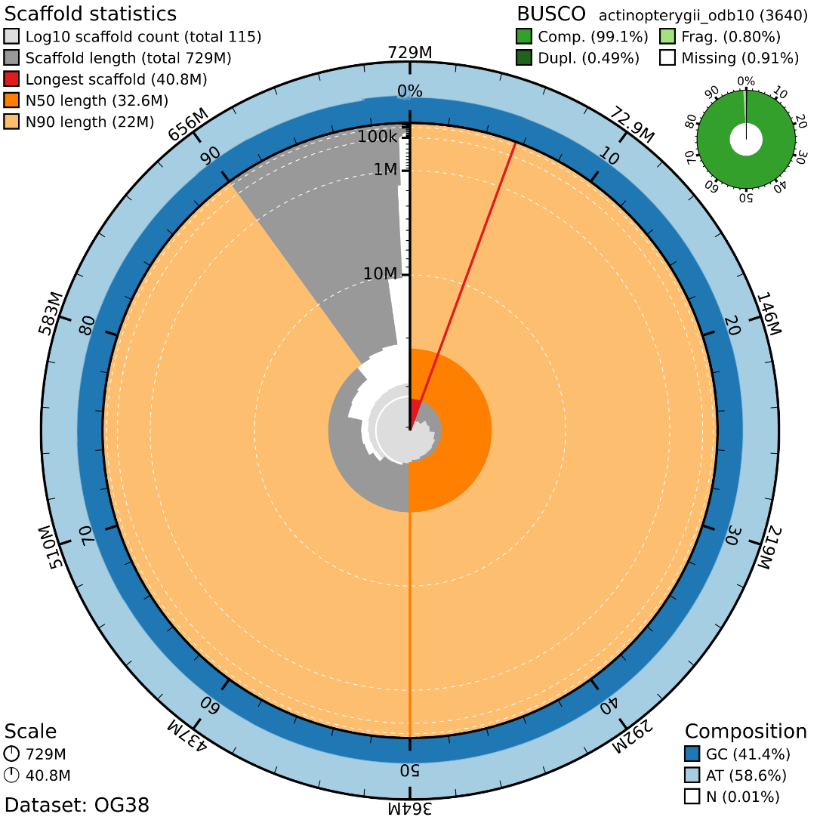

Figure 4: Genome assembly of Ophthalmolepis lineolata fOphLin2.hap1: metrics. The BlobToolKit snail plot provides an overview of assembly metrics and BUSCO gene completeness. The circumference represents the length of the whole genome sequence, and the main plot is divided into 1,000 bins around the circumference. The outermost blue tracks display the distribution of GC, AT, and N percentages across the bins. Scaffolds are arranged clockwise from longest to shortest and are depicted in dark grey. The longest scaffold is indicated by the red arc, and the deeper orange and pale orange arcs represent the N50 and N90 lengths. A light grey spiral at the centre shows the cumulative scaffold count on a logarithmic scale. A summary of complete, fragmented, duplicated, and missing BUSCO genes in the set is presented at the top right.

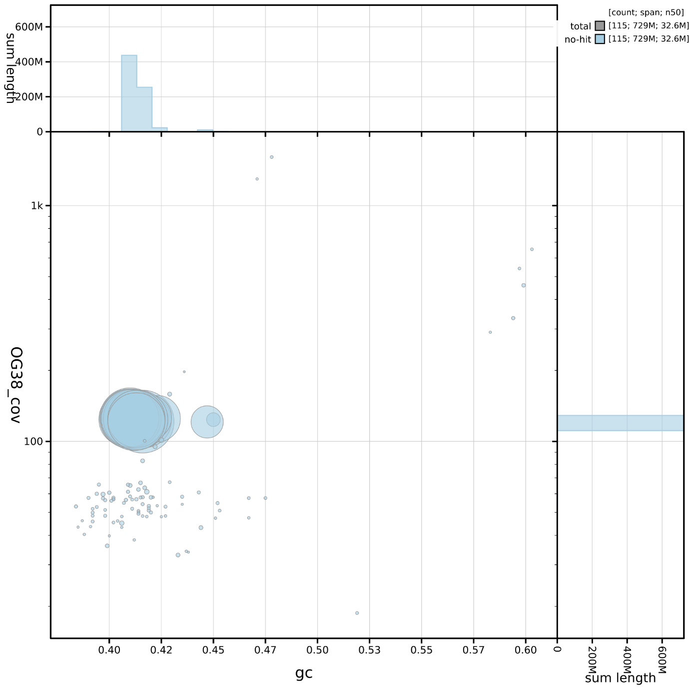

Figure 5: Genome assembly of Ophthalmolepis lineolata fOphLin2.hap1: BlobToolKit GC-coverage plot. Blob plot showing sequence coverage (vertical axis) and GC content (horizontal axis). The circles represent scaffolds, with the size proportional to scaffold length and the colour representing phylum membership. The histograms along the axes display the total length of sequences distributed across different levels of coverage and GC content.
DATA USE AND ATTRIBUTION
OceanOmics Centre is committed to providing data and capabilities for public benefit that are actively communicated to and used by the scientific, conservation management and wider communities. All users of OceanOmics Centre data and capabilities are expected to demonstrate professional courtesy and scientific integrity, and to use the data in ways that advance Minderoo’s charitable purposes of protecting and enhancing the natural environment, whilst promoting scientific research and the provision of information education relating to the natural environment.
Users of these data agree to do so in accordance with our Data Use and Sharing Policy and are expected to cite this genome note and its DOI. Users should further cite the source of the data and support by including the following standard attribution statement in the acknowledgement section of research outputs: “We acknowledge funding and support of Minderoo Foundation and Minderoo OceanOmics Centre at UWA in this work and its mission to protect and restore natural ecosystems for future generations”.
Notification of communications and research outputs that make use of OceanOmics Centre data and capabilities are requested to be sent to oceanomicscentre@uwa.edu.au to assist with our impact measurement and learning. We welcome collaborators and data users to share impact stories that describe how the data or support provided by OceanOmics Centre has elevated their work.

References

Andrews S: FastQC: A Quality Control Tool for High Throughput Sequence Data [Online]. 2010.
Astashyn A, Tvedte ES, Sweeney D, Sapojnikov V, Bouk N, Joukov V, Mozes E, Strope PK, Sylla PM, Wagner L, Bidwell SL, Clark K, Davis EW, Smith-White B, Hlavina W, Pruitt KD, Schneider VA, Murphy TD: Rapid and sensitive detection of genome contamination at scale with FCS-GX. bioRxiv. 2023.
Brown MR, Gonzalez de La Rosa P, Blaxter M: tidk: a toolkit to rapidly identify telomeric repeats from genomic datasets. Bioinformatics. 2025; btaf049.
Bushnell B: BBMap: A Fast, Accurate, Splice-Aware Aligner. Lawrence Berkeley National Laboratory. 2014.
Camacho C, Coulouris G, Avagyan V, Ma N, Papadopoulos J, Bealer K, et al. BLAST+: architecture and applications. BMC Bioinformatics. 2009;10:421.
Challis R, Richards E, Rajan J, Cochrane G, Blaxter M: BlobToolKit – interactive quality assessment of genome assemblies. G3: Genes, Genomes, Genetics. 2020; 10(4) 1361–74.
Cheng H, Concepcion GT, Feng X, et al.: Haplotype-resolved de novo assembly using phased assembly graphs with hifiasm. Nature Methods. 2021; 18 170–75.
Ewels P, Magnusson M, Lundin S, Käller M: MultiQC: Summarize analysis results for multiple tools and samples in a single report. Bioinformatics. 2016; 32(19) 3047–48.
Ewels PA, Peltzer A, Fillinger S, Patel H, Alneberg J, et al.: The nf-core framework for community-curated bioinformatics pipelines. Nature Biotechnology. 2020; 38(3) 276–78.
Fishes of Australia: Ophthalmolepis lineolata. Available at https://fishesofaustralia.net.au/home/species/260#summary. Accessed 5 March 2026.
Formenti G, Abueg L, Brajuka A, Brajuka N, Gallardo-Alba C, Giani A, Fedrigo O, Jarvis ED: Gfastats: Conversion, evaluation and manipulation of genome sequences using assembly graphs. Bioinformatics. 2022; 38(17) 4214–16.
Harry E: PretextView (Paired REad TEXTure Viewer): A desktop application for viewing pretext contact maps.
Howe K, Chow W, Collins J, Pelan S, Pointon DL, et al.: Significantly improving the quality of genome assemblies through curation. GigaScience. 2021; 10(1).
Karlicki M, Antonowicz S, Karnkowska A: Tiara: deep learning-based classification system for eukaryotic sequences. Bioinformatics. 2022; 38(2) 344–50.
Kingsford MJ, Carlson IJ: Patterns of distribution and movement of fishes, Ophthalmolepis lineolatus and Hypoplectrodes maccullochi, on temperate rocky reefs of south eastern Australia. Environmental Biology of Fishes. 2010; 88 105–18.
Kurtzer GM, Sochat V, Bauer MW: Singularity: Scientific containers for mobility of compute. PLOS ONE. 2017; 12(5) e0177459.
Li H, Durbin R: Fast and accurate short read alignment with Burrows-Wheeler transform. Bioinformatics. 2009; 25(14) 1754–60.
Li H, Handsaker B, Wysoker A, Fennell T, Ruan J, Homer N, Marth G, Abecasis G, Durbin R: The Sequence Alignment/Map format and SAMtools. Bioinformatics. 2009; 25(16) 2078–79.
Manni M, Berkeley MR, Seppey M, Simão FA, Zdobnov EM: BUSCO update: Novel and streamlined workflows along with broader and deeper phylogenetic coverage for scoring of eukaryotic, prokaryotic, and viral genomes. Molecular Biology and Evolution. 2021; 38(10) 4647–54.
McGrouther M: Southern Maori Wrasse, Ophthalmolepis lineolatus (Valenciennes, 1839). Australian Museum. 2019.
Morton JK, Gladstone W, Hughes JM, Stewart J: Comparison of the life histories of three co-occurring wrasses (Teleostei: Labridae) in coastal waters of south-eastern Australia. Marine and Freshwater Research. 2008; 59(7) 560–74.
Morton JK, Platell ME, Gladstone W: Differences in feeding ecology among three co-occurring species of wrasse (Teleostei: Labridae) on rocky reefs of temperate Australia. Marine Biology. 2008; 154 577–92.
Open2C, Abdennur N, Fudenberg G, Flyamer IM, Galitsyna AA, Goloborodko A, Imakaev M, Venev SV: Pairtools: from sequencing data to chromosome contacts. bioRxiv. 2023.
Quinlan AR and Hall IM, 2010. BEDTools: a flexible suite of utilities for comparing genomic features. Bioinformatics. 26, 6, pp. 841–842.
Ranallo-Benavidez TR, Jaron KS, Schatz MC: GenomeScope 2.0 and Smudgeplot for reference-free profiling of polyploid genomes. Nature Communications. 2020; 11 1432.
Rhie A, McCarthy SA, Fedrigo O, Damas J, Formenti G, et al.: Towards complete and error-free genome assemblies of all vertebrate species. Nature. 2021; 592(7856) 737–46.
Rhie A, Walenz BP, Koren S, et al.: Merqury: Reference-free quality, completeness, and phasing assessment for genome assemblies. Genome Biology. 2020; 21 245.
Russell B, Fairclough D, Pollard D: Ophthalmolepis lineolata. The IUCN Red List of Threatened Species. 2010.
Sim SB, Corpuz RL, Simmonds TJ, et al.: HiFiAdapterFilt, a memory efficient read processing pipeline, prevents occurrence of adapter sequence in PacBio HiFi reads and their negative impacts on genome assembly. BMC Genomics. 2022; 23 157.
Uliano-Silva M, Ferreira JGRN, Krasheninnikova K, Blaxter M, Mieszkowska N, et al.: MitoHiFi: A python pipeline for mitochondrial genome assembly from PacBio high fidelity reads. BMC Bioinformatics. 2023; 24(1) 288.
Vasimuddin Md, Misra S, Li H, Aluru S: Efficient architecture-aware acceleration of BWA-MEM for multicore systems. IEEE International Parallel and Distributed Processing Symposium (IPDPS). 2019; 314–24.
Zhou C, McCarthy SA, Durbin R: YaHS: Yet another Hi-C scaffolding tool. Bioinformatics. 2023; 39(1).

