Filling out first exercise:

After hitting ‘create new session’:

After creating multiple sessions (shows as same day because I made them all today, but it’s intended for them to show in descending order so the most recent sessions are up at the top to pick and choose from)

if I select the ‘Push’ day, it brings up the into saved:  
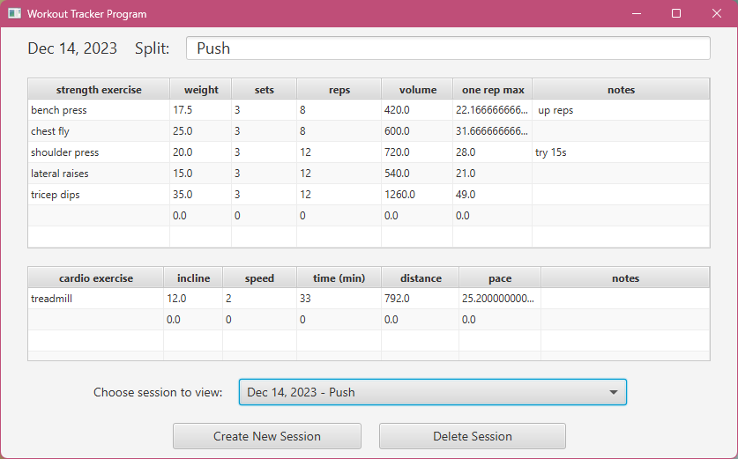

to look at sessions again:

click ‘mistake session’:

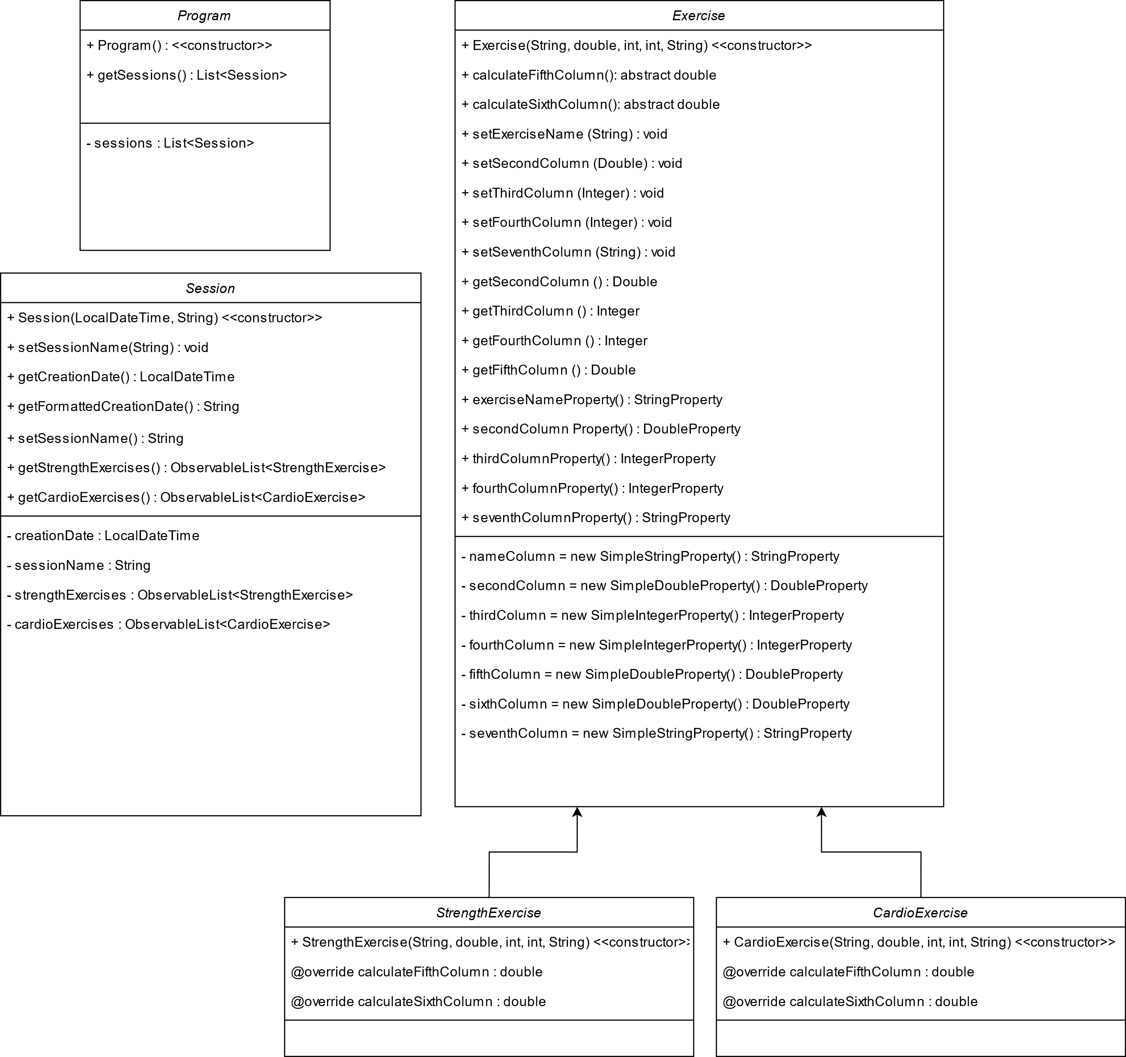

After hitting ‘delete session’ (will show the next recent session in order):  
