LAMP Stack Process Book
Lauren Lee
Trevecca Nazarene University
CIT-4450-O006
Dr. Timothy S. Myatt

In the world of computer programming, CRUD is an acronym that stands for create, read, update, and delete. In this process book, I will present a step-by-step process of creating a CRUD model through PHP and MySQL that will allow front-end users to access and edit the content stored in a database through an HTML document.

Part 1 – Configuring the Web Server on my Computer
MAMP config screen
I downloaded MAMP PRO to set up my local server environment. After opening MAMP PRO, the MAMP configure screen shows the port numbers for the web server, Apache, and MySQL, that I must set up to turn my local computer into a web server. After clicking “WebStart” within the MAMP PRO application, it will use the default host called “localhost” to communicate with PHP and the data that is inserted in the database in MySQL.

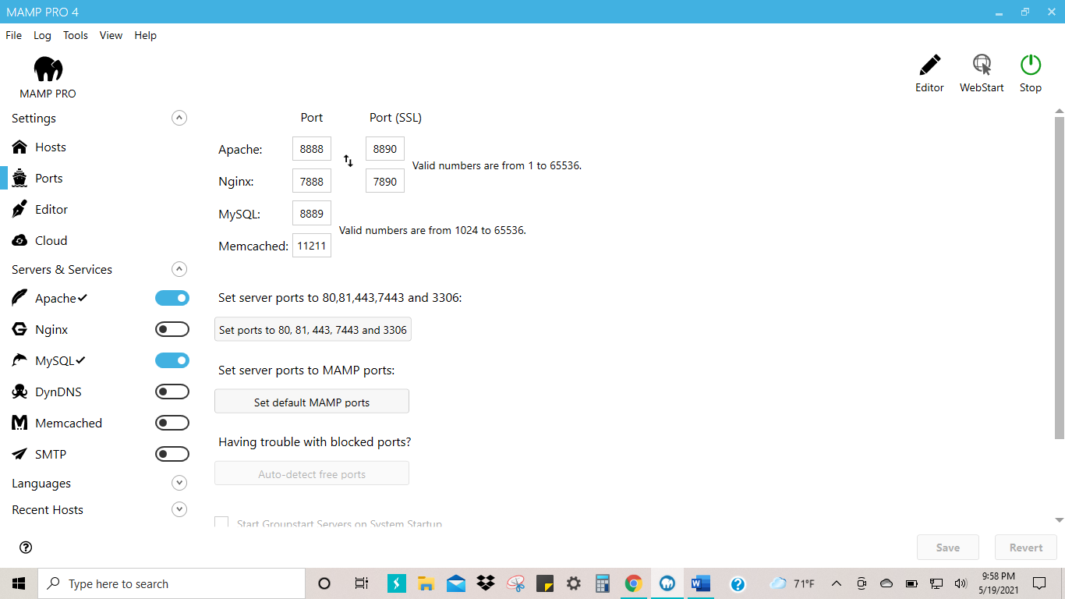

Local Host Welcome Screen
This “Welcome Screen” indicates that I have successfully set up the Apache server and MySQL database. With the use of an IDE, integrated development environment, I will build on the back end of a complex web page that will be presented through this “localhost” server. Because a browser can only read HTML, the PHP code will allow the browser to communicate with the database.

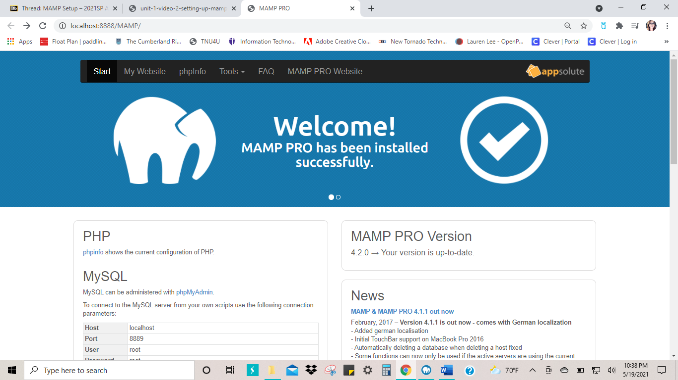

phpMyAdmin
On the MAMP PRO Welcome screen, the phpMyAdmin link will take me to the page where I will create my databases.

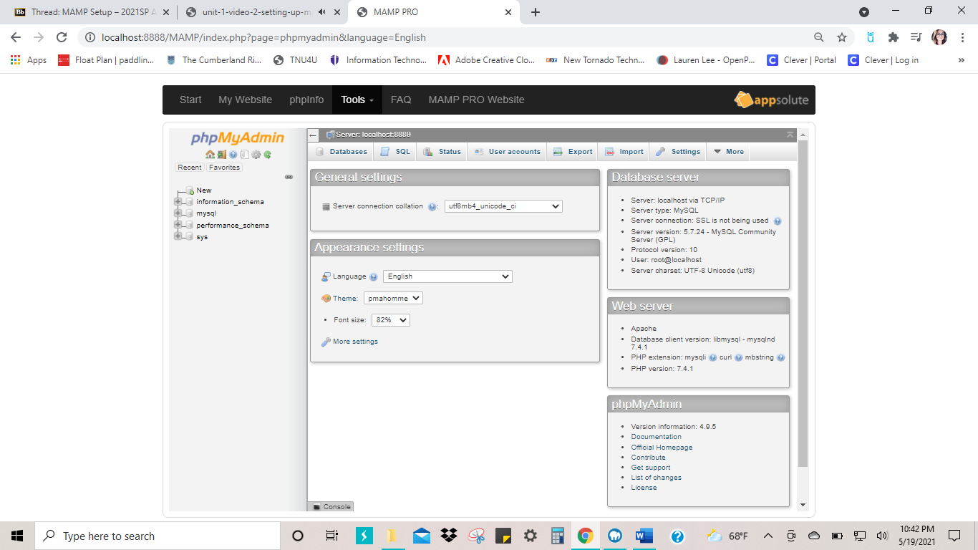

Database: Demo

I created my first database called demo. Inside the database, I created a table labeled content. This is where user input data will be stored.

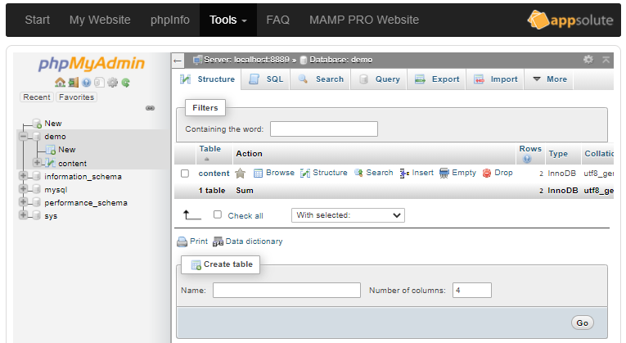
Part 2 – Client-Side to Server-Side Post Methods

Web Form HTML Code

This is the code used to create the simple web form on the client side which also shows set to post to the PHP code in insertContentToDB.php that will push the data into my database.

File name: createContentToDB.php

<!DOCTYPE html>
<html lang="en">
<head>
<meta name="viewport" content="width=device-width, initial-scale=1.0">
</head>

<body>
<h1>Web Form</h1>

<!--PHP Code showing current date and time-->
<?php
echo "Today is " . date("Y/m/d") . "<br>";
echo "at " . date("h:i:sa");
?>

<!--Web Form-->
<form name="myForm" method="post" action="insertContentToDB.php"><br />

<p>Enter a title.
<input type="text" name="title" id="title"><br />
</p>
<p>Enter Keywords.
<input type="text" name="metaKeywords" id="metaKeywords"><br />
</p>
<p>Enter Descriptions.
<input type="text" name="metaDescription" id="metaDescription"><br />
</p>
<p>Enter Content.
<input type="text" name="contentData" id="contentData"><br />
</p>
<input type="submit">
</form>
<br>
<br>
<!--====================================================-->
<?php
//Some PHP string function examples
$first = "Web Form created ";
$second = "by Lauren Lee.";

$third = $first;
$third .=$second;
echo $third;
?>
</body>
</html>

Output of the Simple Web Form with User Data Input

This shows my web form with sample data entered in the text fields ready for submission.

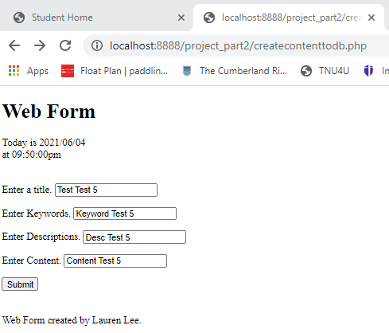
PHP code

This PHP code takes the user input data from the HTML web form and posts it into my database.

File name: insertContentToDB.php

<!DOCTYPE html>
<html>
<body>

<?php
$title = htmlspecialchars($_POST['title']);
$metaKeywords = htmlspecialchars($_POST['metaKeywords']);
$metaDescription = htmlspecialchars($_POST['metaDescription']);
$contentData = htmlspecialchars($_POST['contentData']);

//Debugging Code
/*
echo "DEBUG - The Title = " . $title . "<br />";
echo "DEBUG - The Title = " . $metaKeywords . "<br />";
echo "DEBUG - The Title = " . $metaDescription . "<br />";
echo "DEBUG - The Title = " . $contentData . "<br />";
*/

//Database
$servername = "localhost:8889";
$username = "root";
$password = "root";
$dbname = "demo";

//Database Connection
$conn = new mysqli($servername, $username, $password, $dbname);

//Check connection
if($conn->connect_error) {
die("Connection Failed: " . $conn->connect_error);
}

//SQL Command
$sql = "INSERT INTO content (title, metaKeywords, metaDescription, contentData)
VALUES ('$title', '$metaKeywords', '$metaDescription', '$contentData')";

if(mysqli_query($conn, $sql)) {
echo "New record created successfully!";

}

else {
echo "Error: " . $sql . "" . mysql_error($conn);
}

$conn->close();
?>
</body>
</html>

Successful Posted Message

After the “submit” button is clicked, I get a message that lets me know the record has been successfully created via the PHP code above.

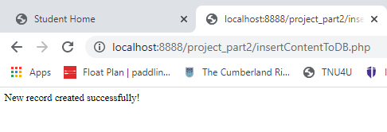

Data Posted in the Database
This screen shot shows the record posted successfully into the MySQL database, demo, from the HTML web form.
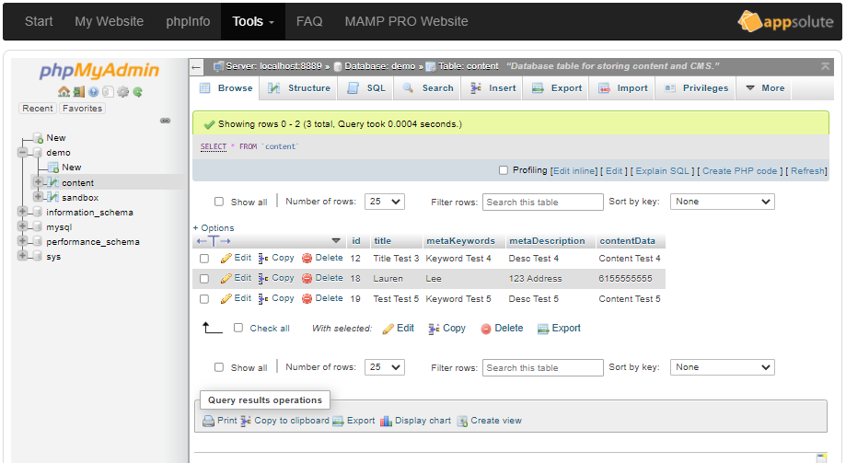
Part 3 – Reading Records

The php code below will allow all the data inside the table, content, display to the screen by creating a link that uses a query parameter. I built in a query string that tells the browser to pull up the URL when the user clicks the link.

File name: selectContentToModify.php

<!DOCTYPE html>
<html>
<body>
<h1>All Data Selected from the Database table: demo</h1>
<a href="/project_part2/createContentToDB.php">Back to Home</a>
<br />
<?php
//Database
$servername = "localhost:8889";
$username = "root";
$password = "root";
$dbname = "demo";

//Create Connection
$conn = new mysqli($servername, $username, $password, $dbname);

//Check connection
if($conn->connect_error) {
die("Connection Failed: " . $conn->connect_error);
}

//Creating string to pull everything from the database.
$sql = "SELECT * FROM content";

//Created table to display information from database.
if($result = mysqli_query($conn, $sql)) {

if(mysqli_num_rows($result) > 0) {
echo "<table>";
echo "<tr>";
echo "<th>id</th>";
echo "<th>Title</th>";
echo "<th>Meta Keywords</th>";
echo "<th>Meta Descriptions</th>";
echo "<th>Content Data</th>";
echo "</tr>";

while($row = mysqli_fetch_array($result)) {
echo "<tr>";
echo "<td>" . "<a href=" . "updateContent.php?page=" . $row['id'] . ">" . $row['id'] . "</a>" . "</td>";
echo "<td>" . "<a href=" . "updateContent.php?page=" . $row['id'] . ">" . $row['title'] . "</a>" . "</td>";
echo "<td>" . "<a href=" . "updateContent.php?page=" . $row['id'] . ">" . $row['metaKeywords'] . "</a>" . "</td>";
echo "<td>" . "<a href=" . "updateContent.php?page=" . $row['id'] . ">" . $row['metaDescription'] . "</a>" . "</td>";
echo "<td>" . "<a href=" . "updateContent.php?page=" . $row['id'] . ">" . $row['contentData'] . "</a>" . "</td>";
echo "</tr>";
}
echo "</table>";

mysqli_free_result($result);

}
//If no information in database, message will display to user.
else {
echo "No records matching your query.";
}
}

else {
echo "ERROR: Could not execute $sql." . mysqli_error($conn);
}

mysqli_close($conn); //close database. good practice.

?>
</body>
</html>

Screenshot of the Display Page

This is what users will see when accessing information in the database using the code above.

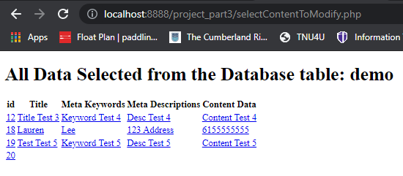
Part 4 – Updating Records
The code below allows the user to update records within the database through the browser interface by clicking on a link. It will take the user to a new form in which they will fill out, click “submit”, and the record will update in the database. In my code, I have also implemented a debugging tool that can aid in investigating any errors that may occur during the execution of my code. You will also see a navigation file was added to easily click back and forth through the pages.
File name: updateContent.php
<!DOCTYPE html>
<html lang="en">
<head>
<link rel="stylesheet" type="text/css" href="mycss.css"/>
<meta charset="UTF-8">
<meta name="viewport" content="width=device-width, initial-scale=1.0">
<title>Update Content</title>
</head>
<body>
<div class="header">
<h1>Update Content</h1>
</div>

<?php

//Debugging
/*
//These two lines go one time at the start of the script

error_reporting(E_ALL);
ini_set('display_errors', 1);

//These three lines can go multiple times anywhere in the script
echo "<pre>";
print_r(get_defined_vars());
echo "</pre>";
*/

//Global Nav for easy navigation between different pages
require_once("navigation.php");

//Set up database connection.
//Database
$servername = "localhost:8889";
$username = "root";
$password = "root";
$dbname = "demo";

//Create Connection
$conn = new mysqli($servername, $username, $password, $dbname);

//Check connection
if($conn->connect_error) {
die("Connection Failed: " . $conn->connect_error);
}

//Set up variable for query sting - GET method

$page = htmlspecialchars($_GET['page']); //get page variable from browser URL string nad put in local variable
//echo "DEBUG = $page";

//Grab all content from table
$sql ="SELECT * from content WHERE id='$page'";
$result = mysqli_query($conn,$sql);

if(mysqli_num_rows($result) > 0) {

while ($row = mysqli_fetch_assoc($result)) {

//echo "DEBUG - id " . $row["id"] . " - Title = " . $row["title"] . "<br />";

//Creating local variables
$title = $row["title"];
$metaKeywords = $row["metaKeywords"];
$metaDescription = $row["metaDescription"];
$contentData = $row["contentData"];

}

}

mysqli_close($conn);

?>

<div class="content">
<form name="myForm" method="post" action="updatedContentToDB.php"><br />

<input type="hidden" name="content_id" id="content_id" value="<?php echo $page;?>">

<p>Enter a title.
<input type="text" name="title" id="title" value="<?php echo $title;?>"><br />
</p>
<p>Enter Keywords.
<input type="text" name="metaKeywords" id="metaKeywords" value="<?php echo $metaKeywords;?>"><br />
</p>
<p>Enter Descriptions.
<input type="text" name="metaDescription" id="metaDescription" value="<?php echo $metaDescription;?>"><br />
</p>
<p>Enter Content.
<input type="text" name="contentData" id="contentData" value="<?php echo $contentData;?>"><br />
</p>
<input type="submit">
</form>
<br>
<br>
</div>

</body>
</html>

File name: navigation.php

This is the file I created for the global navigation.

<?php

echo "Global Nav: ";
echo "<a href='createContentToDB.php'>Create Content</a>";

echo "<hr />"

?>

After submitting the changes, the code below processes the update request to reflect in the database.

File name: updatedContent.php

<!DOCTYPE html>
<html lang="en">
<head>
<meta charset="UTF-8">
<meta name="viewport" content="width=device-width, initial-scale=1.0">
<title>Updated Content to DB</title>
</head>

<body>

<?php
//Debugging Code
/*
//These two lines go one time at the start of the script

error_reporting(E_ALL);
ini_set('display_errors', 1);

//These three lines can go multiple times anywhere in the script
echo "<pre>";
print_r(get_defined_vars());
echo "</pre>";
*/

//Global Nav
require_once("navigation2.php");

$id = htmlspecialchars($_POST['content_id']); //Primay key in content DB table to perform the UPDATE
$title = htmlspecialchars($_POST['title']);
$metaKeywords = htmlspecialchars($_POST['metaKeywords']);
$metaDescription = htmlspecialchars($_POST['metaDescription']);
$contentData = htmlspecialchars($_POST['contentData']);

//Database
$servername = "localhost:8889";
$username = "root";
$password = "root";
$dbname = "demo";

//Create Connection
$conn = new mysqli($servername, $username, $password, $dbname);

//Check connection
if($conn->connect_error) {
die("Connection Failed: " . $conn->connect_error);
}

$sql = "UPDATE content SET title='$title', metaKeywords='$metaKeywords', metaDescription='$metaDescription', contentData='$contentData'
WHERE id='$id'";

if(mysqli_query($conn, $sql)) {
echo "New record created successfully!";

}

/*else {
echo "Error: " . $sql . "" . mysql_error($conn);
}
*/
$conn->close();

?>

</body>
</html>

Screenshot of Data to Update (selectContentToModify.php)

This is the output with the given code above. It gives the user access to the data in the database through the browser.

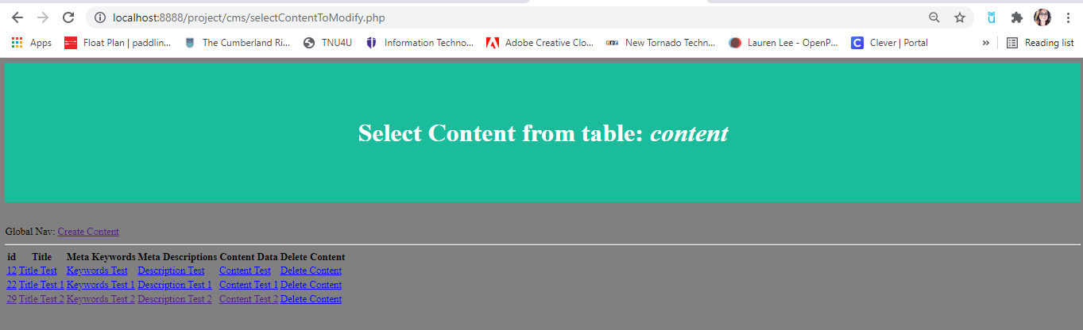

Screenshot of the “Update Content” Web Form (updateContent.php)
After clicking id “29”, the user will input new data into this form to replace the existing data in that column.
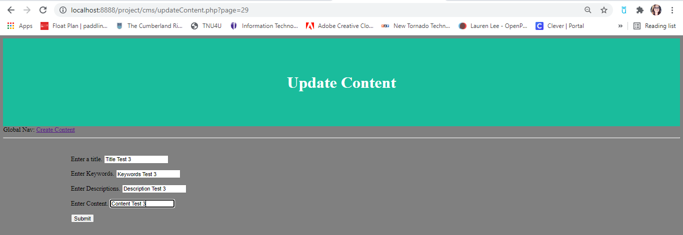

After successfully creating the record the user will be brought to a new page (updatedContentToDB.php), with a navigation link can take the user back to the table of data where the user can view the update.

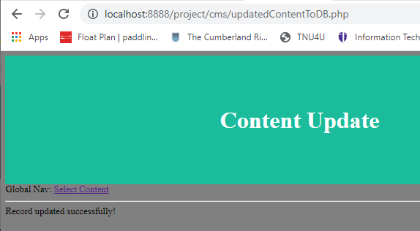

The record id “29” has been updated (back to selectContentToModify).

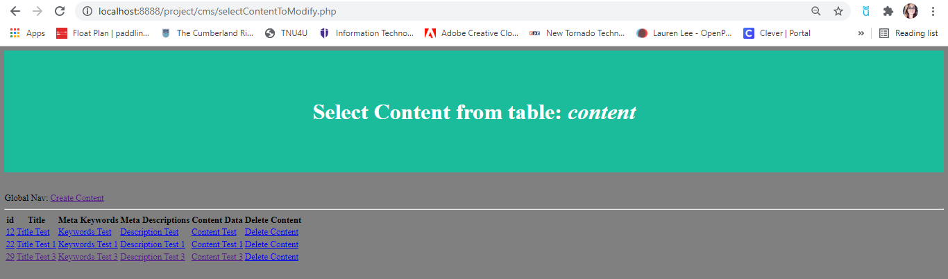

Part 5 – Deleting Records

As part of the CRUD process, we want to allow the user to be able to delete a record. The code below will add an option for the user to click and delete a record within the database. To utilize reusable code that will prevent us from having to rewrite long code, I put the code that opens a connection to the MySQL server into its own file (highlighted below). Using require_once will tell PHP to check that the file has been included and not to include it again.

File name: deleteContent.php

<!DOCTYPE html>
<html lang="en">
<head>
<meta name="viewport" content="width=device-width, initial-scale=1.0">
<title>Create Content Web Form</title>
<link rel="stylesheet" href="mycss.css"/>
</head>

<body>
<div class="header">
<h1>Create Content Web Form</h1>
</div>

<?php
//Global Nav
require_once("navigation2.php");
require_once("databaseConnect.php");

//Deleting
$id = htmlspecialchars($_GET['page']); //get user id to delete from the database from prior screen

//sql to delete record
$sql = "DELETE FROM content WHERE id='$id'"; //query string

if(mysqli_query($conn, $sql)) {
echo "Record deleted successfully.";
}

else {
echo "Error deleting record: " . mysqli_error($conn);
}

mysqli_close($conn);
?>

</body>
</html>
File name: databaseConnect.php
<?php

//Database
$servername = "localhost:8889";
$username = "root";
$password = "root";
$dbname = "demo";

//Create Connection
$conn = new mysqli($servername, $username, $password, $dbname);

//Check connection
if($conn->connect_error) {
die("Connection Failed: " . $conn->connect_error);
}

?>

Screenshot of the Result (deleteContent.php)
Below shows the “delete content’ column has been added.



After clicking “Delete Content” for record “29”, the record shows to have been successfully deleted. And the link will take the user back to the “Select Content” page.

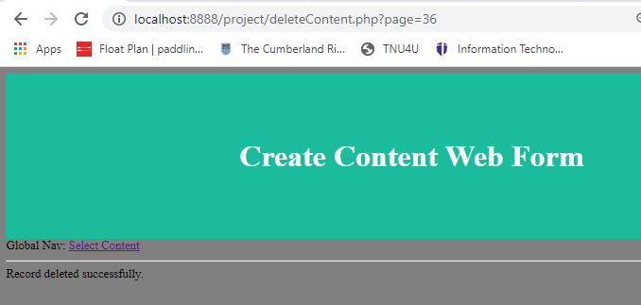

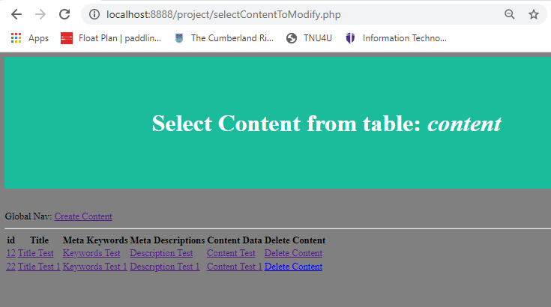

Screenshot of the updated database

The record has been successfully deleted from the database.

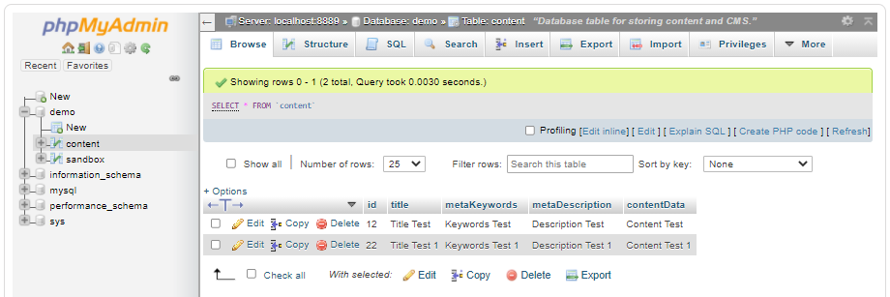
Part 6 – Display Record
To wrap up the content management system using the CRUD model, the code below will create a display page
File name: viewContent.php
<?php
require_once("cms/databaseConnect.php");

$page = htmlspecialchars($_GET['page']); //query string to get page in the database to load
// echo "DEBUG = $page";

$sql = "SELECT * from content where id='$page'";

$result = mysqli_query($conn, $sql);

if (mysqli_num_rows($result) > 0) {

//if we found records then display that info
while ($row = mysqli_fetch_assoc($result)) {

echo "DEBUG - id " . $row["id"] . " - Title = " . $row["title"] . "<br />";

//Local Variables
$title = $row["title"];
$metaKeywords = $row["metaKeywords"];
$metaDescription = $row["metaDescription"];
$contentData = $row["contentData"];

}

}

else {
echo "0 Results";
}

?>

<!DOCTYPE html>
<html lang="en">
<head>
<meta charset="utf-8">
<meta name="viewport" content="width=device-width, initial-scale=1.0">
<link rel="stylesheet" href="cms/mycss.css"/>
<title><?php echo $title;?></title>
<meta name="description" content="<?php echo $metaDescription;?>">
</head>

<body>

<?php echo $contentData;?>
</body>
</html>

Screenshot of createContentToDB.php
The WYSIWYG editor is entered in the file creating the content text line a more dynamic way to enter content. The “input” was changed to “textarea” to allow more content to be entered.

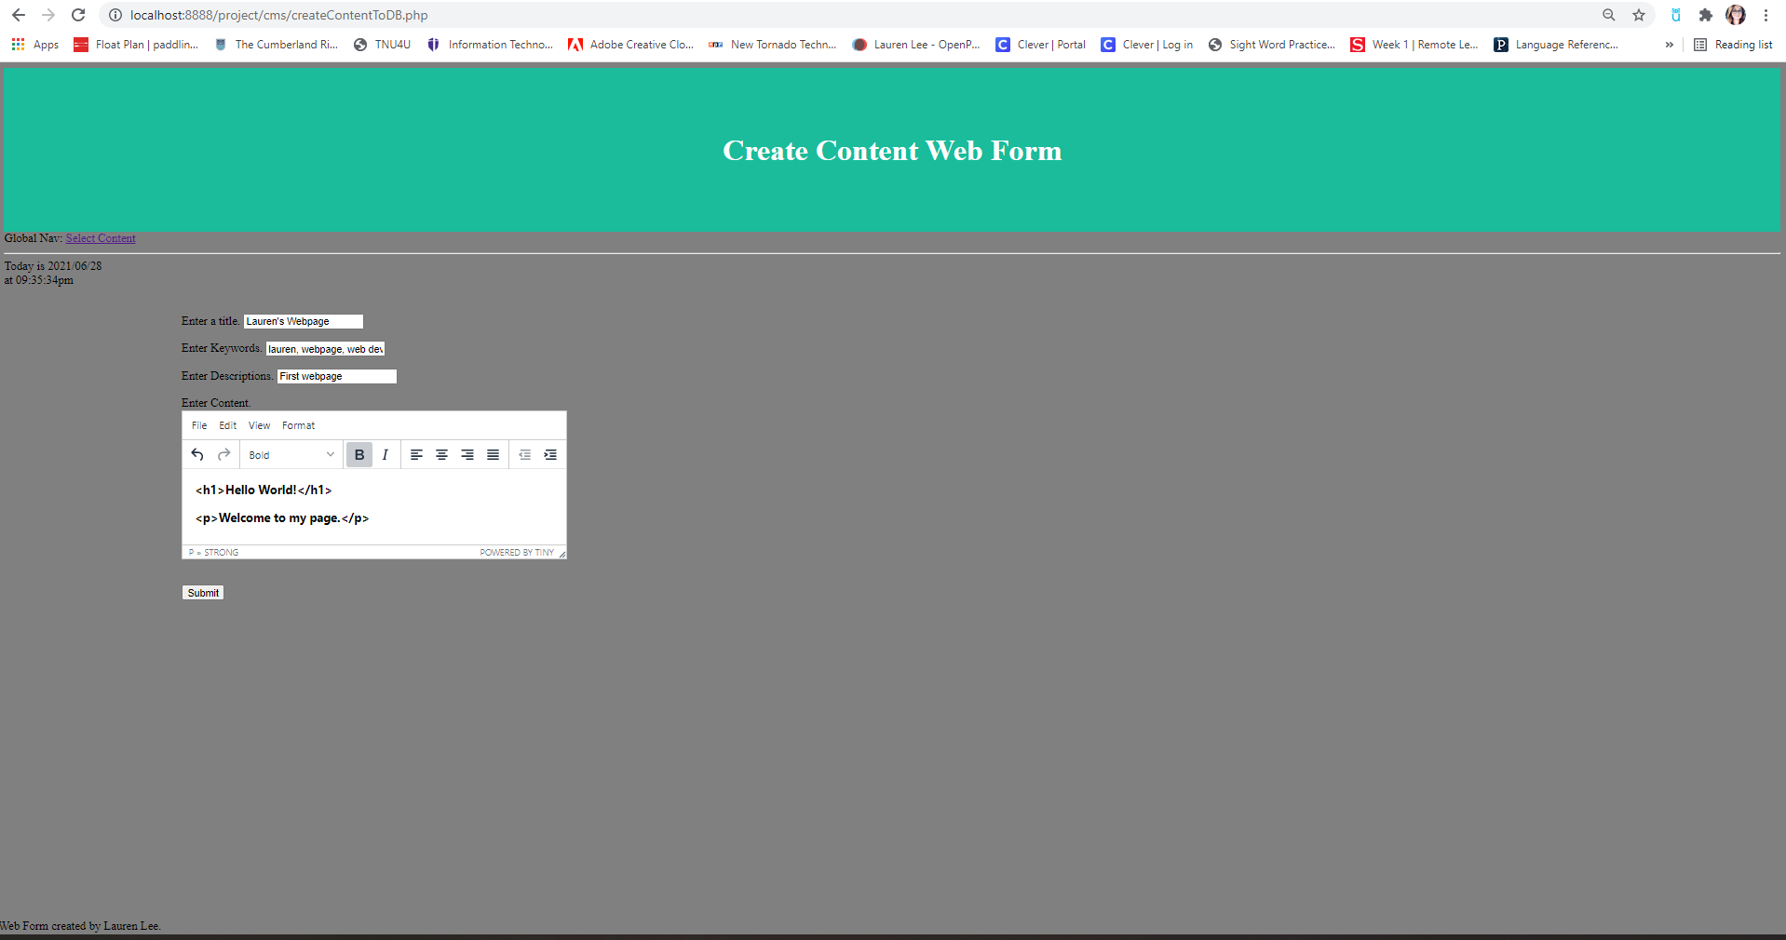

When I click “submit”, the record is added with the HTML tags corresponding to the styles I chose shown on the “create content” page.
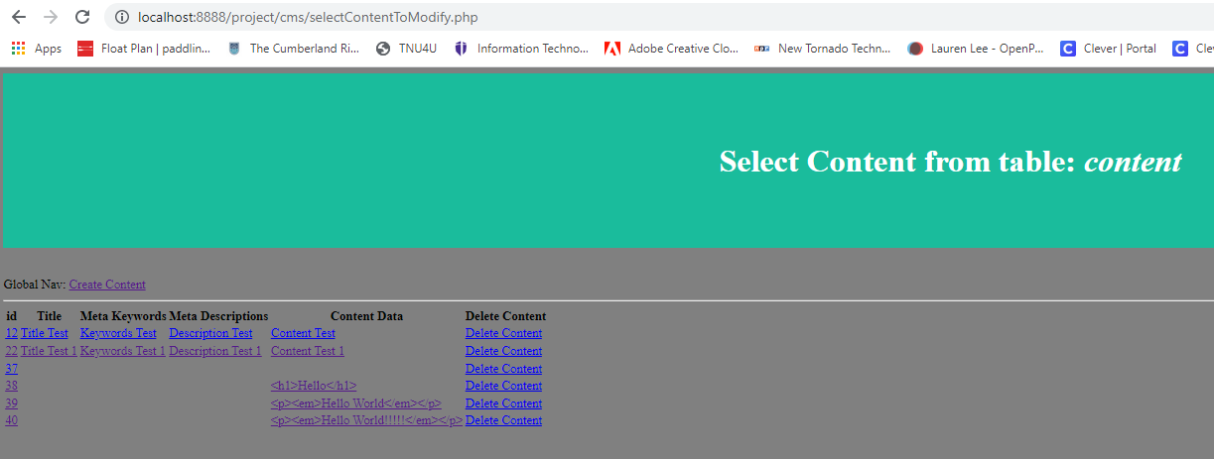

It is updated in the database.
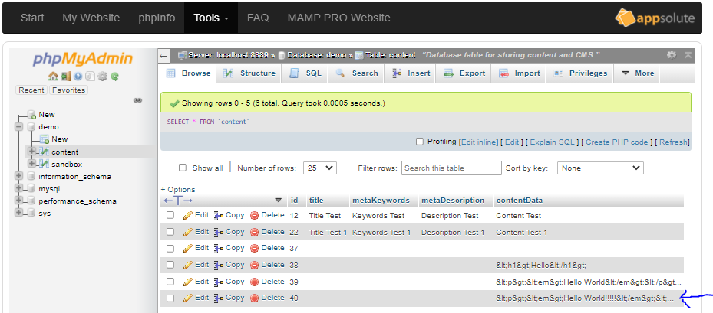

Using the “viewContent.php”, I entered the page number indicated on the “select content” screen by hovering my mouse over the record. It will bring up the corresponding record by adding “?page=52” at the end of the URL and take me directly to the record.
