Lab 5: Biodiversity

Problem set 1

1) There were 93 unique genera of bivalves in the Miocene.

sum(table(BivalveAbundance["Miocene",]))

[1] 2334

2334-2241

[1] 93

2) The Berger-Parker Index for brachiopods in the Pliocene was 0.58.

> table(BrachiopodAbundance["Pliocene",])

0 1 2 3 4 7 14

3256 7 1 1 1 1 1

> sum(table(BrachiopodAbundance["Pliocene",]))

[1] 3268

> 3268-3256

[1] 12

> 7/12

[1] 0.5833333

{{{{{{0.22?

sum(BrachAbundance["Pliocene",])

[1] 99

> max(BrachAbundance["Pliocene",])

[1] 22

> 22/99

[1] 0.2222222}}}}}}

3) The Gini Coefficient for Late Ordovician Brachiopods was 0.74.

> table(BrachiopodAbundance["Late Ordovician",])

0 1 2 3 4 5 6 11 12 17 18 19 23 31

3205 30 9 4 1 2 1 1 1 1 1 1 1 1

35 38 48 51 54 58 61 107 322

1 1 1 1 1 1 1 1 1

> 3268-3205

[1] 63

> Abundances<-c(30,9,2,4,1,1,1,1,1,1,1,1,1,1,1,1,1,1,1,1,1,1)

> 1-sum((Abundances/63)^2)

[1] 0.7432603

4) Shannon’s Entropy for Late Cretaceous bivalves is 1.35 (?)

table(BivalveAbundance["Late Cretaceous",])

0 1 2 3 6 11 16

2320 8 2 1 1 1 1

5)Shannon’s Entropy for Paleocene is 1.73?

table(BivalveAbundance["Paleocene",])

0 1 2 3 4 5 6 7 8 10 11 12 13 16

2222 50 16 20 10 3 2 1 1 1 1 2 1 1

18 21 29

1 1 1

length(which(BivalveAbundance["Paleocene",]!=0))

[1] 112

6) The percent change between the two is 22%. The drastic change in diversity can be attributed to alarming spikes in iridium worldwide, which probably indicates some sort of accelerated extraterrestrial flux. Or something.

7)

exp(1.35)

[1] 3.857426

> exp(1.73)

[1] 5.640654

> exp(.22)

[1] 1.246077

Problem Set 2

1) specnumber(BivalveAbundance["Miocene",])

[1] 634

2) diversity(BrachiopodAbundance["Late Ordovician",], index="simpson")

[1] 0.9784588

3) diversity(BivalveAbundance["Late Cretaceous",],index="shannon")

[1] 5.086512

4) diversity(BivalveAbundance["Paleocene",],index="shannon")

[1] 4.511063

Problem Set 3

OrderedBiv<-array(c(42,48,87,56,66,81,51,111,88,70,99,104,160,191,156,101,151,242,217,202,270,393,573,304,512,355,634,534,498),dimnames=list(c("E Ord","M Ord","L Ord","Lland","Wenlock","Ludlow","Pridoli","E Dev","M Dev","L Dev","Miss","Penn","Cisur","Guad","Loping","E Tri","M Tri","L Tri","E Jur","M Jur","L Jur","E K", "L K","Paleoc","Eoc","Olig","Mio","Plio","Pleist"))

+ )

> OrderedBiv

E Ord M Ord L Ord Lland Wenlock Ludlow Pridoli E Dev M Dev

42 48 87 56 66 81 51 111 88

L Dev Miss Penn Cisur Guad Loping E Tri M Tri L Tri

70 99 104 160 191 156 101 151 242

E Jur M Jur L Jur E K L K Paleoc Eoc Olig Mio

217 202 270 393 573 304 512 355 634

Plio Pleist

534 498

> OrderedBrachiopods

E Ord M Ord L Ord Lland Wenlock Ludlow Pridoli

141 282 331 271 257 234 138

E Dev M Dev L Dev Miss Penn Cisur Guad

497 353 274 314 284 564 549

Loping E Tri M Tri L Tri E Jur M Jur L Jur

406 63 111 193 130 175 111

EK LK Paleocene Eocene Olig Miocene Pliocene

125 96 29 57 38 45 23

Pleist

19

1) Bivalve and Brachiopod richnesses are negatively correlated.

cor(OrderedBiv,OrderedBrachiopods)

[1] -0.5668888

2) Bivalve and brachiopod Gini coefficients are also negatively correlated.

Biv<-diversity(BivalveAbundance,index="simpson")

> Brach<-diversity(BrachiopodAbundance,index="simpson")

> cor(Biv,Brach)

[1] -0.2623969

3) The greatest drop in brachiopod richness occurred across the Lopingian-Early Triassic, no doubt in response to the Permo-Triassic extinction.

Problem Set 4:

1) StandardizedRichness<-apply(BrachiopodAbundance,1,subsampleIndividuals,Quota=63)

> StandardizedRichness[1:6]

Mississippian Pennsylvanian Early Ordovician Middle Ordovician

42.94 34.67 38.15 46.54

Late Ordovician Llandovery

41.64 41.76

2) All StandardizedRichness values are all values between 10 and 51, while all OrderedBrachiopod values are between 19 and 564.

max(StandardizedRichness)

[1] 50.86

> min(OrderedBrachiopods)

[1] 19

> max(OrderedBrachiopods)

[1] 564

3)

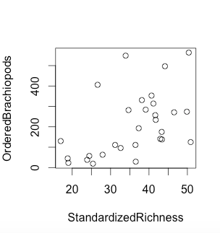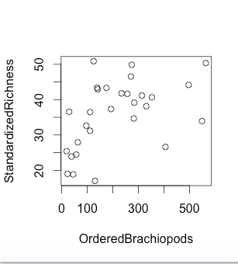

I neglected to do a decorana analysis due to time constraints, so I stuck with simple scatterplots that were also more intuitive. These two plots are functionally rotated mirror images of one another, so they show the same trend. There is a loosely linear relation between standardized richnesses and unstandardized brachiopods with low richness. However, high richness doesn’t seem to be compatible with standardization, indicating that high richness may not actually represent “richness”; hence, the need to standardize.