Paleo Lab

Problem set 1

1. North America has moved progressively westward over the past 66 million years.
2. plot(ModernMap,col=rgb(1,0,0,0.33),lty=0.01,add=TRUE)

plot () will___________, col= determines the color of the continents in each map (blue for the Cretaceous, red for the modern). “rgb” indicates the order of colors in the “col” component, so by putting a 1 in any of the three positions designates that color. lty= determines the type of lines that outline the shapes (in this case, 0.01 is used to make the lines very fine/not bold?). And ADD=TRUE means that the _______.

3) AlbianMap<-downloadPaleogeography(Age=110)

******Should actually be AptianMap, as the Aptian-Albian stage boundary was at 113 Ma according to the 2015 ICS timeline.

4) plot(AlbianMap,col=rgb(0,1,0,0.33),lty=0.01)

> plot(CretaceousMap,col=rgb(0,0,1,0.33),lty=0.01,add=TRUE)

> plot(ModernMap,col=rgb(1,0,0,0.33),lty=0.01,add=TRUE)

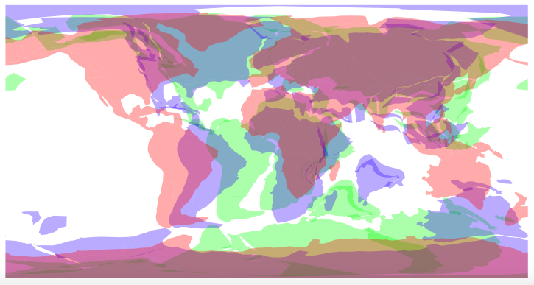

5) There has been more North-South movement in the Eastern Hemisphere, due to Africa rotating into its present position from a more inclined orientation, and Australia and India’s detachment and northward movement from Antarctica.

6) There has been more East-West movement in the Western Hemisphere due to the rifting of the present Atlantic and the near-latitudinal movement of North and South America westward.

Problem set 2

1)

PETMMap<-downloadPaleogeography(Age=56)

plot(PETMMap,col=rgb(1,0,0,0.33),lty=0.01)

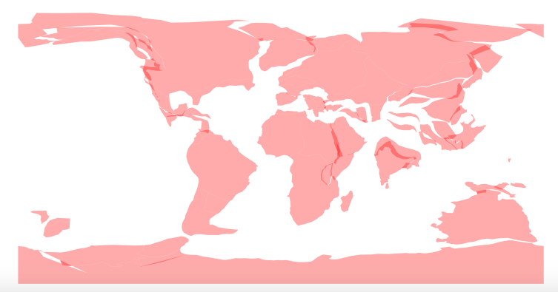

1. source("https://raw.githubusercontent.com/aazaff/paleobiologyDatabase.R/master/communityMatrix.R")

Anthozoa<-downloadPBDB(Taxa=c("Anthozoa"),StartInterval="Paleocene",StopInterval="Eocene")

> Anthozoa<-cleanRank(Anthozoa)

1. 2721 occurrences?
2. Column names:

[[2]]

[1] "occurrence_no" "record_type"

[3] "reid_no" "flags"

[5] "collection_no" "identified_name"

[7] "identified_rank" "identified_no"

[9] "difference" "accepted_name"

[11] "accepted_rank" "accepted_no"

[13] "early_interval" "late_interval"

[15] "max_ma" "min_ma"

[17] "reference_no" "paleomodel"

[19] "paleolng" "paleolat"

[21] "geoplate" "phylum"

[23] "class" "order"

[25] "family" "genus”

phylum, class, order, family and genus all refer to the taxonomic classifications of each Anthozoa occurrence.

“Paleolng” and “paleolat” refer to the global coordinates of each fossil occurrence at the time when they were alive.

“geoplate” applies to the ancient landmass on which each occurrence lived. “max_ma” and “min_ma” gives the earliest and latest possible ages of the occurrence.

“early interval” and “late interval” is the StartInterval and StopInterval we coded for, to constrain the time period in which we’re interested.

“occurrence_no” returns each occurrence’s ID number.

“reid_no” indicates whether or not the occurrence has been assigned to a new classification since its first description.

“record_type” means that all the individual rows are fossil occurrences and not some other type.

“flags” will only return a symbol if the occurrence has been re-identified.

“collection_no” tells us what repository holds it, or what expedition or study first described it.

“identified_name” and “accepted_name” return each occurrence’s taxonomic name, while “identified_rank” and “accepted_rank” yield the taxonomic rank of each occurrence.

“identified_no” and “accepted_no” tell who first described it.

“difference” tell us, in the case of a reassigned taxonomic name, why the occurrence was re-identified.

5)

PaleoLNG<-c(Anthozoa[,"paleolng"])

> PaleoLAT<-c(Anthozoa[,"paleolat"])

plot(PETMMap,col=rgb(1,0,0,0.33),lty=0.01)

> points(PaleoLNG,PaleoLAT,type="p",col=rgb(0,0,1))

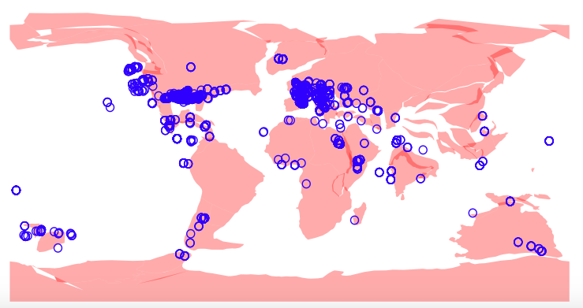

1. Eastern-hemisphere Anthozoa of the Paleocene and Eocene tended to cluster around the Mediterranean, inland off the coast of East Africa (which was then an epicontinental sea) and in general along continental margins. Anthozoa are scleractinian corals, sea anemones and sea pens, so they naturally live only in marine environments (especially warm, clear, shallow areas). From their broad extent, even into high latitudes and moern continental interiors, we can thus surmise that the Earth was in a greenhouse state and that sea level was high enough to flood continents. The abundance of Anthozoa around the Mediterranean suggests that it received the ideal amount of sunlight (for zooxanthellae), was the ideal salinity, temperature and water depth. As it happens, the Med at that time was part of the closing Tethys, and the center of a seaway that was fringed with mangrove swamps (in the present day Sahara) and even accommodated whales.

Problem set 3

1)

Perissodactyla<-downloadPBDB(Taxa=c("Perissodactyla"),StartInterval="Paleogene",StopInterval="Paleogene")

Perissodactyla<-cleanRank(Perissodactyla)

2) Perissodactyla are ungulates (four-legged mammals) with an odd number of toes on each foot. Horses, zebras and donkeys all have one toe per foot (the hoof), while rhinos and tapirs have three toes per foot. 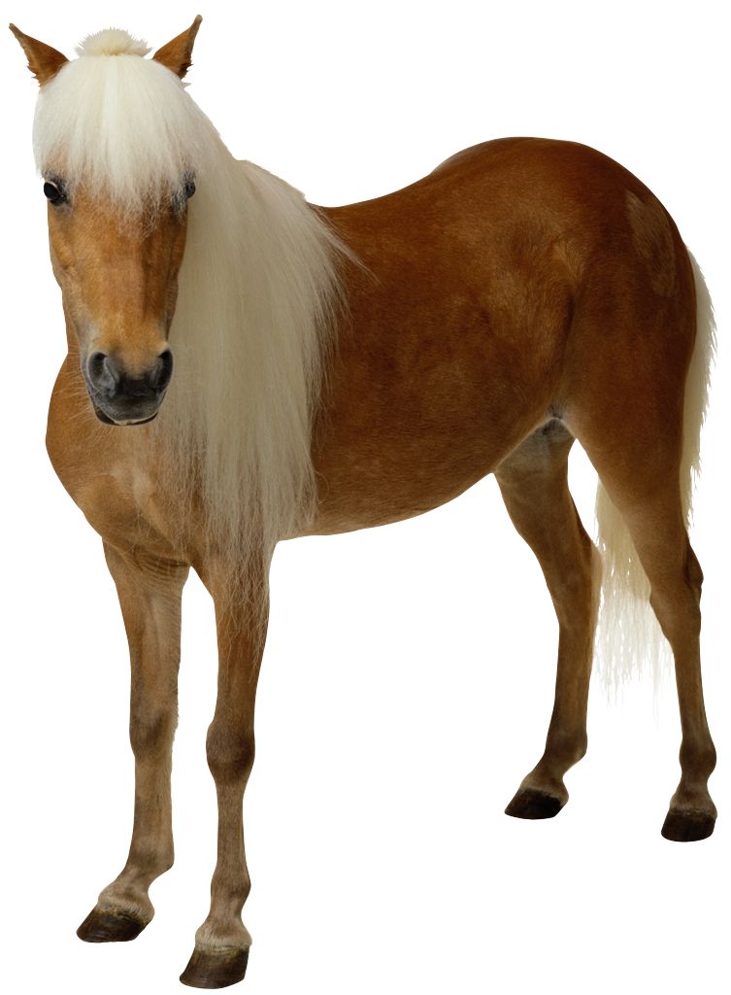

3) head(Perissodactyla[which(Perissodactyla[,"collection_no"]==112723),])

occurrence_no record_type reid_no flags

3949 961980 occ NA NA

3951 963172 occ NA NA

collection_no identified_name

3949 112723 Eotitanops pakistanensis

3951 112723 Balochititanops haqi

identified_rank identified_no difference

3949 species 169823

3951 species 192106

accepted_name accepted_rank

3949 Eotitanops pakistanensis species

3951 Balochititanops haqi species

accepted_no early_interval late_interval max_ma

3949 169823 Ypresian 56

3951 192106 Ypresian 56

min_ma reference_no paleomodel paleolng paleolat

3949 47.8 36699 gp_mid 70.7 2.76

3951 47.8 36699 gp_mid 70.7 2.76

geoplate phylum class order

3949 501 Chordata Mammalia Perissodactyla

3951 501 Chordata Mammalia Perissodactyla

family genus

3949 Brontotheriidae Eotitanops

3951 Brontotheriidae Balochititanops

4) This occurrence was found on geoplate 501, which is presently found as part of the Indian subcontinent.

points(70.7,2.76,type="p",col=rgb(0,0,1))

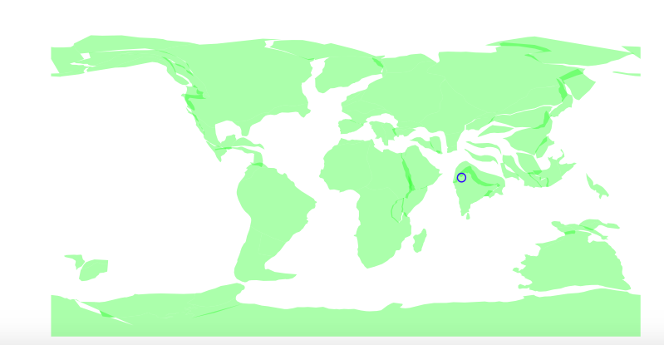

5)

PerryinIndia<-c(Perissodactyla[,"geoplate"]==501)

> head(PerryinIndia)

[1] FALSE FALSE FALSE FALSE TRUE FALSE

> table(PerryinIndia)

PerryinIndia

FALSE TRUE

3838 75

There are 75 occurrences of Perrissodactyla on the Indian subcontinent.

1. The Indian subcontinent detached from Gondwana (specifically, it was docked against Antarctica) in the Late Jurassic/Early Cretaceous. Throughout the Cenozoic, it plowed northward, rotating very slightly until it collided with Asia around the late Eocene and began forming the Himalayas.

AlbianMap<-downloadPaleogeography(Age=110)

MaastrichtianMap<-downloadPaleogeography(Age=66)

EoceneMap<-downloadPaleogeography(Age=57)

> OligoceneMap<-downloadPaleogeography(Age=36)

> MioceneMap<-downloadPaleogeography(Age=23)

> PlioceneMap<-downloadPaleogeography(Age=5)

plot(MaastrichtianMap,col=rgb(0,1,0,0.33),lty=0)

> plot(AlbianMap,col=rgb(1,0,0,0.33),lty=0, add=TRUE)

> plot(EoceneMap,col=rgb(0,0,1,0.33),lty=0, add=TRUE)

> plot(OligoceneMap,col=rgb(0,0,1,0.33),lty=0, add=TRUE)

> plot(MioceneMap,col=rgb(0,1,0,0.33),lty=0, add=TRUE)

> plot(PlioceneMap,col=rgb(1,0,0,0.33),lty=0, add=TRUE)

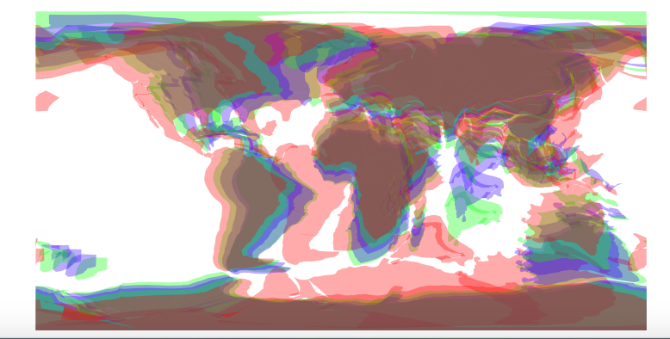

1. I decided to map all occurrences of Perissodactyla based on their earliest interval; so, I subset Perissodactyla that originated in the Paleocene(of which their were none), those that originated in the Eocene and those that originated in the Oligocene. I then mapped them on maps for each epoch.

PaleocenePerry<-subset(Perissodactyla,Perissodactyla[,"early_interval"]=="Paleocene")

> EocenePerry<-subset(Perissodactyla,Perissodactyla[,"early_interval"]=="Eocene")

> OligocenePerry<-subset(Perissodactyla,Perissodactyla[,"early_interval"]=="Oligocene")

PaleoPerryLNG<-c(PaleocenePerry[,"paleolng"])

PaleoPerryLAT<-c(PaleocenePerry[,"paleolat"])

plot(PaleoceneMap,col=rgb(0,0,1,0.33),lty=0)

points(PaleoPerryLNG,PaleoPerryLAT,type="p",col=rgb(0,1,0))

EoPerryLNG<-c(EocenePerry[,"paleolng"])

> EoPerryLAT<-c(EocenePerry[,"paleolat"])

> plot(EoceneMap,col=rgb(0,0,1,0.33),lty=0)

> points(EoPerryLNG,EoPerryLAT, type="p",col=rgb(0,1,0)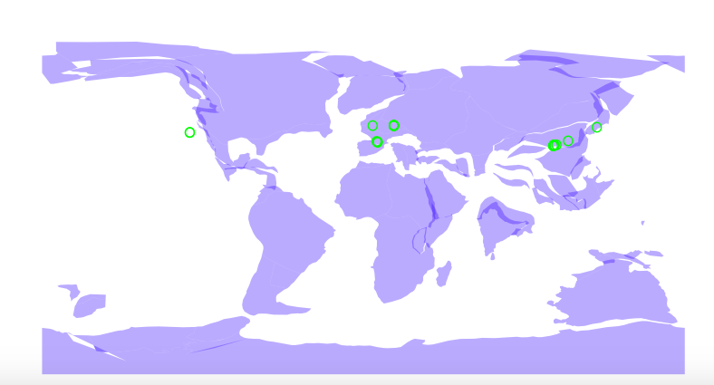

> OligPerryLNG<-c(OligocenePerry[,"paleolng"])

> OligPerryLAT<-c(OligocenePerry[,"paleolat"])

> plot(OligoceneMap,col=rgb(0,0,1,0.33),lty=0)

> points(OligPerryLNG,OligPerryLAT,type="p",col=rgb(0,1,0))

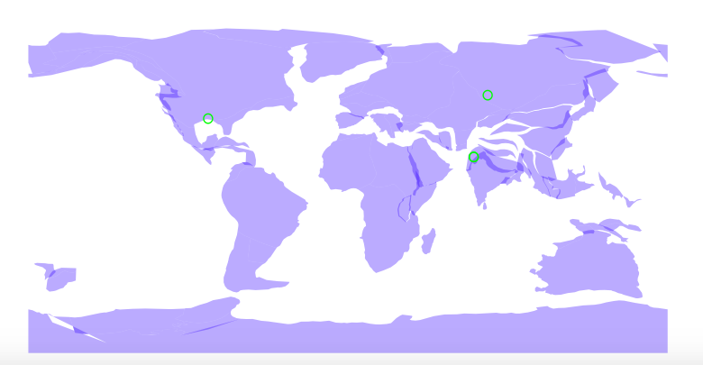

Perissodactyla is found in the Oligocene throughout Asia and in the far west of India. In the Oligocene map, India appears to have made initial land-land contact with Asia via the eastern margin of India. In the Eocene, Perissodactyla are present throughout Asia and Europe but not on the then-still-isolated India. So:

Species of Perissodactyla did NOT migrate from isolated India through Asia after the two joined. There are no species present on India before the contact, and one occurrence after, while species were already widespread on Eurasia before and after.

Species of Perissodactyla probably migrated from China to region-X during the Paleogene. This is supported by the maps of the Eocene and Oligocene, in which Perissodactylids are present throughout China in both but only appear on India in the Oligocene. This indicates westward migration of Perissodactylids across China and Southeast Asia and into India via the eastern contact.

The species of Perissodactyla did NOT evolve separately on both landmasses. Not only does this contradict most (credible) models of speciation, it is also not supported by fossil evidence since species are simply not present on both landmasses contemporaneously.