# Task 3.1

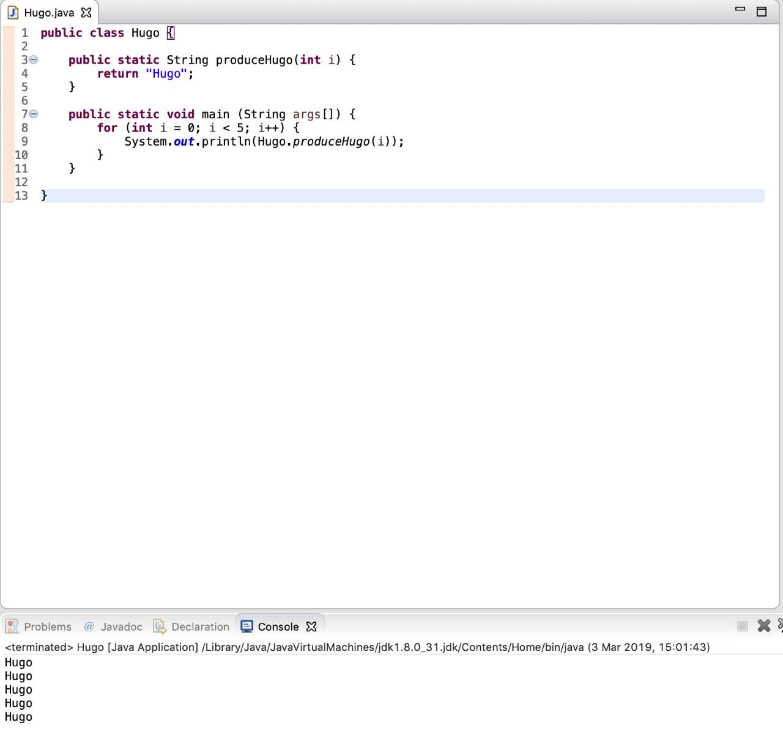

# Task 3.2

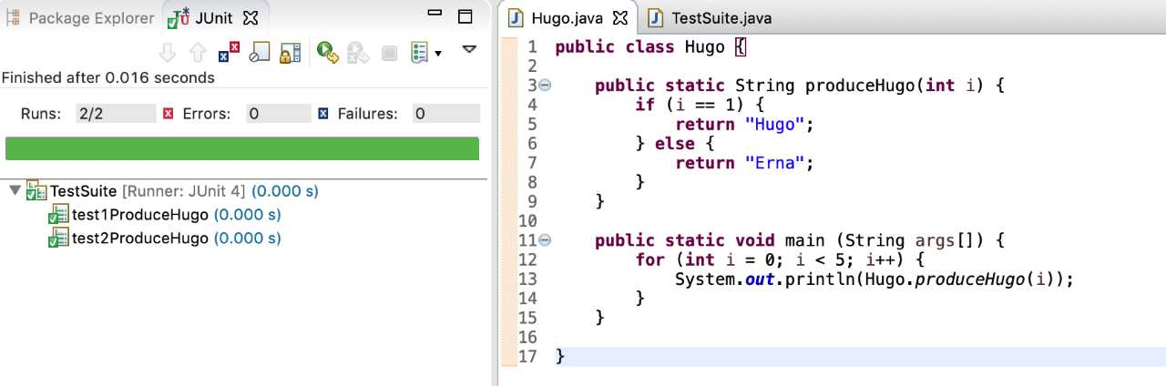

# Task 3.3

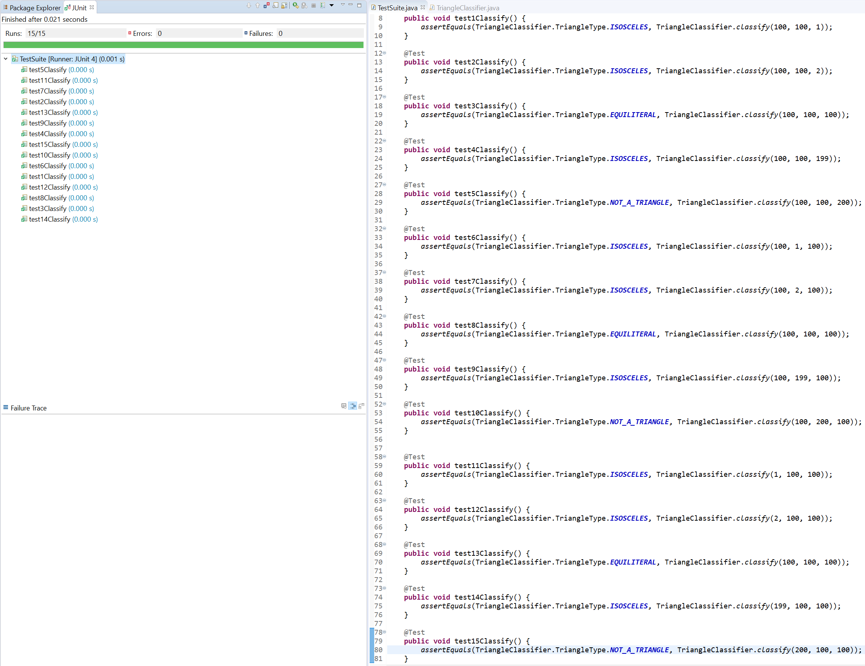

## Code – TestSuite.java

import static org.junit.Assert.*;

import org.junit.Test;

public class TestSuite {

@Test

public void test1Classify() {

assertEquals(TriangleClassifier.TriangleType.ISOSCELES, TriangleClassifier.classify(100, 100, 1));

}

@Test

public void test2Classify() {

assertEquals(TriangleClassifier.TriangleType.ISOSCELES, TriangleClassifier.classify(100, 100, 2));

}

@Test

public void test3Classify() {

assertEquals(TriangleClassifier.TriangleType.EQUILITERAL, TriangleClassifier.classify(100, 100, 100));

}

@Test

public void test4Classify() {

assertEquals(TriangleClassifier.TriangleType.ISOSCELES, TriangleClassifier.classify(100, 100, 199));

}

@Test

public void test5Classify() {

assertEquals(TriangleClassifier.TriangleType.NOT_A_TRIANGLE, TriangleClassifier.classify(100, 100, 200));

}

@Test

public void test6Classify() {

assertEquals(TriangleClassifier.TriangleType.ISOSCELES, TriangleClassifier.classify(100, 1, 100));

}

@Test

public void test7Classify() {

assertEquals(TriangleClassifier.TriangleType.ISOSCELES, TriangleClassifier.classify(100, 2, 100));

}

@Test

public void test8Classify() {

assertEquals(TriangleClassifier.TriangleType.EQUILITERAL, TriangleClassifier.classify(100, 100, 100));

}

@Test

public void test9Classify() {

assertEquals(TriangleClassifier.TriangleType.ISOSCELES, TriangleClassifier.classify(100, 199, 100));

}

@Test

public void test10Classify() {

assertEquals(TriangleClassifier.TriangleType.NOT_A_TRIANGLE, TriangleClassifier.classify(100, 200, 100));

}

@Test

public void test11Classify() {

assertEquals(TriangleClassifier.TriangleType.ISOSCELES, TriangleClassifier.classify(1, 100, 100));

}

@Test

public void test12Classify() {

assertEquals(TriangleClassifier.TriangleType.ISOSCELES, TriangleClassifier.classify(2, 100, 100));

}

@Test

public void test13Classify() {

assertEquals(TriangleClassifier.TriangleType.EQUILITERAL, TriangleClassifier.classify(100, 100, 100));

}

@Test

public void test14Classify() {

assertEquals(TriangleClassifier.TriangleType.ISOSCELES, TriangleClassifier.classify(199, 100, 100));

}

@Test

public void test15Classify() {

assertEquals(TriangleClassifier.TriangleType.NOT_A_TRIANGLE, TriangleClassifier.classify(200, 100, 100));

}

}