# Task 6.2

The clip method does not show as 100% because the default constructor class generated by java (because there is not one implemented) is not being tested. Only the method inside the class is being tested. Because clip is a static method it doesn’t use the class declaration.

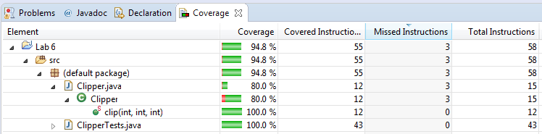

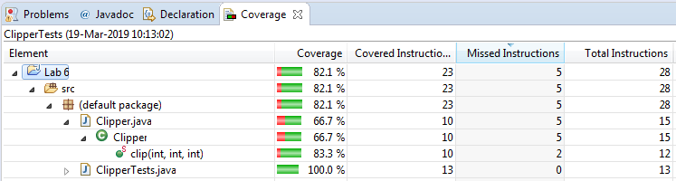

# Task 6.3

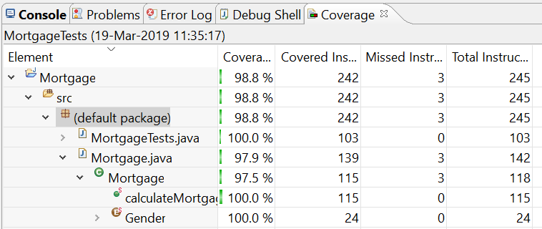

## Junit Code

**import** **static** org.junit.Assert.*;

**import** org.junit.Test;

**public** **class** MortgageTests {

@Test

**public** **void** test1() {

**int** x = Mortgage.*calculateMortgage*(25, 50000, Mortgage.Gender.***MALE***);

*assertEquals*(375000, x);

}

@Test

**public** **void** test2() {

**int** x = Mortgage.*calculateMortgage*(40, 50000, Mortgage.Gender.***MALE***);

*assertEquals*(275000, x);

}

@Test

**public** **void** test3() {

**int** x = Mortgage.*calculateMortgage*(50, 50000, Mortgage.Gender.***MALE***);

*assertEquals*(175000, x);

}

@Test

**public** **void** test4() {

**int** x = Mortgage.*calculateMortgage*(25, 50000, Mortgage.Gender.***FEMALE***);

*assertEquals*(350000, x);

}

@Test

**public** **void** test5() {

**int** x = Mortgage.*calculateMortgage*(40, 50000, Mortgage.Gender.***FEMALE***);

*assertEquals*(250000, x);

}

@Test

**public** **void** test6() {

**int** x = Mortgage.*calculateMortgage*(50, 50000, Mortgage.Gender.***FEMALE***);

*assertEquals*(150000, x);

}

@Test

**public** **void** test7() {

**int** x = Mortgage.*calculateMortgage*(90, 50000, Mortgage.Gender.***MALE***);

*assertEquals*(0, x);

}

@Test

**public** **void** test8() {

**int** x = Mortgage.*calculateMortgage*(90, 50000, Mortgage.Gender.***FEMALE***);

*assertEquals*(0, x);

}

@Test

**public** **void** test9() {

**int** x = Mortgage.*calculateMortgage*(15, 50000, Mortgage.Gender.***MALE***);

*assertEquals*(0, x);

}

@Test

**public** **void** tes10() {

**int** x = Mortgage.*calculateMortgage*(15, 50000, Mortgage.Gender.***FEMALE***);

*assertEquals*(0, x);

}

}