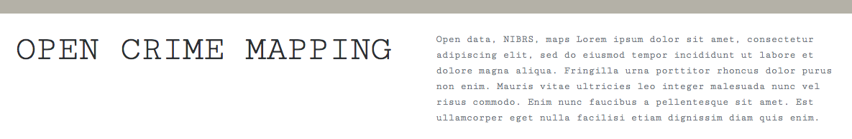

This site is part of a graduate data science capstone project. Why a geovisual framework for a data science capstone? Well, many types of data we encounter has a spatial element, especially when we think about the growth of Internet of Things (IOT) and smart cities, just to name two. The ability to analyze, model and communicate results within varying types of audiences visually is important. This project is motivated by both open data and the migration of law enforcement data from Universal Crime Reporting to the new National Incident Based Reporting Systems (NIBRS) in 2021.

**Dot Map**

Dot maps are a type of thematic map that shows the variable of interest using a dot. In the below map this a one-to-one dot density map. This means that each dot represents a single burglary. Another type of dot map is a one to many where each dot represents a set of aggregated data.

# Bottom Text

The above dot map represents burglaries from XXXX, both residential and business from the Dallas Police Incident data set. The colors were chosen to show a clear distinction between residential and business. We also wanted to make sure that the colors would work for those with color blindness. A great tool for choosing colors for thematic maps can be found at <http://colorbrewer2.org/>. The user in this case has the ability to choose between basemaps to compare and contrast. The interactivity of this map provides the Modus Operandi (M.O.), type of premise, zip code, and 3 time features in calendar date, day of the week and time.

**Heat Map**

Heat mapping in a geovisual context, is a way of displaying how dense an activity is geographically. ‘Heat’ in this case refers to higher density of occurrences in the variable of interest. Heat maps have advantages in that they can cross geographic boundaries like zip codes, or counties. They also present some challenges. Setting the intensity too small and nothing will come, set the intensity too high and patterns may disappear altogether.

# Bottom Text

The above heat map represents burglaries from XXXX, both residential and business from the Dallas Police Incident data set. The colors are a little different from a traditional heap map of blue -> green -> red in that the colors are changed to help in the case the viewer is color blind. The user in this case has the ability to choose between basemaps to compare and contrast.