**Sujet** Prénom : …………………………………………………………………………

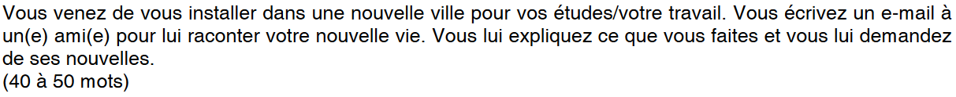

………………………………………………………………………………………………………………………………………………………………………………………………………………………………………………………………………………………………………………………………………………………………………………………………………………………………………………………………………………………………………………………………………………………………………………………………………………………………………………………………………………………………………………………………………………………………………………………………………………………………………………………………………………………………………………………………………………………………………………………………………………………………………………………………………………………………………………………………………………………………………………………………………………………………………………………………………………………………………………………………………………………………………………………………………………………………………………………………………………………………………………………………………………………………………………………………………………………………………………………………………………………………………………………………………………………………………………………………………………………………………………………………………………………………………………………………………………………………………………………………………………………………………………………………………………………………………………………………………………………………………………………………………………………………………………………………………………………………………………………………………………………………………………………………………………………………………………………………………………………………………………………………………………………………………………………………………………………………………………………………………………………………………………………………………………………………………………………………………………………………………………………………………………………………………………………………………………………………………………………………………………………………………………………………………………………………………………………………………………………………………………………………………………………………………………………………………………………………………………………………………………………………………………………………………………………………………………………………………………………………………………………………………………………………………………………………………………………………………………………………………………………………………………………………………………………………….

**Sujet** Prénom : …………………………………………………………………………

……………………………………………………………………………………………………………………………………………………………………………………………………………………………………………………………………………………………………………………………………………………………………………………………………………………………………………………………………………………………………………………………………………………………………………………………………………………………………………………………………………………………………………………………………………………………………………………………………………………………………………………………………………………………………………………………………………………………………………………………………………………………………………………………………………………………………………………………………………………………………………………………………………………………………………………………………………………………………………………………………………………………………………………………………………………………………………………………………………………………………………………………………………………………………………………………………………………………………………………………………………………………………………………………………………………………………………………………………………………………………………………………………………………………………………………………………………………………………………………………………………………………………………………………………………………………………………………………………………………………………………………………………………………………………………………………………………………………………………………………………………………………………………………………………………………………………………………………………………………………………………………………………………………………………………………………………………………………………………………………………………………………………………………………………………………………………………………………………………………………………………………………………………………………………………………………………………