Influence of Elastic Energy onnthe Unlkoading Behaviour of NiTi Shape Memory Alloys

Yinong Liu¹, Denis Favier² and Laurent Orgéas²

1. Department of Mechanical and Materials Engineering, University of Western Australia, Nedlands, WA 6907, Australia.

2. Laboratoire Sols-Solides-Structures, Université Joséph Fourier, BP 53 x, 38041 Grenoble, Cedex, France.

Abstract. A non-linear unloading path of deformed NiTi shape memory alloys was observed during mechanical testing at various temperatures, giving a strain recovery larger than what expected from elasticity. Whilst the non-linear unloading path at above the As temperature may be rationalised by a simultaneous reverse transformation from the oriented martensite to austenite, the non-linear strain recovery during unloading at below the As temperature must have a different mechanism, because the thermodynamic driving force for a reverse transformation is negative. This second mechanism is ascribed to a 'self-deorientation' process of the fully oriented martensite and the driving force for this process is attributed to the elastic energy stored in the matrix during the forward deformation process.

1. INTRODUCTION

Although not recognised with scientific interest, almost every mechanical testing of shape memory alloys is found to exhibit a non-linear unloading path. Typical examples of stress-strain curves exhibiting such behaviour can be found in literature for various alloy systems, heat treatment and testing conditions, and deformation mode and specimen geometry combinations, such as tensile testing using wire or bulk samples [1,2], shear testing using plate samples [3,4], for near-equiatomic NiTi alloys [5,6], Cu-based alloys [7,8], in pseudoelasticity [1,5] or in shape memory effect [5]. The deformation behaviour of shape memory alloys, in pseudoelasticity at T>Af for example, is usually interpreted as following. Loading induces elastic deformation until a critical value of stress is reached when stress-induced martensitic transformation starts. Unloading upon the completion of the stress-induced martensitic transformation leads to an elastic recovery at a lower critical stress level. The difference between the two critical stresses, i.e. the stress hysteresis of pseudoelasticity, is due to some internal resistance to the movement of phase boundaries. In some experiments distinctive starting points have been observed on stress-strain curves for both the forward and reverse transformations associated with a Lüder's type deformation behaviour [1,9]. These apparent starting points have been attributed to the nucleation of martensite for the forward process and the nucleation of austenite within the stress-induced martensite for the reverse process, respectively [1]. The non-linear loading and unloading behaviour prior to the apparent onset points for the forward and reverse transformations clearly deviate from the hypothesis of elasticity in these regions. While the non-linear loading path may be rationalised by a simultaneous stress-induced martensitic transformation at very low average stress levels due to local stress concentrations, the non-linear unloading path clearly requires more discussion. This work attempts to characterize the unloading behaviour of a NiTi alloy under different testing conditions. The discussions are devoted to clarify the nucleation hypothesis and influences of thermodynamic free energy balances on the unloading behaviour of shape memory alloys.

2. EXPERIMENTAL PROCEDURE

Two commercial NiTi alloys were used in this study. Alloy 1 was received in wire form and has a nominal composition of Ti - 50.20at%Ni. Alloy 2 was received in plate form and has a nominal composition of Ti - 50.15at%Ni. The received materials were cold worked by wire or plate rolling and then heat treated at different temperatures. The critical temperatures of transformation of the materials were determined using a Perkin-Elmer 4 Differential Scanning Calorimeter.
The wire material was cut into tensile specimens with a gauge length of 27 mm and a cross-section of 0.83x0.83 mm. Tensile tests were performed on an Instron-4301 testing machine. The plate material was cut into shear specimens of 35x18x1 mm with a shear gauge section of 35x3x1 mm and a shear direction along the length of the specimens. Shear tests were carried out using an Adamel Lhomargy DY35 universal mechanical testing machine. In both tests the testing temperature was controlled by liquid baths to within an accuracy of 0.1 K.

3. RESULTS

Figure 1 shows the engineering tensile stress-strain curve of a pseudoelastic cycle of a wire specimen tested at 343 K. The specimen was annealed at 723 K after cold rolling. A distinctive point separating two deformation stages, as marked as 'a' in the figure, was observed during loading. The deformation before this point was uniform and that after this point exhibited a typical Lüder's type behaviour. The unloading path also exhibited two distinctive stages, being separated by a point 'b' as indicated in the figure. The deformation recovery before this point was uniform whilst that after this point was localised. The uniform recovery path was clearly non-linear. A reference elastic unloading line was also drawn in the figure using E=90 GPa [3] and the total deformation is thus decomposed into elastic strain (εel), pseudoelastic strain (εps), residual strain (εre) and self-recovered strain (εsr).
Figure 2 shows the engineering stress-strain curve of a ferroelastic cycle of a specimen tested in shear at 278 K. A non-linear unloading path was recognised at either end of the deformation. The total deformation may be considered as having an elastic strain (γel), stress-assisted martensite reorientation strain (γmr), and self-recovered strain (γsr).

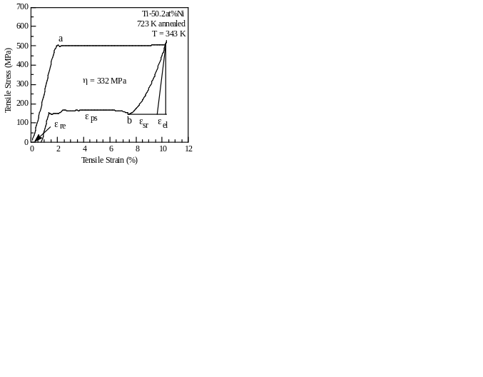
Fig.1 Pseudoelastic curve of Ti-50.2at%Ni in tension | Fig.2 Ferroelastic curve of Ti-50.15at%Ni in shear

Shown in figure 3 are the tensile stress-strain curves of two groups of wire specimens annealed at 973 K after cold rolling. The critical temperatures of transformation of the specimens were Mf = 292 K, Ms = 304 K, As = 325 K and Af = 335 K, as determined by differential calorimetric measurement. The testing temperature was 308 K, being between the Ms and the As temperatures. Specimens shown in dotted curves were cooled by immersing in liquid nitrogen to achieve a thermal martensite structure and then heated to the testing temperature for deformation. The deformation mechanism of these specimens was martensite reorientation (MR). Specimens shown in solid curves were heated in boiling water to achieve an austenite structure and then cooled to the testing temperature. The deformation mechanism of these specimens during loading was stress-induced martensitic transformation (SIM). Different levels of deformation were performed on specimens from each group. It is seen that a difference in unloading path between the two groups of specimens was observed.
The stress-strain curves shown in figure 4 were tested in shear at 323 K. The specimens were annealed at 903 K after cold rolling. The critical temperatures of transformation of the specimens were virtually the same as those of the specimens shown in figure 3. The testing temperature was just below the As temperature. Similar to the experiment shown in figure 3, two different testing conditions were applied to the specimens. Specimens shown in dotted curves were deformed via martensite reorientation by immersing the specimens in liquid nitrogen prior to the deformation. Specimens shown in solid curves were deformed via stress-induced martensitic transformation by immersing the specimens in boiling water prior to the deformation. It was observed that characteristic stresses for stress-induced martensitic transformations were apparently higher than those for martensite reorientation at the testing temperature.
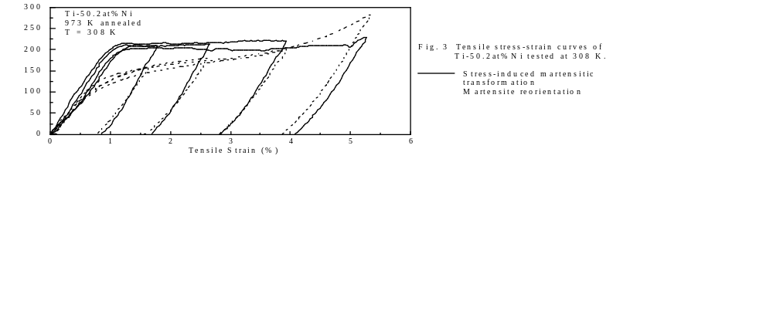
This is due to the testing temperature being nearly 20 K above the Ms temperature of the specimens. This difference in the characteristic stress for deformation imposes a problem in estimating the tendency of self-recovery by the measurement of self-recovered strain or energy at zero stress, because for the stress-induced martenste an unloading of ~150 MPa was allowed before such a measurement wherease for the reoriented martensite the unloading magnitude was only ~120 MPa, as in the case of the sepcimens deformed to 12% for instance. To make a valide comparison, the self-recovered energies were measured with an equal magnitude of unloading from the unloading point for each pair of specimens.

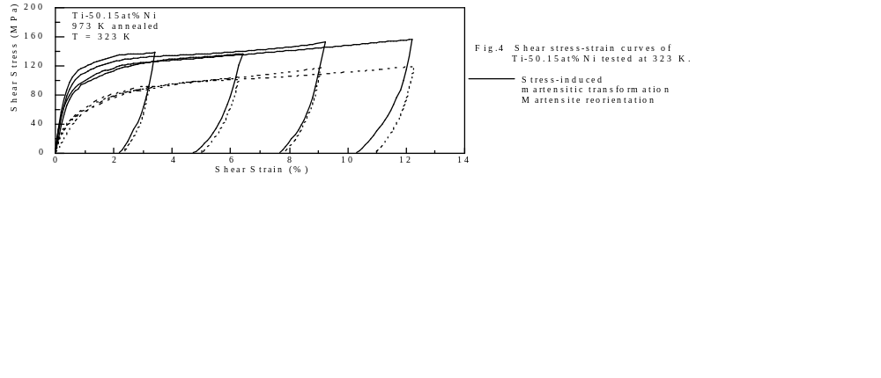

Shown in figure 5 are the measurements of energy released by the specimens during self-recovery. The self-recovered energy is measured from the stress-strain curves (shown in figures 3 and 4) after subtracting the elastic energy. Elastic energy is estimated using a tensile modulus of elasticity of 91 GPa and a shear modulus of elasticity of 35 GPa for tensile and shear specimens, respectively. The results are shown as function of the volume fraction of deformed martensite, either stress-induced martensite or reoriented martensite, as defined as the ratio of deformation of a specimen to the maximum deformation of each test. The measurements showed a general increase in self-recovered energy with increasing amount of deformation and a maximum value of self-recovered energy of ~0.25 J/g was measured in the wire specimen deformed in tension to a maximum strain. Referring to figures 3 and 4, however, it is seen that the general increase in self-recovered energy is associated with the increase in stress at the reversion point of deformation. Thus, to compare the tendency of self-recovery between different specimens self-recovered energies after unloading by an equal stress magnitude are measured from the stress-strain curves. For the tensile tests the self-recovered energy is measured for unloading 147 MPa from the reversion point and for the shear tests the unloading stress magnitude is 85 MPa for the calculation. The two stress magnitudes were chosen according to σ = τ. The measurements of this normalised self-recovered energy are shown in figure 6, with the same legend as in figure 5. It is seen that the wire specimens tested in tension showed higher tendency of self-recovery as compared to the plate specimens tested in shear and that the specimens deformed in martensite state exhibited higher tendency of self-recovery as compared to the specimens deformed via stress-induced martensitic transformations for both loading conditions.

Fig.5 Self-recovery energy as function of fraction of stress-induced martensite or reoriented martensite | Fig.6 Normalised self-recovery energy as function of fraction of stress-induced martensite or reoriented martensite

4. DISCUSSION

Two different modes of deformation have been adopted in this study: the stress-induced martensitic transformation and martensite reorientation. The final structure of a specimen at the end of deformation is expected to be a fully oriented martensite with a minimum degree of variant self-accommodation irrespective to the mode of deformation. This structure is expressed as the fully oriented martensite without trying to differentiate between a stress-induced martensite and a reoriented martensite in the following discussion. It has to be pointed out, however, that in a polycrystalline material a fully oriented structure does not necessarily imply a single crystalline structure in each grain, due to the necessity to maintain the matrix continuity at grain boundaries.

4.1 Mechanisms of self-recovery

The non-linear unloading behaviour, as demonstrated in this study, leads to a strain recovery higher than what can be expected for elasticity during unloading. For deformation at temperatures above the As temperature of a specimen, two possibilities exist for the self-recovery of deformation upon unloading: simultaneous reverse transformation of the stress-induced martensite to austenite and a change of the structure of the stress-induced martensite to a configuration of higher degree of self-accommodation. The first process is hereafter termed simultaneous pseudoelasticity in distinction to the pseudoelastic recovery occurring at a definite hysteresis. The second mechanism is termed self-deorientation in contrast to the reorientation process in which the degree of self-accommodation of a multi-variant structure is reduced by twinning. The simultaneous pseudoelastic recovery may be facilitated by a minority of martensite variants which have negligible resistance for their reversion to austenite. The occurrence of the simultaneous reverse transformation during unloading invalidates the onset point of the Lüder's type reversion behaviour being associated with the nucleation, hence the start, of the reverse transformation. Whether the actual mechanism of this non-linear unloading behaviour is simultaneous pseudoelasticity, self-deorientation or a mixture of the two, however, needs to be clarified in further investigation. This can be done by in situ thermal analyses during unloading, since a reverse martensite-to-austenite phase transformation can be discriminated from the self-deorientation of martensite by its latent heat effect.
For deformation at temperatures below the As temperature, the simultaneous pseudoelasticity mechanism is not operative, because the thermodynamic driving force for a reverse transformation is negative in this case. The only possibility for a shape change must be associated with a twinning process of the martensite, i.e. self-deorientation. The relationship between the non-linear unloading behaviour and 'detwinning' of martensite has been acknowledged in literature [10] with no explanation to the driving force of this process. Since the self-recovery of deformation occurs in the opposite direction to the unloading stress, the driving force for this process must be from inside the specimen. The sources of driving force for a thermoelastic martensitic transformation in shape memory alloys include the chemical free energy change and internal elastic energy. The chemical free energy, being determined by the crystal structure, is expected to be the same for fully oriented and self-accommodated martensites. Thus, the internal elastic energy remains to be the sole driving force for the self-deorientation of the oriented martensite.

4.2 Internal elastic energy

In a polycrystalline specimen elastic energy may be stored in the matrix due to lattice distortion mismatch between different martensite variants at various boundaries including twin boundaries, grain boundaries and transformation interfaces. The difference in grain orientation and the necessity to maintain matrix continuity at grain boundaries prevent that a single variant martensite is formed in each grain by deformation. A structure of a single variant in each grain is only possible at high deformation levels when a large quantity of dislocations are introduced to accommodate the orientation mismatch among different grains. Within the deformation range adopted in this study multi variants are expected to exist in each grain. These variants are arranged and oriented under the influence of the bias stress to give a macroscopic deformation. The bias stress is balanced by internal elastic stresses, which are most concentrated at the vicinity of various boundaries and interfaces.
During unloading, the diminishing of the bias stress and the restoration of elastic deformation within the matrix may cause some variants to reorient backwards, yielding an extra deformation recovery. This reverse orienting process is expected to occur primarily at the vicinity of transformation interfaces and other boundaries where internal elastic stresses are concentrated. The maximum value of energy released by martensite during unloading is measured to be ~0.25 J/g in this study. This value is believed to correspond only to a portion of the elastic energy stored in the matrix. When internal elastic stresses are relaxed by this self-recovery process to below the resistance to twin boundary or transformation boundary movement in the specimen, the process stops while a portion of the elastic energy still remains in the matrix.
It is seen in figure 6 that a higher self-recovery tendency was measured in a reoriented martensite matrix than in a stress-induced martensite matrix under similar testing conditions. This fact, however, does not necessarily imply that the elastic energy stored in a reoriented martensite is higher than that stored in a stress-induced martensite, because the mobility of a boundary also directly affects the self-recovery process. Changes in testing conditions and specimen preparation history are very likely to alter the comparison of self-recovery behaviour between the two martensites. In fact, it has been observed that mechanical cycling promotes self-recovery in both cases of pseudoelasticity [11] and ferroelasticity [3].
Limited data has been reported in literature for internal elastic energies associated with martensite in shape memory alloys. Salzbrenner and Cohen estimated that the elastic energy associated with a multi-interface martensitic transformation in a single crystal specimen of CuAlNi alloy is ~10% of the chemical enthalpy change of the transformation [12]. Liu and McCormick estimated the elastic energy stored during the course of a thermal martensitic transformation in an annealed polycrystalline NiTi to be ~0.5J/g based on measurements of transformation temperature intervals [13]. These measurements of elastic energy are made with reference to thermal martensite. The internal elastic energy stored or released during a mechanical process, either a stress-induced martensitic transformation or a stress-directed martensite reorientation, can be quite different. Liu et. al. estimated the elastic energy released from a matrix of thermal martensite in NiTi during the course of reorientation deformation to be 1.44J/g, corresponding to ~5% of the transformation enthalpy change of the martensite in the alloy [14]. It appears that a good understanding and a reliable estimation of the elastic energies of different martensite structures in various alloy systems are yet to be established.

4.3 Lüder's type deformation

Lüder's type deformation is commonly observed for the stress-induced martensitic transformation in NiTi wire specimens during tensile test [1,9]. Lüder's type deformation is characterised by an upper limit and a deformation stress plateau at a lower level. The presence of Lüder's deformation is usually considered as indicative to that the resistance to transformation interface propagation is lower than that to the nucleation of martensite elsewhere in the austenitic matrix. Lüder's type behaviour is also observed during the reverse transformation of stress-induced martensite in pseudoelasticity [1], in which a lower recovery stress is followed by an increase of stress to a plateau level higher. The upper limit during loading and the lower limit during unloading have been interpreted as being associated with the nucleation of martensite and the nucleation of austenite for the two processes, respectively [1].
A few points remain unexplained with the nucleation hypothesis. First, the reason why the resistance to martensite variant growth is lower than that to nucleation is unexplained. In fact, due to the accumulation of elastic stresses in front of martensite nuclei, it is expected that the resistance to their growth becomes greater with their growing into larger sizes. It is for this reason that a temperature interval is always observed with multi-interface martensitic transformations [12]. Second, the non-linear loading and unloading curves prior to the onset of Lüder's type deformation and recovery denounce elasticity for deformation prior to these distinctive points. Whereas the inelasticity of deformation recovery during unloading can be rationalised in terms of self-deorientation of martensite, the inelastic deformation of austenite prior to the point on loading can only be attributed to a stress-induced martensitic transformation, thus invalidating the point being interpreted as being associated with nucleation of martensite. Furthermore, Lüder's type behaviour is also observed in martensite reorientation deformation processes [15], in which no nucleation is involved.
A possible explanation to Lüder's deformation behaviour is as following. The stress-induced martensitic transformation actually starts soon as the stress-strain curve deviates from its initial linearity (in fact, an experimental observation of linearity on loading does not necessarily exclude the possibility for a stress-induced martensitic transformation). This initial deformation may be uniform or localised macroscopically. The upper limit of the Lüder's type deformation only marks the moment when a transformation band (martensite) has spread over the entire cross-section of the specimen. As the transformation band reaches the free surface of the specimen a portion of the internal elastic energy stored by the formation of martensite is released, resulting in a decrease in the resistance to the propagation of the band interface, thus exhibiting upper-lower stress limits for the stress-induced martensitic transformation. For the same reason, the lower stress limit for the reversion of martensite during pseudoelastic unloading indicates the moment when a reverse transformation band (austenite) has propagated across the entire cross-section, instead of being associated with the nucleation of austenite.
Furthermore, an engineering tensile stress-strain curve is determined using the initial cross-section area, Ao, of the specimen. The true stress-strain curve deviates from the engineering curve at point 'a' when deformation is localised. The actual stress deforming the specimen after point 'a' can be estimated using A=Ao(1-εtr), assuming that the martensitic transformation is isovolume. The εtr is the transformation strain, i.e. local strain at the deformation band, instead of the apparent strain of the specimen. Using a transformation tensile strain of 7% for polycrystalline NiTi alloys, the true stress after point 'a' is expected to be approximately 7% higher than the engineering stress. A similar correction may also be applied to the unloading curve at point 'b'. That will result in an increase of stress in the section prior to point 'b' on the unloading curve. These corrections lead to at least a partial removal of the Lüder's effect on the engineering stress-strain curves. In the case of plate-sample shear deformation, on the other hand, no cross-section area change is involved in the deformation band. In addition, with a large cross-section (30x1 mm) to width (3 mm) ratio, the formation of a thin deformation band across the entire cross-section of the specimen is very difficult. Thus, neither of the two contributions to Lüder's type behaviour is operating. That may explain why Lüder's type deformation was not observed in isothermal shear tests of the same alloy [16].
It is thus suggested that both a change in the internal elastic energy and a sample geometrical effect contribute to the upper-lower deformation limit phenomenon observed in tensile tests using wire specimens. This hypothesis is valid for both a phase transformation between martensite and austenite and a reorientation process between martensite variants. In the latter case when a reorientation band, a band of fully oriented martensite, spreads across the entire cross section and reaches the free surfaces of the specimen, elastic energy is released and a local deformation necking is formed, resulting in a typical Lüder's type deformation behaviour.

References

1. Stachowiak G.B. and McCormick P.G., Acta Metall. 36 (1988) 291.
2. Proft J.L., Melton K.N. and Duerig T.W., Proc. ICOMAT-86, JIM, (1987), pp742.
3. Liu Yinong and Favier D., "Shear Cycling of NiTi in Ferroelasticity" (1995), to be published.
4. Manach P-Y., Ph.D. dessertation, Institute National Polytechnique de Grenoble, 1993.
5. Miyazaki S., Ohmi Y., Otsuka K. and Suzuki Y., Journal de Physique 43 (1982) C4-255.
6. Eucken S. and Duerig T.W., Acta metall. 37 (1989) 2245.
7. Otsuka K. and Shimizu K., Int. Metals Rev. 31 (1986) 93.
8. Van Humbeeck J., Stalmans R., Chandrasekaran M. and Delaey L., "On the stability of shape memory alloys", Engineering Aspects of Shape Memory Alloys, Butterworth-Heinemann, London (1990), pp96.
9. Miyazaki S., Imai T., Otsuka K. and Suzuki Y., Scripta Metall. 15 (1981) 853.
10. Duerig T.W. and Zadno R., "An enengineer's perspective of pseudoelasticity", Engineering Aspects of Shape Memory Alloys, Butterworth-Heinemann, London (1990), pp369.
11. Miyazaki S., "Thermal and stress cycling effects and fatigue properties of Ni-Ti alloys", Engineering Aspects of Shape Memory Alloys, Butterworth-Heinemann, London (1990), pp394.
12. Salzbrenner R.J. and Cohen M., Acta Metall. 27 (1979) 739.
13. Liu Yinong and McCormick P.G., Acta metall. mater. 42 (1994) 2401.
14. Liu Yinong, Favier D. and McCormick P.G., "Stabilisation of martensite due to cold deformation in NiTi" (1995), to be published.
15. Liu Yinong and McCormick P.G., ISIJ International 29 (1989) 417.
16. Orgéas L. and Favier D., "Non-symmetric tension-compression behaviou of NiTi alloy" Proc. ICOMAT-95, (1995).

