A.Turn on the cross-origin resource sharing (CORS) feature for the S3 bucket in Account A.

B.In Account A, set the S3 bucket policy to the following:

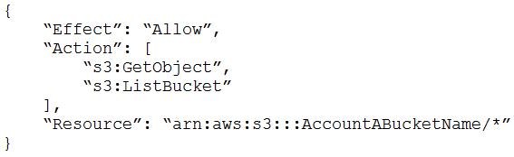

C.In Account A, set the S3 bucket policy to the following:

Most Voted

D.In Account B, set the permissions of User_DataProcessor to the following:

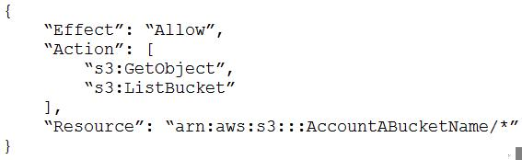

E.In Account B, set the permissions of User_DataProcessor to the following:

