+
-
.
/
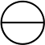



-
-
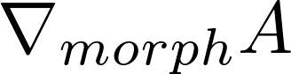
*
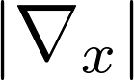+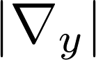
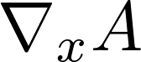
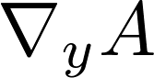

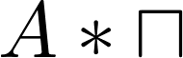
median(A)
