PRESS FACT SHEET  GENRE  Physics-based survival / rolling fortress / sci-fi survival crafting PLATFORM  PC / Steam  DEMO  May 26, 2026  STEAM NEXT FEST  June 15, 2026  RELEASE  [Early Access date / TBA]  DEVELOPER  Breaking Walls  LOCATION  Montreal, Canada  LINKS  STEAM  https://store.steampowered.com/app/2640150/Venus_The_Last_Ascent/  TRAILER  [YouTube / trailer URL]  PRESS KIT  [Public press kit URL]  WEBSITE  www.venusthelastascent.com  PRESS CONTACT  NAME  Nathanael Dufour  EMAIL  venus@breakingwalls.co  SOCIAL  [@studiohandle] | 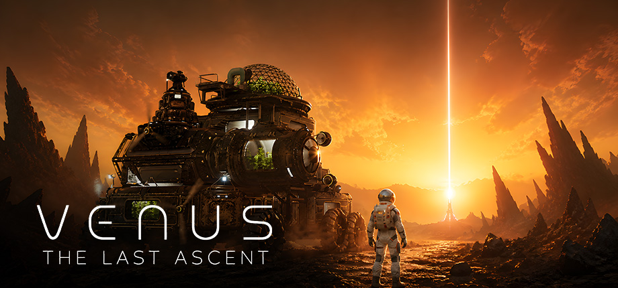  ONE-LINE PITCH  A physics-based survival game where your base is a massive rolling fortress crossing the hostile surface of Venus.  DESCRIPTION  Venus: The Last Ascent is a physics-based survival game where your base is also your vehicle. Build a massive rolling fortress of drills, farms, weapons, shields, and reactors, survive the hostile surface of Venus, and fight your way toward the last city above the clouds.  KEY FEATURES  • Build a massive rolling fortress — Expand your mobile base with drills, farms, weapons, shields, reactors, oxygen systems, storage, and tools.  • Engineer with real physics — Every part affects weight, balance, movement, and stability. Build bigger, but make sure your fortress can actually survive the terrain.  • Survive Venus on the move — Cross acid plains, glass deserts, storms, ruins, and unstable ground while keeping your machine alive.  • Mine, refine, and upgrade — Cut into Venusian rock, gather minerals, unlock blueprints, and build more powerful systems.  • Defend your machine — At sunrise, abandoned solar-powered machines wake up and hunt your energy. Fight them off, scavenge their remains, or keep moving.  •Discover lost industrial ruins — Explore pre-war outposts to find blueprints, logs, clues, and the remains of earlier attempts to survive Venus.  •Reach Cloud City — Follow the beam of light on the horizon and build a machine powerful enough to reach the last city above the clouds.  ABOUT BREAKING WALLS  Breaking Walls is an independent game studio based in Montreal, Canada, focused on atmospheric worlds, systemic gameplay, and ambitious player-driven experiences.  The studio’s upcoming game, Venus: The Last Ascent, combines physics-based vehicle building, survival crafting, tower-defense pressure, and sci-fi exploration on the hostile surface of Venus.  FOR JOURNALISTS  Demo available ahead of Steam Next Fest; new trailer follows June 2, 2026.

VENUS: THE LAST ASCENT — FACT SHEET DETAILS
GAME METADATA  Official title: Venus: The Last Ascent  Subtitle: No for Demo, Yes for Full game  Developer: Breaking Walls  Publisher: Breaking Walls  Country: Canada  Language support: EN for Demo, Multiples for Full game  Price: TBD  Release window: Fall 2027  Demo availability: May 26, 2026  Steam Next Fest status: June 15, 2026  TECHNICAL INFO  Platform: PC / Steam  Engine: Unreal Engine  Controller support: No  Steam Deck status: No  Minimum specs: Intel i3 @ 3.0 GHz, GTX 2070 Super 8 GB RAM, 20 GB available space  Recommended specs: Intel Quad Core i7 @ 3.6 GHz or higher (or AMD equivalent), GeForce 2080 Ti / 3080 / Radeon RX, 12 GB RAM, 20 GB available space  Save system: Yes  Build version: Demo 1.0 | PRESS LINKS  Steam page: https://store.steampowered.com/app/2640150/Venus_The_Last_Ascent/  Trailer: [Add info]  Press kit folder: [Add info]  Website: [Add info]  YouTube: [Add info]  X / Twitter: [Add info]  TikTok: [Add info]  Discord: [Add info]  Bluesky: [Add info]  Newsletter: [Add info]  EMBARGO / REVIEW INFO  Embargo date: [Add info]  Review code availability: [Add info]  Demo key needed?: [Add info]  Best contact: [Add info]  Interview availability: [Add info]
PRESS KIT CHECKLIST
CORE ASSETS  • ☐ Fact sheet PDF/DOCX  • ☐ Press release  • ☐ Steam page link  • ☐ Trailer link  • ☐ Developer bio | VISUAL ASSETS  • ☐ 5–10 screenshots  • ☐ Key art horizontal  • ☐ Key art vertical  • ☐ Transparent logo  • ☐ Steam capsule art | USEFUL EXTRAS  • ☐ Gameplay GIFs  • ☐ Studio logo  • ☐ Interview notes  • ☐ Gameplay bullet list  • ☐ Known coverage angle

