Press Release  Editable announcement for demo, trailer, and Steam Next Fest outreach | 
FOR IMMEDIATE RELEASE
Venus: The Last Ascent Releases New Demo Ahead of Steam Next Fest
Build a rolling fortress, survive Venus, and engineer your way to the last city above the clouds.
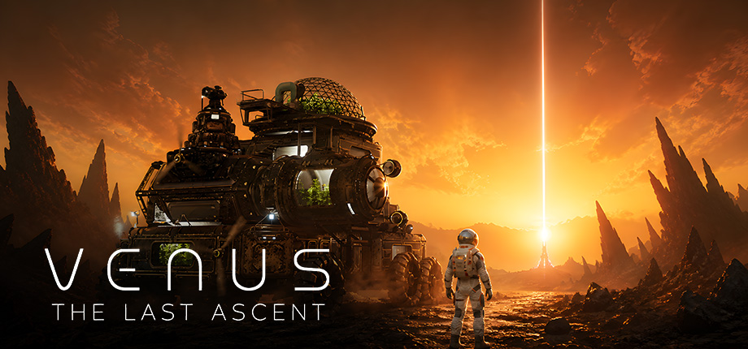
Montreal, Canada – May 26, 2026 - Breaking Walls has announced that a new demo for Venus: The Last Ascent, a physics-based sci-fi survival game where the player’s base is also their vehicle, will be available ahead of Steam Next Fest on June 15, 2026.
In Venus: The Last Ascent, players build and expand a massive rolling fortress across the hostile surface of Venus. The machine acts as a home, workshop, power grid, oxygen supply, mining rig, weapon platform, and only way forward.
Every component added to the fortress matters. Drills, farms, weapons, shields, reactors, storage, tools, and oxygen systems all affect what the machine can do — but they also affect weight, balance, movement, and stability. A badly designed fortress can get stuck, flip, or fail when the terrain turns against it.
The demo introduces players to the game’s core fantasy: mining Venusian rock, upgrading a physics-driven mobile base, surviving dangerous terrain, and defending precious energy from abandoned solar-powered machines that wake up with the sun.
The goal is to keep moving toward Cloud City, the last city above the clouds. Every upgrade, every repair, and every fight brings the player closer to escape.
A new trailer will be released on June 2, 2026. Venus: The Last Ascent will be featured in Steam Next Fest beginning June 15, 2026.
LINKS
STEAM PAGE | https://store.steampowered.com/app/2640150/Venus_The_Last_Ascent/
TRAILER | [YouTube URL]
PRESS KIT | [Press kit URL]
DEMO | [Demo URL or Steam demo note]

ABOUT VENUS: THE LAST ASCENT
Venus: The Last Ascent is a physics-based survival game where your base is also your vehicle. Build a massive rolling fortress of drills, farms, weapons, shields, and reactors, survive the hostile surface of Venus, and fight your way toward the last city above the clouds.
KEY FEATURES
• Build a massive rolling fortress — Expand your mobile base with drills, farms, weapons, shields, reactors, oxygen systems, storage, and tools.
• Engineer with real physics — Every part affects weight, balance, movement, and stability. Build bigger, but make sure your fortress can actually survive the terrain.
• Survive Venus on the move — Cross acid plains, glass deserts, storms, ruins, and unstable ground while keeping your machine alive.
• Mine, refine, and upgrade — Cut into Venusian rock, gather minerals, unlock blueprints, and build more powerful systems.
• Defend your machine — At sunrise, abandoned solar-powered machines wake up and hunt your energy. Fight them off, scavenge their remains, or keep moving.
•Discover lost industrial ruins — Explore pre-war outposts to find blueprints, logs, clues, and the remains of earlier attempts to survive Venus.
•Reach Cloud City — Follow the beam of light on the horizon and build a machine powerful enough to reach the last city above the clouds.
ABOUT BREAKING WALLS
Breaking Walls is an independent game studio based in Montreal, Canada, focused on atmospheric worlds, systemic gameplay, and ambitious player-driven experiences.
The studio’s upcoming game, Venus: The Last Ascent, combines physics-based vehicle building, survival crafting, tower-defense pressure, and sci-fi exploration on the hostile surface of Venus.
PRESS CONTACT
Nathanael Dufour – Creative director – venus@breakingwalls.co – www.venusthelastascent.com - [Social links]

