MailWatcher : parametrable filter through predicates

Update package :
bin : nmwadvt.exe ( 3.95.3)
nsf : mw_rules_395_1.ntf
Within the filtering rules, some arguments can be defined as being properties of FROM or TO – in other term for Sender ( From ) and Recipients ( To[1,..,n] ).
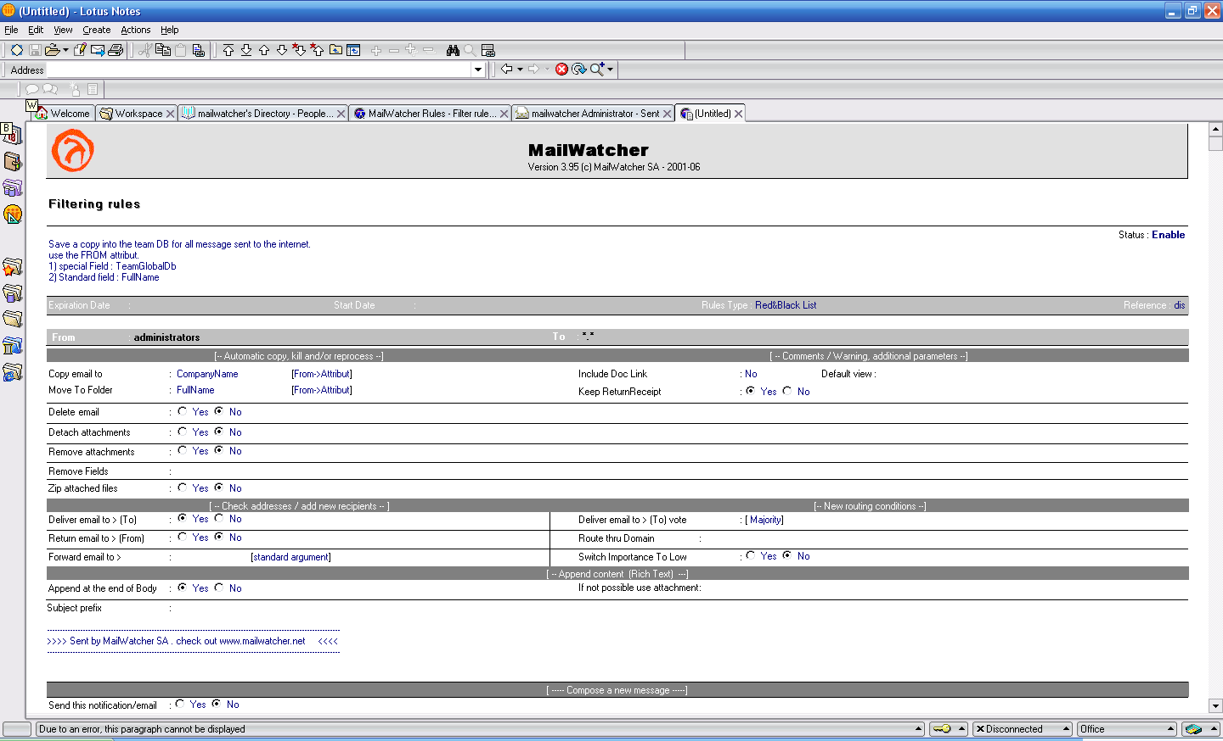
Predicates are loaded in the memory in order to optimize performances, the DumpBlackList.txt file is rendering information using the following way :
Below is an extract of the DumpBlackList.txt file, in bold is a predicate, syntax : Name of the field in the PERSON document / its value(s)
[ INTERNET ADDRESS TEST MW ]
COMPANYNAME|COMPANY_FOR_MW TEST, DOCUMENTACCESS|[USERMODIFIER], FATEST, MW TEST,
[ TEST MW ]
COMPANYNAME|COMPANY_FOR_MW TEST, DOCUMENTACCESS|[USERMODIFIER], FATEST, MW TEST,
[ TEST MW SHORT NAME 5 ]
COMPANYNAME|COMPANY_FOR_MW TEST, DOCUMENTACCESS|[USERMODIFIER], FATEST, MW TEST,

Memory Optimization

The loading of all the predicates in the memory rules is done only for arguments (FROM,TO,EXCEPT_*) with the corresponding types { User, Grp, Meta Group } therefore not for { Meta }.

Rule example

Capture send and received flow based on the population type.

Designated email addresses are linked to another email addresses that is automatically added to email recipients.
➔ to internet avoiding domains known as internal
(belong to the organization)

FROM – line1 / EXCEPT_FROM – line2 | TO – Line1 / EXCEPT_TO – line 2
OK_To_Send_To_Internet (grp) | *.* ( meta)
OK_PassDroit (grp) | internal_SMTP_Domain (meta grp)

Actions
Deliver To : Yes
Forward Email To : {PersonDocumentField} [From->Attribut]
⬅ From internet avoiding domains known as internal
FROM – line1 / EXCEPT_FROM – line2 | TO – Line1 / EXCEPT_TO – line 2
*.* (meta) | OK_To_Receive_From_Internet (grp)
internal_SMTP_Domain (meta grp) | OK_PassDroit (grp)

Actions -
Deliver To : Yes
Forward Email To : {PersonDocumentField} [To->Attribut]


5 rue Hoche
92300 – Levallois-Perret
France
Tél : +33 (0)1 41 05 42 00
Fax : +33 (0)1 41 05 08 00
www.mailwatcher.net

