Seita User Guide

Seita is an App that allow any user to Produce PCF or any other kind of documents on demand.

The 3 main functionalities are :

1. Download Input Files
   1. By Filling a Param CSV File, you will define what you will download
   2. Where to pick it up
   3. Where to Save it
2. Produce PCF
   1. Needs Python development
3. Send the document by Emails
   1. params also defines in a CSV File

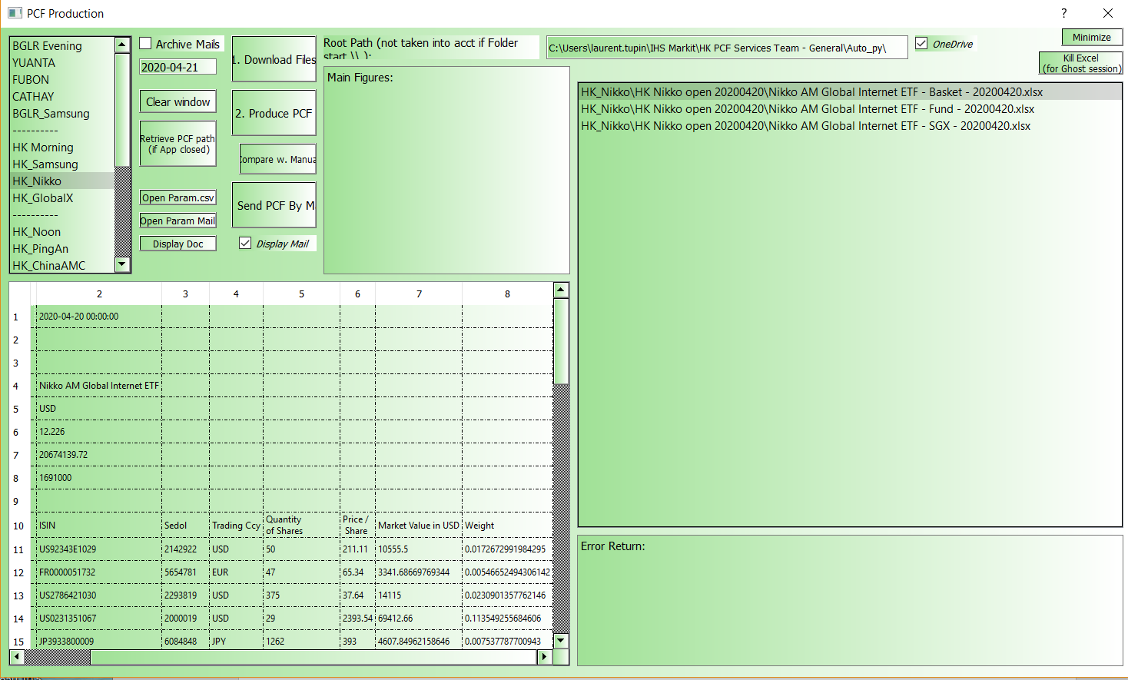

*Perimeters*:

Bengalore - YUANTA

Bengalore – FUBON

Bengalore – CATHAY

Bengalore – SAMSUNG (Script done by Thanos, I developed this case on how I adapted it on:

\\uk-pdeqtfs01\E\SolaBI\Python_Installer\Py_Package\Seita\Add New PCF to Seita.docx

HK – SAMSUNG

HK – NIKKO

HK – Global X (will be over in May 2020)

HK – PingAn

HK – WisdomTree

# 1. Download Files

a. Download the Files of the PCF you want to create

b. Produce PCF will download the files automatically but can lead to mis-interpretating with Error message

c. You can download the files of a set of PCF by choosing a perimeter: "HK - AM", "HK - Post AM" (10-11am), "HK - PM"

d. Outlook specificity

d1. Archive Mails (check Box)

i. If you are downloading Files from Outlook, you can choose to Archive them

ii. You will not be able to download it again if it is Archived

d2. Renaming of the file

i. Some files in mails have Hour & minute in their name

ii. Thus, i choose to change their name, and display this change in the exchange window

iii. You might need to check that the date is the same between the 2 names or you didn’t download the right file

EX: RENAMING

str_file : SKCO00844753_SR0490XP_20190304_1_200123.csv

str_FileName: SKCO00844753_SR0490XP_20190304.csv

# 2. Produce PCF

a. You can create the PCF on the same model than downloading files

b. A result will appear in the Main Figures window with some information you can check

c. The path of these files will appear as a list, you can select them to make other actions after

# 3. Load PCF Path (created)

a. This option is useful if you created already the PCF and you want to retrieve their Path on the dedicated window

b. This is particularly relevant if you launch "HK - AM" in the morning in remote and arrive to your desk, you can just retrieve your path (for sending them by mail by example)

# 4. Compare with Manual PCF

a. It will compare the PCF you produced with the manual one

b. That is to say:

b1. Folder Root (\\uk-pdeqtfs01\E\Data\Lucerne\Data\SOLA PCF\**Auto_Py**\) + Path you select in the list

b2. Folder Root (\\uk-pdeqtfs01\E\Data\Lucerne\Data\SOLA PCF\) + Path you select in the list

c. It will compare both files and let appear only the difference between the 2

d. It will also display the second column by default if there is any difference in the row

# 5. Send PCF by Mail

a. You can select all the path you just created and send them

b. By default the option DISPLAY MAIL is checked, so you can review the mail before to send it

c. But if you remove that option, the mail will be sent without your review