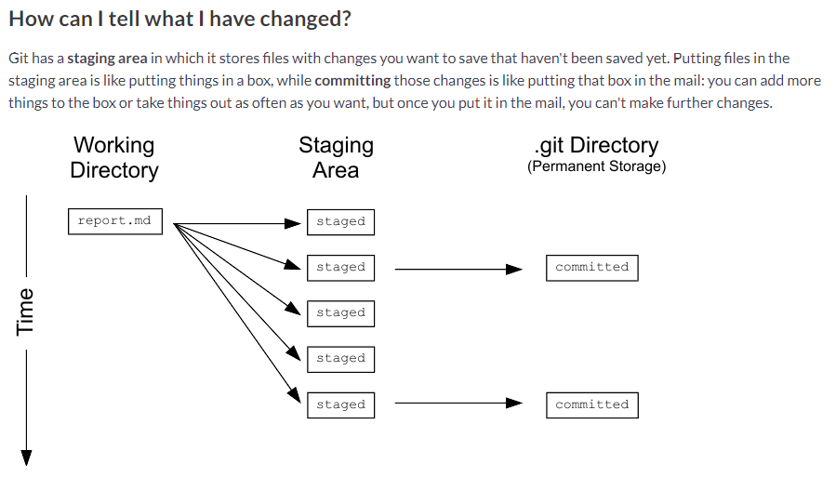

***Command basic***:

git status

***To see the changes*between *file on local and staging***

* git diff filename
* git diff
  + without any filenames will show you all the changes in your repository
* git diff directory
  + how you the changes to the files in some directory
* git diff -r HEAD
  + To compare the state of your files with those in the staging area, you can use
  + -r flag means "compare to a particular revision"
  + HEAD is a shortcut meaning "the most recent commit".

***Add in the staging area***:

* git add filename

***Nano***

nano filename

Fill the file, Ctrl-O (*Save*), Enter, Ctrl-X (*Exit*)

***Commit***

git commit -m "some message in quotes"

If you accidentally mistype a commit message, you can change it using the --amend flag.

git commit --amend - m "new message"

***Commit Historic:***

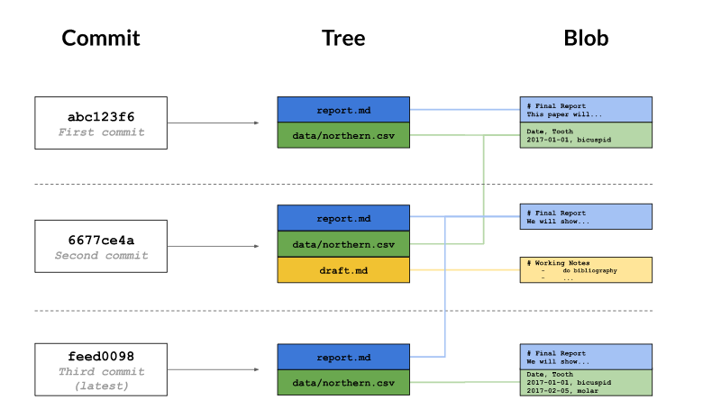

To view the details of a specific commit, you use the command

* git log
* git log *.csv
* git show cf86a6
  + 6 first char of the commit’s hash
* git show HEAD
  + Last commit
* git show HEAD~1
  + commit before last commit…
* git annotate report.txt

***To see the changes*between*two commits,***

* git diff abc123..def456
* git diff HEAD~1..HEAD~3

***config***

* git config –-global user.email
* git config –-global user.name
  + to change it:
  + git config –-global user.name ‘Laurent’

***BRANCH***

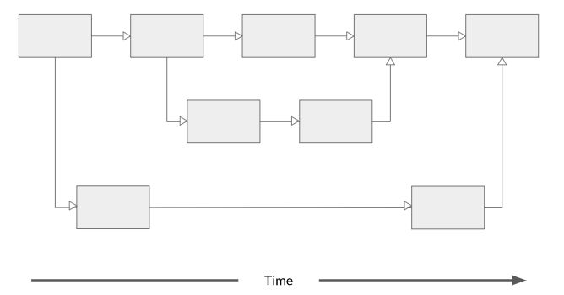

* git branch
  + List Branch
* git diff branch1..branch2
  + diff on branch
* git checkout branch1
  + Change branch you are working on
* ls
  + List files in the branch you are on

***Create Branch***

git checkout -b newBranch

***Merge Branch***

git merge newBranch master

***REMOTE***

***create a new repository***

git init project

***Turn an existing project into a Git repository***

git init /path/To/Project

***Catch the project for a new user: from Git to local***

git clone <https://...Seita_live.git> Seita

Seita is optional, if nothing, the name if the project will be Seita_live

To get back the git address, from the local folder:

git remote -v

git remote add remote-name URL

git remote rm remote-name

(rm = Remove)

***Pull***

*Make sure you are in the master branch (git branch / (if needed) git branch checkout master)*

git pull Seita_live (remote name *.git) master (branchName)

***Push***

git push Seita_ live (remote name *.git) master (branchName)