Rubric 1 Generating Real Estate Listings with an LLM

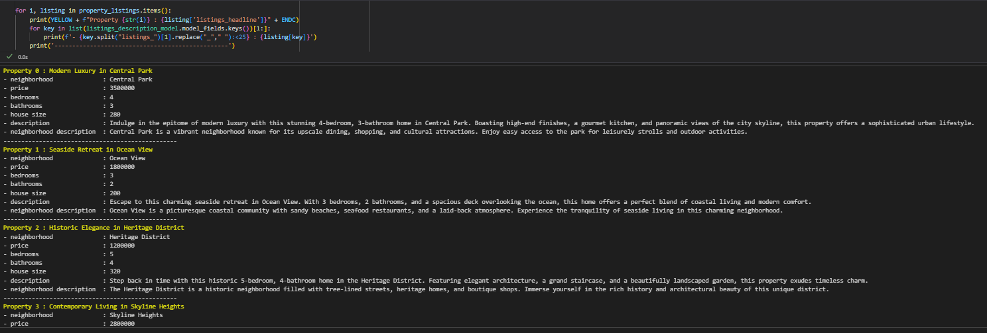

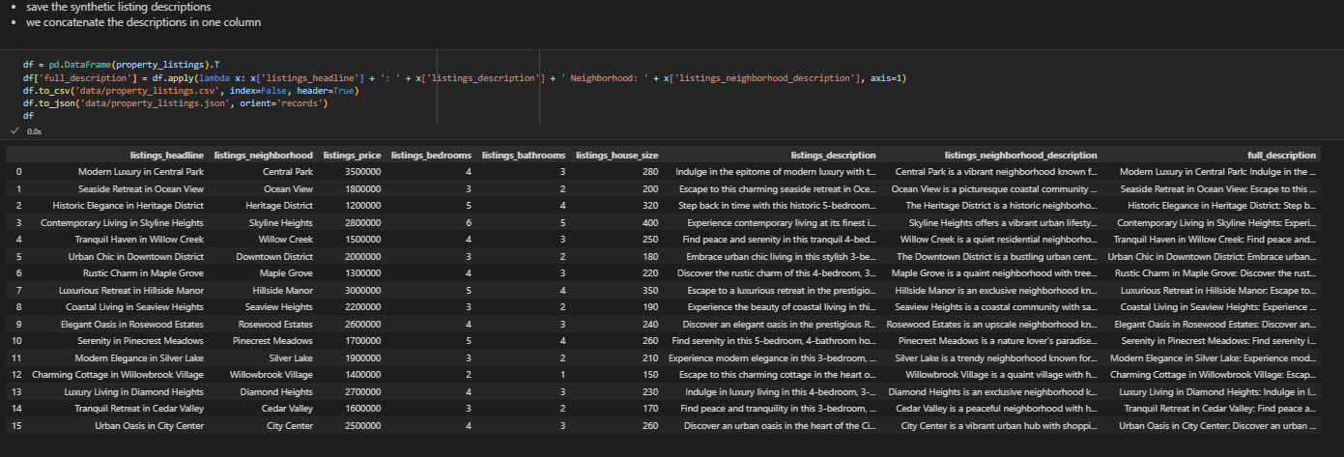

Rubric 2 Creating a Vector Database and Storing Listings

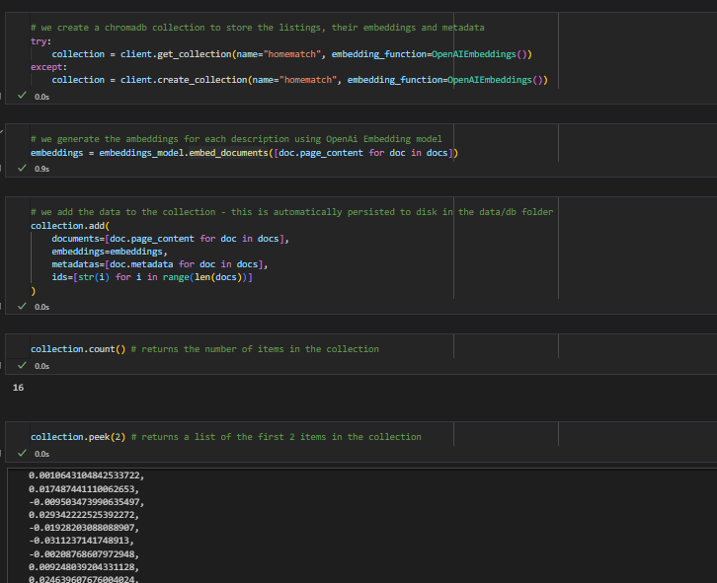

Rubric 3 Semantic Search of Listings Based on Buyer Preferences

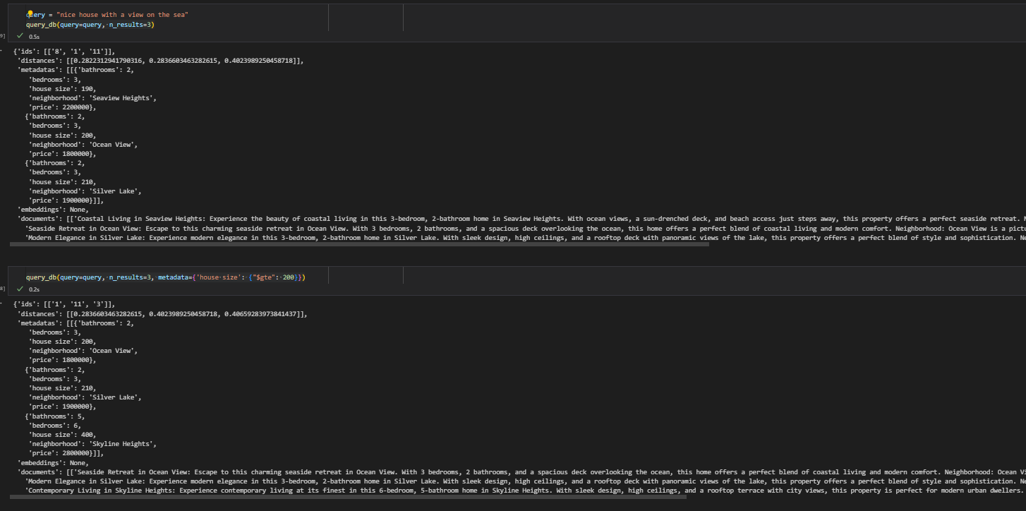

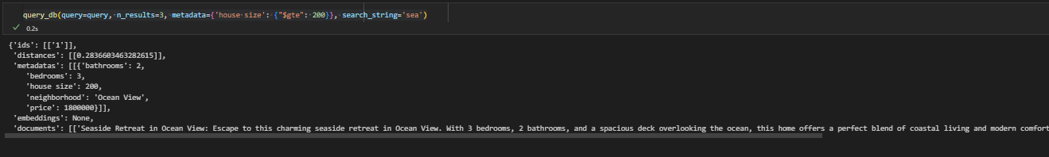

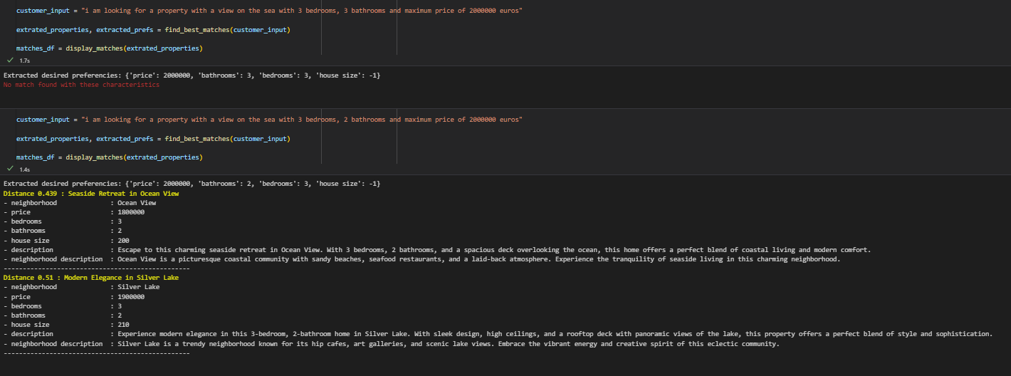

RUBRIC 4 Logic for Searching and Augmenting Listing Descriptions

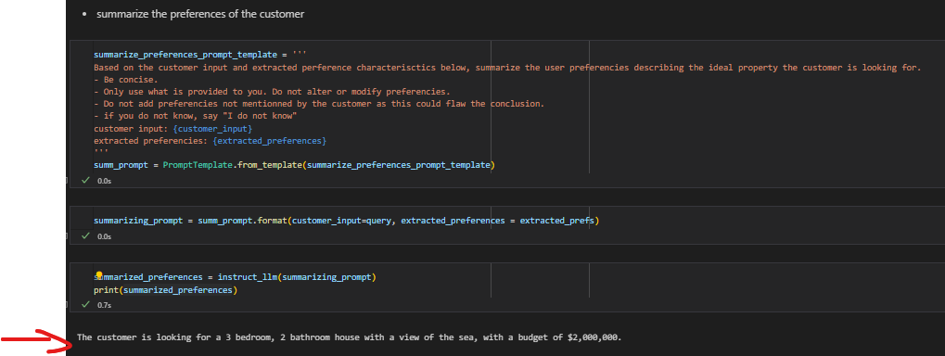

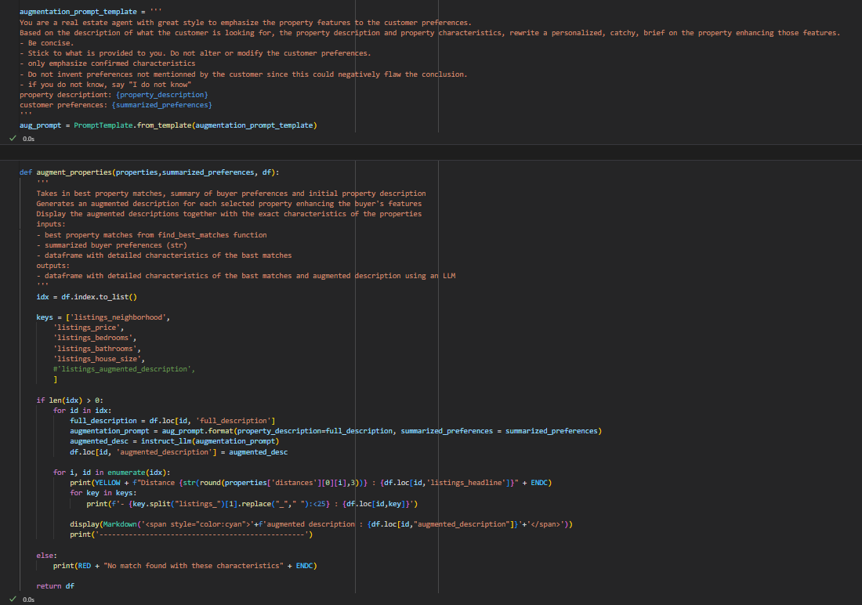

RUBRIC 5 Use of LLM for Generating Personalized Descriptions



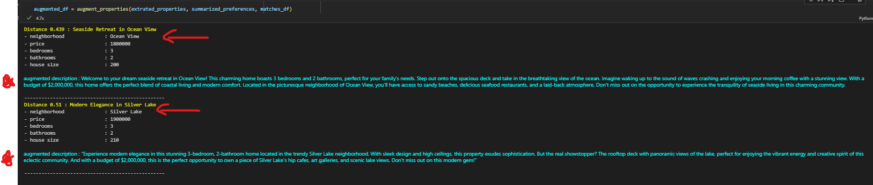

Workflow from user input, best matches DB extraction, personalized description generation and response in natural Language

