Personal Assistant – Holiday Planner

Introduction

Imagine planning your next holiday with ease and precision, finding the perfect destinations tailored to your preferences. That's what we aim to achieve with our project. We're developing a tool that acts like a personal assistant for holiday planning, powered by the latest technology. Whether it's discovering serene spots in the Netherlands with breathtaking views or finding hidden gems in bustling cities, our tool is designed to make your travel planning experience as enjoyable as the trip itself.

Motivation

The inspiration for our project comes from the challenges travelers face when surfing through the vast amount of information available online. Travel planning often involves hours of research, comparing numerous websites, and trying to gauge the reliability of different sources. Our goal is to streamline this process, offering a solution that understands and caters to individual travel preferences and needs. We envision a tool that not only simplifies the search but also brings joy and excitement to the travel planning process, transforming it from a task into an integral part of the adventure.

Problem Description

The core challenge of our project is developing a system that accurately interprets and responds to a wide range of user inquiries about holiday destinations. It's about efficiently navigating through the sea of online data to find information that precisely aligns with the user's requests. Our system needs to be adept at processing natural language queries, understanding the nuances of travel-related questions, and delivering specific, relevant, and reliable responses in an intuitive chat interface. The goal is to ensure that our digital assistant not only finds answers but also resonates with the user's travel aspirations.

Related Work

1. AI in Holiday Planning with Chatbots (Qulix): As highlighted by Anton Rykov, Product Manager at Qulix Systems, chatbot technology is emerging in the tourism industry, with applications developed by companies like Skyscanner and Kayak. These chatbots, integrated into platforms like Facebook Messenger and WhatsApp, answer queries and recommend travel options, promising enhanced customer service and satisfaction (<https://www.qulix.com/about/blog/ai-holiday-planning-with-chatbot/>).

2. Machine Learning in Tourism (Neptune.ai): An article by Ogbeide Nelson discusses the role of AI and ML in solving business problems in tourism. It mentions how ML improves customer satisfaction and experience, particularly through chatbots, recommendation systems, and social media sentiment analysis. ML models are used to suggest personalized travel destinations and understand customer preferences and behavior, significantly enhancing the tourist experience (<https://neptune.ai/blog/how-ai-and-ml-can-solve-business-problems-in-tourism-organization-chatbots-recommendation-systems-and-sentiment-analysis>).

A little about the data: 306 features, mostly related to New York borough (latitude, longitude, Neighborhood, Borough). The dataset focuses on Manhattan only.

*\*borough = administrative unit (NY has 5 boroughs that each have neighborhoods)*

Ce e asta de sus??? Sterge te rog. Inlocuieste cu cele de jos:

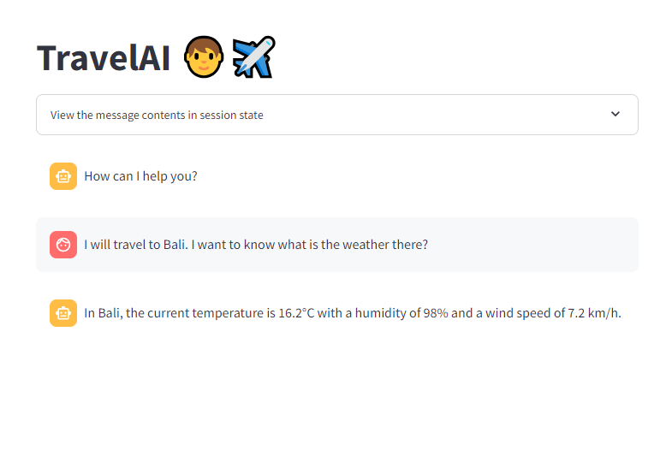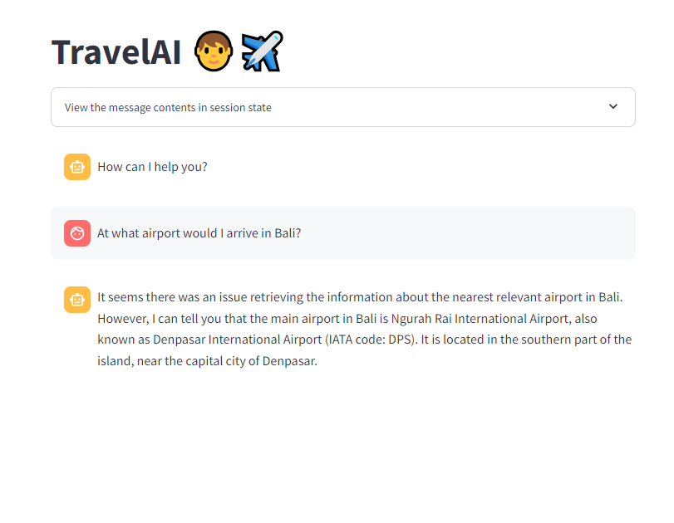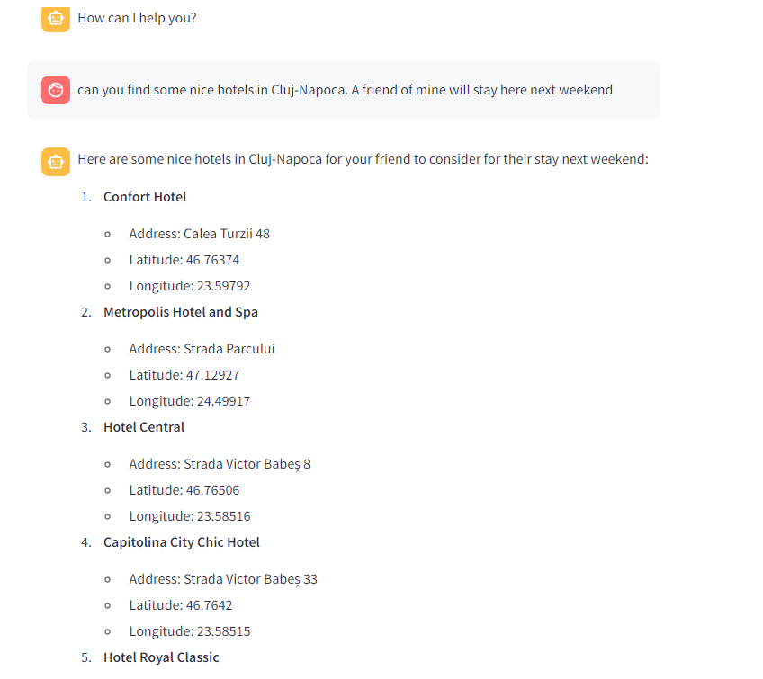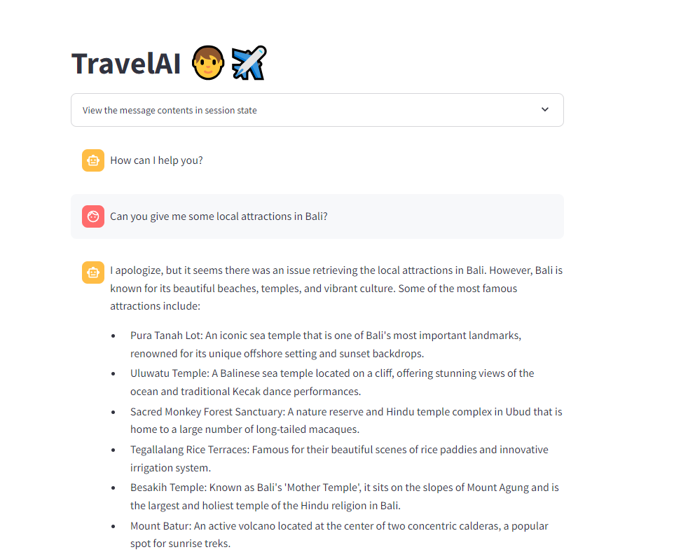

Tech Stack

* Amadeus for Developers: This will help us access real time travel-related data like flight and hotel information or points of interest near the city.
* OpenAI GPT-4-turbo: we will use this model because it is SOTA for language tasks in general and because it has a nice built-in function calling.
* LangChain: Here we will build our agent that takes the input from the user and connects the OpenAI model with the tools we want to call in order to answer the question. This is the glue between our functions and the LLM.
* Open Meteo API: We'll use this to gather real-time weather information.
* Wikipedia API: for gathering general information about the place to visit.
* Other API’s