DOCUMENTATIE

TEMA 4

NUME STUDENT: Tusa Laurentiu
GRUPA: 30421

CONTENTS

1. Assignment objective 3
2. Problem analysis, scenarios,use-cases 3
3. Design 6
4. Implementation 8
5. Results 13
6. Conclusions 16
7. Bibliography 16

Assignment objective
Main objective :
- Design and implement an application for managing the food orders for a catering company and provide a graphical user interface that allows access the user, employees and admin to manipulate the contents of menus. The program will be developed using specific Java OOP language.
Secondary objectives :
• Analyze the problem and identify requirements – 2. Problem analysis, scenarios, use-cases
• Design the food orders application – 3. Design
• Implement the food orders application – 4. Implementation
• Test the food orders application – 5. Results and tests

- Problem analysis, scenarios, use-cases
Functional requirements :
- The application should allow the administrator to add a new base product
- The application should allow the administrator to add a new composite product
- The application should allow the administrator to delete a product
- The application should allow the administrator to modify a product
- The application should allow the administrator to generate reports based on previous orders and products
- The application should allow the client to register
- The application should allow the client to login
- The application should allow the client to search through the products , using up to 7 filters
- The application should allow the client to select multiple products and make an order out of them
- The application should notify an employee when an order has been created

Non-Functional requirements :
- The application should be intuitive and easy to use by the user
- The application should execute correctly the commands transmitted by the user through the graphical user interface
- The application should not have any bugs or cases that the logic of the application could not handle.
- The application should inform the user when the input data provided is incorrect
- The application should use authentication to restrict the access of clients and regular employees to the administrator’s functionalities

Use case diagram :
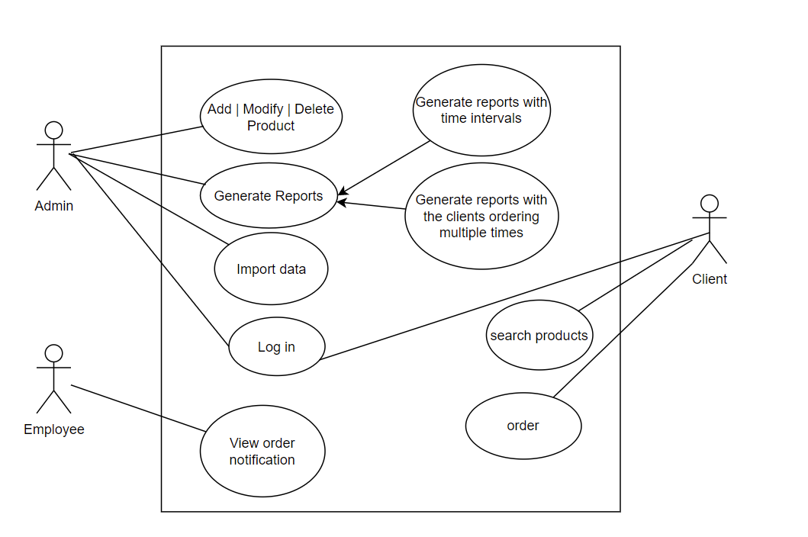
Use cases:

Use Case : add product to the menu
Primary Actor : administrator
Main Success Scenario :
1. The administrator selects the option to add a new product
2. The application will display a form in which the product details
should be inserted
3. The administrator inserts the name of the product, the number of
calories, proteins, fats, sodium and its price
4. The administrator clicks on the “Add” button
5. The application saves the product’s data and displays an
acknowledge message

Alternative Sequence: Invalid values for the product’s data
- The administrator inserts a negative value for the number of
Calories / proteins / fats / sodium / price of the product
- The application displays an error message and requests the administrator
to insert a valid value for the number of
calories / proteins / fats / sodium / price
- The scenario returns to step 3

Use Case : modify product
Primary Actor : administrator
Main Success Scenario :
1. The administrator selects the option to modify product
2. The application will display a form in which the product details
should be inserted
3. The administrator inserts the name of the product, the number of
calories, proteins, fats, sodium and its price
4. The administrator clicks on the “Modify” button
5. The application saves the product’s data and displays an
acknowledge message

Alternative Sequence: Invalid values for the product’s data
- The administrator inserts a negative value for the number of
Calories / proteins / fats / sodium / price of the product
- The application displays an error message and requests the administrator
to insert a valid value for the number of
calories / proteins / fats / sodium / price
- The scenario returns to step 3

Use Case : delete a product from the menu
Primary Actor : administrator
Main Success Scenario :
1. The administrator selects the option to delete a product
2. The application will display a form in which the product details
should be inserted
3. The administrator selects the product from a table ( or multiple products )
4. The administrator clicks on the “Delete” button
5. The application deletes the product( s ) and displays an
acknowledge message

Alternative Sequence: Invalid number of selected products
- The administrator does not select an item
- The application displays an error message and requests the administrator
To select at least 1 item to delete
- The scenario returns to step 3

Use Case : generate reports
Primary Actor : administrator
Main Success Scenario :
1. The administrator selects the option to generate reports
2. The application will display a form in which the product or order details
should be inserted
3. The administrator inserts the name of the product, a date or a time interval
4. The administrator clicks on the “Report” button
5. The application generates the and displays an
acknowledge message

Alternative Sequence: Invalid values for the input data
- The administrator inserts a negative value for the number or invalid date, time , hour, inexistent product
- The application displays an error message and requests the administrator
to insert a valid value for input data
- The scenario returns to step 3

Use Case : search product
Primary Actor : client
Main Success Scenario :
1. The client selects the option to search for products
2. The application will display a form in which the products details
should be inserted
3. The administrator inserts the name of the product, the number of
calories, proteins, fats, sodium and price
4. The client clicks on the “Search” button
5. The application filters the list of products based on the provided input

Alternative Sequence: Invalid values for the product’s data
- The client inserts an invalid value for the input fields of the product
- The application displays an error message and requests the client
to insert a valid value for input fields of the product
- The scenario returns to step 3

Use Case : order
Primary Actor : client
Main Success Scenario :
1. The client selects the option to order products
2. The application will generate an order with the selected products

Alternative Sequence: Invalid number of selected products
- The client does not select any products
- The application displays an error message and requests the client
to select at least 1 product
- The scenario returns to step 1

Design
Package diagram:
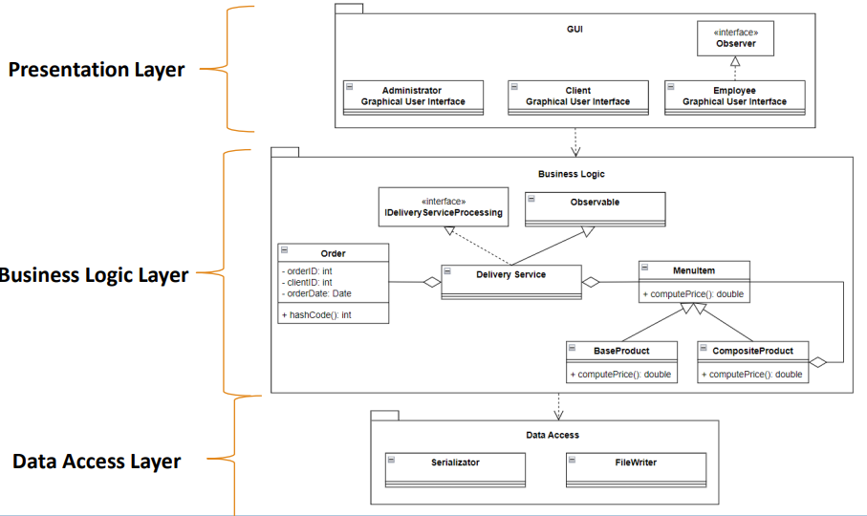

UML diagram:
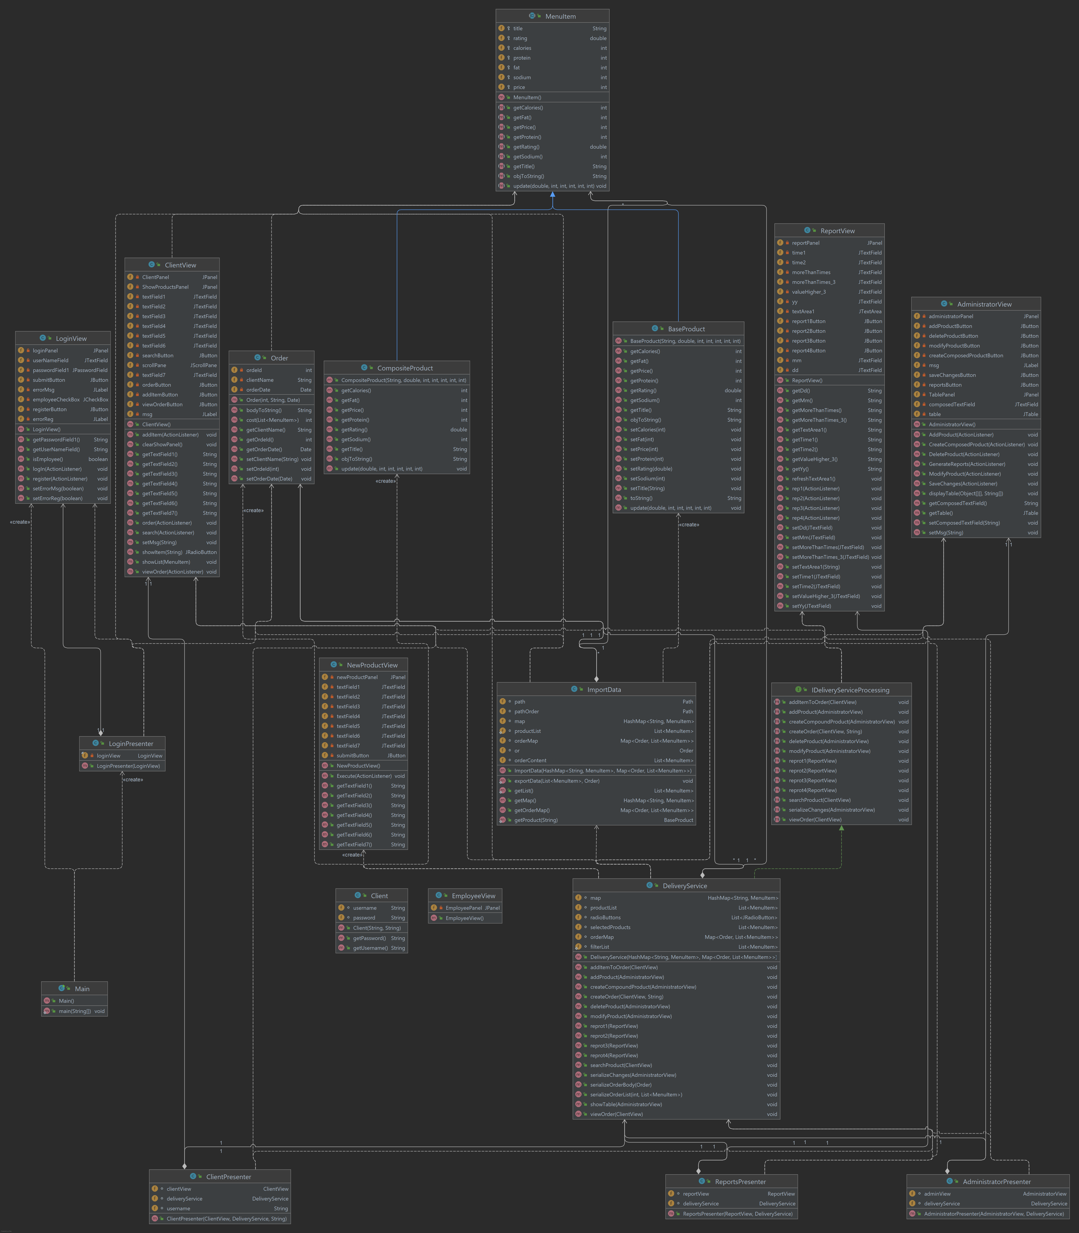

Data structures used:
HashMap<String, MenuItem> map;
List<MenuItem> productList;
List<JRadioButton> radioButtons;
List<MenuItem> selectedProducts;
Map<Order, List<MenuItem>> orderMap;
static List<MenuItem> filterList;

Implementation
GUI:
Login:
The user can login or register. Checkbox Employee is for differentiating between client and employee.
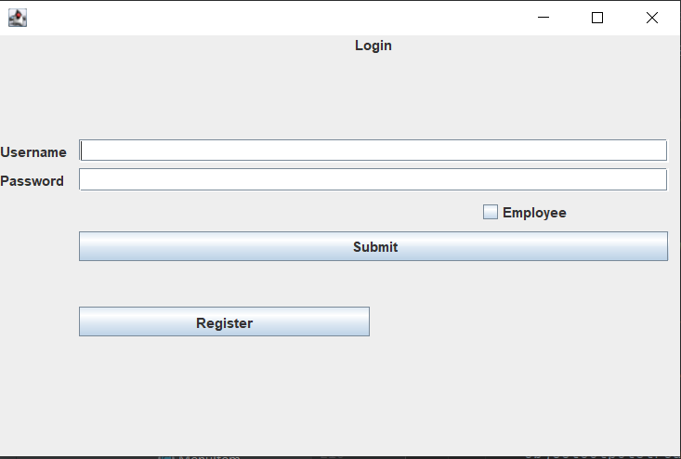
Client:
The client can input up to 7 search filters for identifing products. The desired products are selected, added to the orderList and in the end, the order is placed, which will also generate a bill in a .txt file.
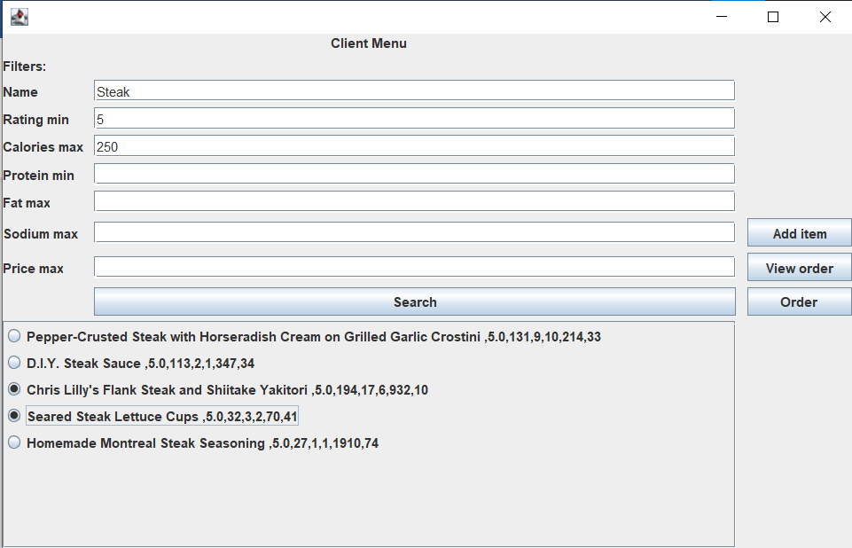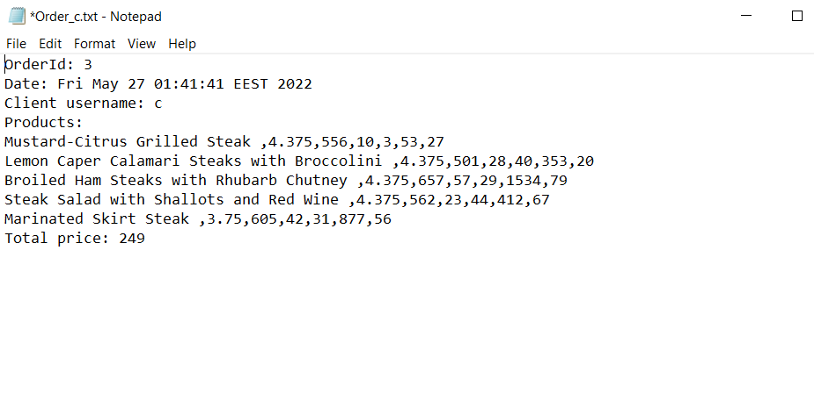

Admin:
The Admin can manipulate any item from the table, even multiple at once, depending on the operation. TextFields are provided for the admin to input the data for a product modelation. Also an report GUI is avaliable for the admin.
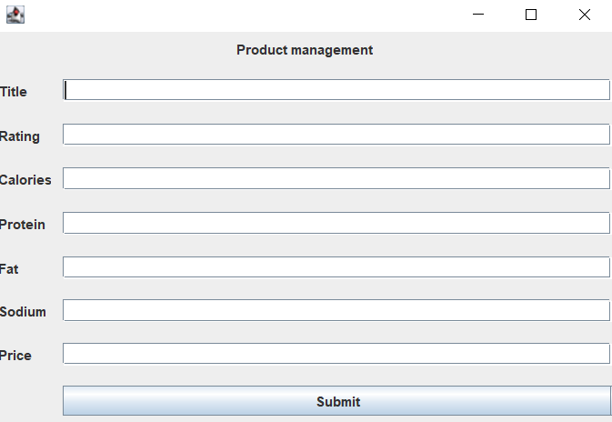
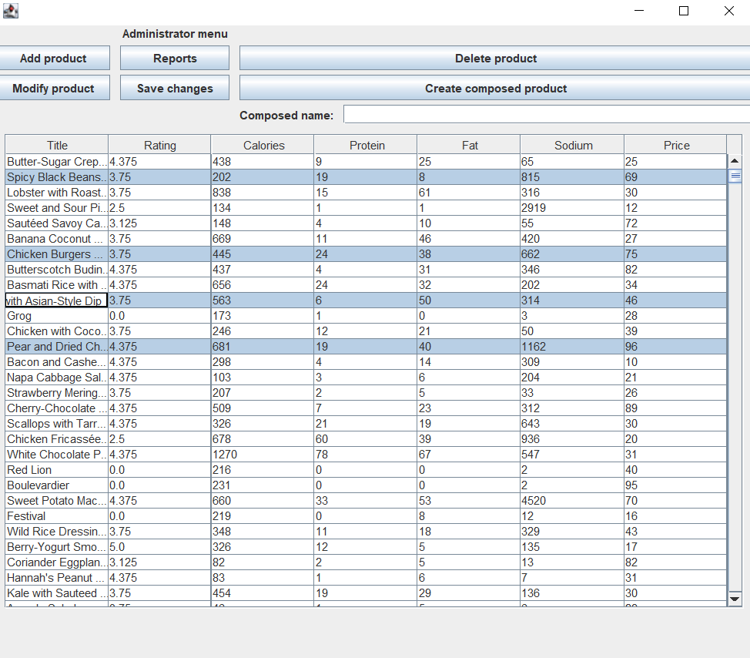

Class descriptions:
ImportData:
- Initial import of products
- Import of previous orders
- Bill generation
The imported data is stored in a HashMap, as it already deals with the duplicates. Data is fetched from the products.csv file
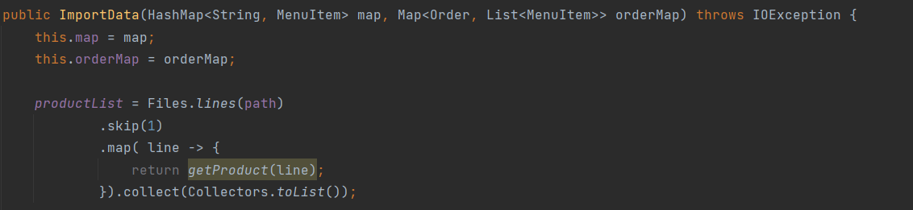
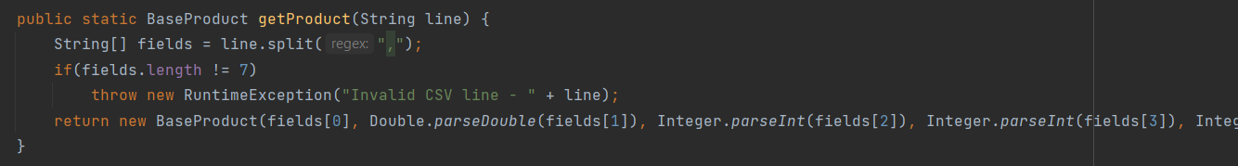

LoginPresenter:
- Client, admin or employee login
- Register for new users
- Password validation
The password validation consists of the deserialization of the file with the name contained in the username textField and comparing its conent with the input provided in the password field.
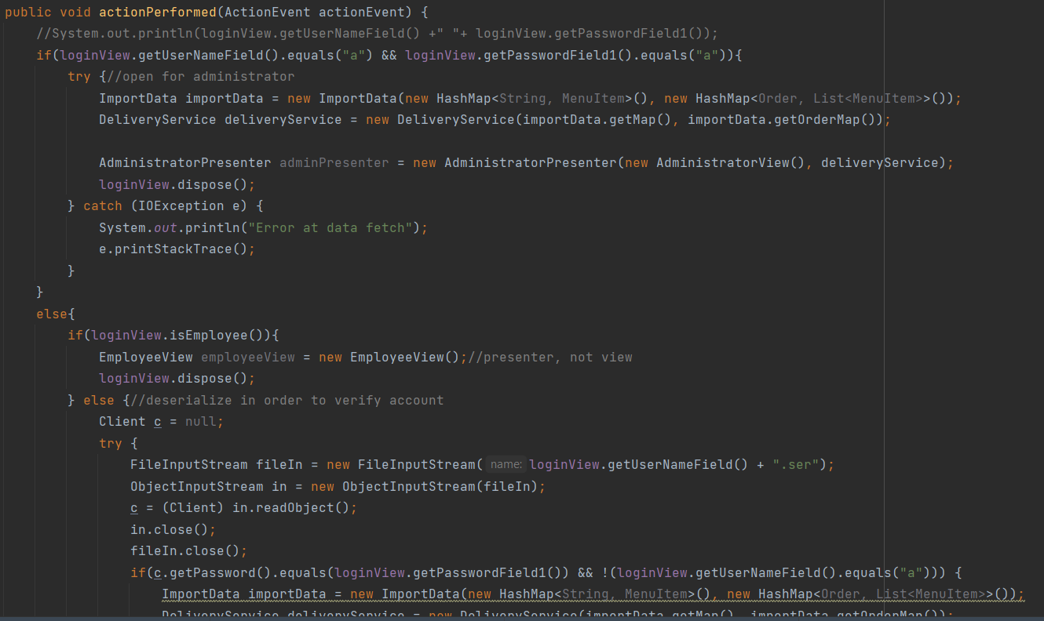

MenuItem:
- Abstract class defining the product
- It is extended by BaseProduct and CompositeProduct
The 3 mentioned classes are implemented using the Composite Design Pattern, CompositeProduct representing a collection of base products
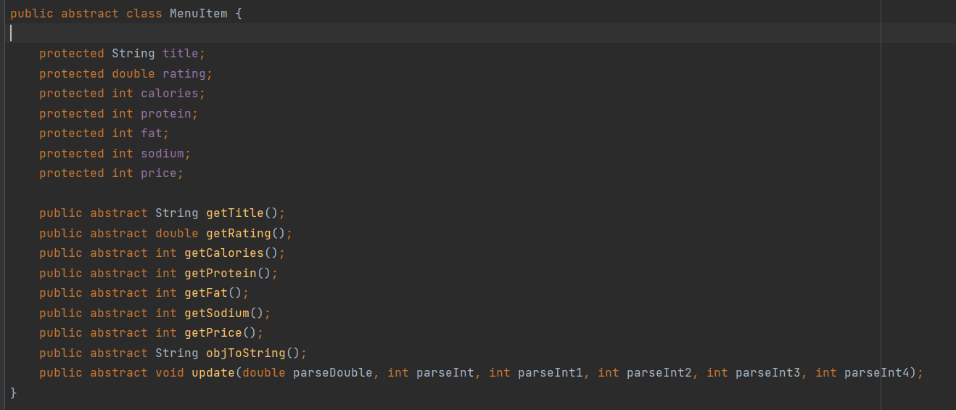

DeliveryService:
- It implements the IDeliveryService interface, that describes all the operations of client user and admin user
- DeliveryService implements the methods from IDeliveryService interface
- It manages the orders an products in HashMaps
- It also contains extra methods, such as serialization methods for minor updates
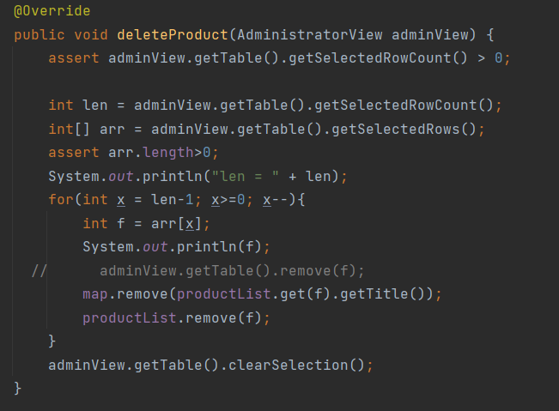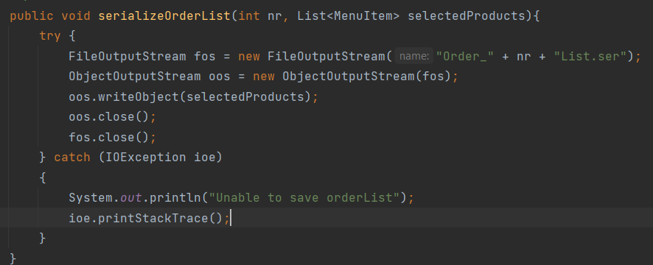
The next method is responsible for serializating updates in the current lists of products
It is implemented in such a way to mimic the products.csv file, respecting the format
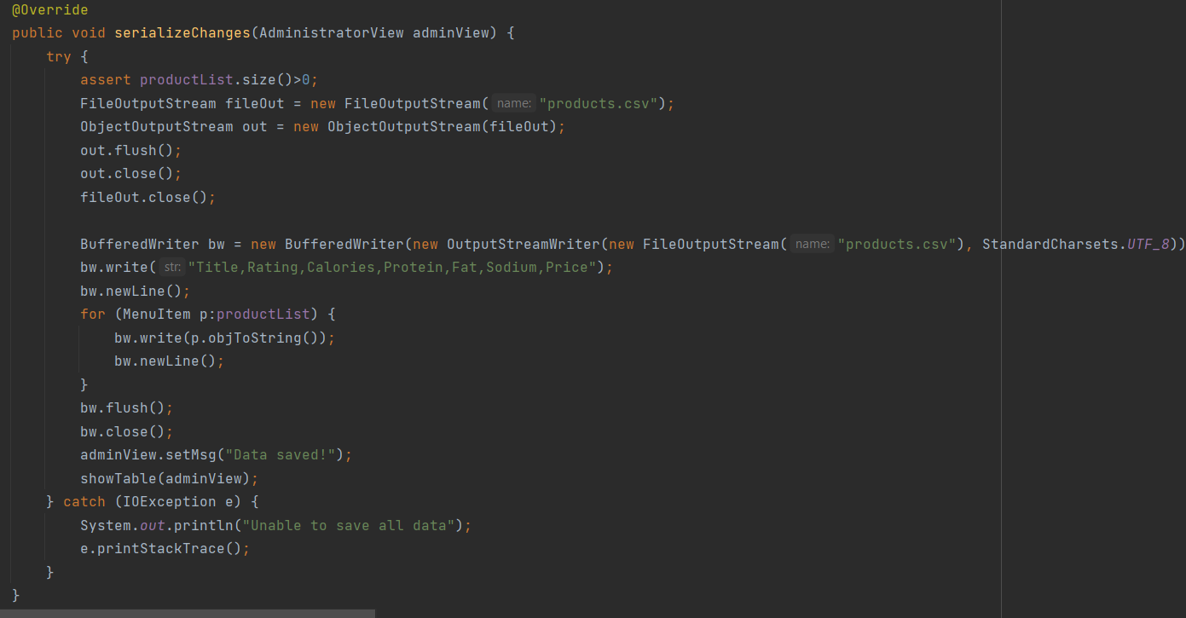
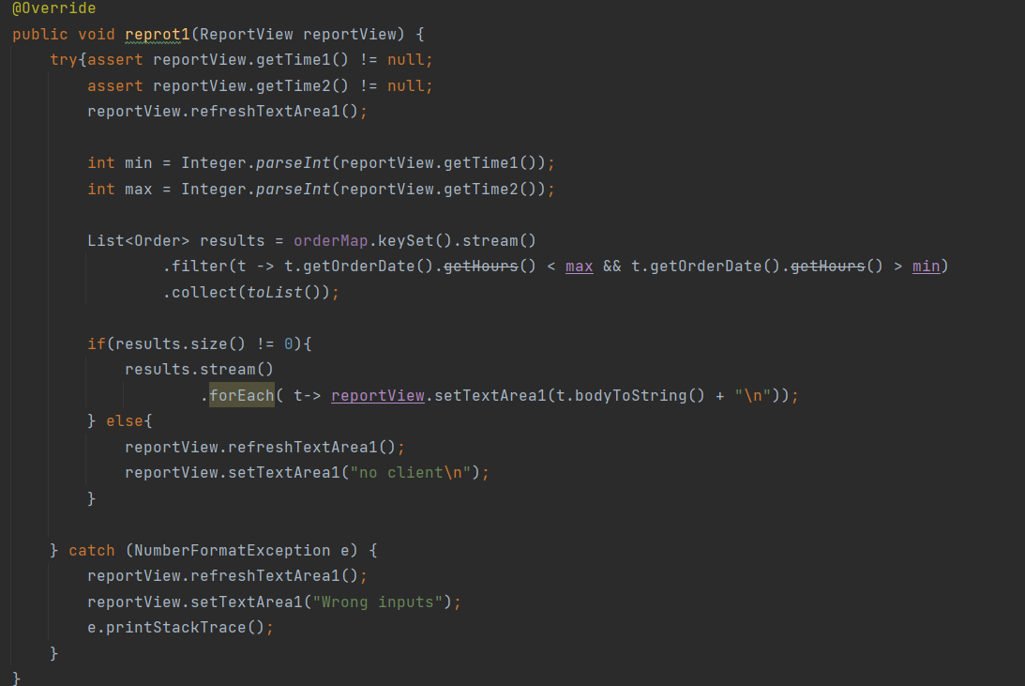
This is the report method, only the admin has acces to it. It has as output generated on the GUI a list of orders

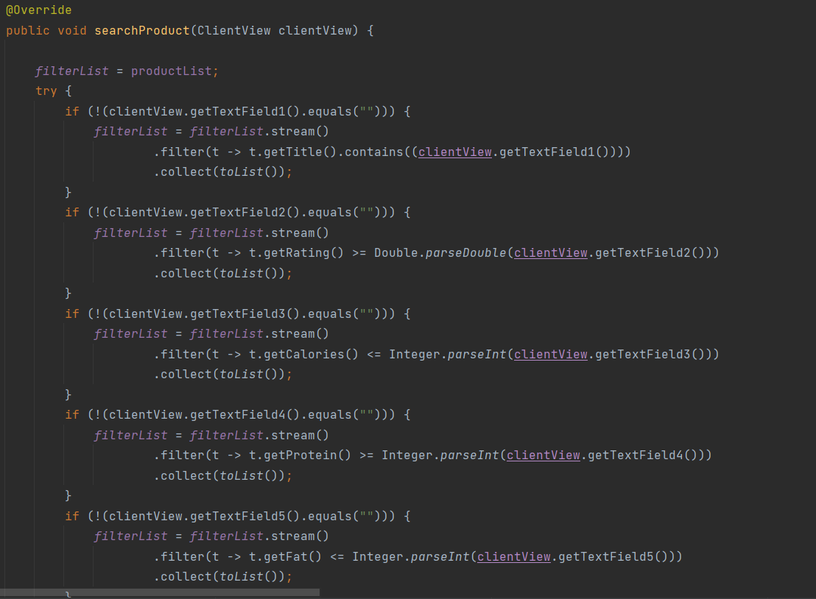
This method is dedicated to the client, it fetches the input from the GUI and based on it, if filters the list of products
Presenters:
All the presenter classes link the GUI to their logic corespondent.

Results
Testing is provided through a series of assertions, based on the operating method.
The assertions are organized through a method in order to cover pre and post conditions
Modify method:
- Checks for invalid input data provided in the GUI
- Checks for empty map of products
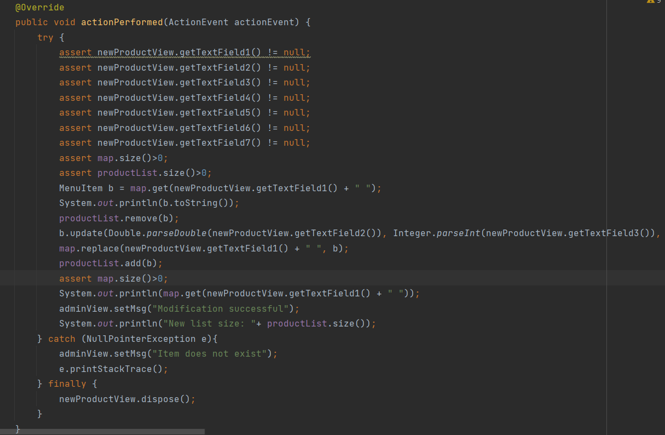

- Assert checks for textfields inputs to be completed
- Assert checks for the value in the textfields inputs to be in [0; 24] - hours
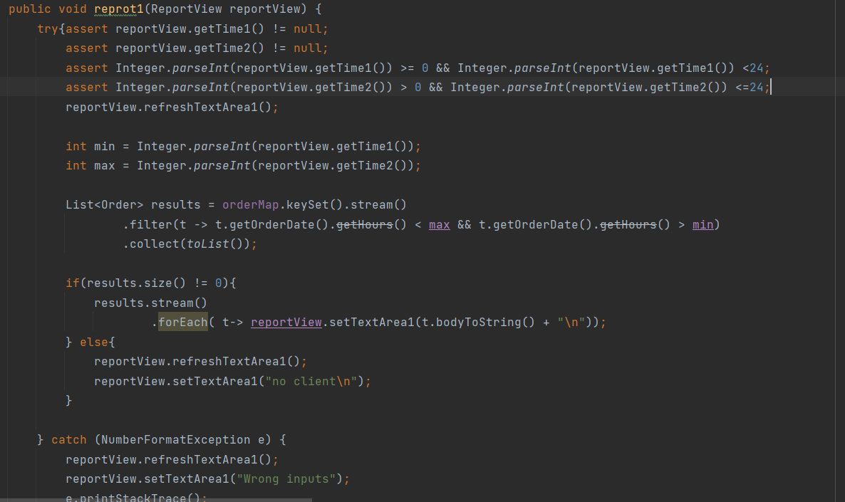
Results can be analyzed through reports from the administrator
Orders in hour interval [0; 6]
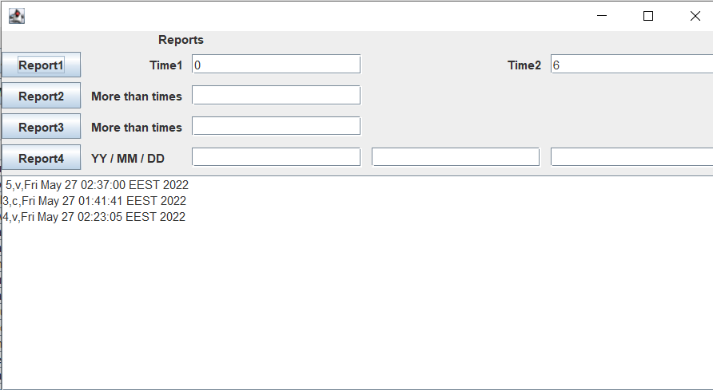

Orders in hour interval [0; 23]
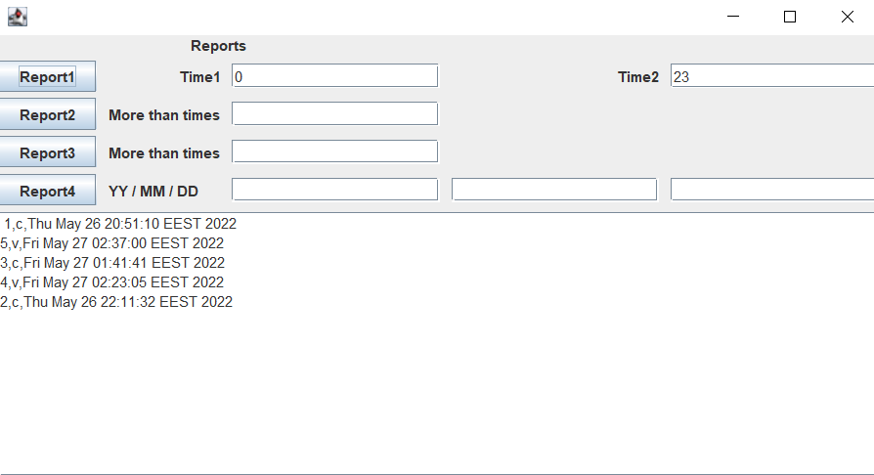
Clients that ordered more than 3 times
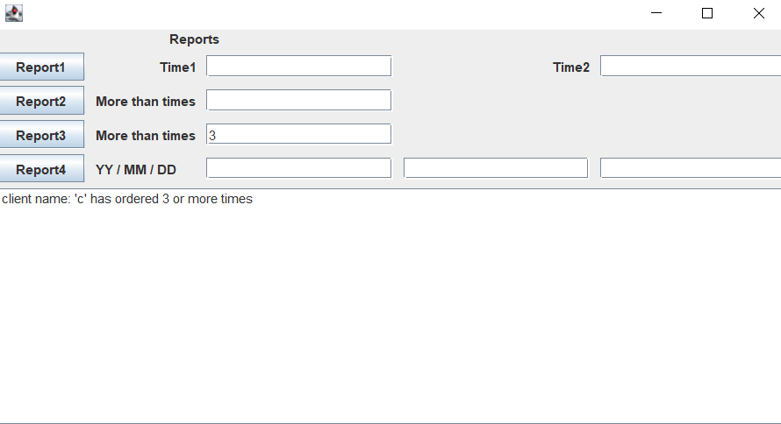

Clients that ordered more than 2 times
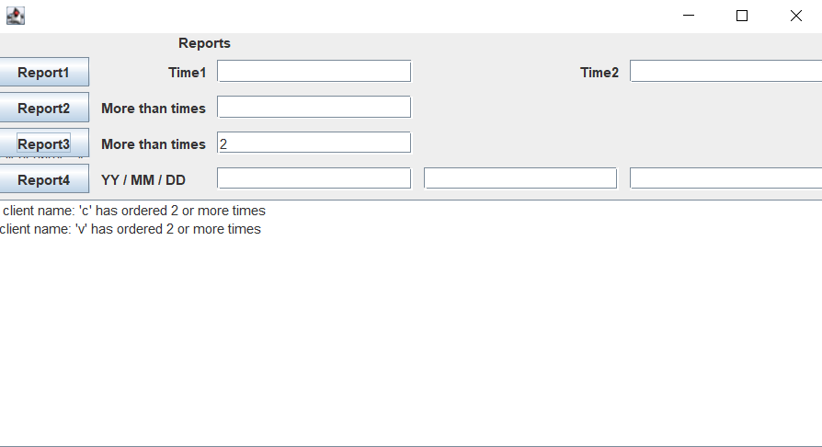

Conclusions
In conclusion, this food order application enables clients to easily interact with the product list and issue and order. The admin can operate on the products, which are serialized and deserialized form a session to another, as the commands are given inside the Java application through the graphical user interface. The application manages the connection with the data files.

Acknowledgements:
- Usage of methods of serialization
- Usage of streams and lambda expressions
- File operations
- JTable methods

Improvements:
- Better usage of means of serialization
- More efficient class design
- More details provided for the product and clients
- More reports

Bibliography

https://winterbe.com/posts/2014/07/31/java8-stream-tutorial-examples/
https://docs.oracle.com/javase/8/docs/technotes/guides/language/assert.html#usage-invariants
https://javarevisited.blogspot.com/2012/01/what-is-assertion-in-java-java.html
https://www.youtube.com/watch?v=MskSpxNl-K8&t=389s
https://stackoverflow.com/questions/28851652/java-lang-classcastexception-java-util-arraysarraylist-cannot-be-cast-to-java
https://www.geeksforgeeks.org/map-putall-method-in-java-with-examples/
https://stackoverflow.com/questions/10462819/get-keys-from-hashmap-in-java
https://howtodoinjava.com/java/collections/arraylist/serialize-deserialize-arraylist/
https://mkyong.com/java8/java-8-convert-map-to-list/

