DOCUMENTATIE

TEMA 1

NUME STUDENT: Tusa Laurentiu
GRUPA: 30421

Contents

1. Assignment objectives 3
2. Problem analysis, modeling, scenarios, use-cases 3
3. Projection 5
4. Implementation 8
5. Results 11
6. Conclusions 12
7. Bibliography 13

Assignment objectives
The main objective of this assignment is to implement a polynomial calculator, that takes as input 1 or 2 polynomials and executes different operations (addition, subtraction, derivation, integration, division, multiplication) and uses a dedicated graphical interface for input gathering and output displaying. The program will be developed using specific Java OOP language.
The secondary objectives are the following:
1. Analyze the problem and identify the assignment’s requirements – 2. Problem analysis, modeling, scenarios, use-cases
2. Design the calculator’s UI - 4. Implementation
3. Design the calculator’s logic – 3. Projection, 4. Implementation
4. Implement the calculator - 4. Implementation
5 Test the calculator – 5. Results

Problem analysis, modeling, scenarios, use-cases
Functional requirements:
- The polynomial calculator should allow the user to input the desired polynomials
- The polynomial calculator should allow the user to select the desired operation to be performed
- The polynomial calculator should add 2 polynomials
- The polynomial calculator should subtract 2 polynomials
- The polynomial calculator should multiply 2 polynomials
- The polynomial calculator should divide 2 polynomials
- The polynomial calculator should derive 1 polynomial
- The polynomial calculator should integrate 1 polynomial
- The polynomial calculator should display the correct input to the user through the GUI
Use case diagram:
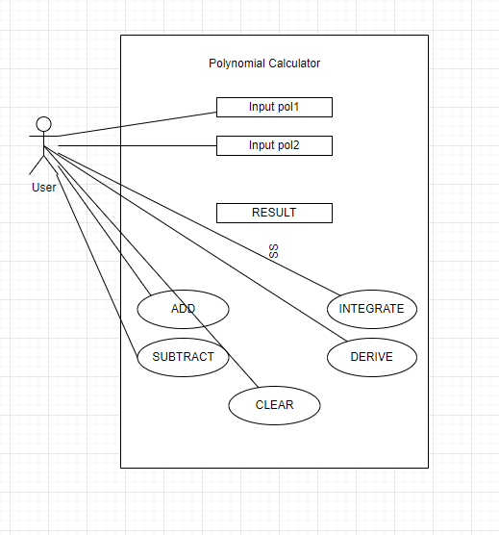
Use cases:

Use case: ADD
Primary Actor: User
Main Success Scenario:
- The user inserts the 2 polynomials in the GUI
- The user selects the ADD button
- The calculator performs the addition of the polynomials
- The result is displayed
Alternative Sequence: Incorrect input
- The user inserts the input wrong
- Errors are encountered, as the number of coefficients and exponents do not match
- There is no result displayed
- The user can insert different polynomials

Use case: SUBTRACT
Primary Actor: User
Main Success Scenario:
- The user inserts the 2 polynomials in the GUI
- The user selects the SUBTRACT button
- The calculator performs the subtraction of the polynomials
- The result is displayed
Alternative Sequence: Incorrect input
- The user inserts the input wrong
- Errors are encountered, as the number of coefficients and exponents do not match
- There is no result displayed
- The user can insert different polynomials

Use case: INTEGRATE
Primary Actor: User
Main Success Scenario:
- The user inserts 1 polynomial in the GUI
- The user selects the INTEGRATE button
- The calculator performs the integration of the polynomial
- The result is displayed
Alternative Sequence: Incorrect input
- The user inserts the input wrong
- Errors are encountered, as the number of coefficients and exponents do not match
- There is no result displayed
- The user can insert a different polynomial

Use case: DERIVATE
Primary Actor: User
Main Success Scenario:
- The user inserts 1 polynomial in the GUI
- The user selects the DERIVE button
- The calculator performs the integration of the polynomial
- The result is displayed
Alternative Sequence: Incorrect input
- The user inserts the input wrong
- Errors are encountered, as the number of coefficients and exponents do not match
- There is no result displayed
- The user can insert a different polynomial

Use case: CLEAR
Primary Actor: User
Main Success Scenario:
- The user selects an operation
- The calculator performs the operation of the polynomial
- The result is displayed
- The CLEAR button is selected
- The result is cleared

Projection
Model data classes diagram:
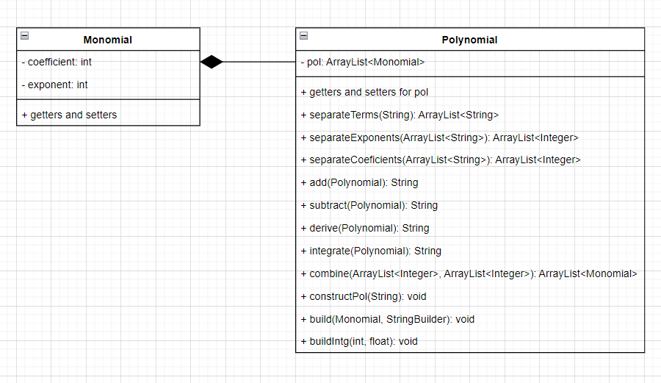
The polynomial calculator program uses 2 classes, having a composition relation between them, which is a special type of aggregation ( Objects of class Polynomial can’t exist without objects of class Monomial – ArrayList<Monomial> is necessary when creating an object of class Polynomial)

UML diagrmas:
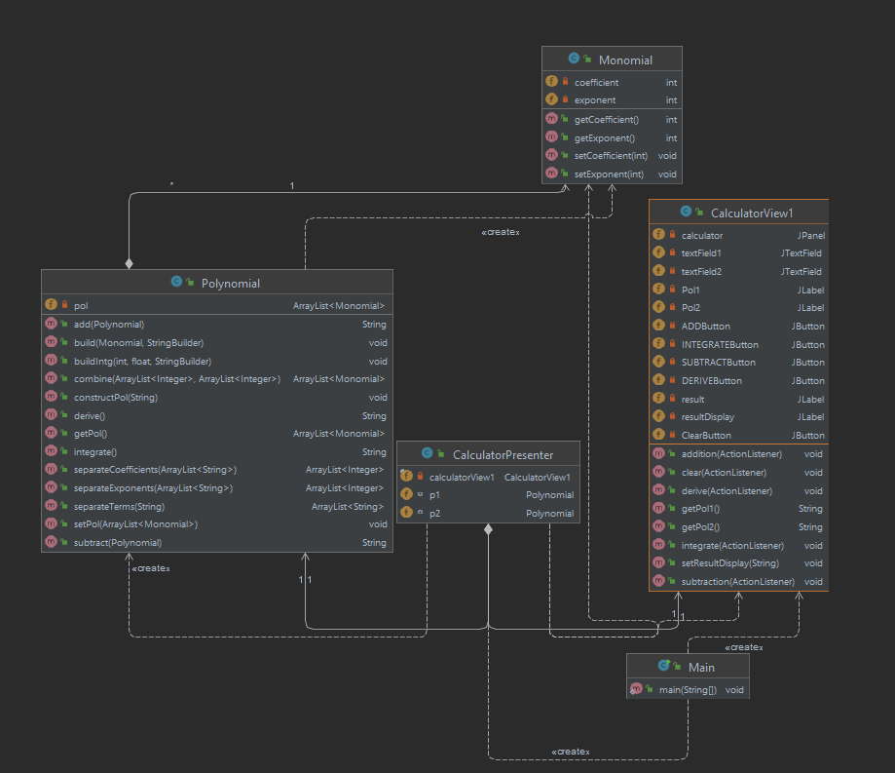
Packages diagram:
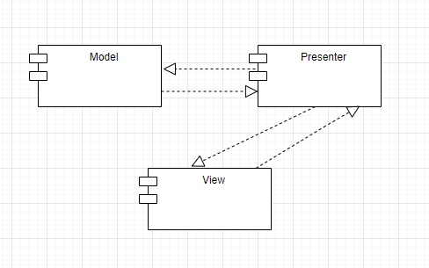

The Model package holds data through 2 classes: Polynomial and Monomial. Commands from the Presenter package update and fetch information from these classes.
The Presenter package is responsible for the logic behind the UI. Data is passed from the View to the Model and back and processed.
The View package is responsible for providing the user with an adequate UI, that enables the user to interact in all the desired ways with the program. It passes data to the Model through the Presenter.

Used algorithms:
The input string transformation to an actual object of class Polynomial:
- The user inputs the polynomial(s) into the text fields provided in the GUI
- The user selects the desired operation to be preformed by the calculator
- The input string is first split into separate terms, stored in an ArrayList through Pattern and Matcher algorithm
- Each term is then processed for exponent and coefficient identification, the same as before using other patterns and matchers and the results are stored in an object of class Monomial.
- An ArrayList of Monomials is formed, which can now create an object of class Polynomial
- Then the selected operation can be performed
- The calculations are done monomial by monomial (ex for addition, the program passes through all monomials in decreasing order of their exponents from the 2 polynomials and generates the output)
- The output is displayed.

Used data structures:
ArrayList<Monomial>
ArrayList<Integer>
ArrayList<Float>

Implementation
Description of packages:
Model:
Class Monomial:
The fields of this class are coefficient and exponent, of type int.
All the necessary methods are getters, setters and constructors.
The object of this class is the basic unit of process, representing 1 term
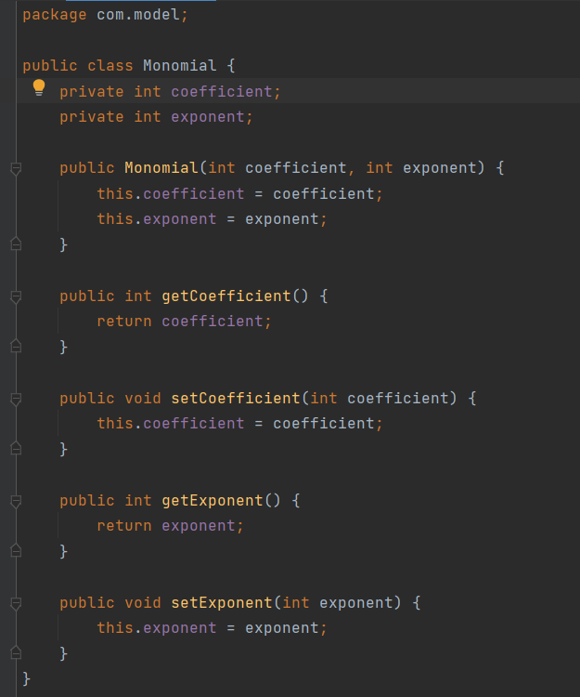

Class Polynomial:
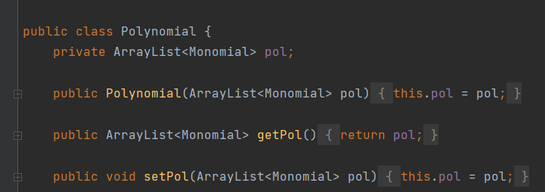
Class Polynomial has just one field, an ArrayList of Monomials.
Basic methods are getters, setters and constructor.

The following image describes 1 of the 3 methods that use the Pattern – Matcher algorithm. A regex is provided to pattern in order to procces the list of terms and extract the coeficients of each term. Special cases must be treated separately, such as x or -x with no coefficient in front. All the cases are matched in different groups: matcher.group(1) matches inputs such as 3x^3, matcher.group(2) is used for +-x and matcher.group(3) is used for coefficients with x^0;
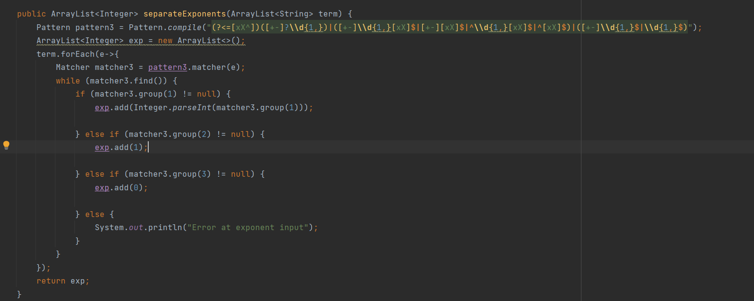

The following image represents the combine method, which takes as input 2 ArrayLists of integers, one for coefficients and one for exponents. The objective of the method is to pass through each element of the lists and create the associated Monomial objects, store them into an ArrayList of tyme Monomial, that will be passed as the argument for the Polynomial constructor

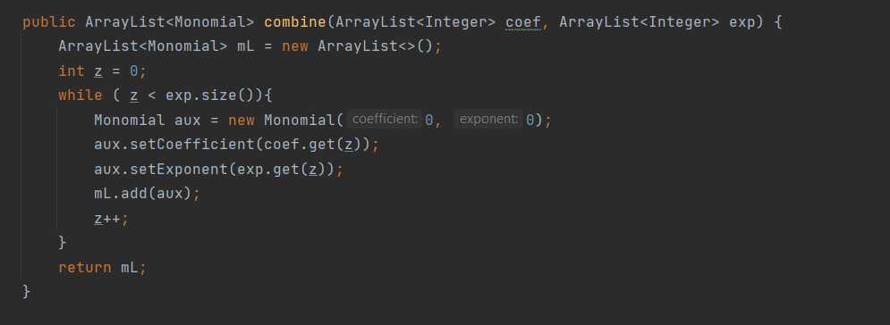

Presenter:
Class CalculatorPresenter:

This class is linked to the calculatorView1 object.
It has 2 polynomials (p1 and p2), which are later being constructed through the methods for the diverse buttons from the UI. Every button from the GUI is given a logic here, in the CalculatorPresenter class.
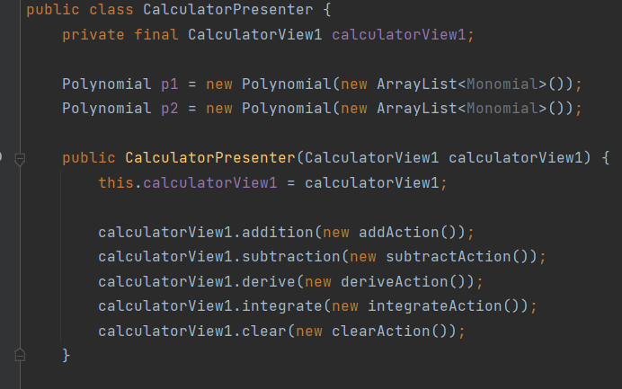

View:
Form CalculatorView1:
All the components of the interface are aligned through the GUI Form, with a Class associated to it
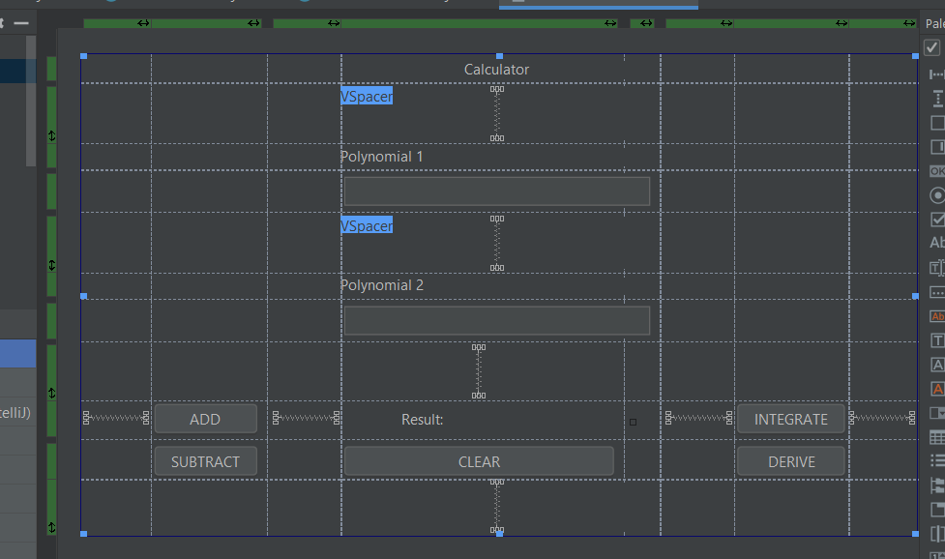

Class CalculatorView1:
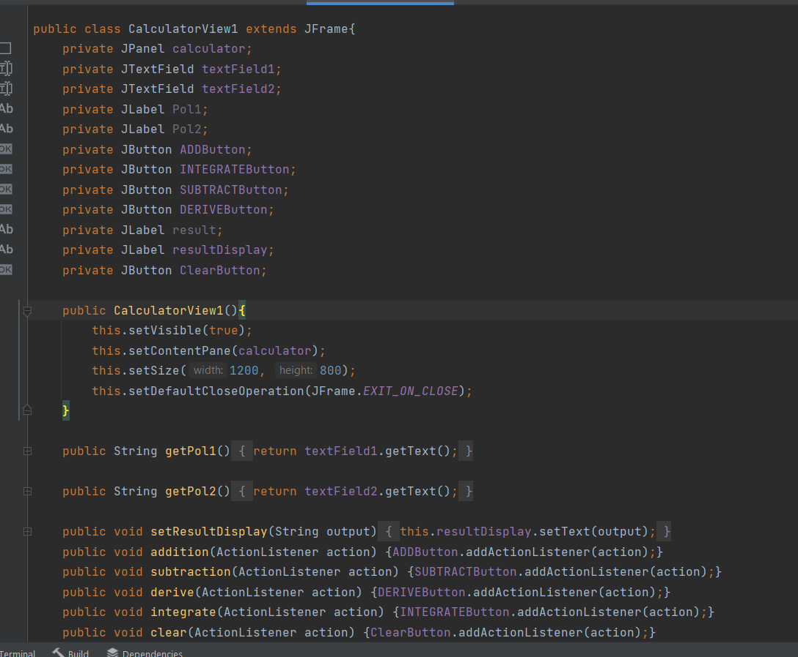
Class CalculatorView1 extends the JFrame class.
Method public CalculatorView1 is resonsible for opening the user interface and setting its dimenisons.
Methods getPol1() and getPol2 gather the input from the user as strings.
The last block of methods are responsible for the logic behind the buttons that the user interacts with. This logic is detailed in the Presenter (Class CalculatorPresenter1).

Results
The testing scenarios are implemented using JUnit 5. Several methods are tested, in order to see if the desired results are the ones actually computed by the methods.
The test for the method “add” is the most important one, as the method “add” includes almost all the other input processing methods (constructPol – separateTerms – separateCoefficients – separateExponents – combine – build - display). So the correctness of this method depends on the correctness of all the others.

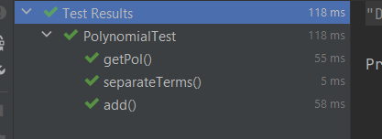
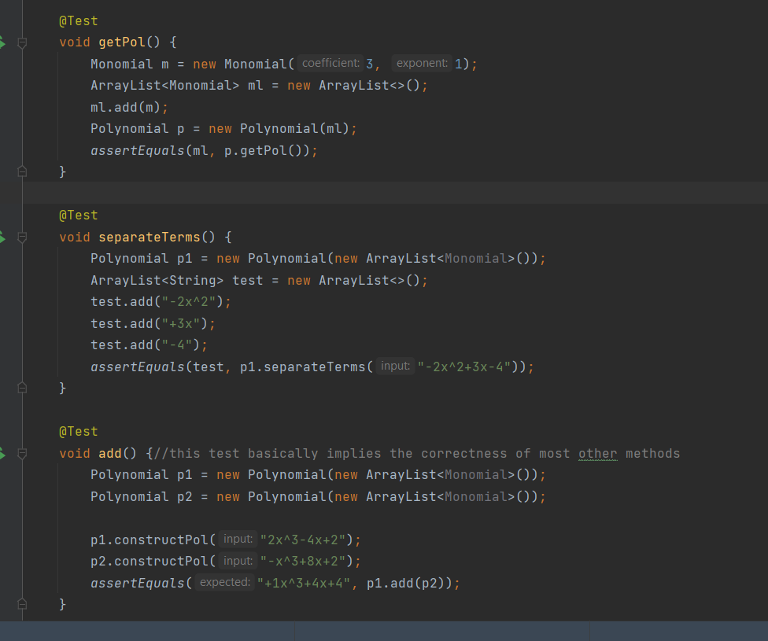

Conclusions
Conclusions:
The project fulfills the proposed objectives, primary and secondary ones. The calculator computes multiple types of operations on polynomials inserted by the user as input through an UI.
Aspects learned:
The use of regex functions
Pattern and Matcher functionalities
Class fields restrictions, when it comes to type conversions
Loops efficiency levels
Make sure to check all the input cases even if a small change to the code has been made
Further development:
Implement multiplication and divide operations and update the UI to enable the user to interact with such functionalities.
Multiple variables for polynomials
Improve the regex function that separates the terms:
-other variables available, not just “x” or “X”
-prevent more wrong inputs from terminating the execution, when the errors can be easily interpreted correctly
-fewer groups for the matcher, more generalized pattern

Bibliography
Java naming conventions - https://google.github.io/styleguide/javaguide.html

Junit - https://www.baeldung.com/junit-5
- https://www.vogella.com/tutorials/JUnit/article.html
- https://www.youtube.com/watch?v=o5pE7L2tVV8

Assignment presentation:
- https://dsrl.eu/courses/pt/materials/A1_Support_Presentation.pdf

Regex:
- https://regexr.com/
- https://www.youtube.com/watch?v=rhzKDrUiJVk

