DOCUMENTATIE

TEMA 2

NUME STUDENT: Tusa Laurentiu
GRUPA: 30421

CONTENTS

1. Assignment objectives 3
2. Problem analysis, scenarios, use-cases 3
3. Design 4
4. Implementation 6
5. Results and Tests 10
6. Conclusions 12
7. Bibliography 12

Assignment objectives
The main objective of this assignment is to design and implement an application aiming to analyze queuing-based systems, by simulating a series of N clients arriving for service, entering Q queues, waiting, being served and finally leaving the queues, and computing the average waiting time, average service time and peak hour. The program will be developed using specific Java OOP language.
The secondary objectives are the following:
- Analyze the problem and identify the assignment’s requirements – 2. Problem analysis, scenarios, use-cases
- Design the simulation – 3. Design
- Implement the simulation – 4. Implementation
- Test the simulation application – 5. Results

Problem analysis, scenarios, use-cases
Functional requirements:
- The simulation application should allow users to setup the simulation, through the graphical user interface
- The simulation application should allow users to start the simulation, through the graphical user interface
- The simulation application should display the real-time queues
evolution
- The simulation application should display the final results: average waiting time, average service time and peak hour
- The simulation application should display the desired results in a separate .txt file
- The simulation application should display the desired results correctly

Non-Functional requirements:
- The simulation application should be intuitive and easy to use by the user
- The simulation application must not start if the input is wrong and inform the user of such case

Use case diagram:
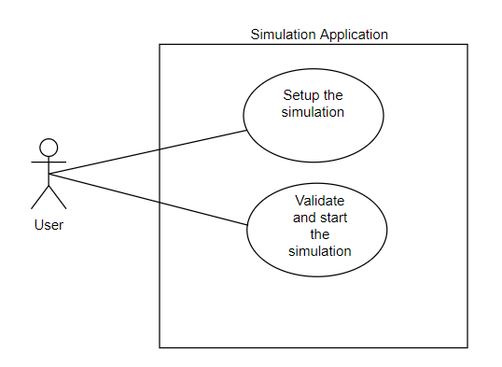
Use cases:

Use case: Setup the simulation
Primary Actor: User
Description: The user inserts the desired parameters for the simulation. The next step represents the next use case, where the input is verified at first. Depending of the result of the validation, the execution begins or not.

Use case: Validate and start the simulation
Primary Actor: User
Description: This use case is dependent on the execution of the previous use case
Main Success Scenario:
1. The user inserts the values for the: number of clients, number of queues, simulation interval, minimum and maximum arrival time, and minimum and maximum service time
2. The user clicks on the validate input data button
3. The application validates the data and displays a message informing the user of the state of the input data and the simulation starts
Alternative Sequence: Invalid values for the setup parameters
- The user inserts invalid values for the application’s setup parameters
- The application displays an error message and requests the user to insert valid values
- The scenario returns to step 1

Design

Application design:
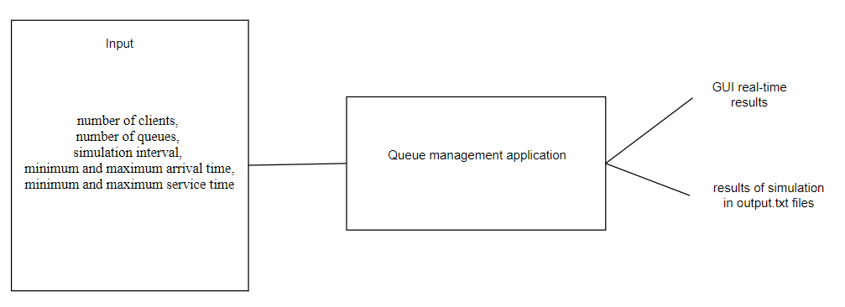
Package diagrams:
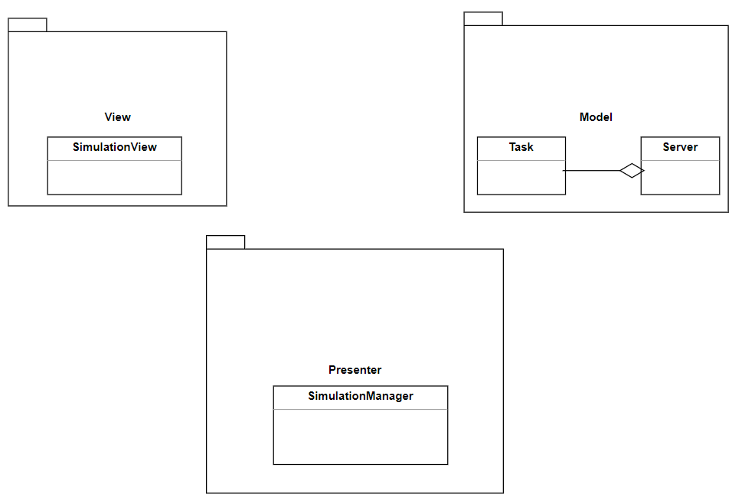
UML digrams:
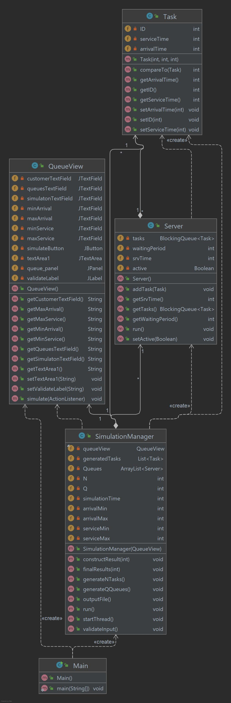

Used data structures:
- Collections.synchronizedList ( new ArrayList <> () )
- List < Task >
- ArrayList < Server >
- BlockingQueue < Task >
- LinkedBlockingDeque < > ( )
Used interfaces:
- Runnable
- ActionListener
- Comparable < Task >
Used algorithms:
- Collections.sort ( )
- Multithreading :
  - t.start ( )
  - Thread.sleep ( 1000 )

Implementation
Creating Threads:
- Runnable interface has been implemented by a few classes
- The Runnable interface defines a single method named run – the method will be implemented by the class implementing the interface and it will include the code that will be executed in the thread
- start of main thread, responsible for tracking simulation time and real-time display of the results :
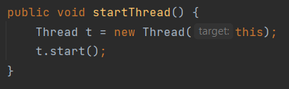
- start of each queue’s thread, responsible for queue management of the incoming clients :
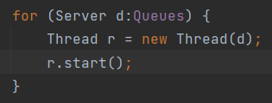
Thread Synchronization has benn managed through Thread Safe Collections :

- Synchronized collections :
  - List < Task > generatedTasks = Collections.synchronizedList ( new ArrayList < > ( ) )
- Concurrent collections :
  - BlockingQueue < Task > tasks

Class description:
- Class Task
This class is responsible for holding information about the clients that must be processed by the queues
The fields are the following: ID, arrival time, service time
Every task is generated at random at the beginning of the execution
The useful methods here are just getters and setters
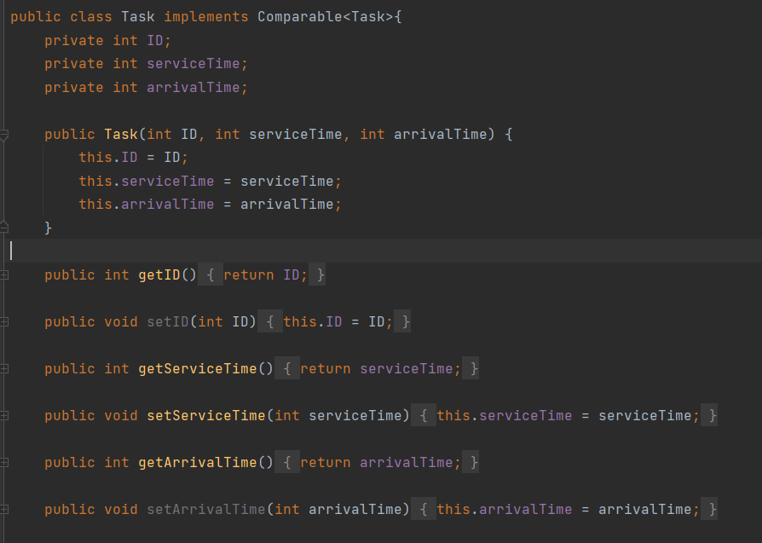

- Class Server
This class is responsible for holding information and creating the queues, as well as the execution process of the multiple threads.
The fields are the following: BlockingQueue < Task > tasks, int waitingPeriod, int srvTime, Boolean active
Every queue is generated at the beginning of the execution. At first, the BlockingQueue < Task > collections are empty. Here the tasks will be stored for further processing.
The “active” field is necessary to stop the thread when there are no more tasks to process
The most important method here is the “run” method, which describes the implementation and logic of the thread that will be created for this type of class.

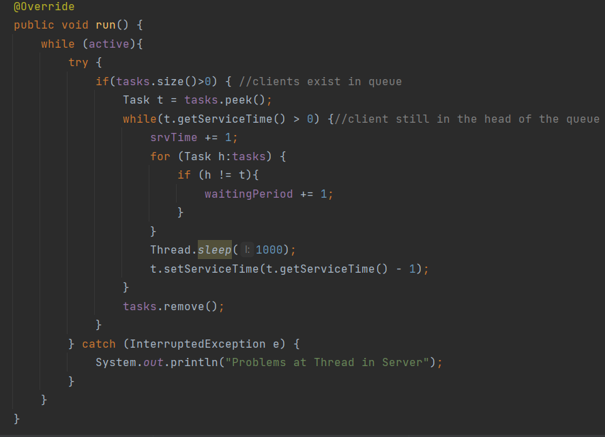
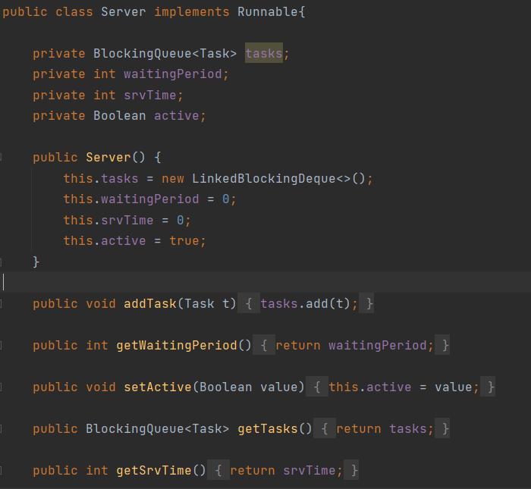

- Class SimulationManager
This class is responsible for the logic and execution of the queue management application. The main thread is created here. Its purpose is to keep track of the simulation time and display the real-time results in the graphical user interface.
The fields required for this class are the following:
private List < Task > generatedTasks = Collections.synchronizedList(new ArrayList < > ( ) )
private ArrayList < Server > Queues = new ArrayList < > ( )
private int N
private int Q
private int simulationTime
private int arrivalMin
private int arrivalMax
private int serviceMin
private int serviceMax
generatedTasks holds the tasks that will be created
Queues holds the queues that will be generated
N = number of tasks to generate
Q = number of queues to generate
The rest of the fields are parameters for simulation intervals. This data is fetched from the graphical user interface
Methods:
- validateInput ()
This method is responsible for validating the input. If the input is incorrect, an exception is thrown and the user is prompted to insert a correct input
- generateNTasks ()
- generateQQueues ()
- startThread ()
This method starts the main thread, having the parameter “this”, since the run method is implemented in the same class
- constructResult ( int time )
This method is responsible for the construction and display of the real-time results of the simulation of the queues
- finalResults ( int peakTime )
This method is responsible for displaying the after-results of the simulation of the queues
- outputFile()
This method is responsible for displaying the results in output.txt files
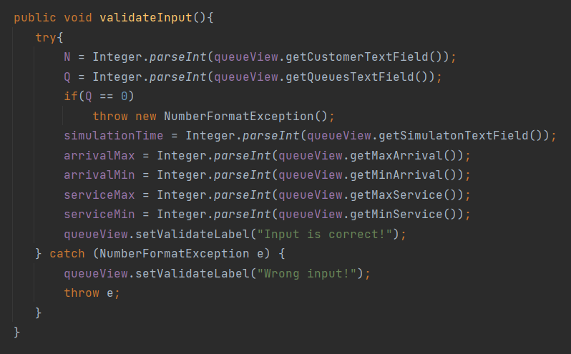
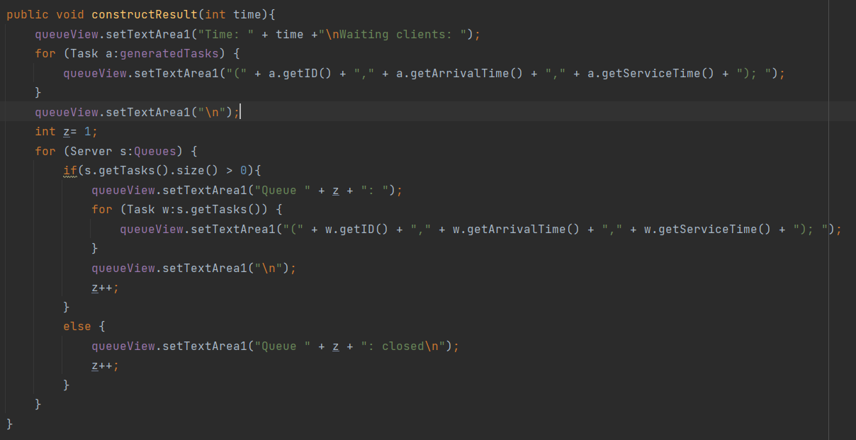
- Class QueueView
This is the class responsible for the graphical user interface. It provides text fields for the user for the required data to be given.
The important methods here are the getText for input gathering and setText for output display.
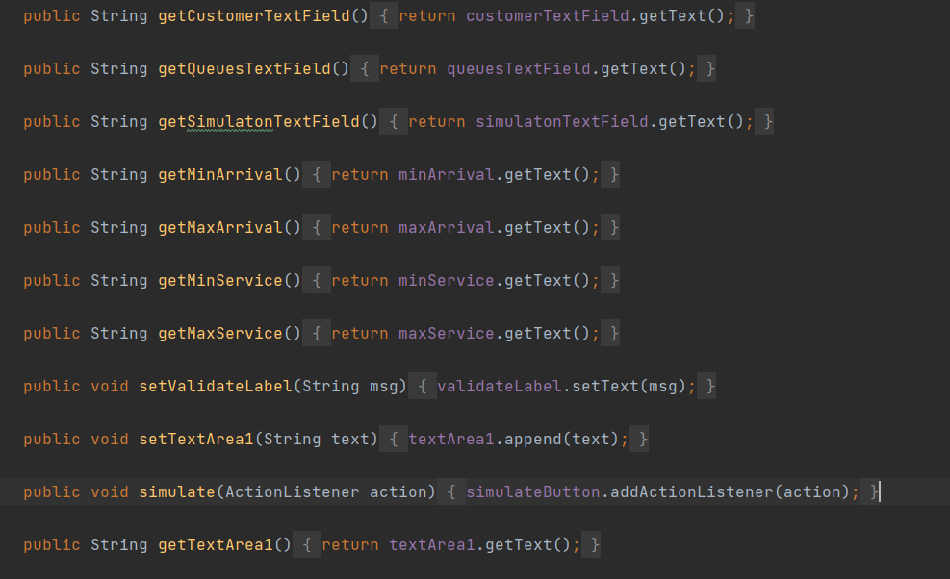

GUI:
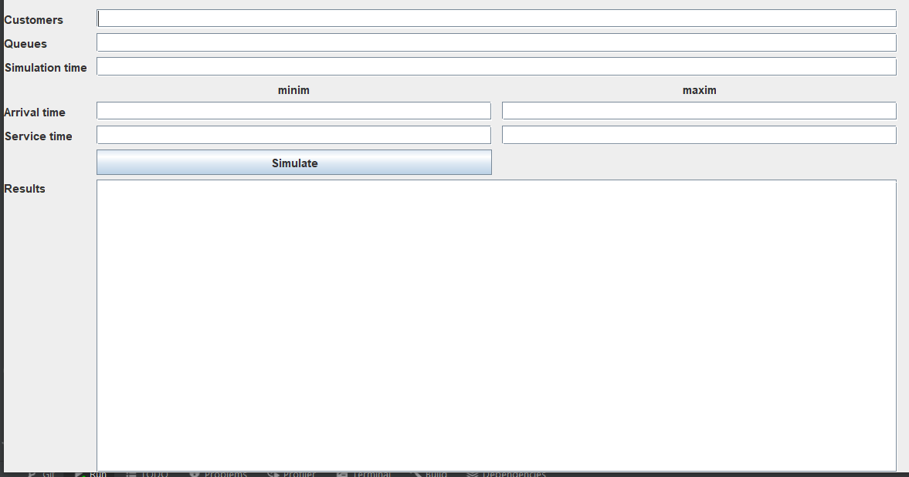

Implementation description and application logic:
- First the input must be provided to the application through the graphical user interface. The input must be valid. Otherwise, the program will not start the execution
- After the correct input is provided, the application validates it and starts the execution
- N random clients are generated at the beginning of the execution
- Q random queues are generated at the beginning of the execution
- The specific number of threads for the queues are being generated
- The main thread starts its execution – it will stop if the simulation time limit is reached or if there are no more clients left to process. It will update the results in the GUI every second
- At each step, the tasks are evaluated. If 1 can be processed, a convenient queue is selected to hold this task. Then it is eliminated from the generatedTasks collection.
- The queues’ threads stop when the processing of the tasks is over
- The final results are displayed on the graphical user interface, as well as in separate output.txt files ( also with the real-time simulation results )
- The main thread ends, as well as the entire application

Results and Tests
The 3 tests provided in the assignment description:

Test 1:
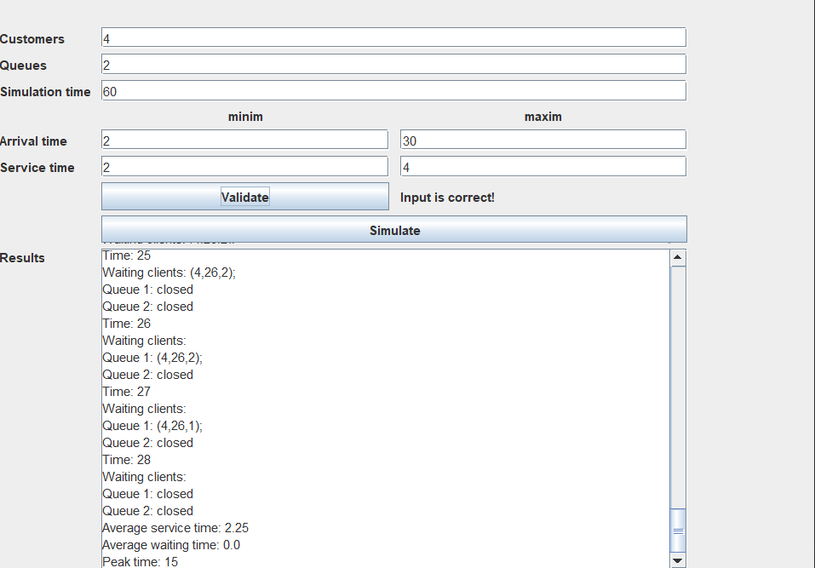
Test 2:
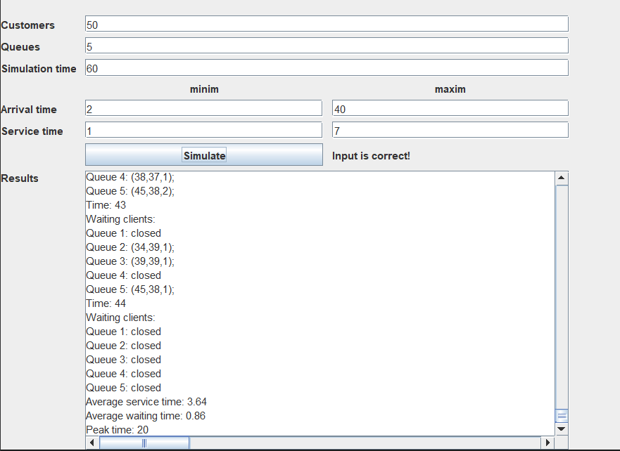

Test 3:
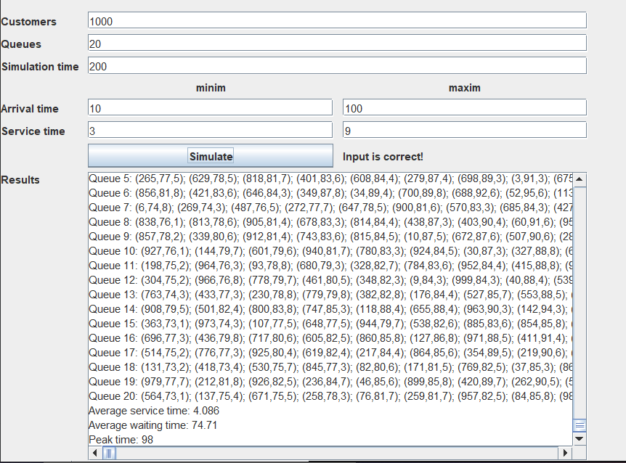

Conclusions
In conclusion, the application executes an efficient way of distributing several tasks to multiple queues, each task being different and generated at random. The simulation parameters are provided by the user through the graphical user interface as many times as it is wanted to simulate. The results are displayed not only in real-time in the graphical user interface, but also in separate output.txt files.

Things learned:
- Multithreading
- Thread manipulation
- Parallel execution of tasks
- Thread problems (racing conditions, corrupted resources by other threads)
Improvements:
- Better thread synchronization
- More real-time information about queues
- Better display of the results

Bibliography

https://docs.oracle.com/javase/tutorial/essential/concurrency/index.html
https://www.baeldung.com/java-synchronized-collections
https://www.baeldung.com/java-synchronized
https://www.baeldung.com/java-runnable-callable
https://docs.oracle.com/javase/8/docs/api/java/util/Timer.html
https://www.youtube.com/watch?v=r_MbozD32eo&t=334s
https://www.youtube.com/watch?v=a_LBuCx1KTE
http://www.javacodegeeks.com/2013/01/java-thread-pool-example-using-executors-andthreadpoolexecutor.html

