***Project documentation***

***-Test app-***

Created by:

-Turcsa Alexandru -> group 30421

-Tusa Laurentiu -> group 30421

Contents:

1. Development and structure
2. Data handling
3. Application description
4. Use cases
5. Conclusion
6. Improvements

1.Development and structure:

The project (Test app) is developed in Java, using a MVP architecture. Every page has its *Presenter* and *View*. The *Presenter* handles the logic behind the GUI. The *View* is responsible for displaying the pages and fetching input data from the user and pass it to the *Presenter*, which will process the data and pass the result to the *Model*. The *Model* is responsible for storing data, which can be accessed and processed by the *Presenter*.

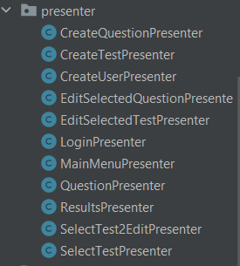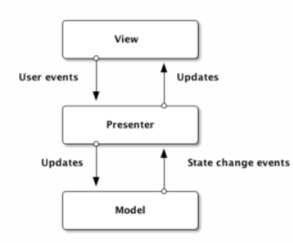MVP flow control: Presenter classes: View classes:

2.Data handling:

The data necessary for this application is stored in a MySQL database, which is linked to the Java project. Required types of data are the following:

-test

-user

-question

Also, the passwords for all the users are stored in the user table as their encrypted form, through the Bcrypt password-hashing function, which generates a string of characters of length 60, regardless of the length of the user’s input password. Therefore, in order to validate a password, the user must input his/her password, which will be hashed through Bcrypt and if the result is the same as in the database, access is granted.

3.Application description:

There are 3 main actions that a user can do in this application:

1. Create test
2. Solve test
3. Edit test

a)Create test:

The user can create a new test, which includes: setting the title of the test and creating new questions for this specific test. The questions consist of the actual question text and 4 variants of answers out of which only 1 is correct.

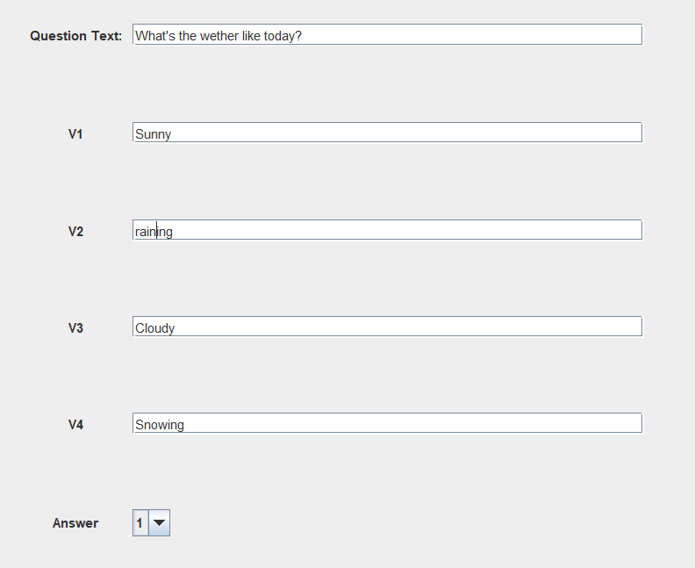

b)Solve test:

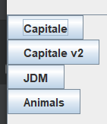 The user is shown a list of tests to choose from. After they select one, the test opens and all the questions from that test are displayed sequentially. After the final question answered, a new page with the results pops up, showing the number of correct answers and the percentage.

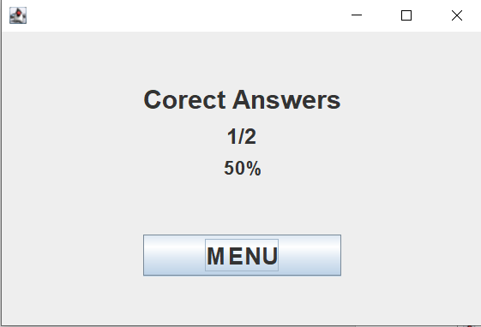

c)Edit test:

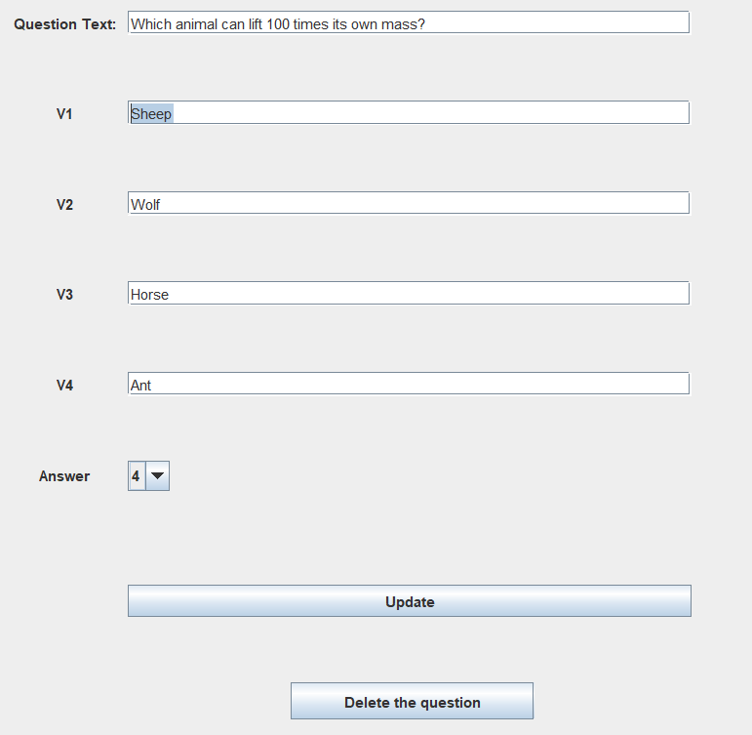 Here it is important to mention that a user can **only** edit his/her tests. Again, a list with the test is shown to the user. After a test is selected, a list with the containing questions is presented for the user to choose. Here the user has the possibility to choose a question to edit (or delete), or to create a new question that will be added to the selected test.

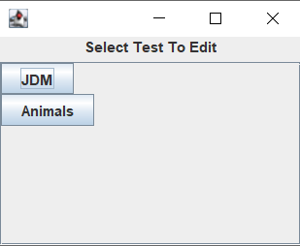

-Compare this with the picture from a) -> only this users test are shown-

4.Use cases:

1. School examination, similar to moodle quizzes or kahoot. The teacher is able to create multiple tests, which are linked to his/her user. During the examination, the students are either asked to select a test from the displayed list, or to solve all of them. At the end, their grade will be displayed. What is important is that the students can not edit the tests in their favor, since their users are different from the teacher’s user, which created the tests.
2. A way to learn in a group, by making tests for each other. In order to prepare for an exam, a group of students could use this application as a mean of practice. Every member can create as many tests as they want about the exams subject. After enough data collected, they can start solving each other’s tests. It would be possible to even simulate a multiple-choice type of exam.
3. Application to prepare and test people during an interview
4. Theoretical examination for the driving license
5. Creation of test for examinations of physical disorders

5.Conclusion:

The Test Application is a useful tool for creating and solving tests in any domain. It can be practical in situations that require an examination of an individual, regarding a specific subject (health, education, job employment etc). The project is implemented in Java and the MVP architecture is being used. All the necessary data is stored in a linked MySQL database, including the encrypted passwords for each user.

6.Improvements:

-store the maximum score for each user for each test

-store all the scores from all the attempts of each user for each test

-questions with more than 1 correct answer

-present the questions in random order

-allow the user to change the order of the questions during the test

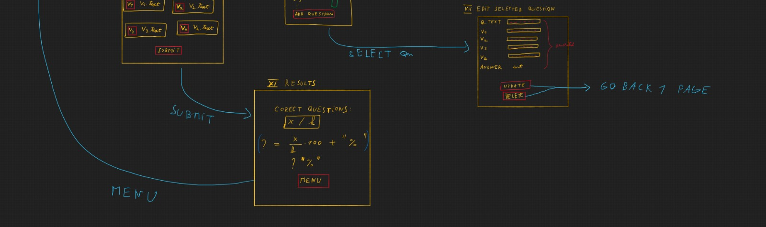 -set a timer on the test

