DOCUMENTATIE

TEMA 3

NUME STUDENT: Tusa Laurentiu
GRUPA: 30421

CONTENTS

1. Assignment objective 3
2. Problem analysis, scenarios,use-cases 3
3. Design 5
4. Implementation 6
5. Results and tests 10
6. Conclusions 12
7. Bibliography 12

Assignment objective
Main objective
• Design and implement an application for managing the client orders for a warehouse and provide a graphical user interface that allows the user to manipulate the contents of the databases. The program will be developed using specific Java OOP language.

Sub-objectives
• Analyze the problem and identify requirements – 2.Problem analysis, scenarios, use-cases
• Design the orders management application – 3.Design
• Implement the orders management application – 4.Implement
• Test the orders management application – 5.Results and tests

- Problem analysis, scenarios, use-cases
Functional requirements:
- The application should allow an employee to add a new client
- The application should allow an employee to add a new product
- The application should allow an employee to add a new order
- The application should allow an employee to edit a new client
- The application should allow an employee to edit a new product
- The application should allow an employee to edit a new order
- The application should allow an employee to delete a new client
- The application should allow an employee to delete a new product
- The application should allow an employee to delete a new order
- The application should allow an employee to view all clients in a JTable in the graphical user interface
- The application should allow an employee to view all products in a JTable in the graphical user interface
- The application should allow an employee to view all orders in a JTable in the graphical user interface

Non-Functional requirements:
- The application should be intuitive and easy to use by the user
- The application should execute correctly the commands transmitted by the user through the graphical user interface, without needing to interact with the database directly
- The application should not have any bugs or cases that the logic of the application could not handle.
- The application should inform the user when the input data provided is incorrect

Use case diagram:
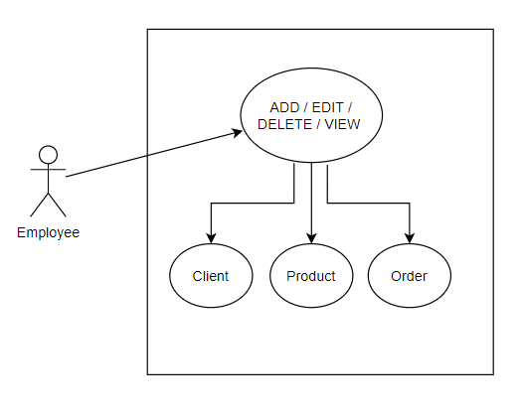
Use cases:

Use Case: add product
Primary Actor: employee
Main Success Scenario:
1. The employee selects the option to add a new product
2. The application will display a form in which the product details
should be inserted
3. The employee inserts the name of the product, its price and
current stock
4. The employee clicks on the “Add” button
5. The application stores the product data in the database and
displays an acknowledge message

Alternative Sequence: Invalid values for the product’s data
- The user inserts a negative value for the stock of the product
- The application displays an error message and requests the user to
insert a valid stock
- The scenario returns to step 3

Use Case: edit product
Primary Actor: employee
Main Success Scenario:
1. The employee selects the option to edit a new product
2. The application will display a form in which the product details
should be inserted
3. The employee inserts the id, name of the product, its price and
current stock
4. The employee clicks on the “Edit” button
5. The application updates the product data in the database, based on the given id and
displays an acknowledge message

Alternative Sequence: Invalid values for the product’s data
- The user inserts a negative value for the stock of the product, or an inexistent id
- The application displays an error message and requests the user to
insert valid input data in the text fields from the graphical user interface
- The scenario returns to step 3

Use Case: delete product
Primary Actor: employee
Main Success Scenario:
- The employee selects the option to delete a product
- The application will display a form in which the product details
should be inserted
- The employee inserts the id of the product to be deleted
- The employee clicks on the “Delete” button
- The application deletes the product data in the database, based on the given id and
displays an acknowledge message

Alternative Sequence: Invalid id values for the product
- The user inserts an incorrect value for the id of the product to be deleted
- The application displays an error message and requests the user to
insert valid input data in the text fields from the graphical user interface
- The scenario returns to step 3

Use Case: view product
Primary Actor: employee
Main Success Scenario:
1. The employee selects the option to view all product in a JTable
2. The application will display a new graphical user interface, in which the product table entries are displayed
3. The employee clicks on the “View” button
4. The application displays the data

Alternative Sequence: Table is empty
- The JTable will be empty
- The scenario returns to step 3

Design
Package Diagram:
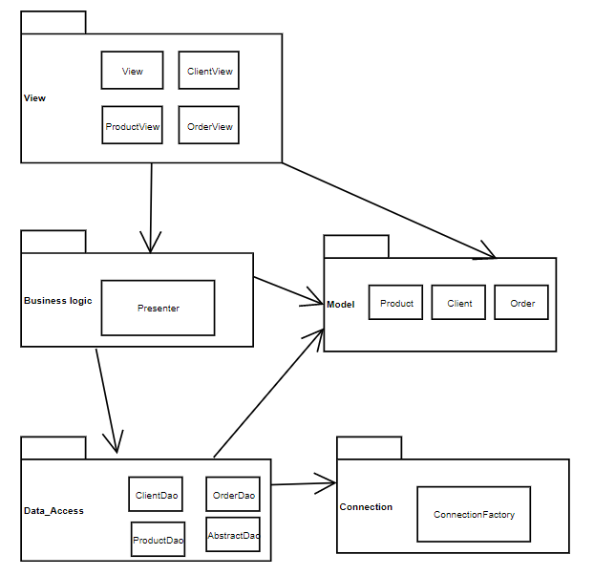
UML diagram:
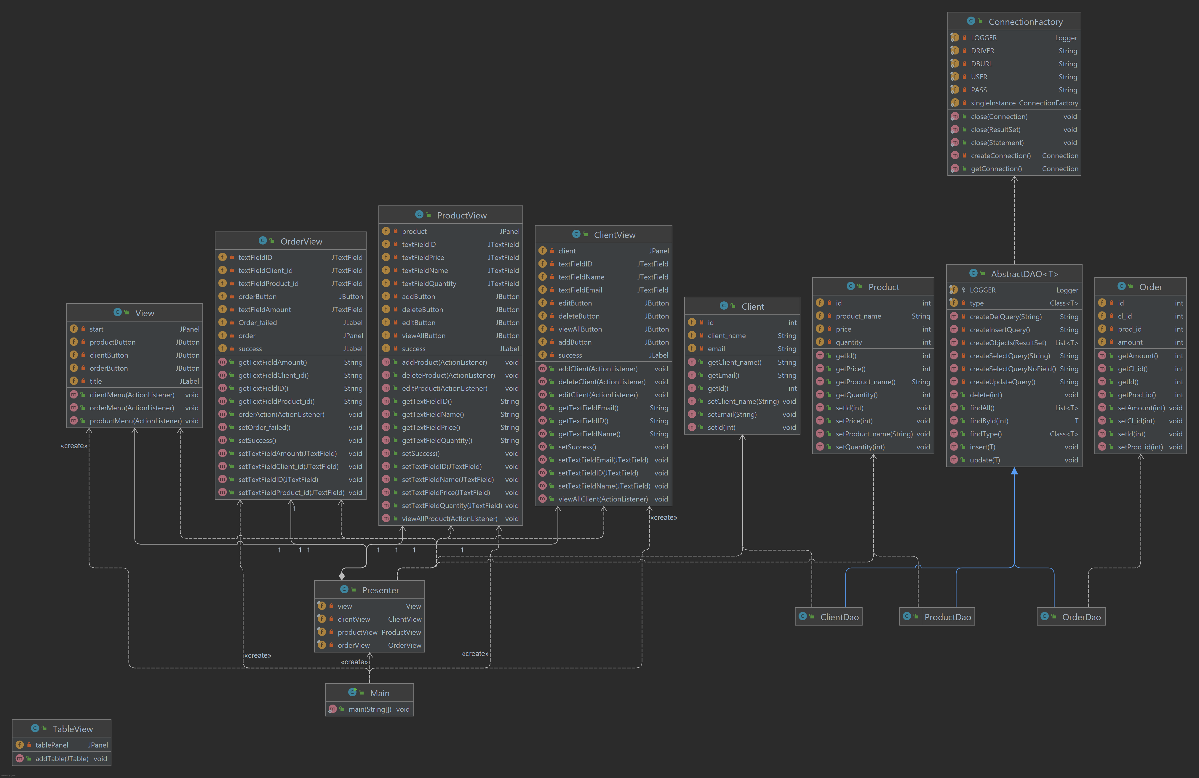

Data structures used:
List < T > with generic type T
ArrayList < Client / Product / Order >
Field [ ]
Object [ ] [ ]

Algorithms / Patterns used:
- ConnectionFactory – the application has a specific class responsible for creating the connection from the java code to the database
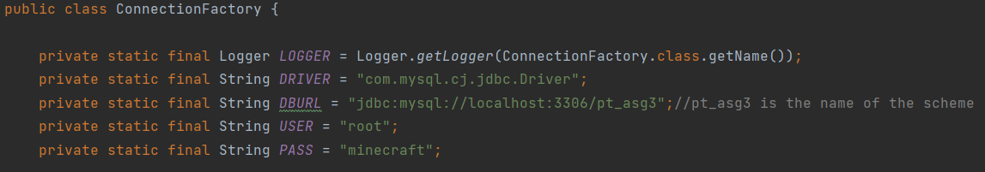
- Class instance creation through Reflection. It makes possible the creation of instances of specific class based on information retrieved from the database
- Use of generics for the Reflection algorithm

Implementation
Graphical user interface implementation:
- The user can select 1 button out of the 3, which represent the 3 categories of data to manage : clients, products or orders
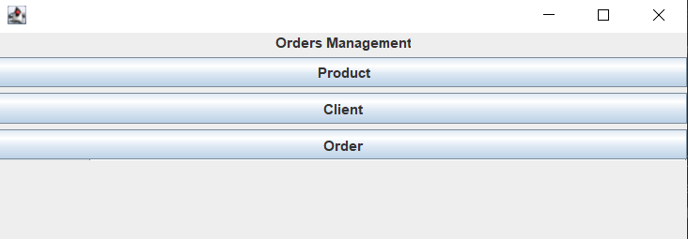

- The available actions are displayed in the graphical user interface through buttons: edit , add , update , delete
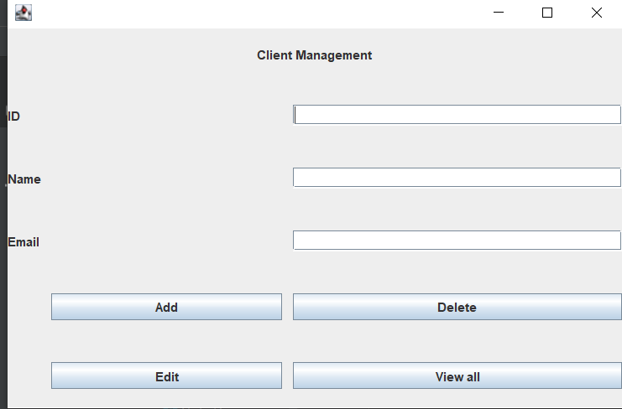

- Input is provided in the text fields and the action is continued by pressing the buttons
The classes are created through GUI forms
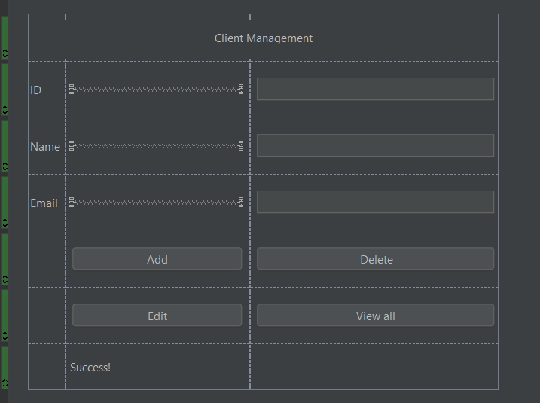
Class descriptions:

- ConnectionFactory :
This class is responsible for providing a connection between the user and the database
- Model classes :
This classes re the model classes, they must have the same fields as the columns of the tables in the database
- AbstractDAO class :
The AbstractDao class has the most methods for handling and creating instances of actual model classes. It does so through the generic parameter T and the Reflection technic
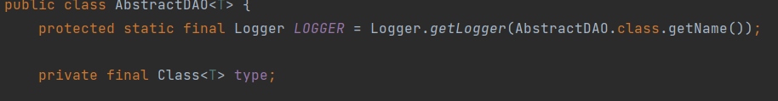
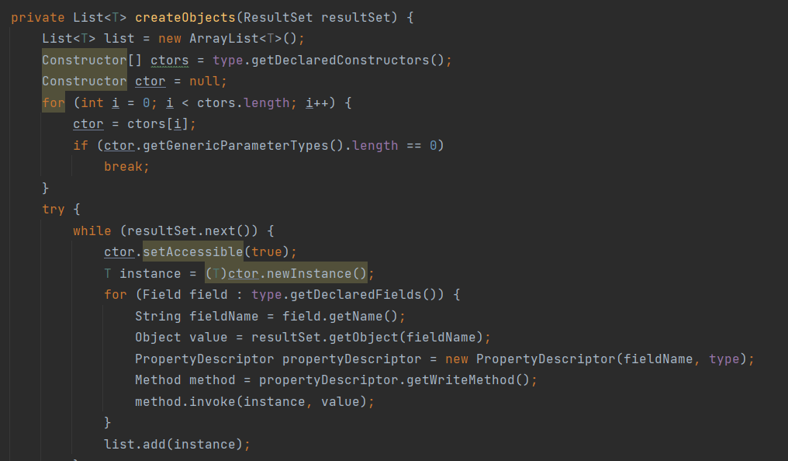
Also methods regarding query construction are present here. They differ by the their usage and so, by their string building procces
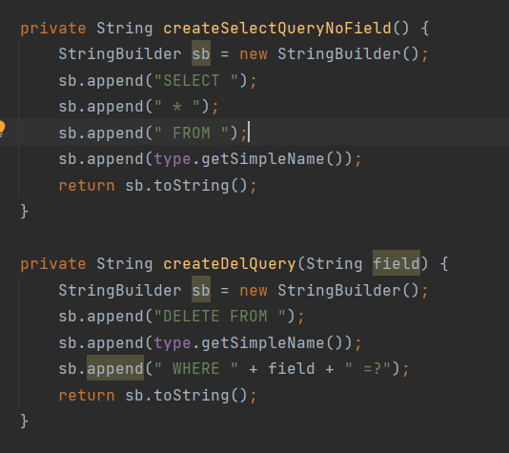
Also the intruction methods can be found in the AbstractDao class, methods such as insert, delete, update
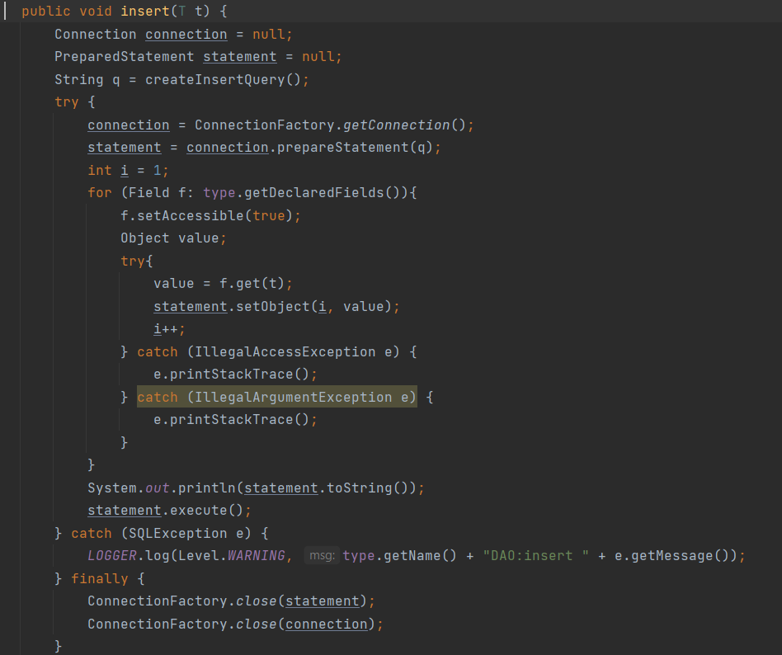

- Presenter class:
The presenter class describes the logic behind all the buttons from the graphical user interface. This class is also responsible for the user interfaces that must be displayed to the user, for fethcing information from the input data from the user, and to create the JTable for viewing the contents of tables
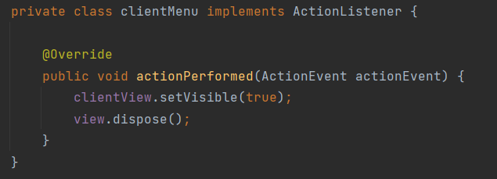
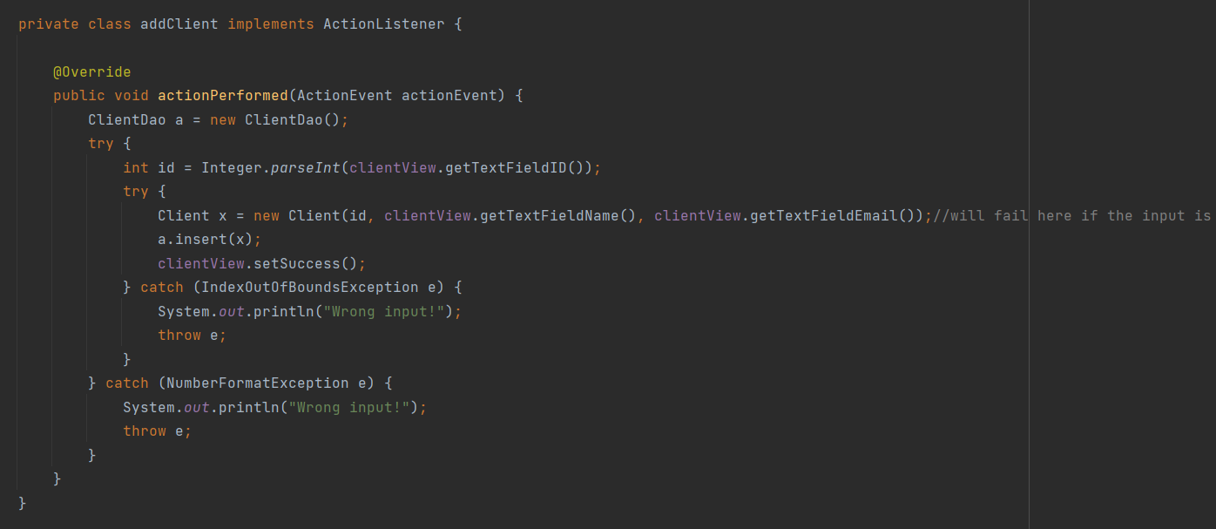
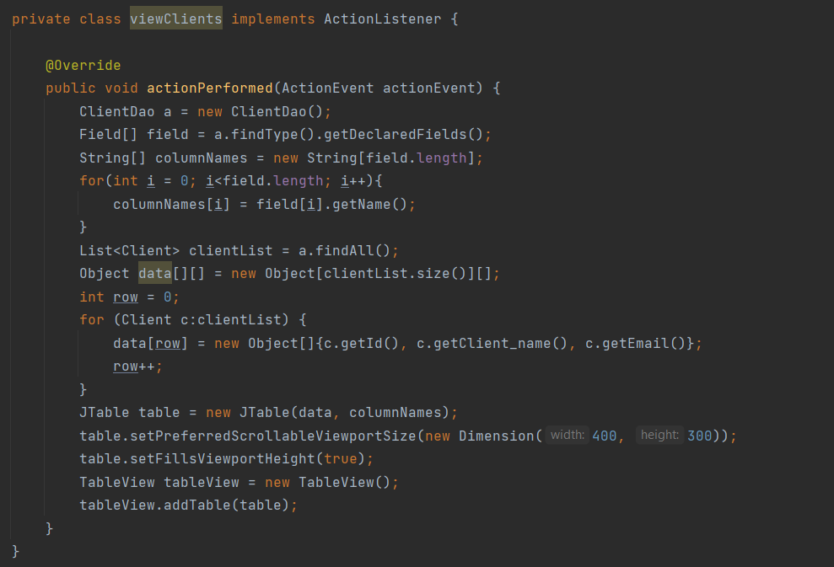

Results and tests
Results will be shown from the actual database, compared to the SQL Dump file

Clients table:
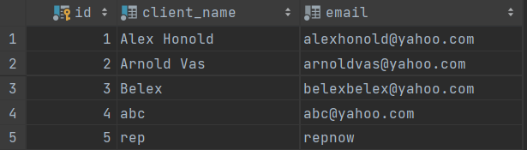
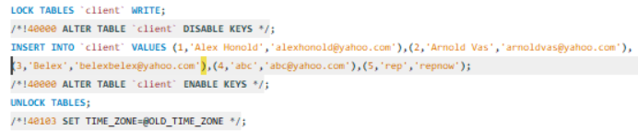

Products table: - the initial values of the quantity field might have changed, depending on the orders that have been created
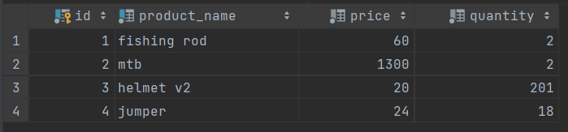
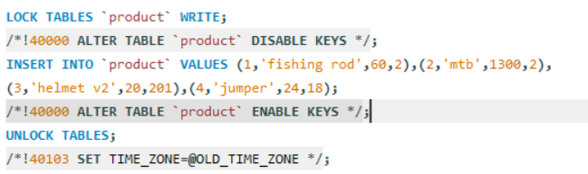

Ordes table:
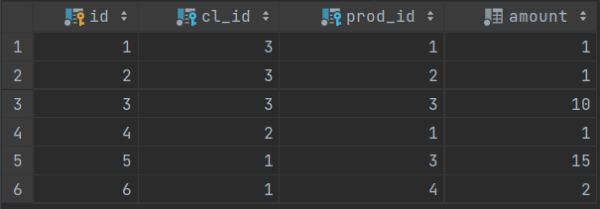
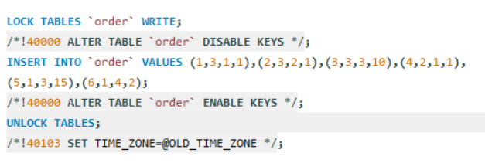

Conclusions
In conclusion, this order-management application enables employees to easily handle orders from a warehouse for example, by operating on data from specific databases. The employee does not need to operate directly on the database, as the commands are given inside the Java application through the graphical user interface. The application manages the connection with the database.

Acknowledgements:
- Usage of generic classes and methods
- Connection with a provided database
- Reflection technics
- Construction of SQL queries inside of the Java application

Improvements:
- Better usage of generic classes and methods
- More efficient class design
- More details provided for the product and clients

Bibliography

https://maven.apache.org/plugins/maven-javadoc-plugin/download.cgi
https://dev.mysql.com/doc/workbench/en/
https://www.youtube.com/watch?v=fAQB556HtiI
https://www.youtube.com/results?search_query=java+JTable
https://bugs.openjdk.java.net/browse/JDK-6985040
http://www.mkyong.com/jdbc/how-to-connect-to-mysql-with-jdbc-driver-java/
https://www.baeldung.com/java-jdbc
https://dzone.com/articles/layers-standard-enterprise
http://tutorials.jenkov.com/java-reflection/index.html
https://www.baeldung.com/java-pdf-creation
https://www.baeldung.com/javadoc
https://dev.mysql.com/doc/workbench/en/wb-admin-export-import-management.html

