Project Portfolio

This project is for an app that will display a portfolio that will be use in a work setting. Its aims to present the person for which it was created so they can present themselves to potential employers. It has one particularity : the client and the executor are one.

This project is under some imposed requirement : the use of one of the following framework is one on them.  
 • Vue JS  
 • React JS  
 • Angular 2  
I decided to use Vue JS because of the three proposed this one have a simplicity to use, a complete documentation et some tools supposed to help. It’s also made to be performant and optimized. Plus it doesn’t ask for a lot of knowledge in front-end development and – considering it’s our first app – it might be best to use something simple. Plus, it’s the one that speak to me the most.  
After some test I find the syntaxe very easy to use and pleasant, it speaks to me on more level than the other two. There is no need to instale anything contrary to Angular2. I found a bunch of useful tutorial I can use as a base to learn VueJS. Plus it offers a reactivity that I find appealing. I find myself really interested by this one more than the others, even if they seemed neat too.  
VueJS is also independant and under a MIT license while the other two are under Facebook and Google licenses, and I prefere to use a free technology.  
It might seem like it the easier road to take but I really think VueJS will be perfect to help me on my project.

Beside we also have to have some obligatory contents :  
 • Our technical competences  
 • Informations about our formation  
 • Some personal infos (name, age, etc.)  
 • Our past projects illustrate, accompany by the title, the complete date and three lines of description.  
 • A contact form  
  
Despite all those restraint I still decided to let my creative spirit express itself in my wireframe. You can discover it right after those lines with a little explanation, that I think is not needed but it can clear some misunderstanding nonetheless.

Here is the loading screen which contains the name of the app/portfolio and exposes the theme I choose to display in it, aka space.

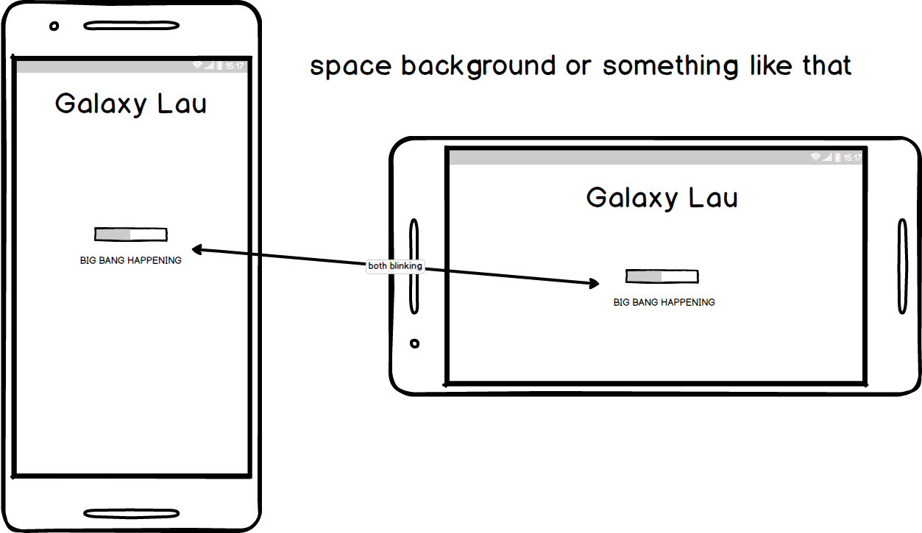

Here are the categories on the form of different planets. As you can see the name is indicated and there is a short description of the categories, which will be the one required. The circle outside the phone is the planet which has been swap under to show the next one.

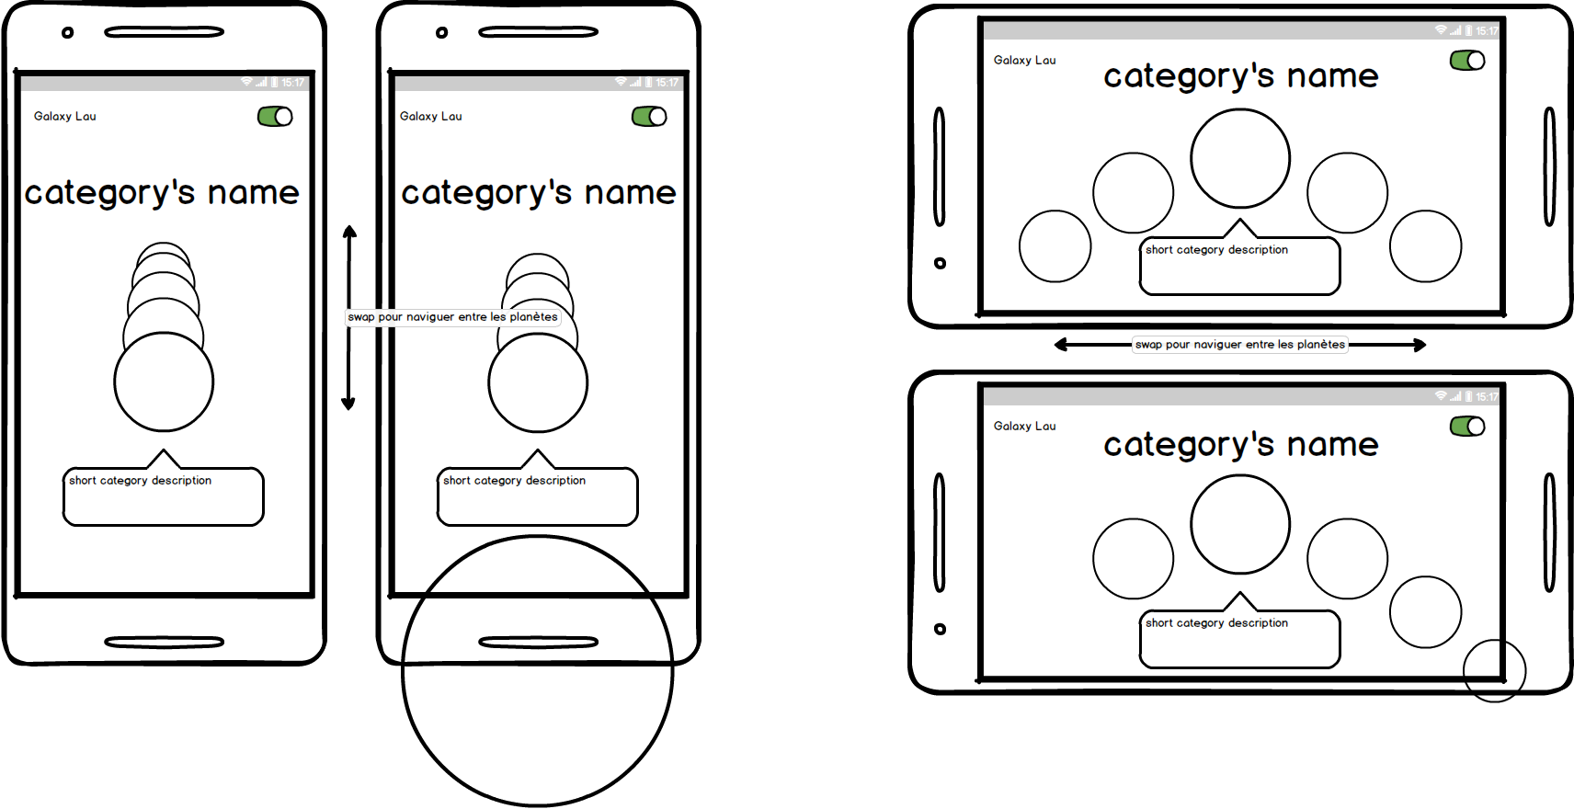  
  
Here you can see the presentation of the owner of the portfolio, which consists of the basics plus some humorous remarks. 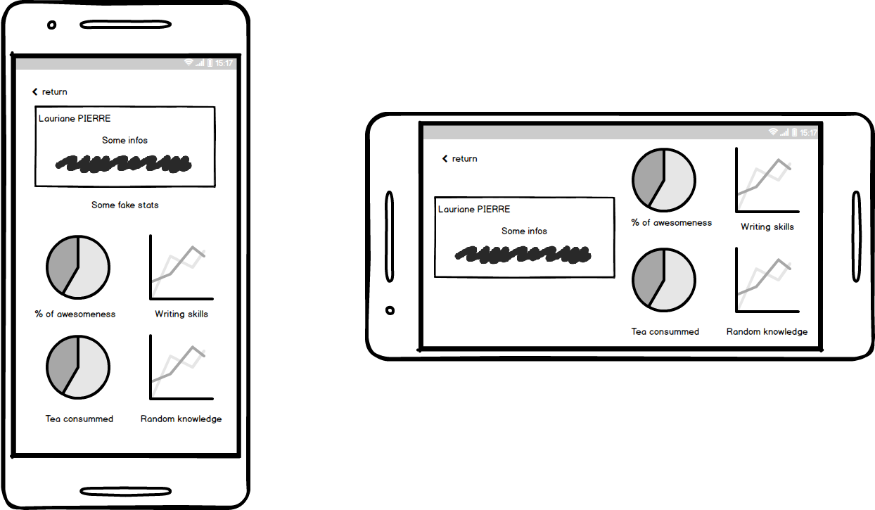

The next category will be the one with the competences. It’s sobre and simple to understand with some additionnal infos about said competences.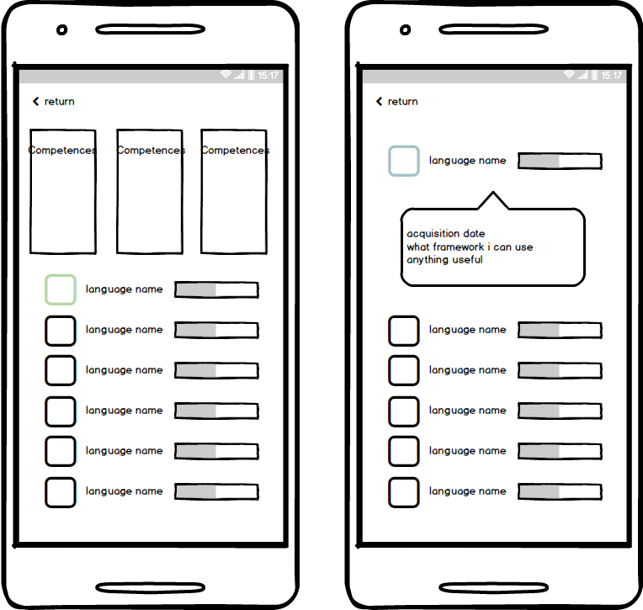

The last bit of personal informations will be about the formation received, which takes the form of a constellation, a path of stars.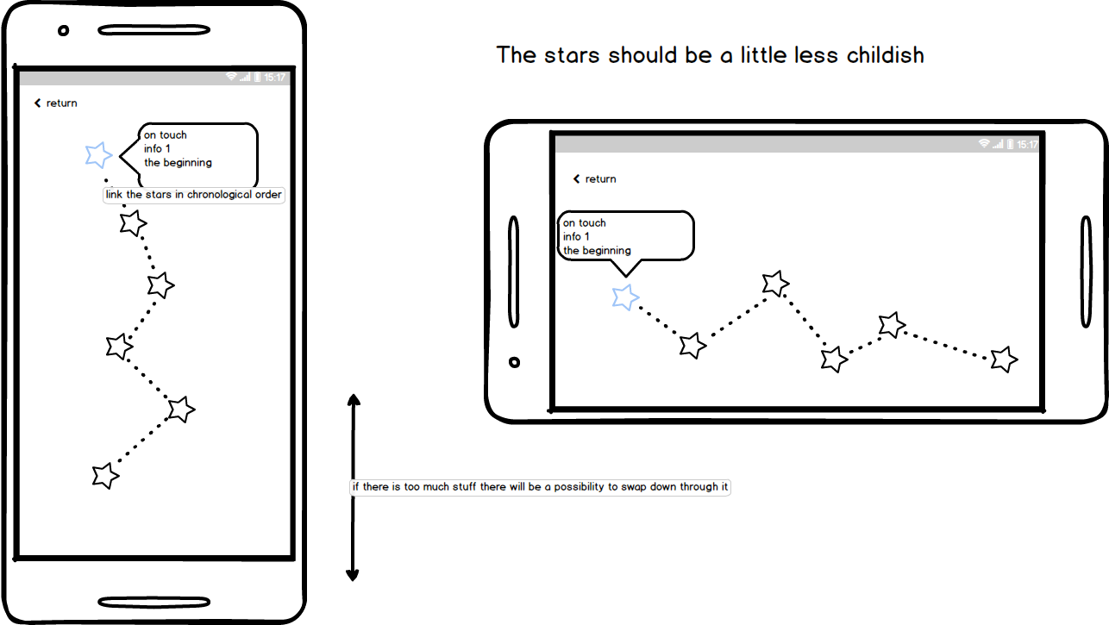

Then we’ll have the category with the projects that will be in two parts : one that will display different kind of projects and the other the projects themselves.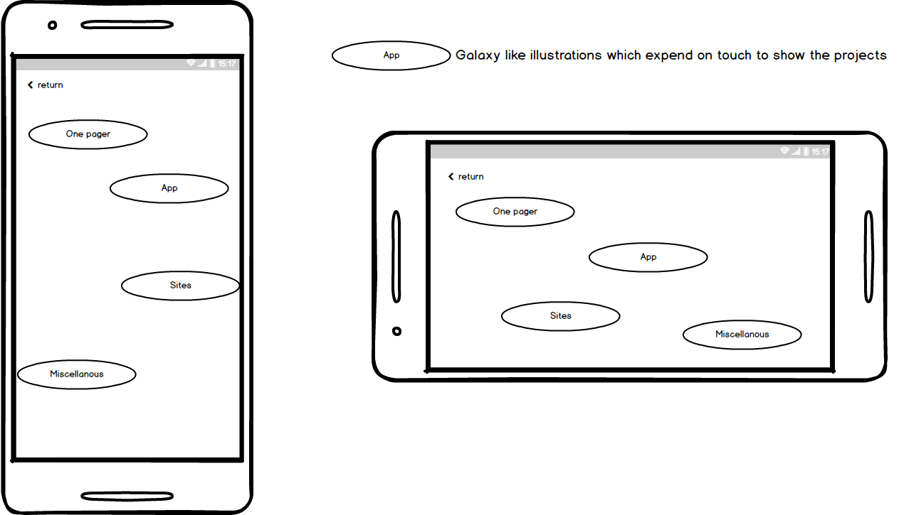

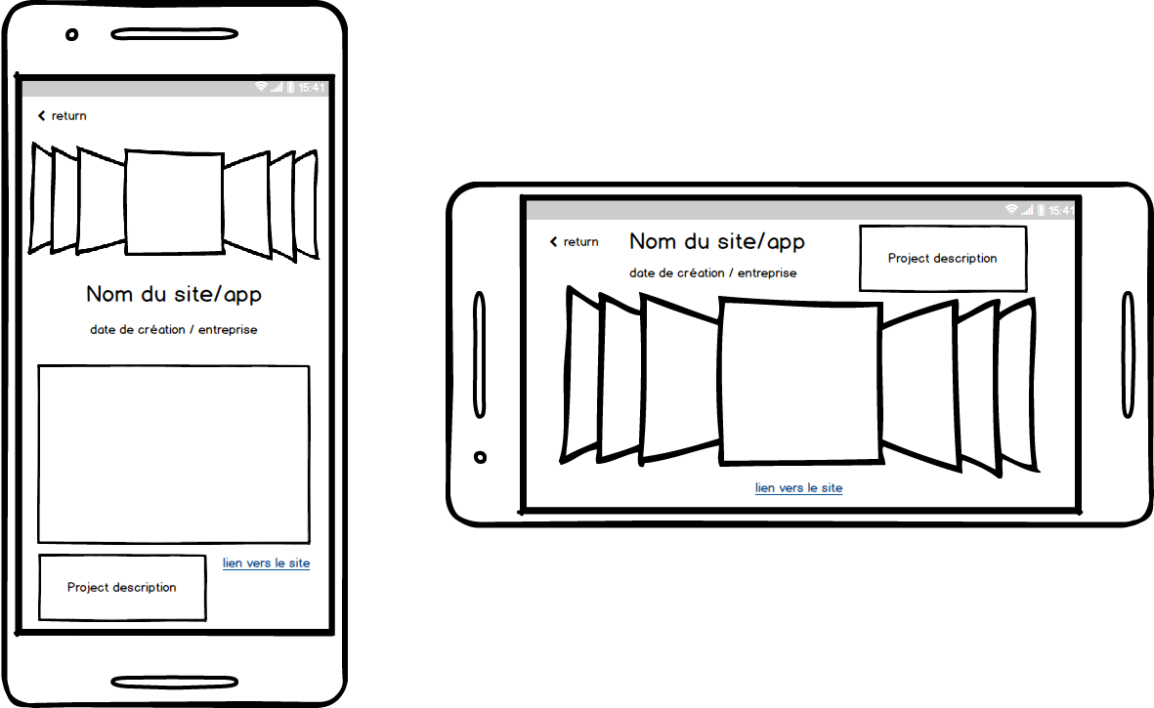

Finally there is the form which stays, once again, sober so it’s easy to access.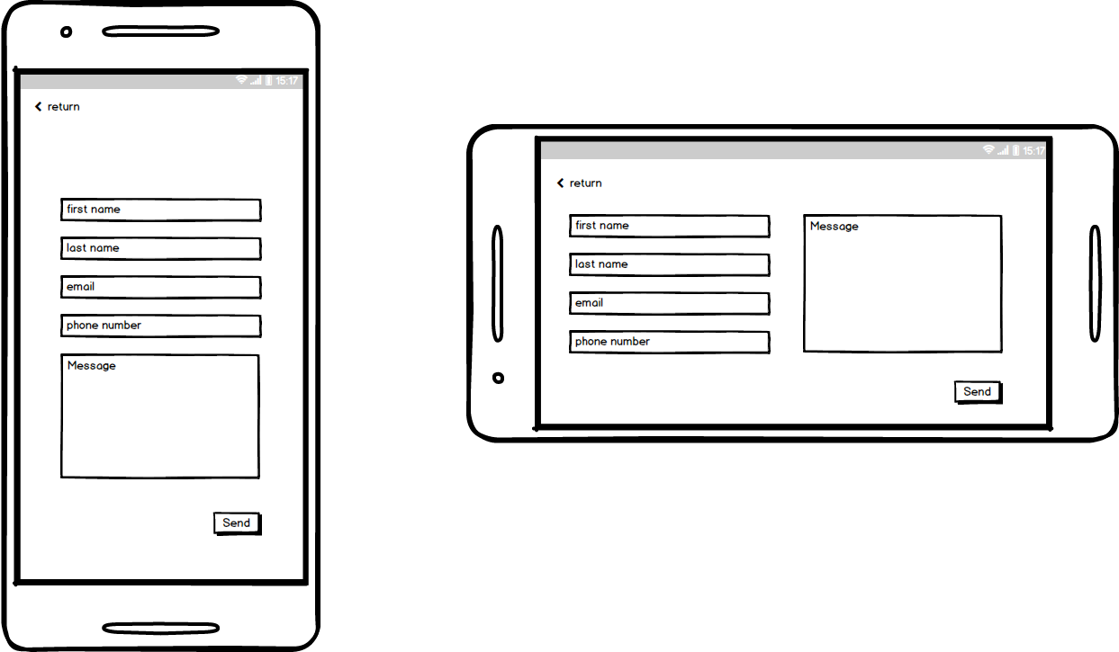

And that’s about it. All is not clear yet I guess, but I will add more information as the project advances more and more.