LAURIER TRADING GROUP · QUANTITATIVE FINANCE PORTFOLIO
Regime-Driven Multi-Strategy Derivatives Portfolio
Project white paper
Item | Detail
Prepared by | Armaan Gandhara, Portfolio Manager, LTG Quant
Date | October 26, 2026
Status | Draft v1
Target deliverable | Fully backtested, tradable system by April 2027
Internal working document. Not investment advice. All figures and allocations shown are illustrative unless stated otherwise.

Contents
1. Executive summary 1
2. Why this project 1
3. System architecture 1
4. The regime engine 1
4.1 Model 1
4.2 From probabilities to allocations 1
5. Strategy sleeves 1
5.1 Sleeve A: Volatility (bets on the size of moves) 1
5.2 Sleeve B: Equity options (bets on direction) 1
5.3 Sleeve C: Cross-asset spread (bets on relationships) 1
5.4 Sleeve comparison 1
6. Defensive reserve 1
7. Risk management 1
8. Diversification profile 1
9. Key risks and mitigations 1
10. Scope 1
10.1 In scope for April 2027 1
10.2 Out of scope this term 1
11. Roadmap and deliverables 1
12. Questions for PMs 1
Appendix A. Glossary 1
Appendix B. Recommended reading 1

1. Executive summary
We propose a multi-strategy portfolio controlled by a central regime engine. The engine estimates the probability that the market is in each of several hidden states (for example calm, stressed or inflationary) and uses those probabilities to allocate capital across three derivatives-heavy strategy sleeves and a defensive reserve. A portfolio-wide risk layer caps combined exposure and cuts risk immediately in sudden shocks.
Each sleeve bets on something different: the volatility sleeve on the size of moves, the equity options sleeve on direction, and the cross-asset spread sleeve on relationships between markets. Combining low-correlation return streams under one allocator is the core multi-strategy idea: the portfolio can achieve a better risk-adjusted return than any sleeve alone.
At a glance
Brain: hidden Markov model regime engine; continuous, probability-weighted allocations.
Sleeves: volatility (A), equity options incl. leveraged-ETF wheel (B), Kalman-filtered cross-asset spread (C).
Protection: defensive reserve (T-bills, gold, cash, tail hedge) plus aggregate risk caps and a VIX circuit breaker.
Horizon: daily to weekly decisions on liquid, IBKR-tradable instruments.

2. Why this project
Criterion | How this project delivers
Real quant depth | Latent-state models (HMM), state-space filtering (Kalman), volatility forecasting and surfaces, Greeks, constrained portfolio optimisation.
Modular | Each component can be built, tested and presented on its own, matching bi-weekly milestones.
Multi-strategy payoff | Sleeves target different risk premia, so combined Sharpe can exceed any individual sleeve.
Recruiting value | Covers macro, cross-asset, derivatives and disciplined backtesting, the areas S&T and buy-side interviews probe.

3. System architecture
The system has two layers. The top layer (the regime engine) decides how much capital each component receives. The bottom layer (the sleeves) decides what to trade within its allocation. The risk layer sits beneath everything and can override any sleeve.
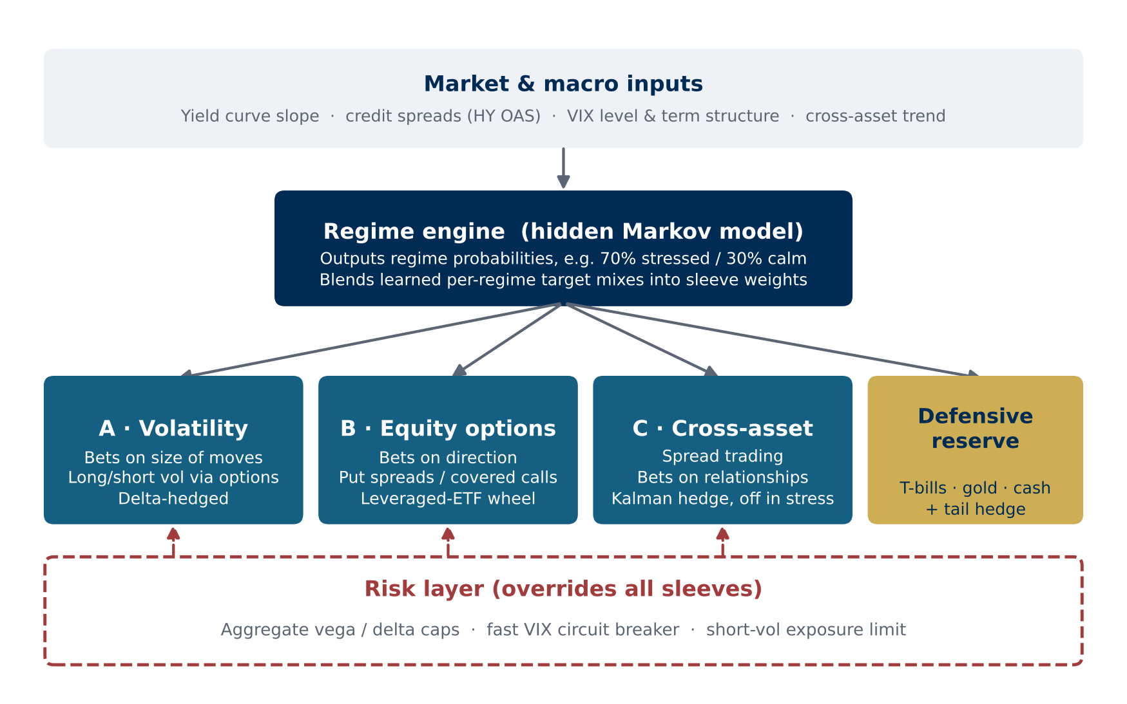
Figure 1. System architecture: inputs feed the regime engine, which allocates across three sleeves and the defensive reserve; the risk layer overrides all sleeves.

4. The regime engine

4.1 Model
The regime engine is a hidden Markov model (HMM). The market is assumed to be in one of a small number of unobservable states at any time, and to switch between them with some persistence. We never see the state directly; we only see its symptoms. The model learns what each state looks like in the data and, each day, outputs the probability of being in each state.
- Candidate inputs: 10y–2y Treasury slope, high-yield credit spreads (HY OAS), VIX level and term structure, cross-asset trend measures.
- Output: continuous probabilities, e.g. 70% stressed / 30% calm, rather than a single hard discrete label.
- Data hygiene: macro series are revised after release; the backtest should use point-in-time (as-first-published) values where available.

4.2 From probabilities to allocations
Each regime has a target mix across the sleeves and the reserve. The live allocation is the probability-weighted blend of those mixes, smoothed to limit turnover. Target mixes are learned from data: we measure how each sleeve behaves inside each historical regime, then optimise the mix. Because there are few historical stress episodes, the optimiser runs with guardrails (weight caps, shrinkage toward equal weights) to avoid overfitting.
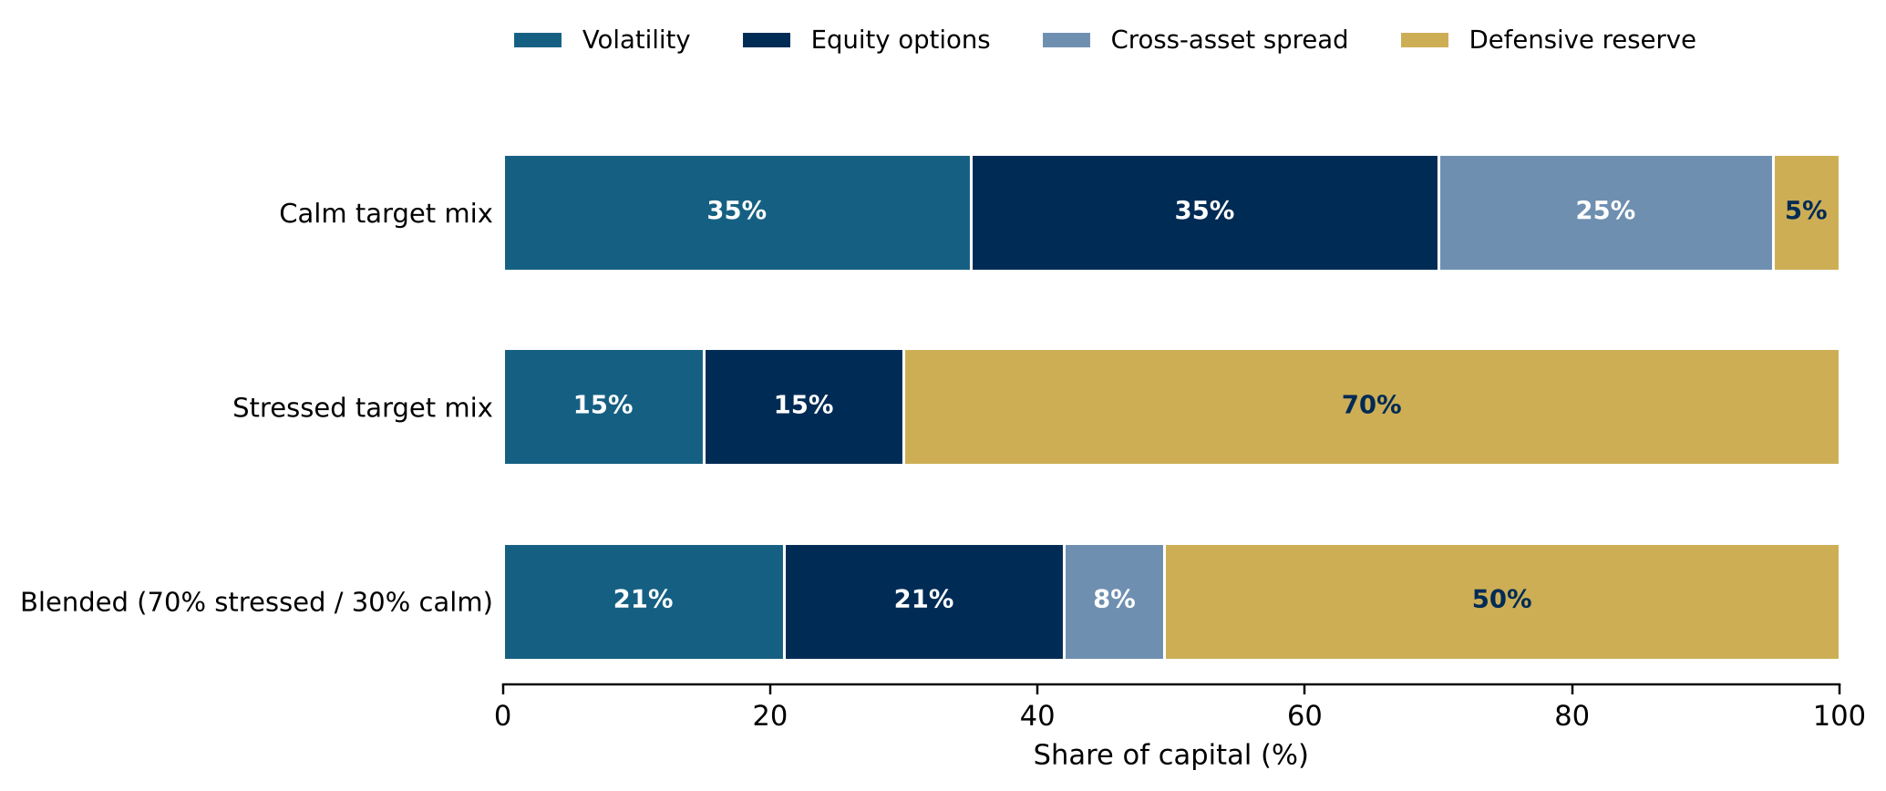
Figure 2. Illustrative blending: at 70% stressed / 30% calm, the live allocation is 70% of the stressed mix plus 30% of the calm mix. Weights shown are placeholders, not results.

5. Strategy sleeves

5.1 Sleeve A: Volatility (bets on the size of moves)
Options embed a forecast of future volatility (implied volatility). Historically, implied volatility has tended to exceed the volatility that is subsequently realised, a gap known as the variance risk premium. This sleeve forecasts realised volatility and compares it with implied volatility.
- Signal: implied vol minus forecast realised vol (HAR-RV / GARCH baseline; ML extension optional).
- Trade: sell volatility when options are rich; buy volatility when they are cheap or stress probability is rising.
- Universe: liquid options on equity indices, Treasuries, gold and oil.
- Hedging: delta-hedged so the position expresses a view on volatility, not direction.

5.2 Sleeve B: Equity options (bets on direction)
This sleeve expresses regime-appropriate equity views through options structures rather than outright stock positions.
- Stressed regime: index put spreads. These also partially hedge the rest of the portfolio.
- Calm regime: covered calls, and out-of-the-money put selling on high-volatility and leveraged ETFs (e.g. TQQQ), whose premium is rich because their volatility is high.
- Assignment handling (the wheel): if a short put is assigned, hold the shares and sell covered calls against them until an exit target is reached or the shares are called away. Exit rules are regime-dependent: continue while calm, exit when stress probability is high.
- Key risk: gap risk. TQQQ fell roughly 80% in 2022; one bad day can erase months of premium. The regime gate and risk layer exist for this reason.
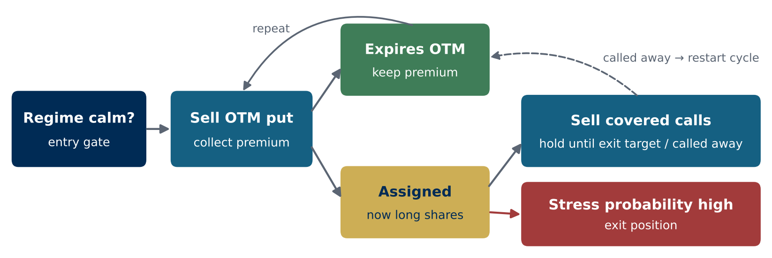
Figure 3. Leveraged-ETF put-selling wheel with regime gating at entry and regime-based exit after assignment.

5.3 Sleeve C: Cross-asset spread (bets on relationships)
Economically linked assets in different markets (for example crude oil and the Canadian dollar, or rate differentials and FX) tend to move together in a certain ratio. The residual after applying that ratio is the spread. When the spread stretches unusually wide, the sleeve bets on it closing.
- Dynamic hedge ratio: a Kalman filter re-estimates the ratio every day, so the spread is always measured against today's relationship rather than a stale historical fit.
- Pair selection: screen a broad universe, then keep only pairs that (i) have a plausible economic link and (ii) hold up on data the model never saw. This limits data-mined false positives.
- Regime switch: turned off in stress, when cross-asset relationships tend to break down.

5.4 Sleeve comparison
 | A · Volatility | B · Equity options | C · Cross-asset spread
Bets on | Size of moves | Direction | Relationships
Main instruments | Index, rates, gold, oil options | Index options; leveraged-ETF puts/calls | Futures, FX, ETFs
Core maths | Vol forecasting, Greeks, vol surface | Payoff structuring, assignment logic | Kalman filter, cointegration
Active regime | All (long or short vol) | All (structure varies) | Calm / normal only
Main risk | Vol spikes when short vol | Gap risk on leveraged ETFs | Relationship breakdown

6. Defensive reserve
The defensive reserve is deliberately not a sleeve. It runs no strategy and seeks no edge; it is a parking spot the regime engine moves capital into as stress rises. Keeping it plain is the point: in a genuine crisis, correlations rise, option spreads widen and complex strategies tend to fail together.
- Contents: short-term Treasury bills, gold, cash, and a small permanent tail hedge (out-of-the-money index puts).
- Why not bonds alone: bonds do not always hedge equities. In 2022 stocks and bonds fell together, so gold and cash are included alongside T-bills.

7. Risk management
In calm regimes, Sleeves A and B can both be short volatility at the same time. A sudden shock would hit both together. The regime engine reacts over days, which is too slow on its own, so the risk layer adds fast, portfolio-wide controls.
Control | What it does | Speed
Aggregate exposure caps | Sums net vega and delta across all sleeves; caps total short-volatility exposure. | Continuous
VIX circuit breaker | A sharp VIX jump immediately cuts short-volatility positions, independent of the HMM. | Same day
Regime de-risking | Rising stress probability shifts capital from sleeves into the defensive reserve. | Days
Permanent tail hedge | OTM index puts in the reserve pay off while sleeves lose, buying time. | Always on
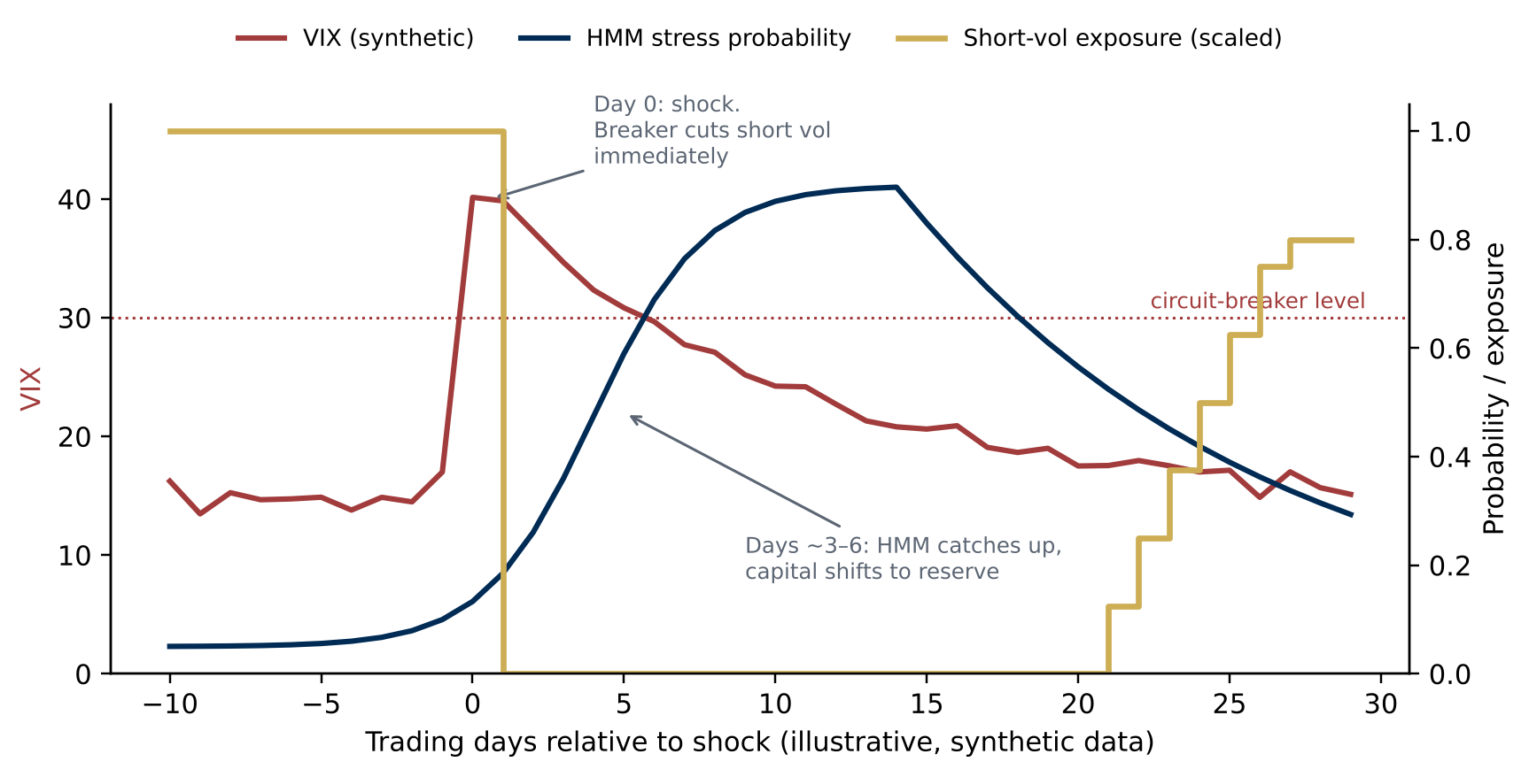
Figure 4. Illustrative shock response (synthetic data): the circuit breaker cuts short-vol exposure on the day of the shock; the HMM recognises the stress regime a few days later; exposure is rebuilt gradually as conditions normalise.

8. Diversification profile
Component | Bets on | Typical behaviour in a crash
Volatility sleeve | Size of moves | Loses if short vol; gains if long. Circuit breaker cuts short vol.
Equity options sleeve | Direction | Stress-mode put spreads offset losses elsewhere.
Cross-asset spread sleeve | Relationships | Switched off in stress.
Defensive reserve | Capital preservation | Receives capital; tail hedge pays off.

9. Key risks and mitigations
Risk | Why it matters | Mitigation
Few regime episodes | Easy to overfit a model that looks brilliant in-sample | Strict out-of-sample testing; few states; weight guardrails
Regime detection lag | Shifts are recognised after part of the move | Fast VIX circuit breaker; permanent tail hedge
Data revisions | Revised macro data leaks future information | Point-in-time data where possible; document gaps
Options data availability | IBKR provides no history for expired options; Bloomberg has download limits | Plan sourcing early; model-repriced backtest with stated limits
Costs and crowding | Known relationships may have little edge after costs | Realistic cost model; out-of-sample pair validation
Crisis correlation | Derivatives strategies can fail together | Defensive reserve; aggregate short-vol cap

Appendix A. Glossary
Term | Plain-English meaning
Hidden Markov model (HMM) | Model that infers which unobservable 'mood' the market is in from observable data, as probabilities.
Kalman filter | Method for tracking a quantity you cannot observe directly (e.g. a hedge ratio), updated as each new data point arrives.
Implied vs. realised volatility | Volatility priced into options vs. volatility the market actually delivers.
Variance risk premium | The tendency for implied volatility to exceed realised volatility; the source of option sellers' long-run edge.
Delta / vega | Option sensitivity to the underlying's price / to implied volatility.
Delta-hedging | Offsetting directional exposure so a position isolates a view on volatility.
The wheel | Sell puts; if assigned, hold shares and sell covered calls; repeat.
Out-of-sample | Testing a model on data it was not fitted on; the main defence against overfitting.

Appendix B. Recommended reading
- Kritzman, Page and Turkington (2012), “Regime Shifts: Implications for Dynamic Strategies,” Financial Analysts Journal. Closest published analogue to the regime engine; read first.
- Ang and Timmermann (2011), “Regime Changes and Financial Markets,” CEPR Discussion Paper 8480. Survey of regime-switching models and their limits.
- Carr and Wu (2009), “Variance Risk Premiums,” Review of Financial Studies. Foundation for Sleeve A.
- Israelov and Nielsen (2015), “Covered Calls Uncovered,” Financial Analysts Journal. Decomposes covered-call returns; relevant to Sleeve B.

