Documentation
CRUD Demo
Base Tabs (Before any Demo of CRUD, some pages or zoomed out to fit the entire table):
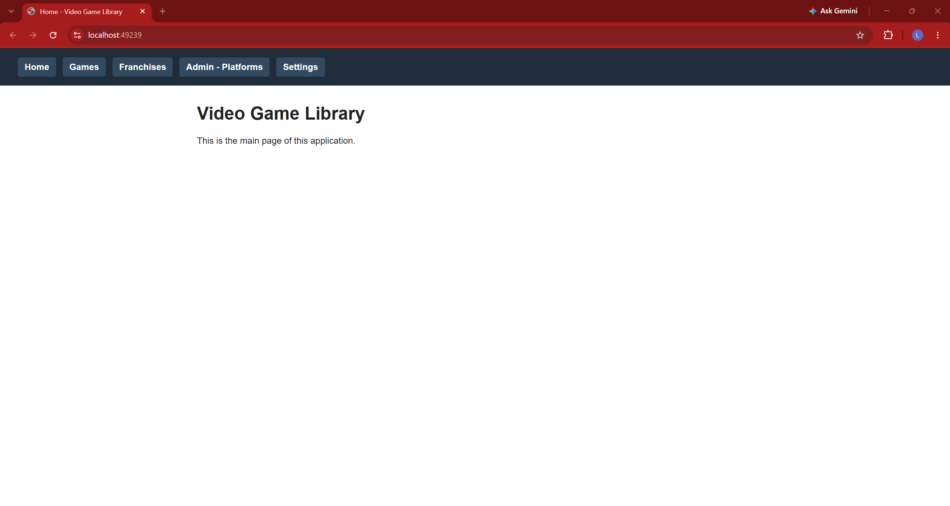
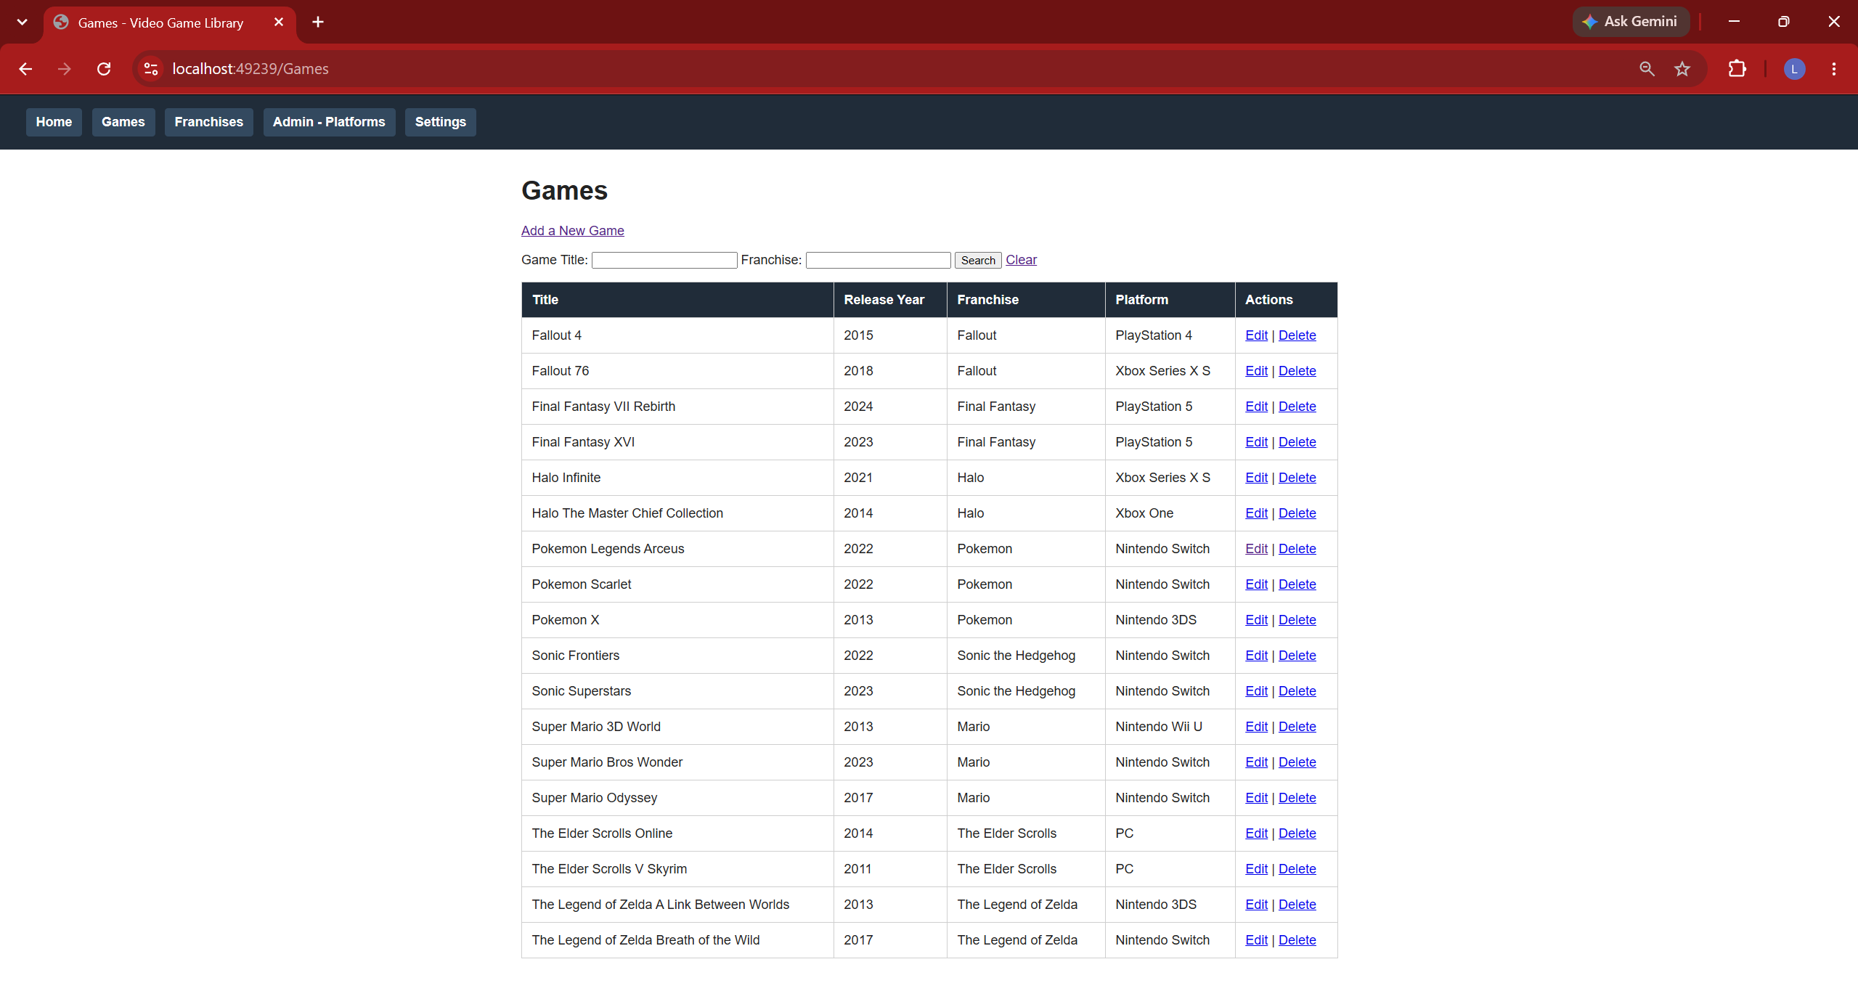
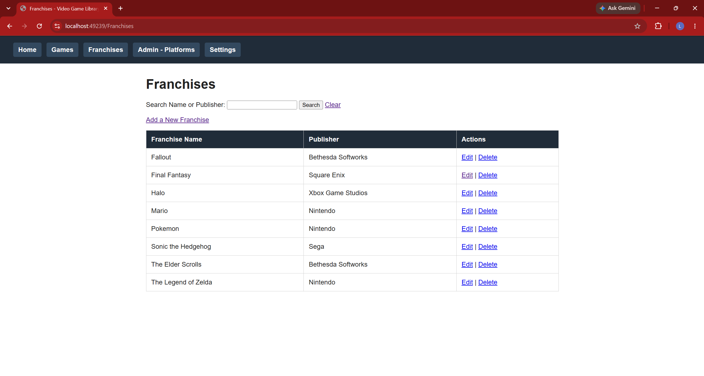
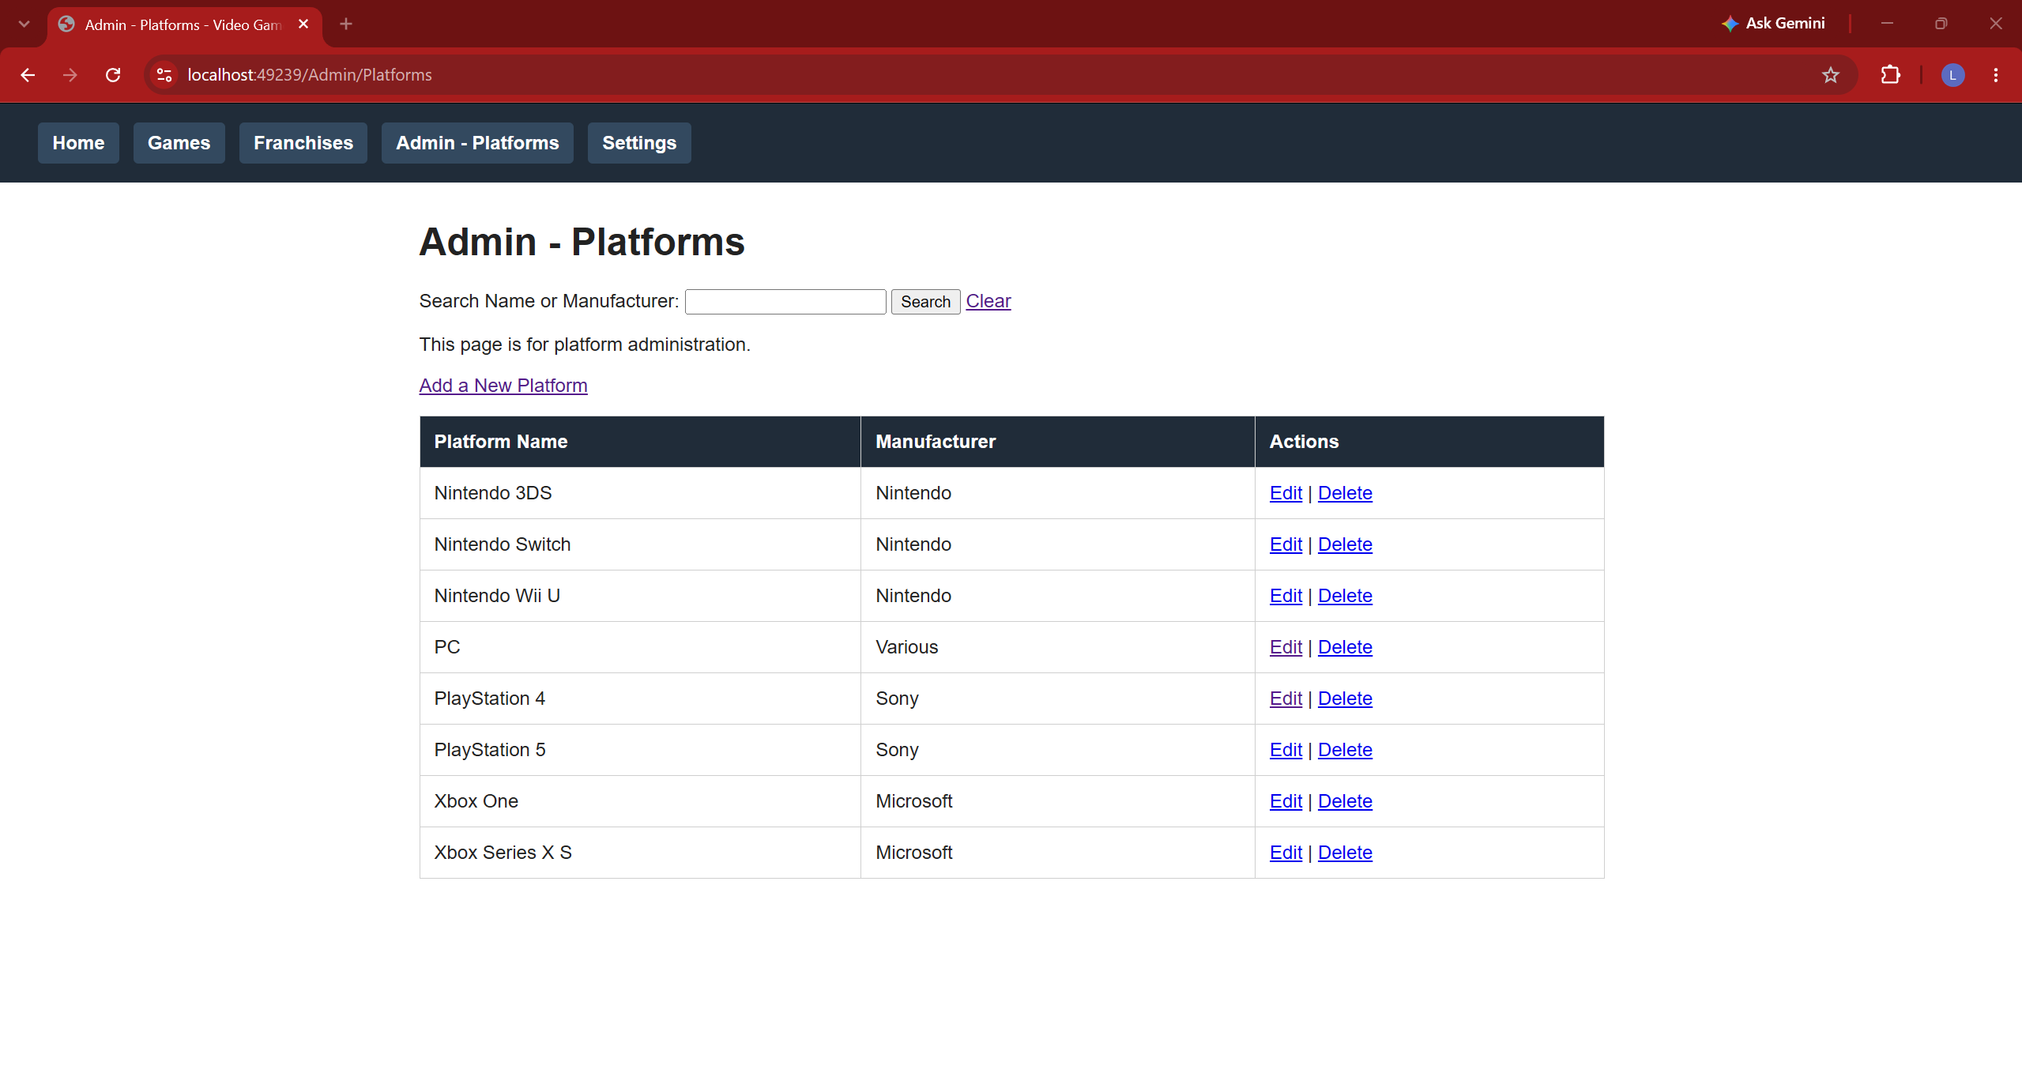
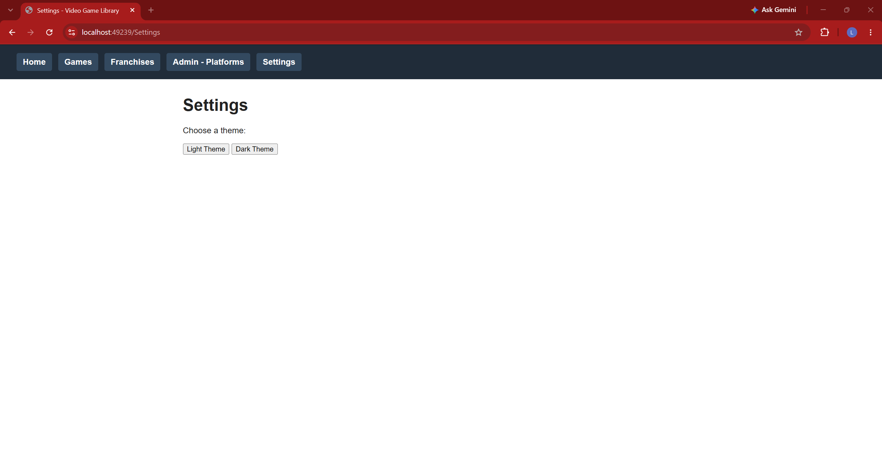

Search:
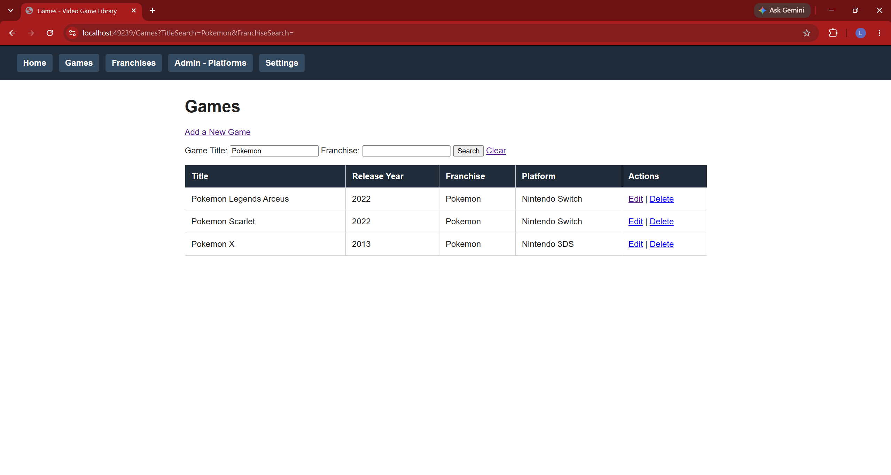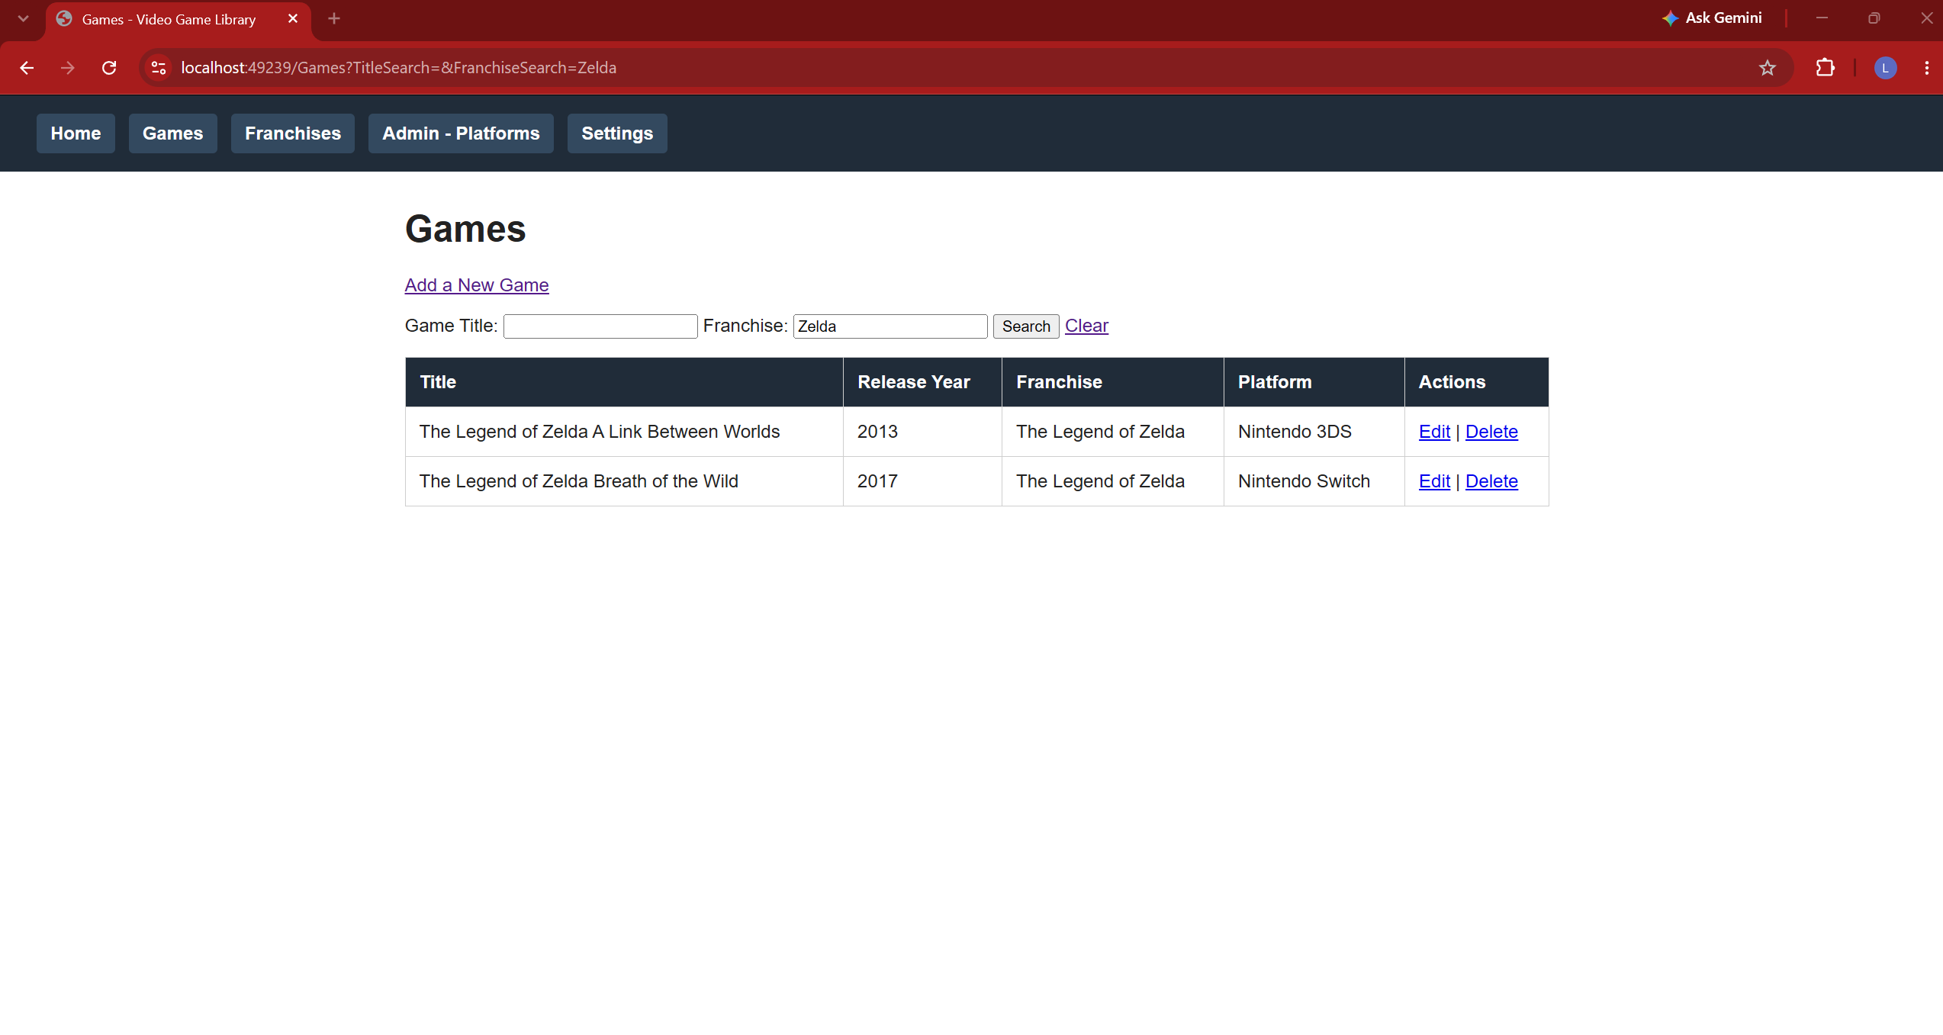
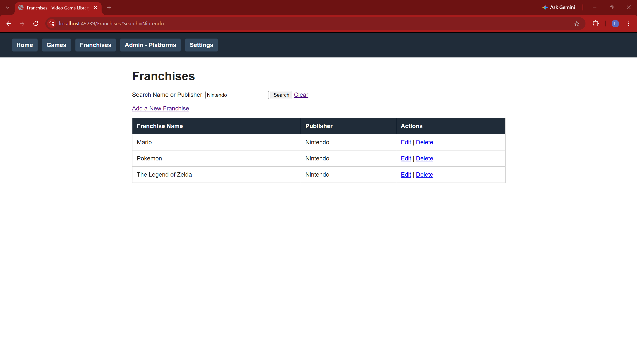
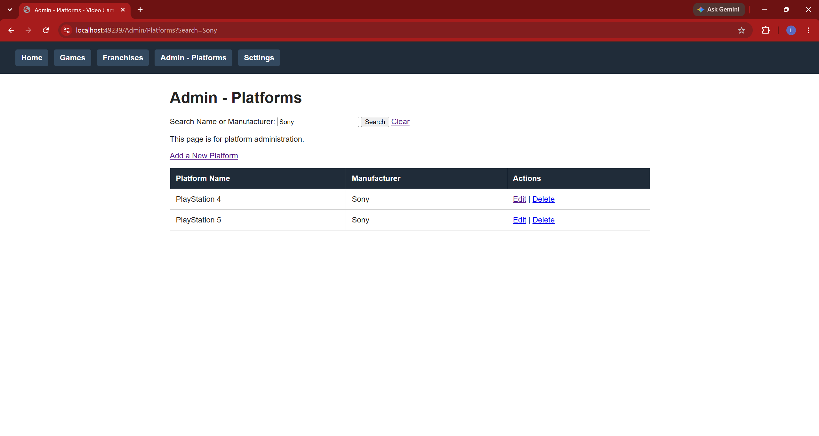

Insert:
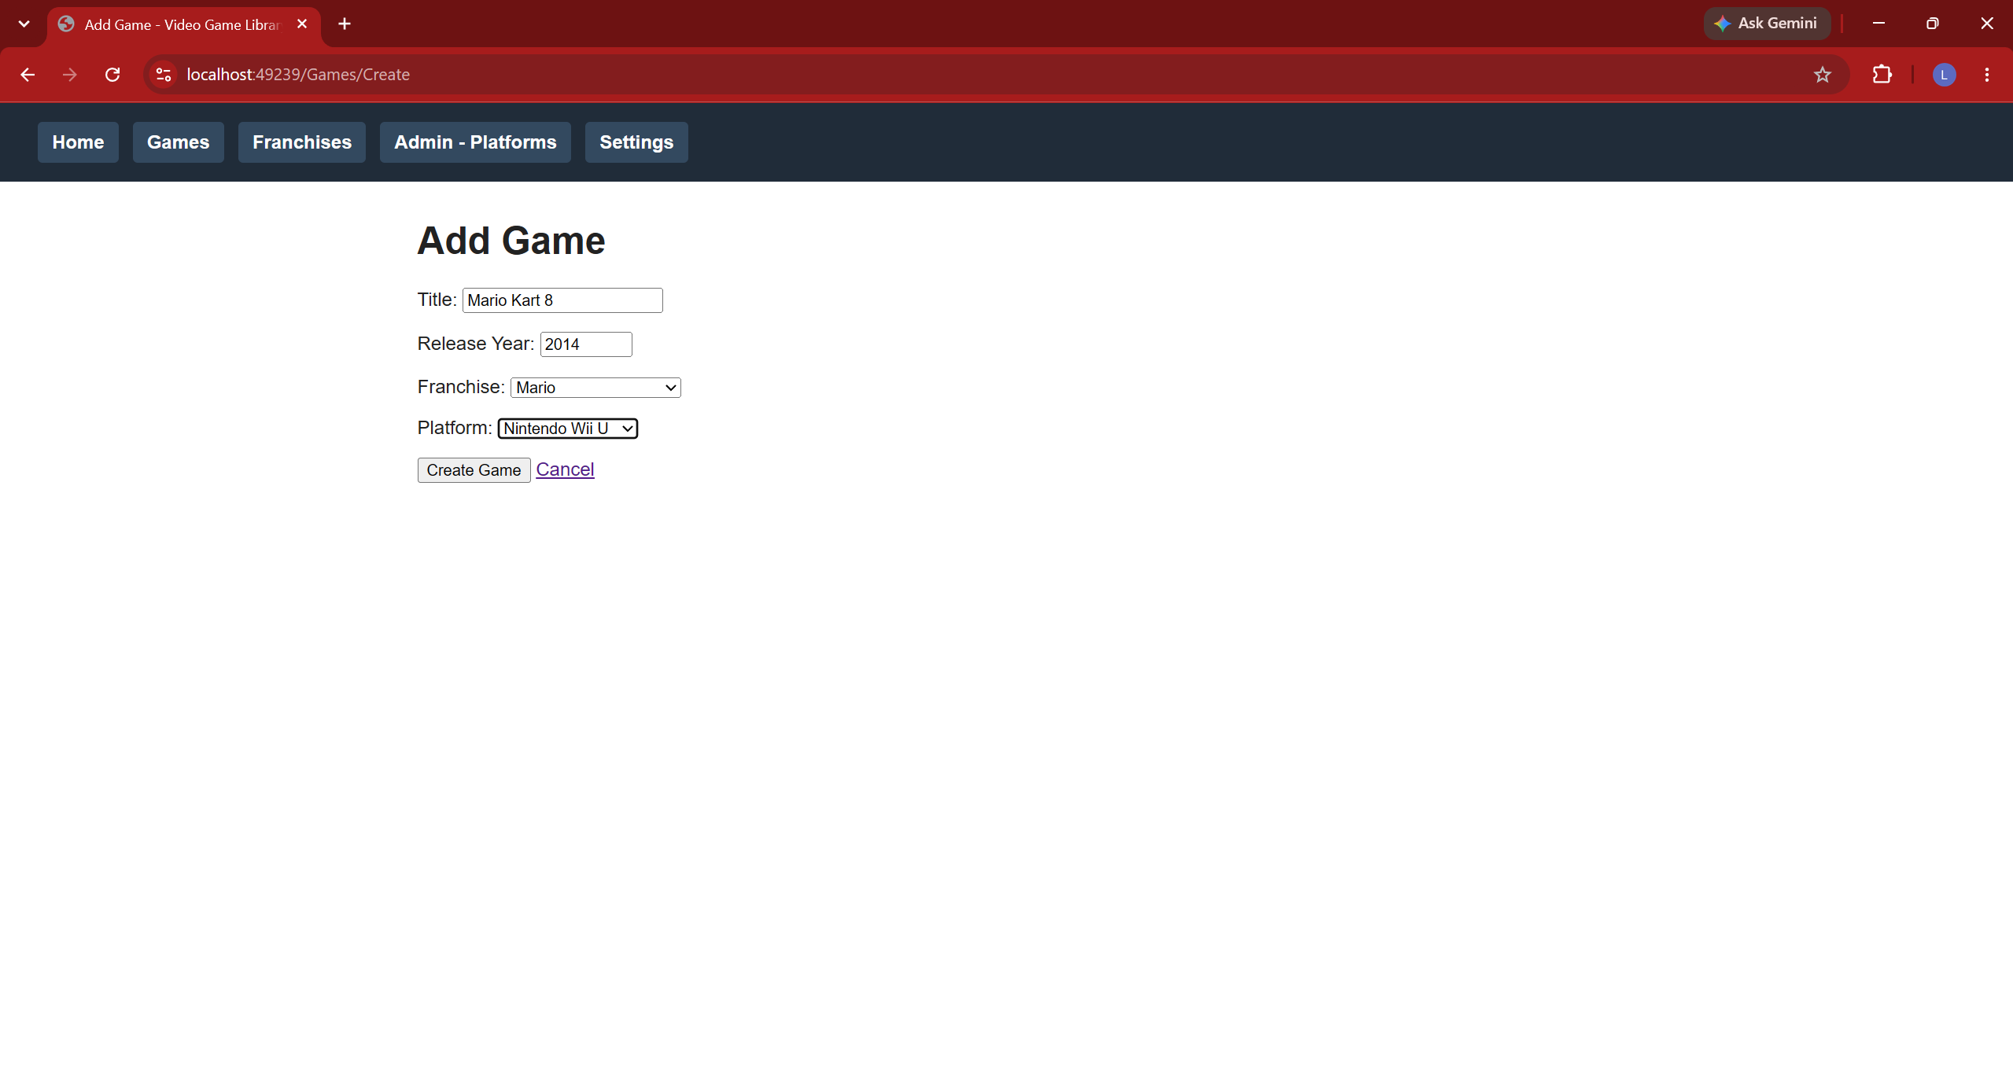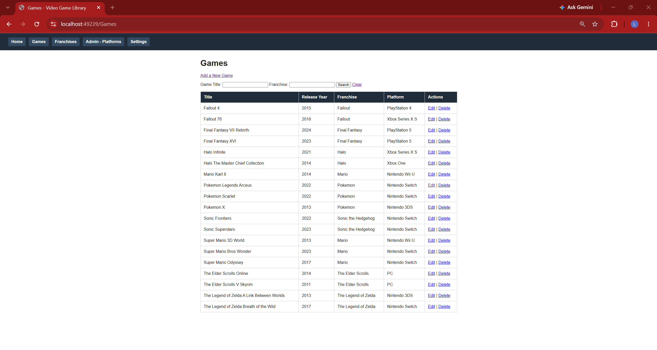
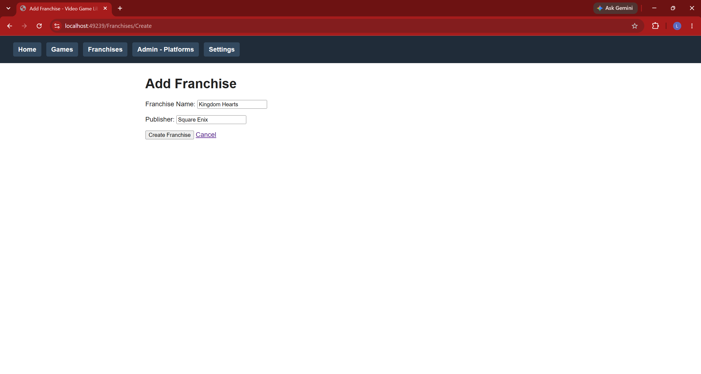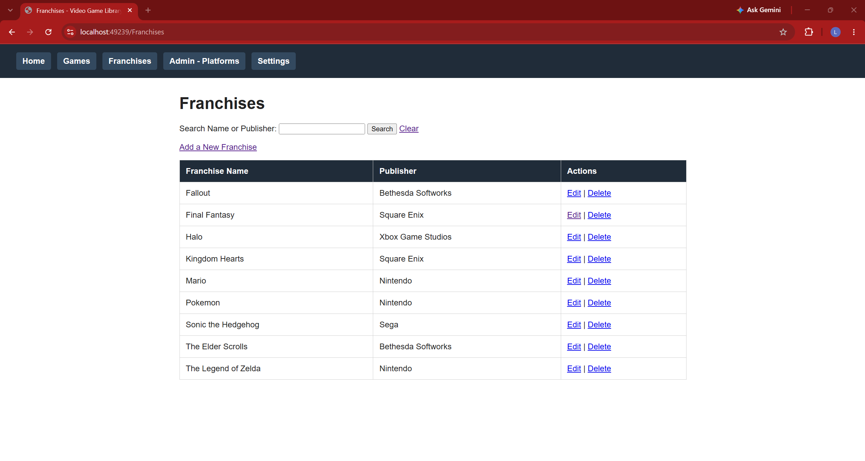
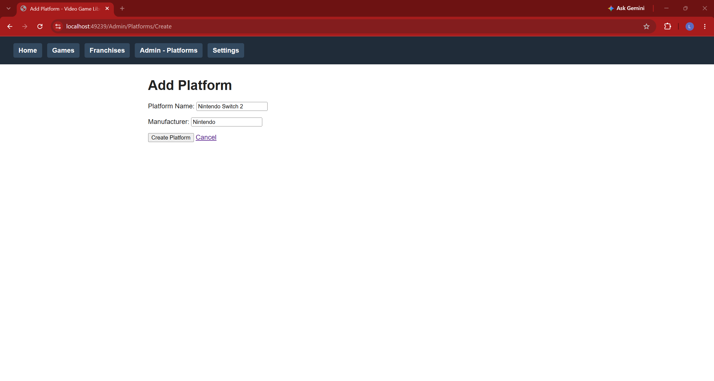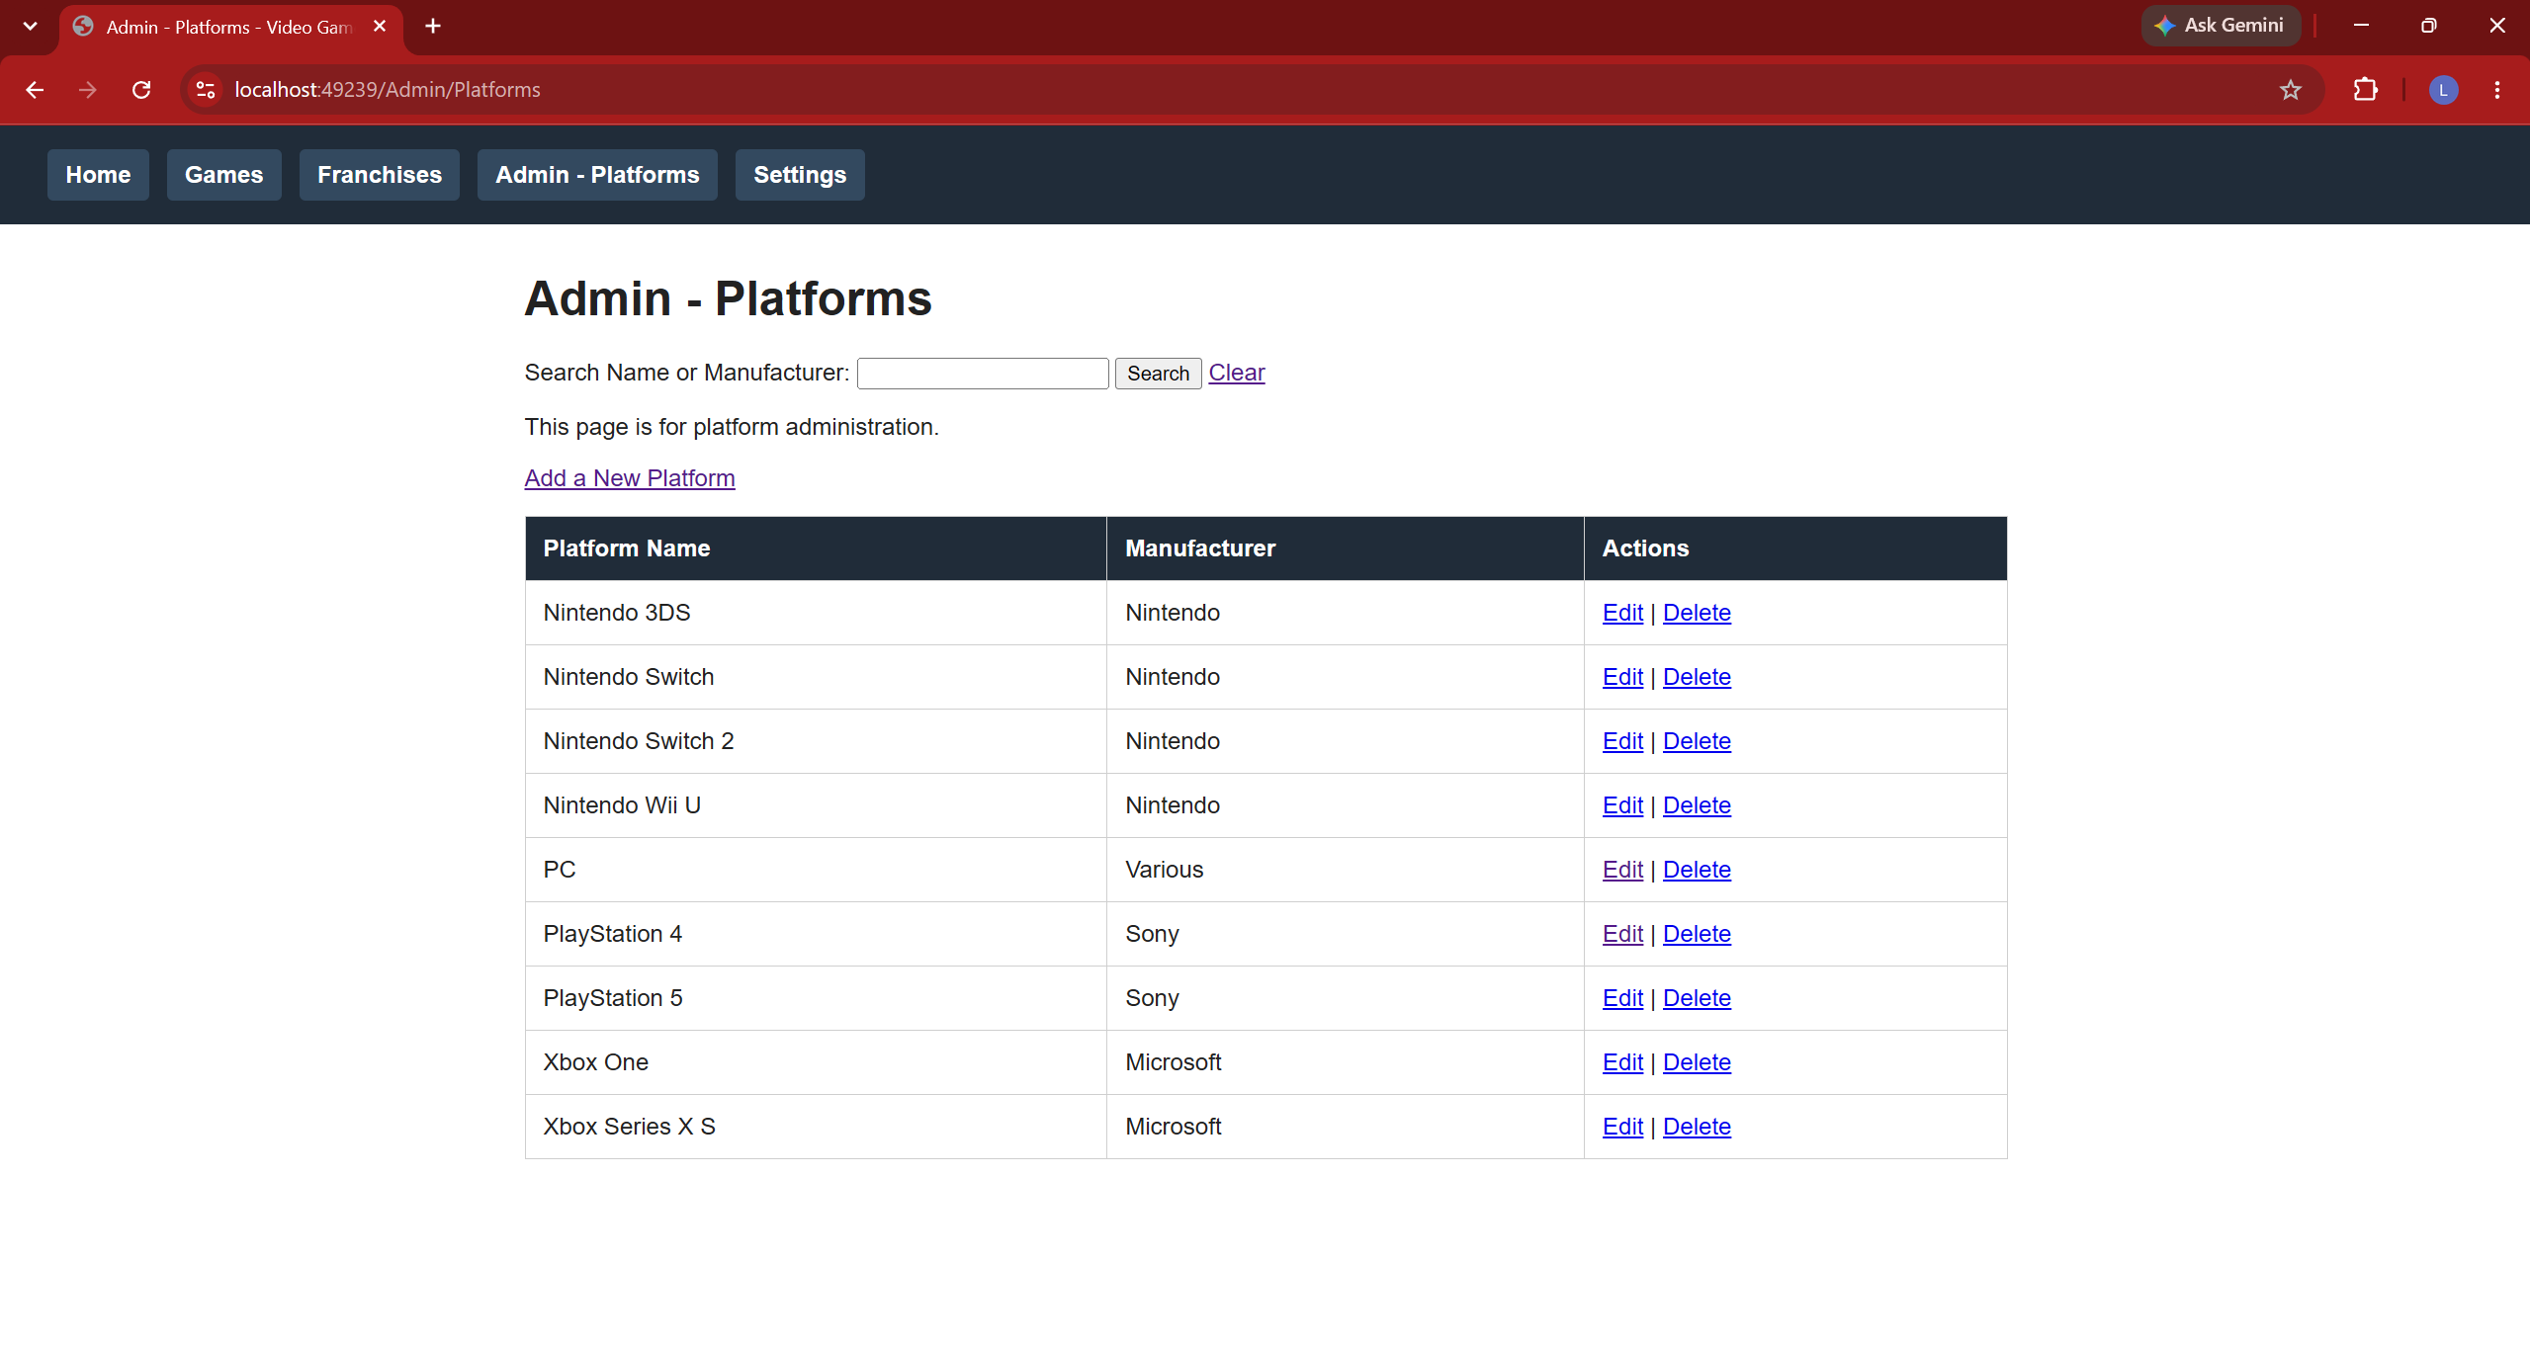

Update: (Some of these obviously aren’t correct, but I’m just demoing update)
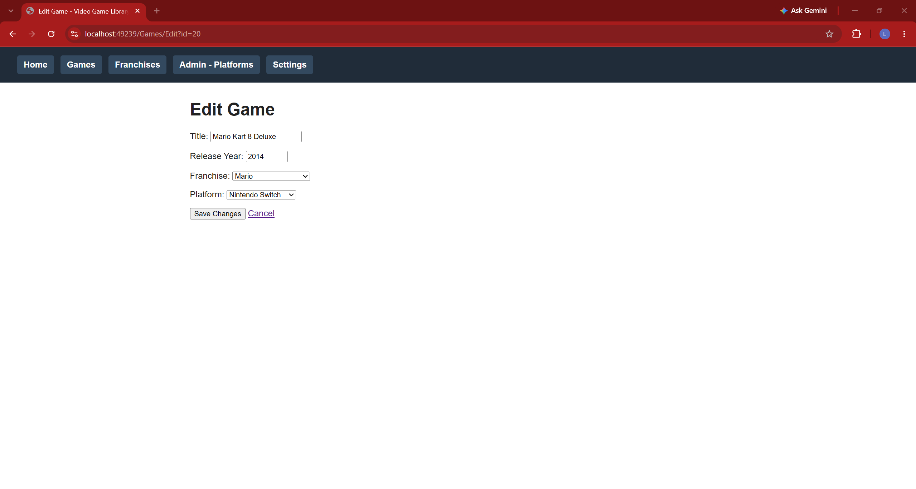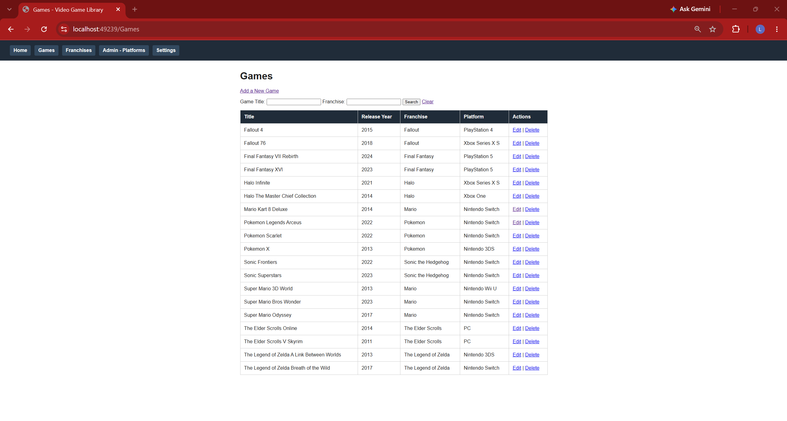
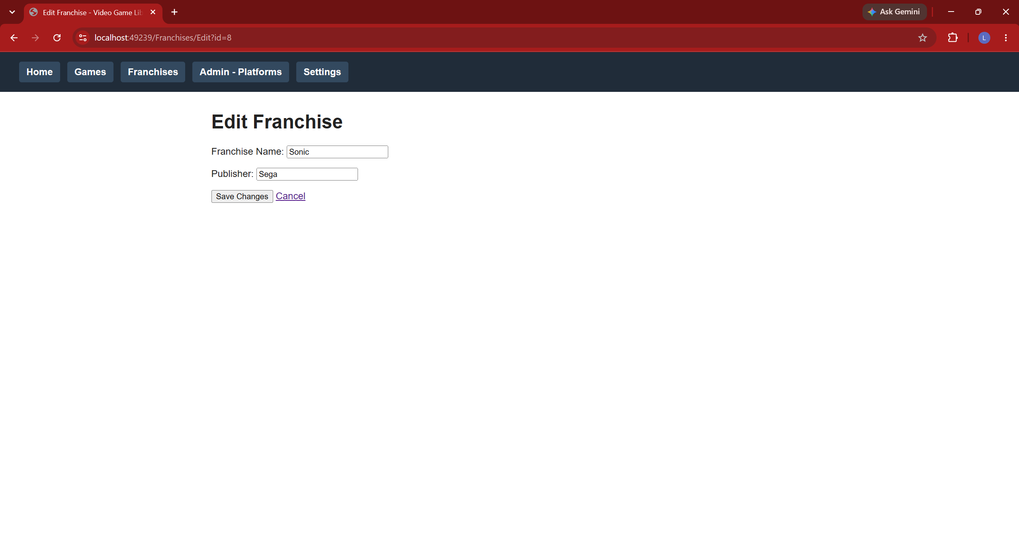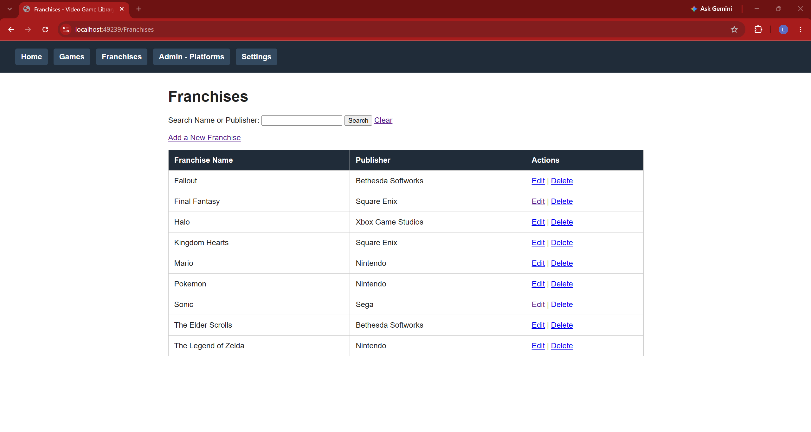
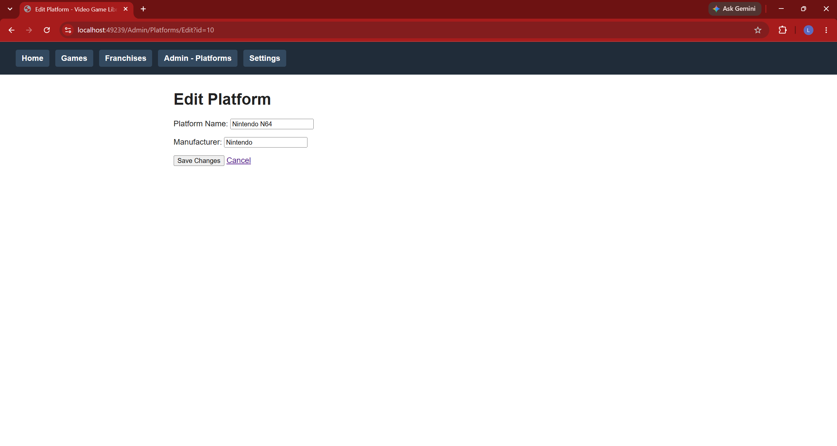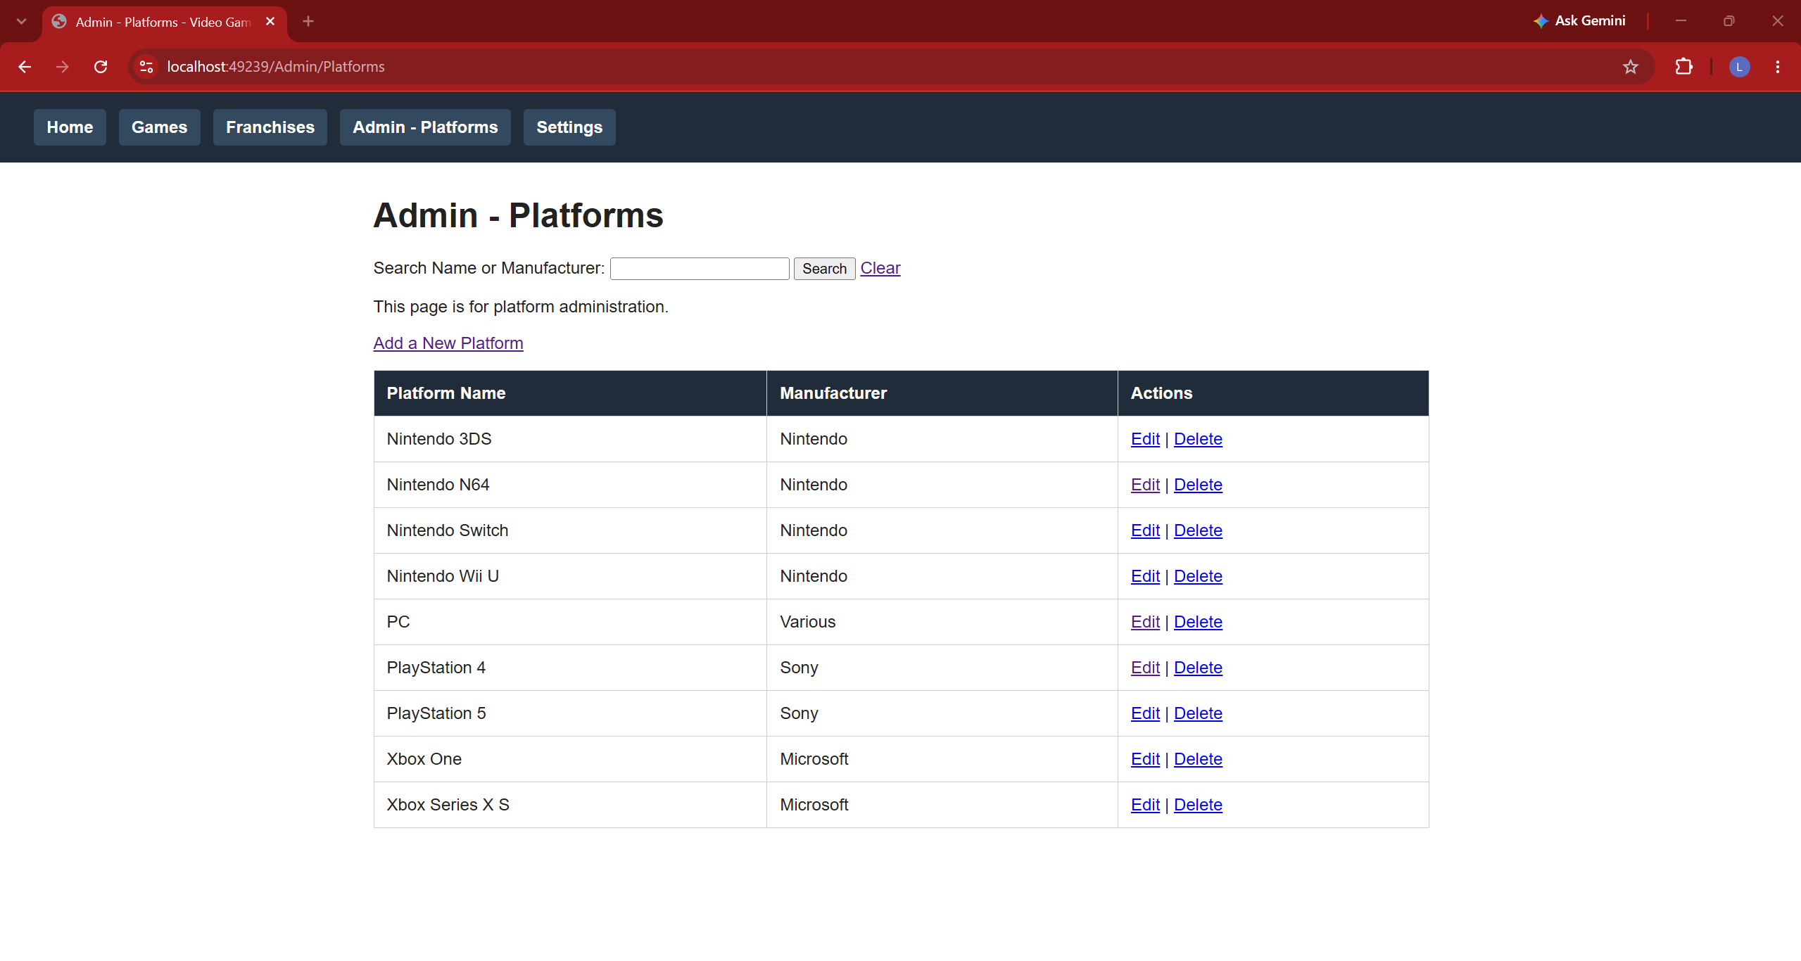

Delete:
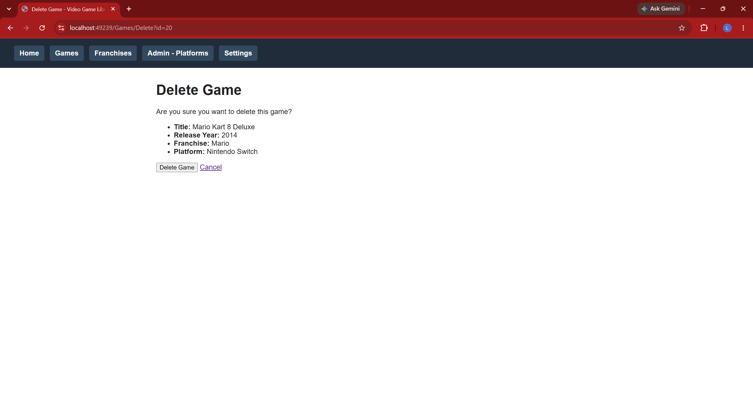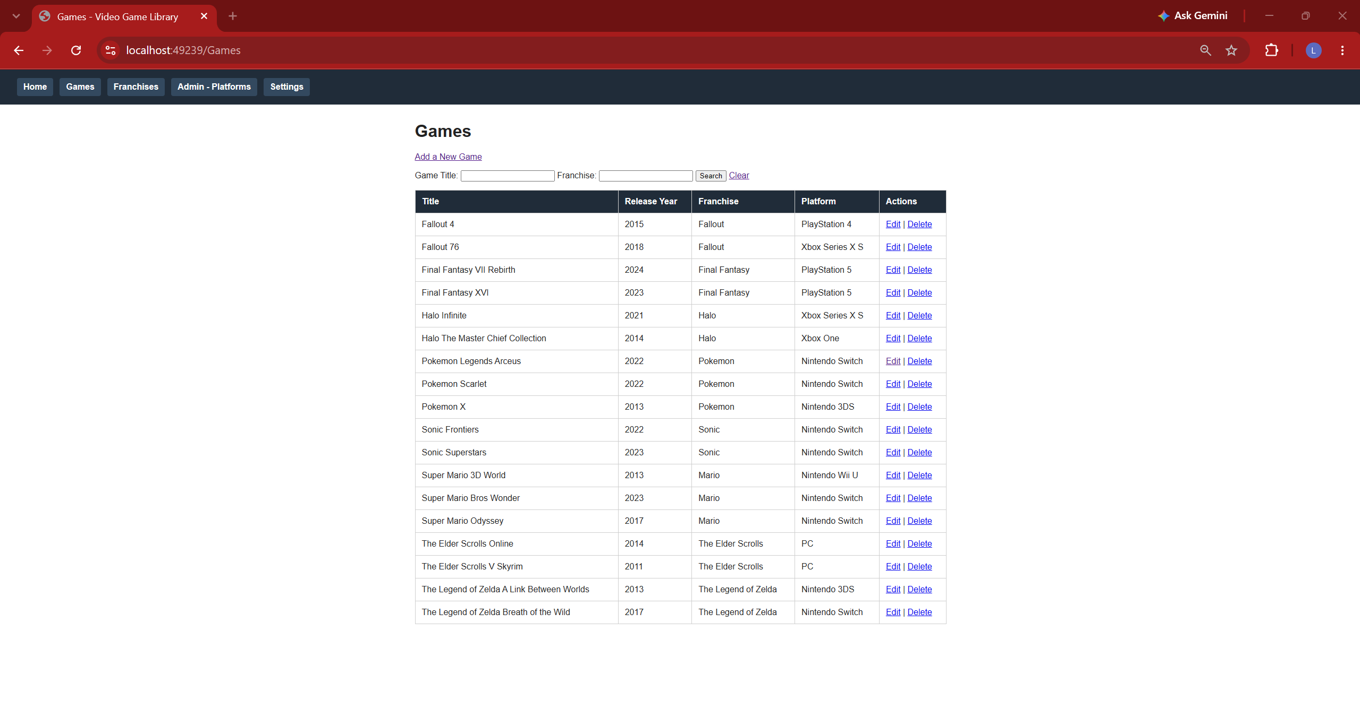
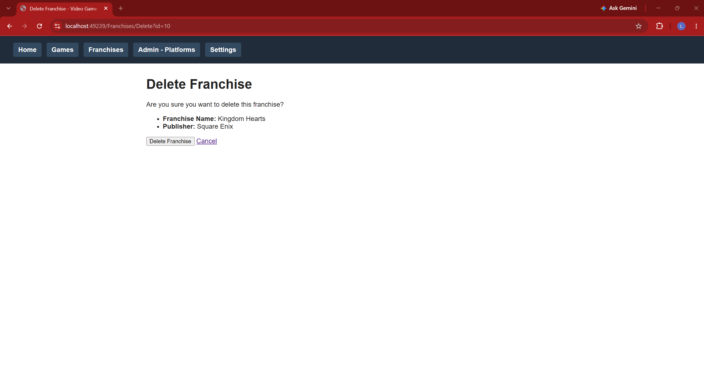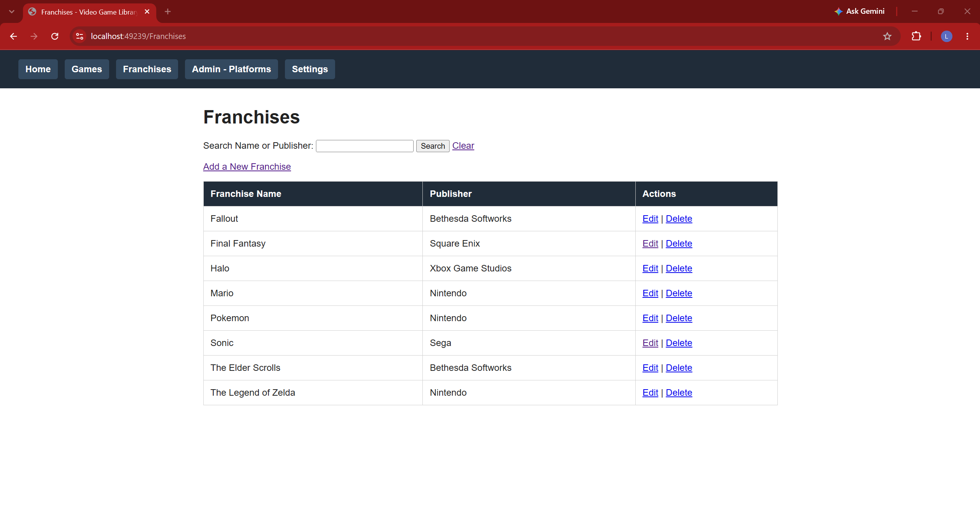
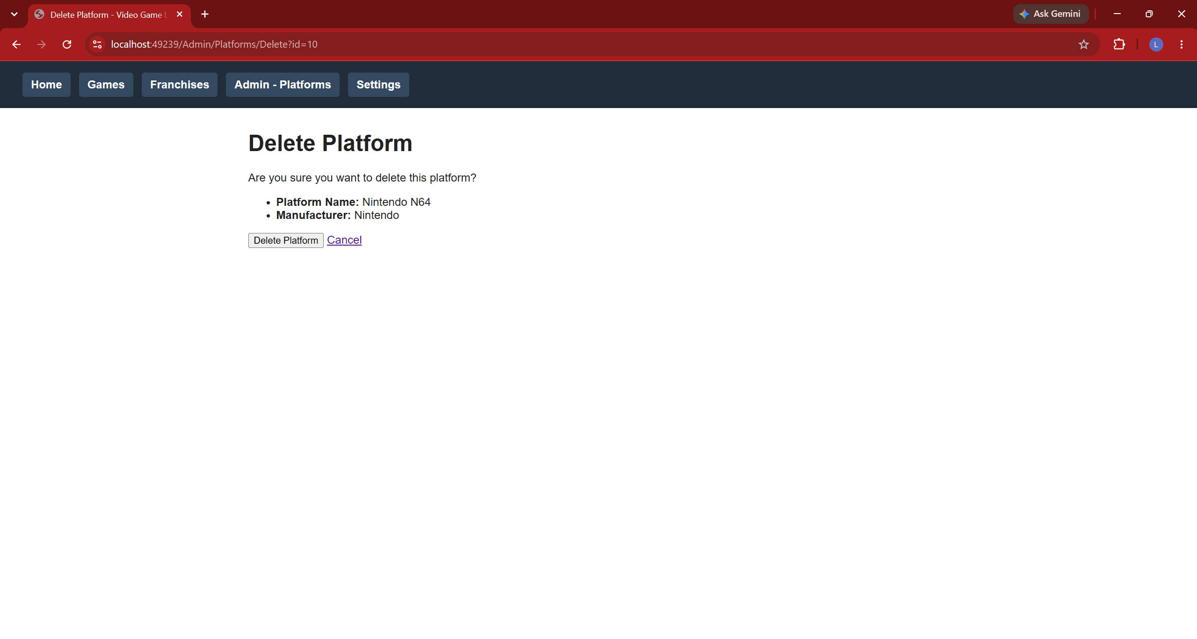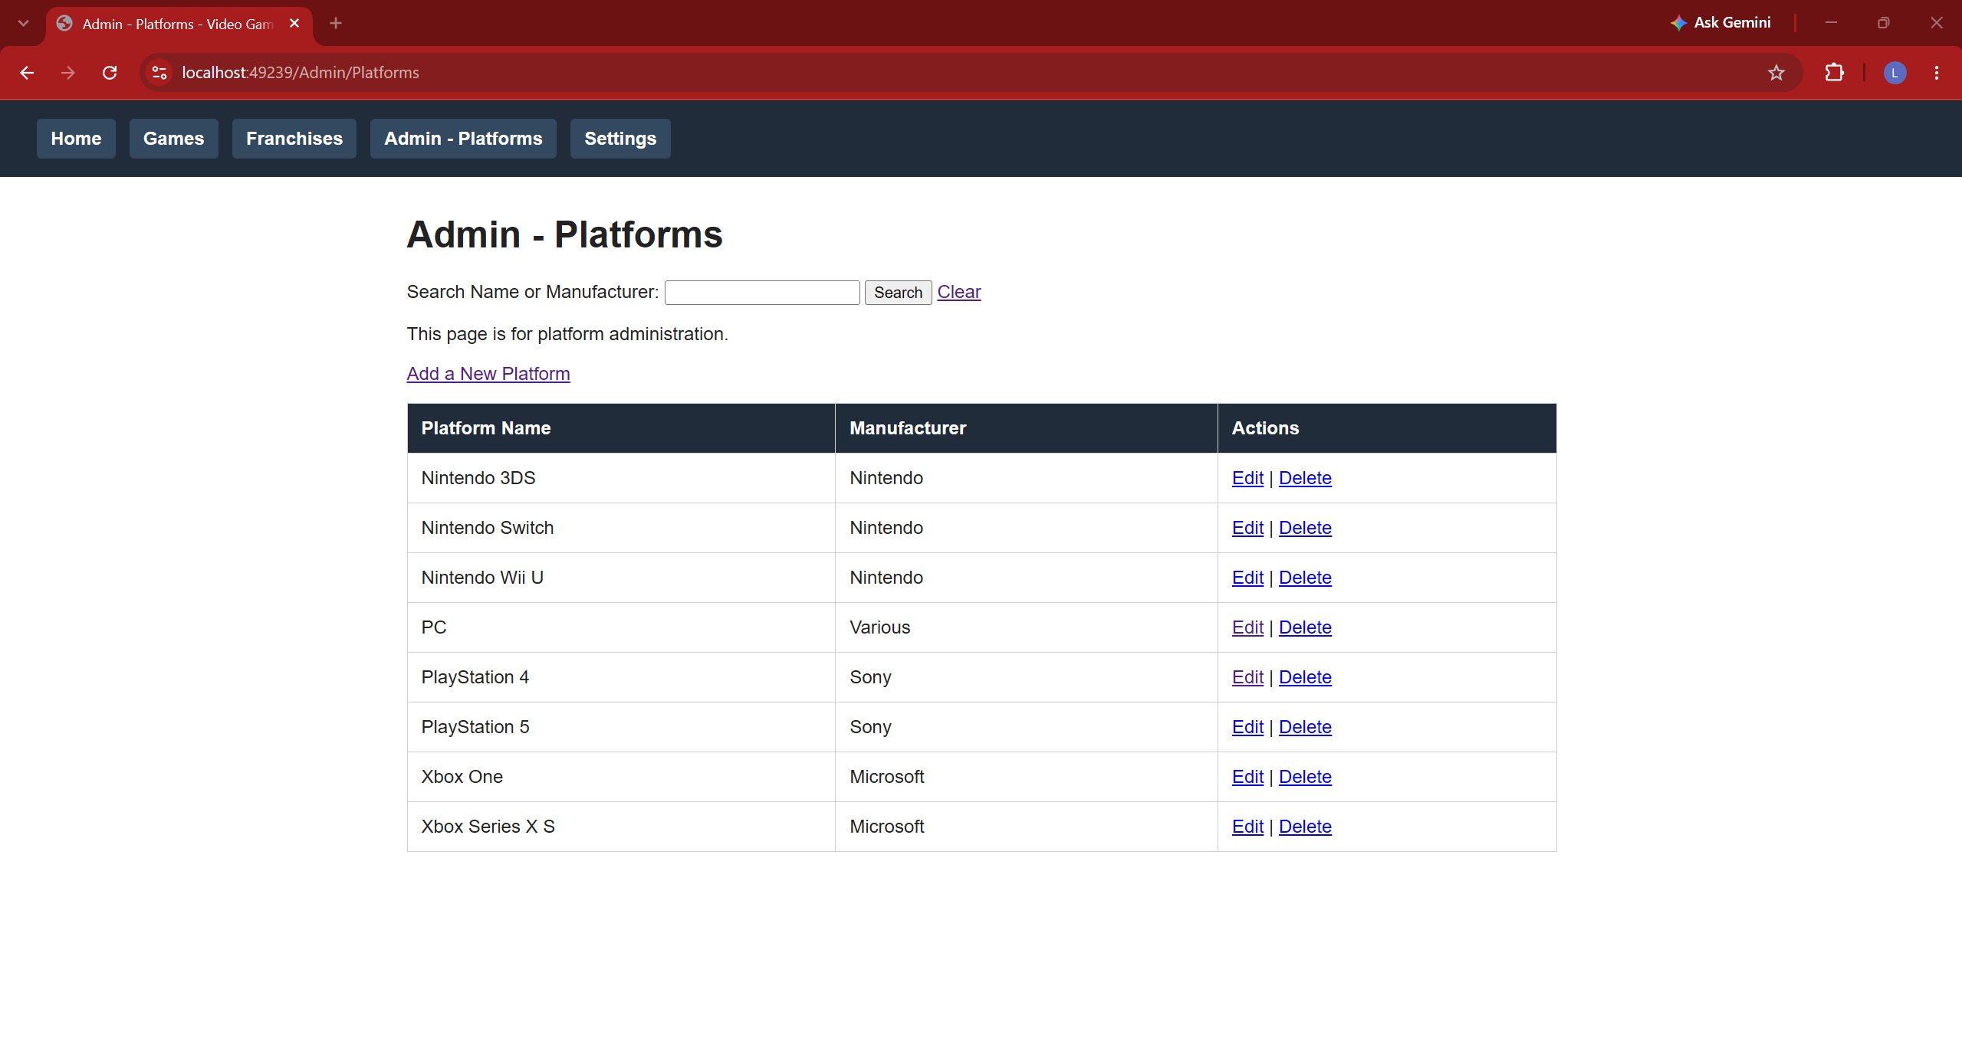

(All second images under Delete are the final tables and pages after CRUD)

Questions
- Describe a Challenge you overcame in this project.
I had to refamiliarize myself with html again and learn how to navigate different pages without directly affecting the URL. I also was still struggling with a depressive episode and had to try and take advantage of every chance I felt even a little motivation.

- Describe a technique you learned in this project.
I learned how to navigate multiple html pages on one site without directly affecting the URL.

- What more would you want to refine in your project to make it ready to sell, ship, and deploy?
I believe that adding new ways to sort data in the tables would improve this greatly. With the current implementation, if a lot of entries are shown, it may be hard to read depending on the information a user is trying to see. For example, if someone wanting to see all games by a specific publisher, they would have to search for a specific publisher or sort through the entire table if they want all entries shown. Also, alternating table row colors may add more contrast, making it easier to clearly navigate a table.

- Which technology did you choose and why?
I chose Razor Pages because it felt the most familiar and beginner friendly. I liked that each page was basically a unique file.

