Documentation
CRUD Demo
Base Tabs (Before any Demo of CRUD):
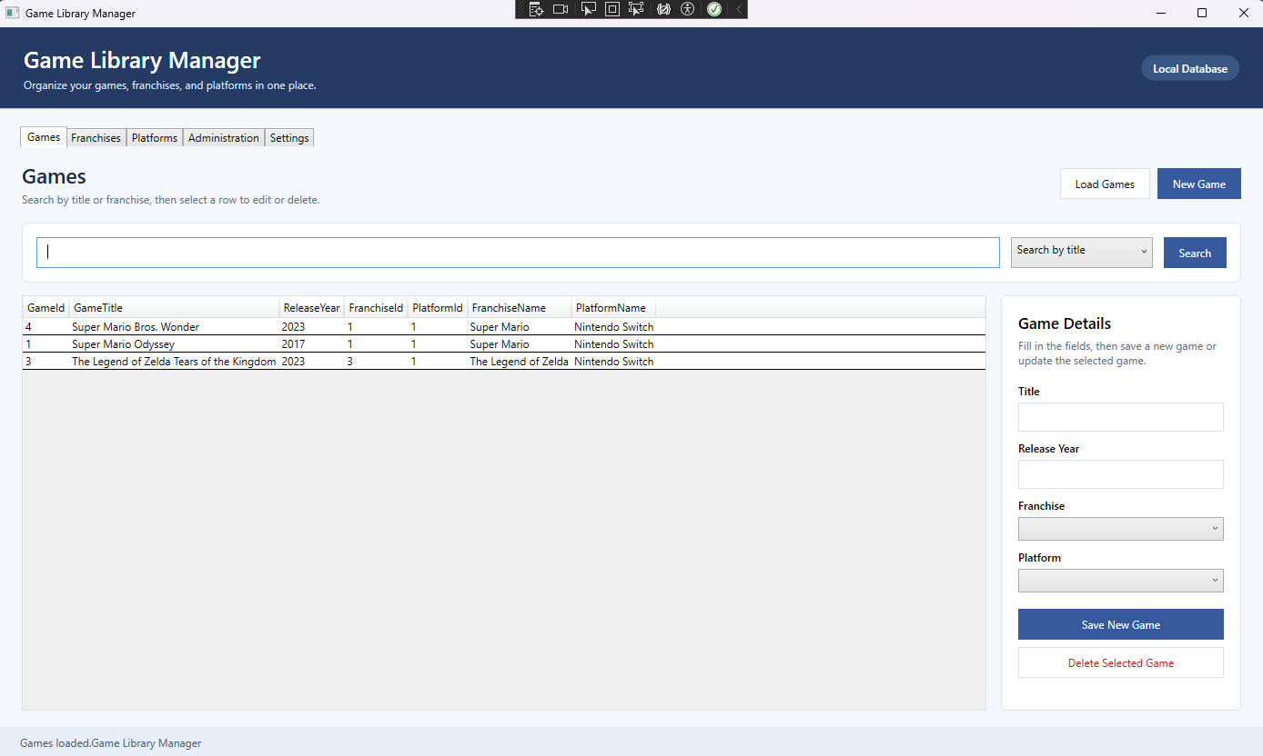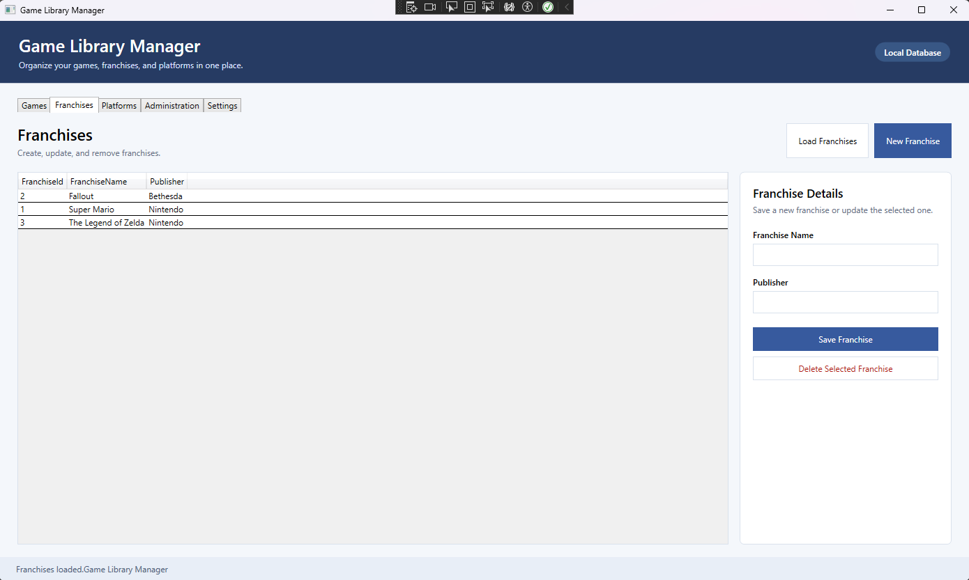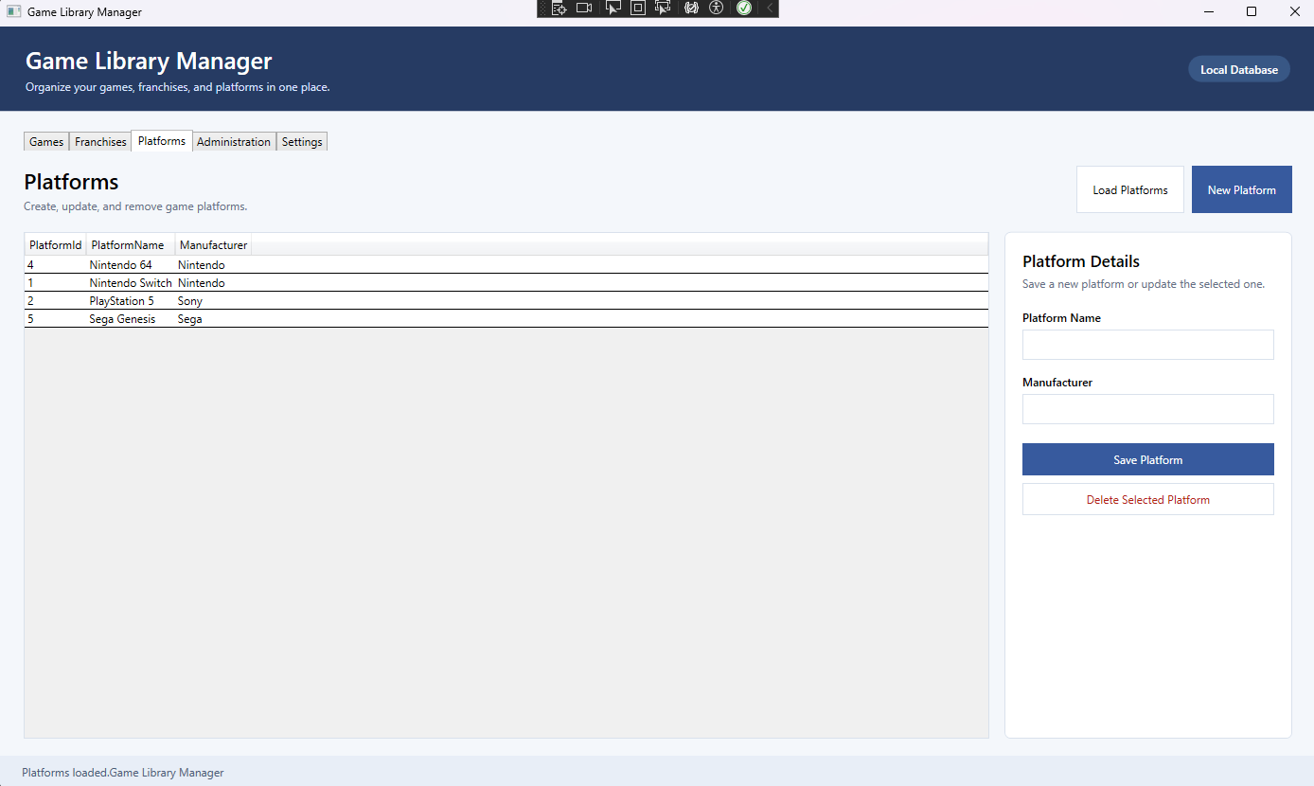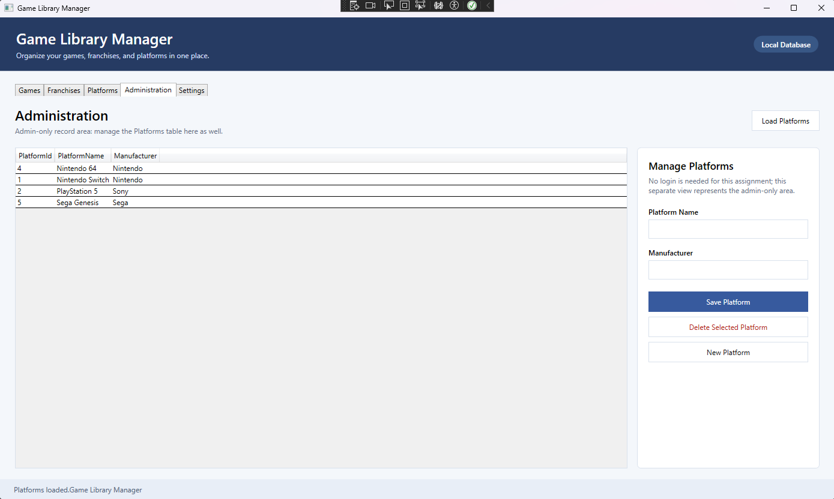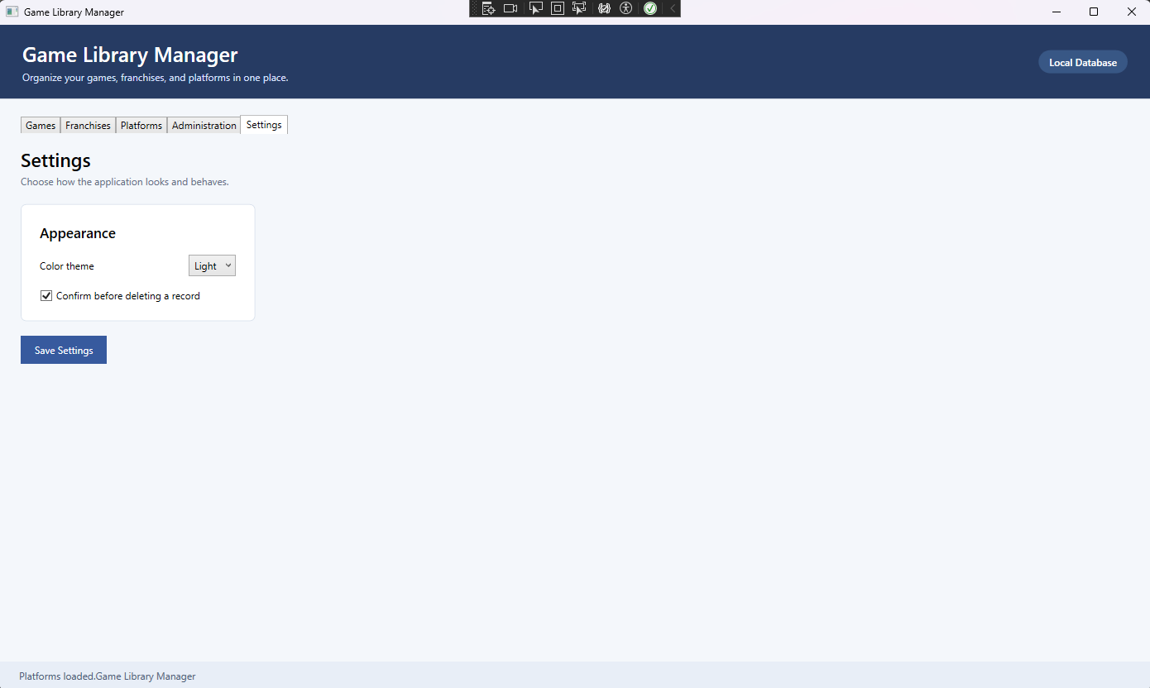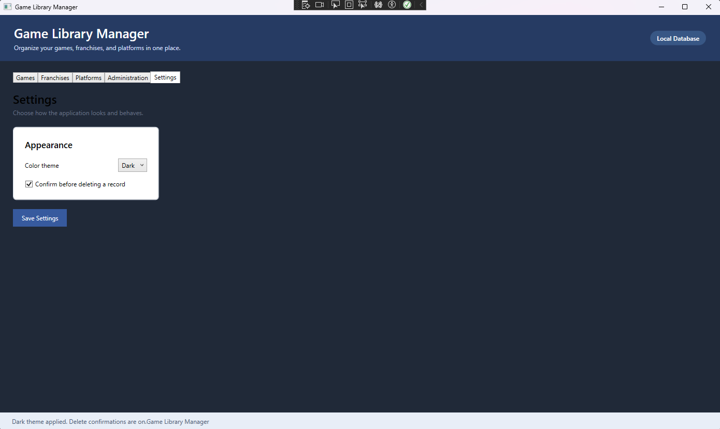

Search:
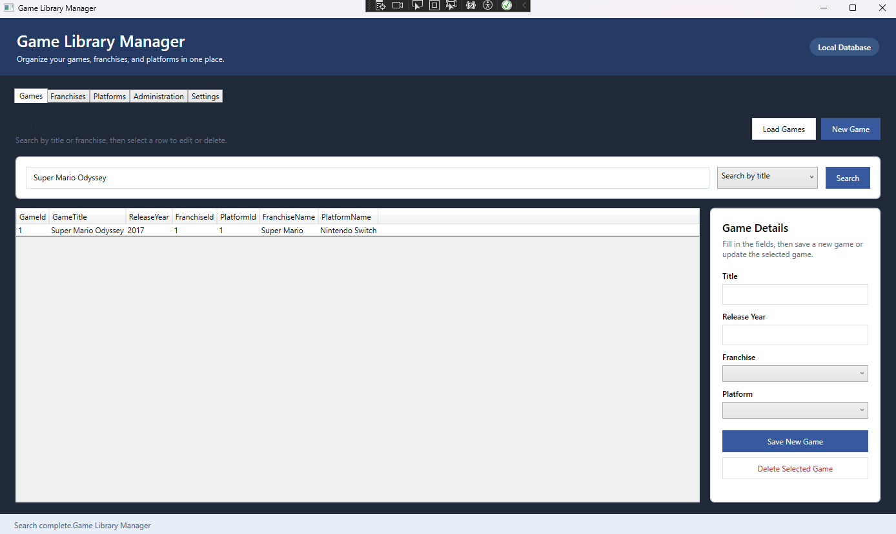
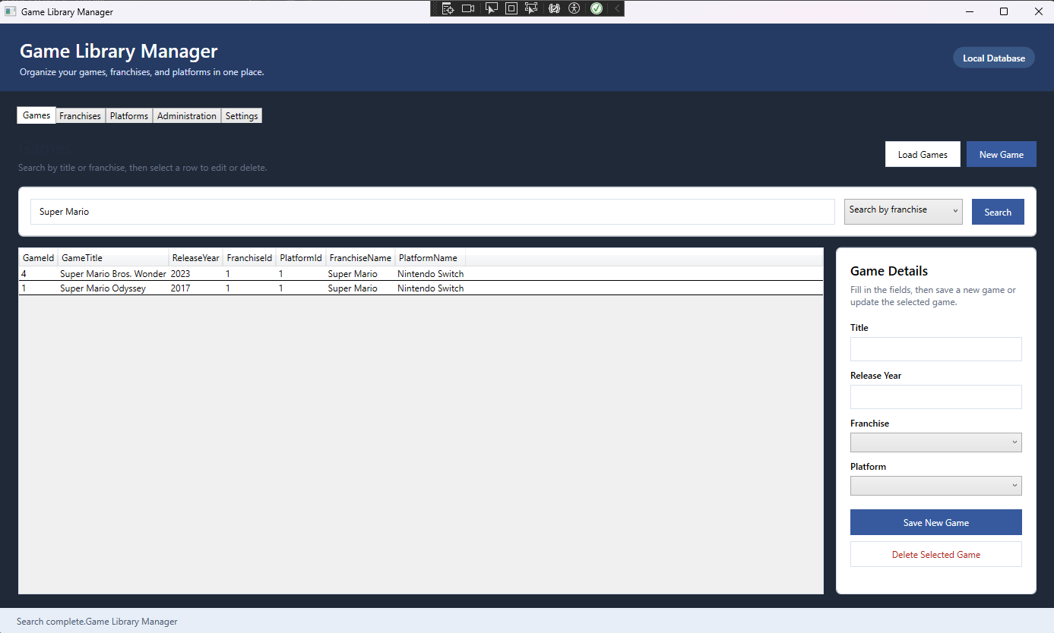

Insert: (The inserted data is erased in the sidebar once inserted, I typed it back in to be clear what was inserted, the same will go for Update and Delete)
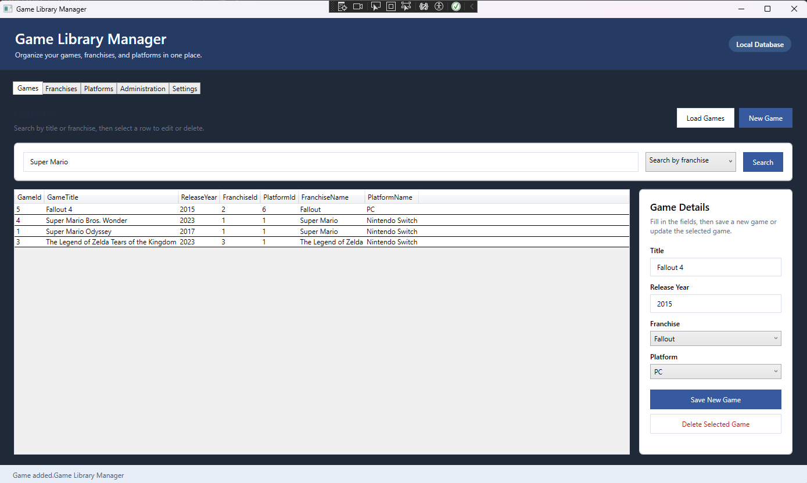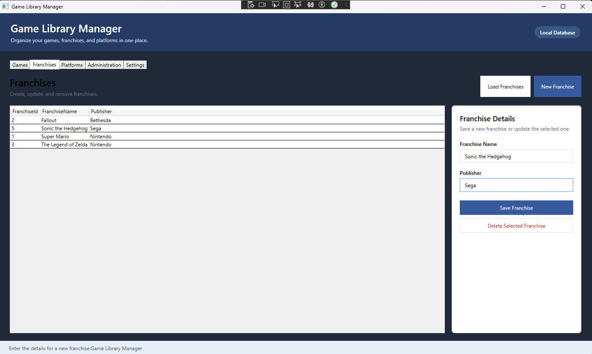
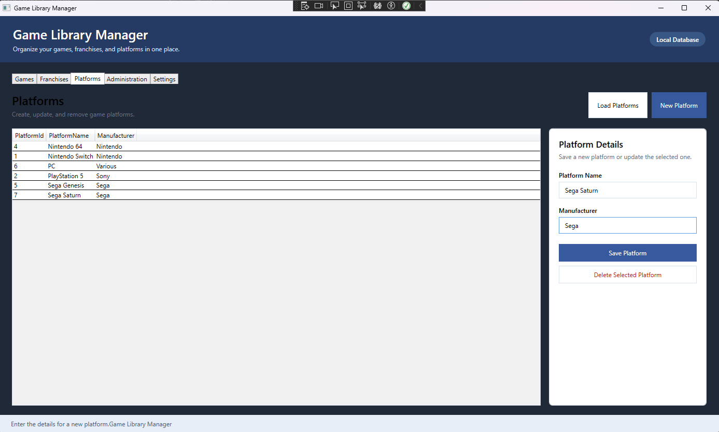
Update: (Some of these obviously aren’t correct, but I’m just demoing update)
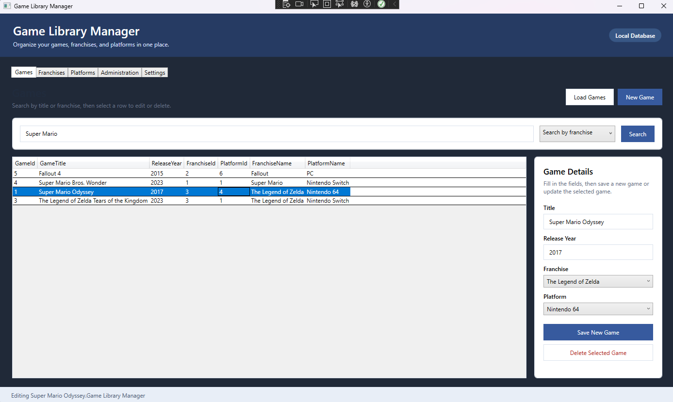
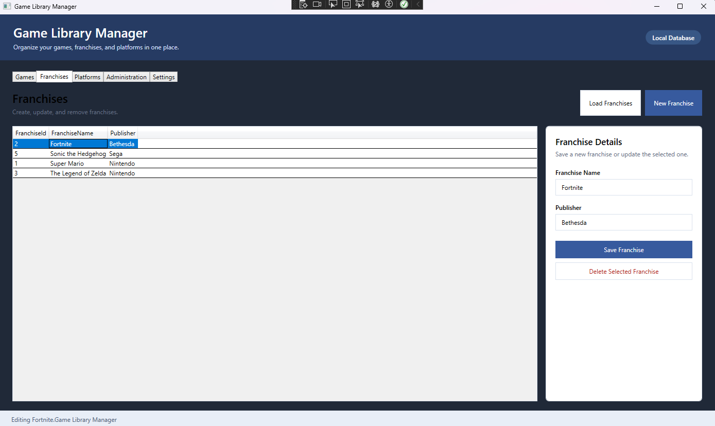
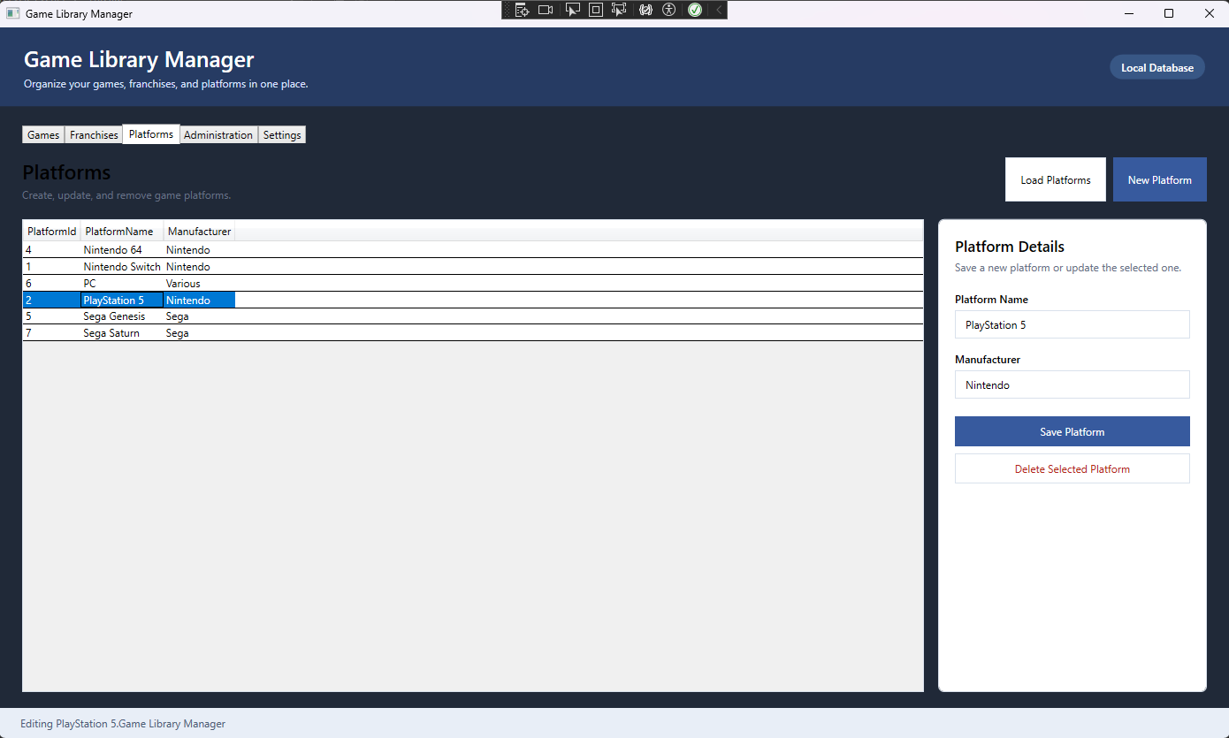
Delete:
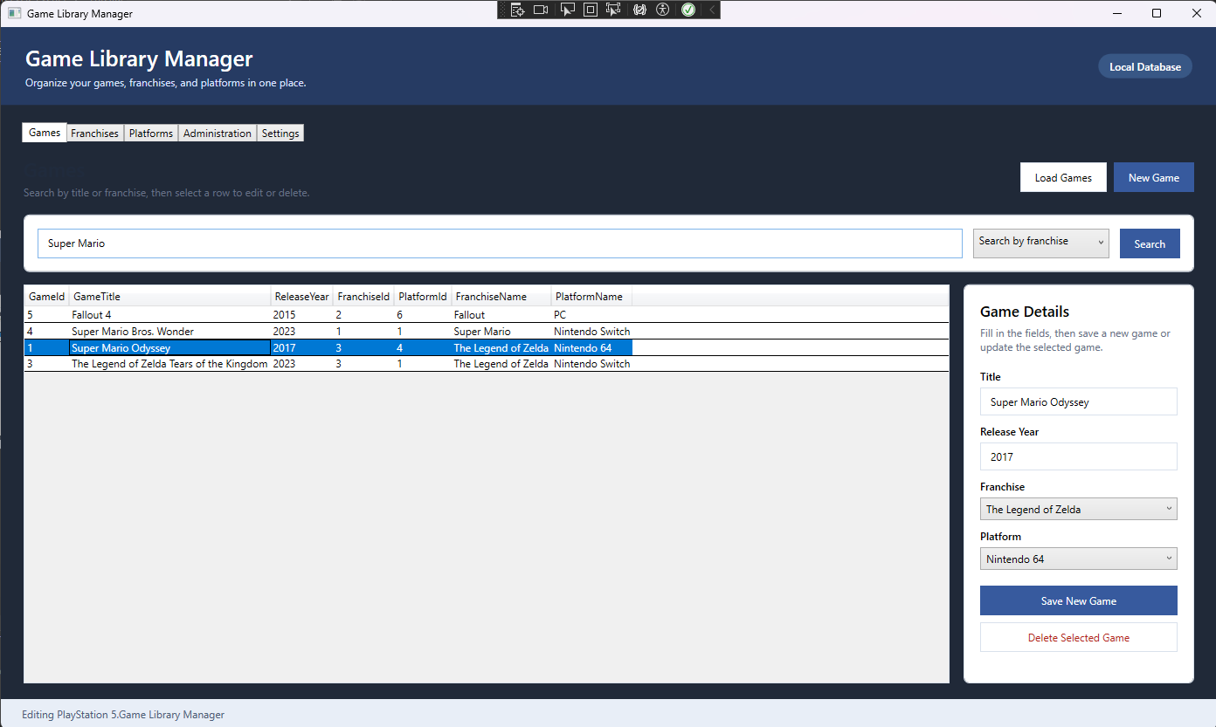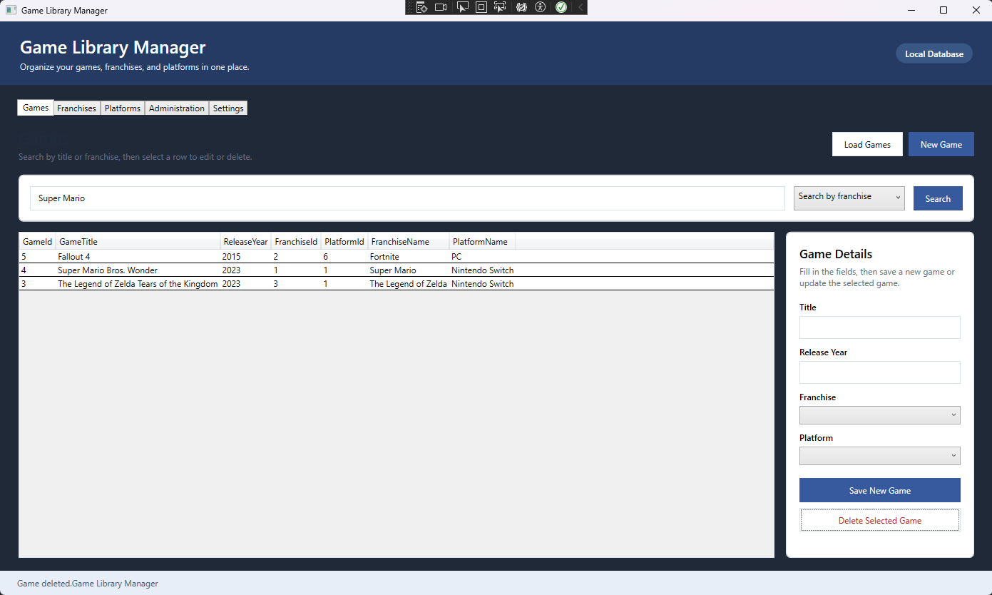
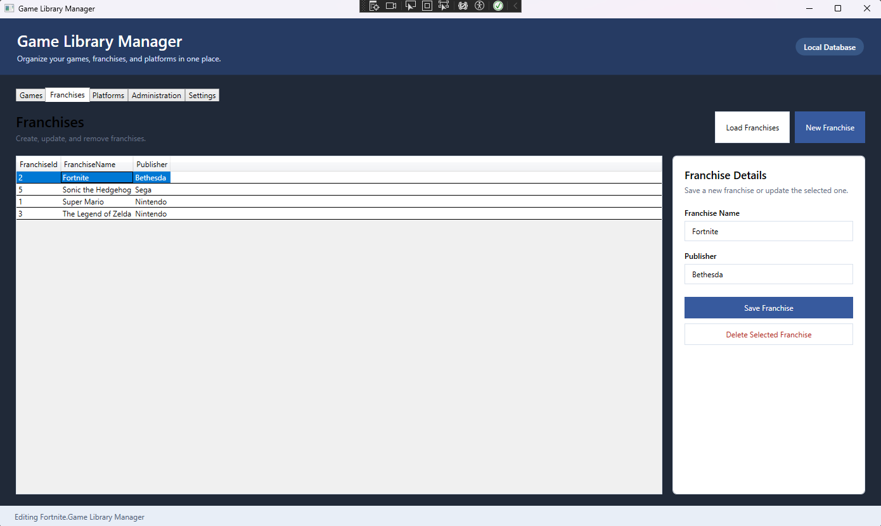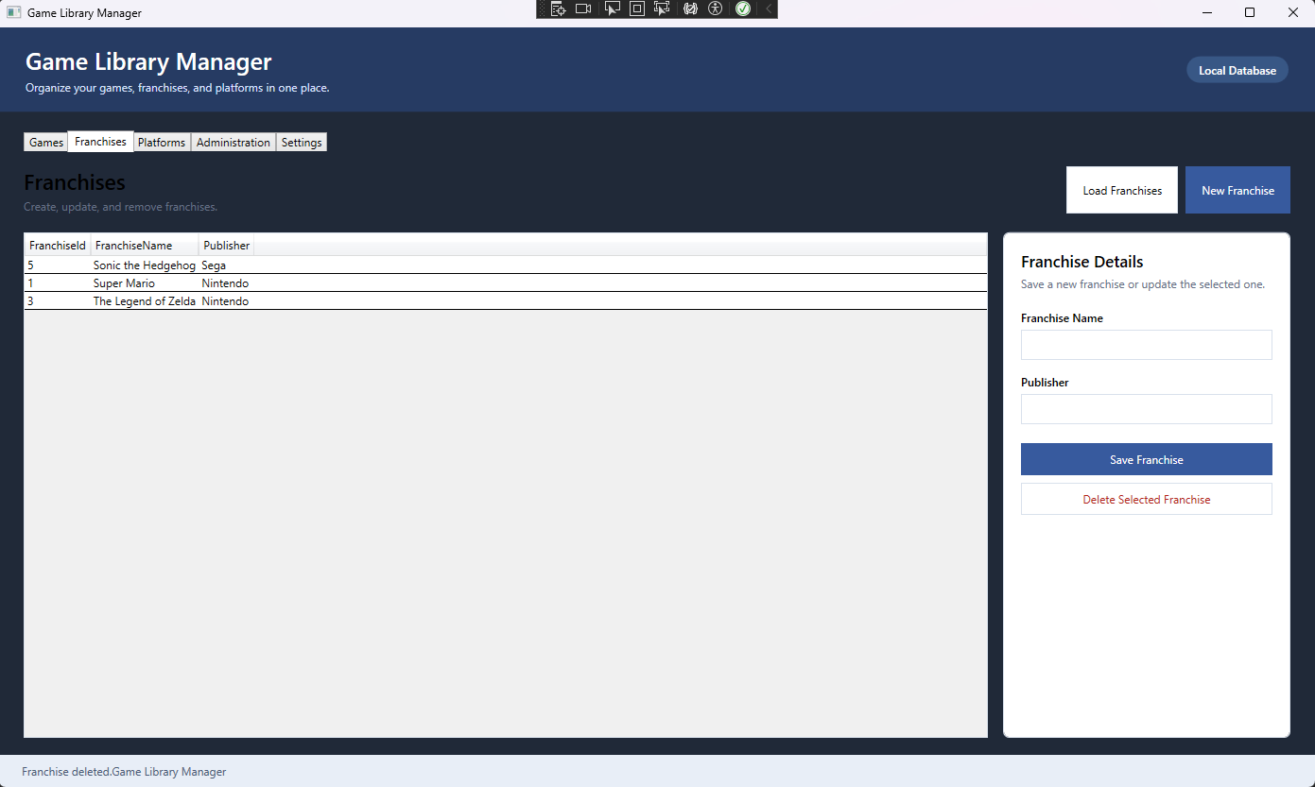
(I had to update Fallout 4’s franchise in Games to delete Fortnite because of a conflict)
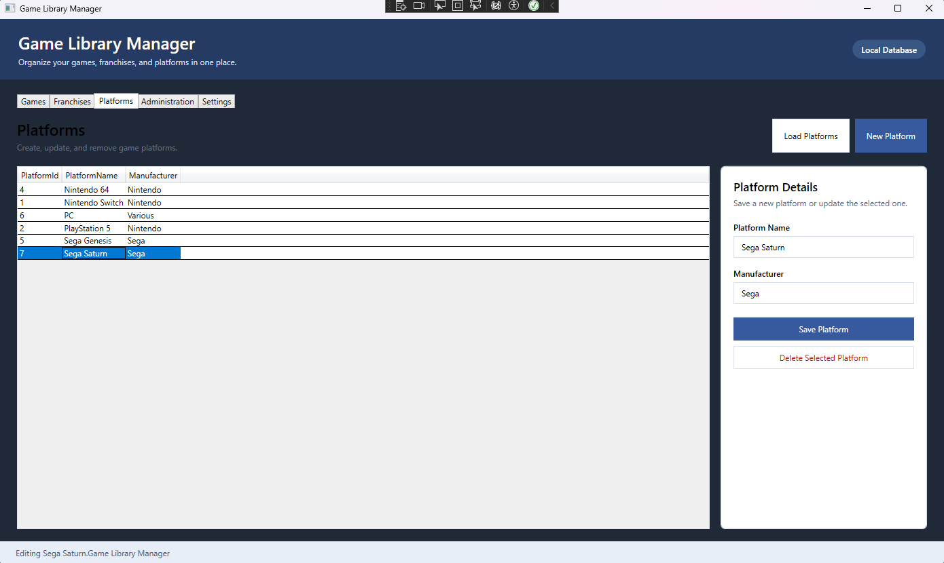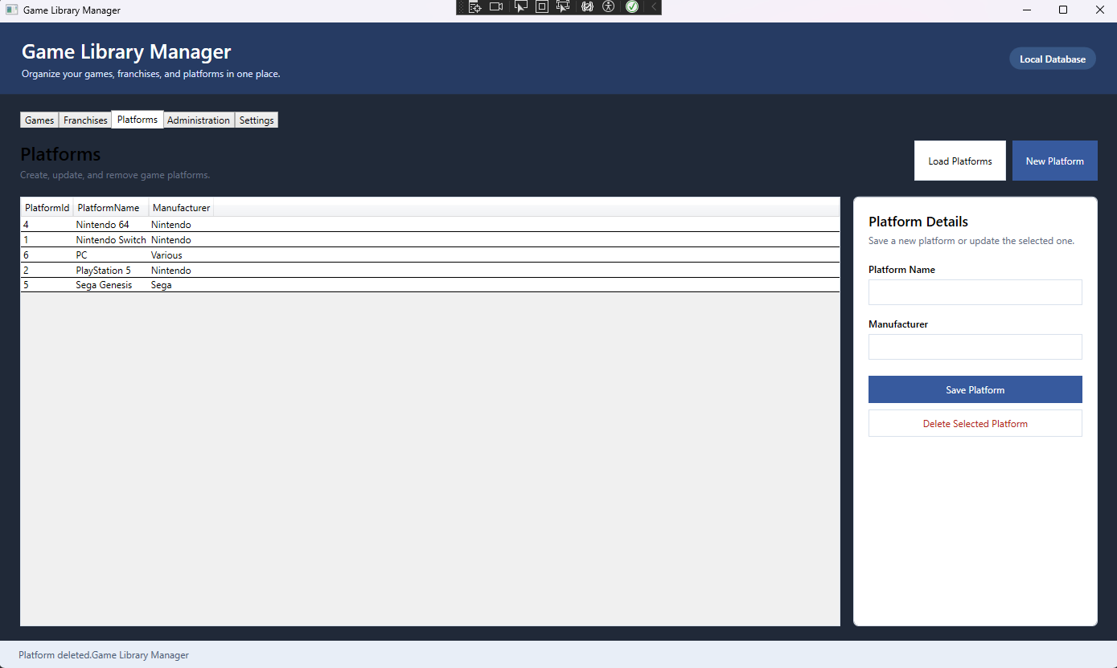

Post-CRUD Demo:
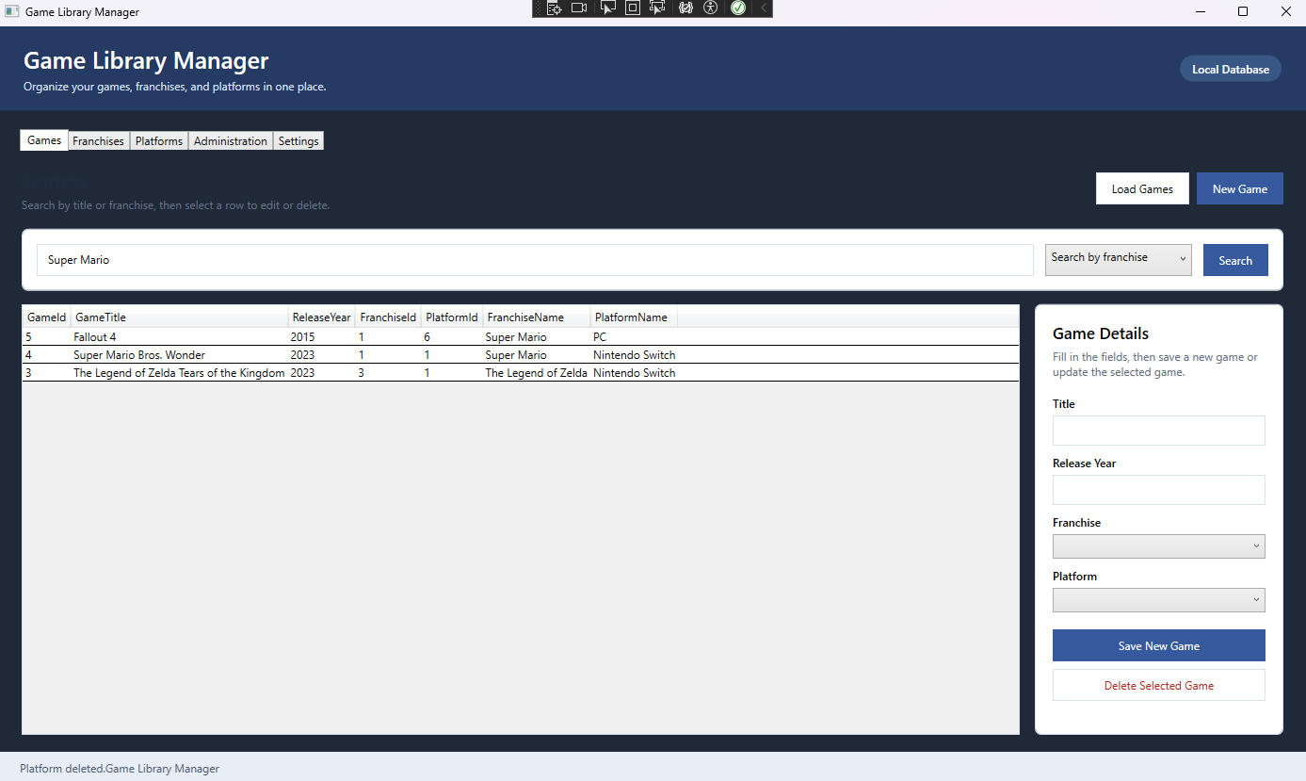
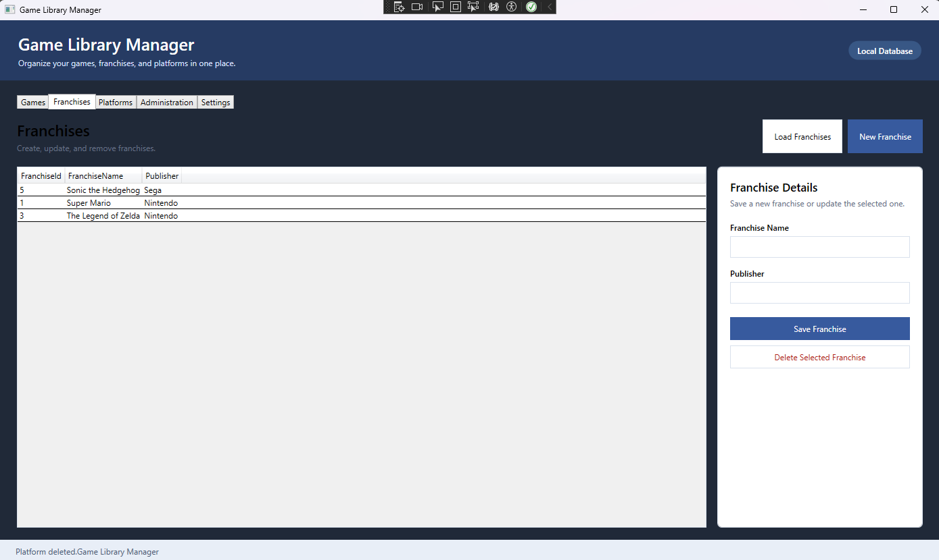
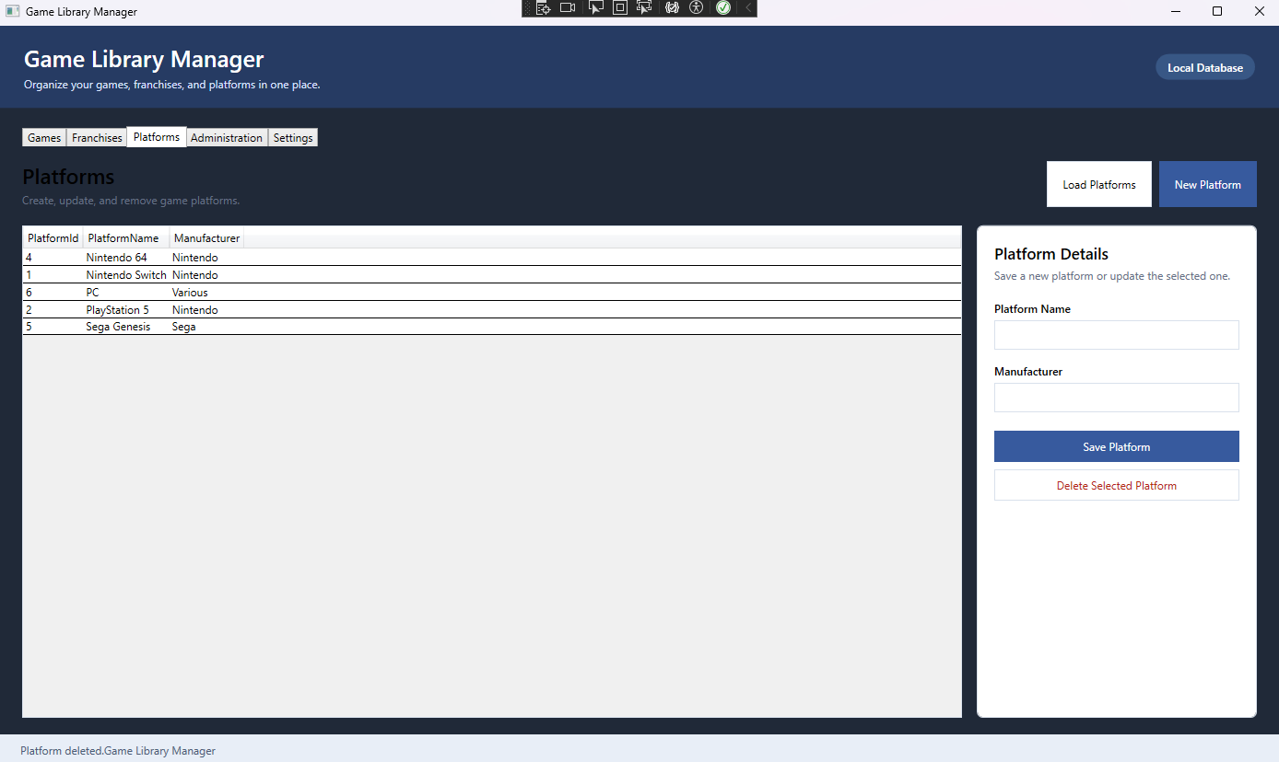
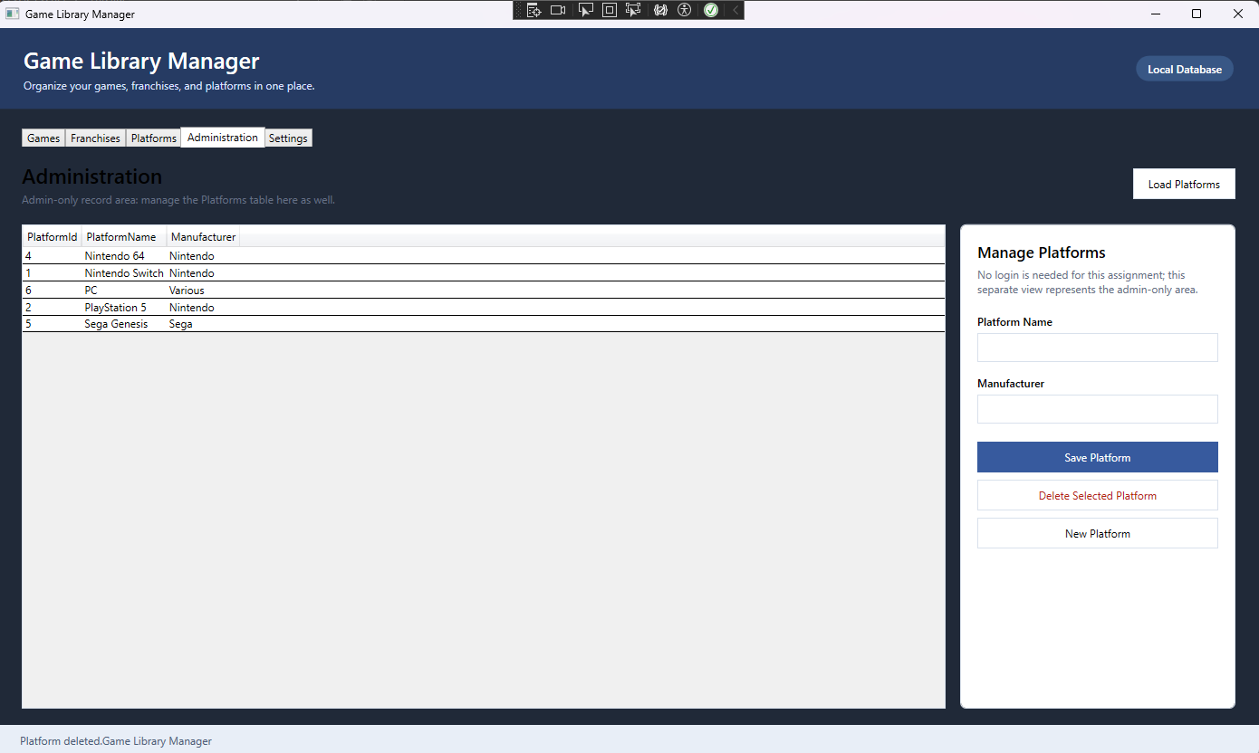

Questions
- Describe a Challenge you overcame in this project.
A challenge I overcame was working with unfamiliar code, in the sense that I had just been given a lot of code and had to understand another person’s thought process and intention in making it. These would be things such as being able to read their code, understand methods, and understand how to implement that in my own work. While not an actual person, I had to adapt to ChatGPT’s creation, which is akin to receiving work from another person.
I also was facing a depressive episode throughout this, which made it difficult to do more than small chunks at a time.

- Describe a technique you learned in this project.
I learned the basics of WPF and understand better how to connect a front end GUI to backend code.

- What more would you want to refine in your project to make it ready to sell, ship, and deploy?
It definitely needs a cleaner design and more functionality than simple manipulation of a table. This feels too barebones to release as a finished product.

- Which technology did you choose and why?
I chose WPF because of it’s drag and drop nature, which would be easier for me than learning how to directly code front-end functionality.

