Dev-Diary Sports Exercise Battle

Inhalt

Setup 1

Introduction 1

Database Access 1

Database Modeling 1

Endpoint USER 2

POST - USER CREATION 2

GET - USER HANDLING 2

PUT – ALTER INFO 3

Endpoint SESSIONS 3

Endpoint STATS 3

Endpoint SCORE 3

## Setup

As a first step I wanted to understand the resources we were allowed to use for the project:

* Lecturer provided code for a functioning HTTP Server Demo (**_08A3A4HttpServerDemo.sln**)
* **PostgresSQL** database run via **Docker**, accessed and modelled with **Datagrip (Jetbrains)**
* **Provided Curl Script** for Integration Tests
* **Swagger** and the MTCG- (previous project) as an API Specification Reference
* **Visual Studio** IDE

Further technologies used:

* **Draw.io** for database modeling
* **External C# libraries: Npgsql** for Unit-Tests, BCrypt.Net for Password Hashing

## Introduction

To have more oversight, I started with creating a flowchart to better understand the provided code in the solution **_08A3A4HttpServerDemo.sln:**

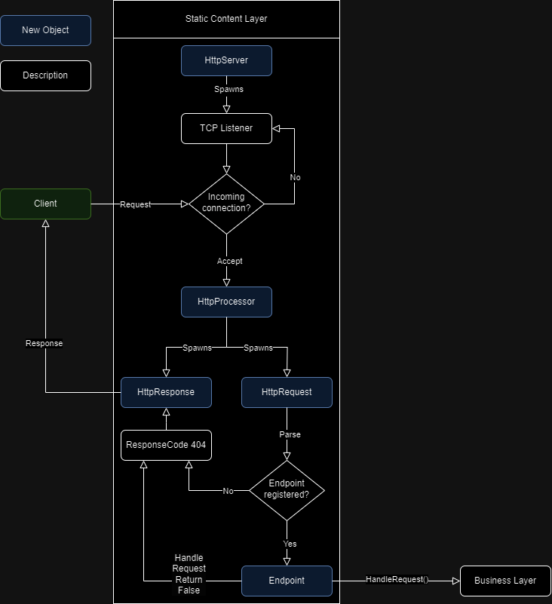

After installing a docker-container with a Postgres Image, I downloaded the Application Datagrip and connected it to my Postgres database. I created a new role “seb_connection” which will be the login credentials for the SEB Datalayer. This role was provided with all privileges on the database and all tables and provided with a password. To test the connection via Datagrip, I created a test DML SQL file to create a table. Then I installed the library **Npgsql** via the nuget packet manager in Visual Studio.

## Database Access

To connect to the database via the application, I created a database connection object which creates a connection, and executes a parameterized query:

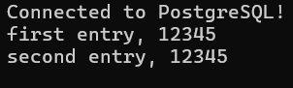

To prevent SQL Injections, all queries are executed as parameterized queries. The BCDatabaseQuery object is the base-class for every data-access object and always provides an open connection to child-classes. All data-access classes inherit this base class. The CRUD-Operations always work in the param-bind-execute schema:

* Establish connection
* Define query including parameter placeholders, i.e. “… WHERE username == @username” these placeholders are required to prevent SQL-Injections
* Bind values to the placeholders query.Parameters.AddWithValue("username", *some variable*);
* Execute the query (variations for different CRUD-Operations
* Close connection

## Database Modeling

I modelled the users table in the database, consisting of a primary key that is automatically assigned, a username and a place to store the password. Passwords will be stored encrypted and will be encrypted in the business logic. A write into the database was also attempted.

To model the database, I used diagrams.net and constructed the DML Statements accordingly.

## Endpoint USER

### POST - USER CREATION

Next, I used the hashing algorithm provided in the Library BCrypt to hash the password. This will be used to store the passwords encrypted in the library and will also be important for the login function.

### GET - USER HANDLING

Every Database access by a client needs to be authenticated first. I added more columns to the users table (token, profilename, bio, image) to represent the new features.

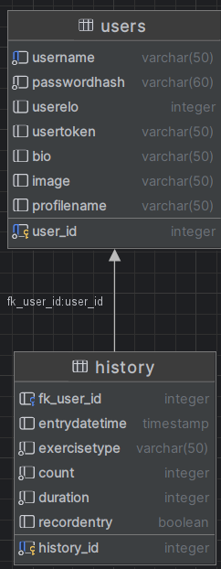

Starting with token, this gets generated at login and maintains a trust connection between the clients and the server by handing the session token to the individual user. As long as the client holds that token it can access and change all user-specific database entries. For that a new class was added (DatabaseAuthenticate) which takes the client provided token and checks it against the database stored token.

I added Bio, Image and ProfileName to a new helper Class “UserData”. The new class DatabaseGetUserInfo and the method GetUserInfo() was added to allow (authenticated) clients to access their profile info.

### PUT – ALTER INFO

For the put method, the client alters the bio of the current user, via the object DatabaseChangeUserInfo().

## Endpoint SESSIONS

Using the provided curl-script as a guideline, I started to implement the endpoint “sessions”. I created a new Endpoint object and registered it in the HTTPServer object. Next, I created a Database-access- object that receives the “user”-Object loaded with all credentials as a parameter and builds a query to access the database based on the username. The verifying of the given password was very tricky, because at first, I thought I had to rehash the given password and then compare it to the one stored in the database, however this did not work, since the used method “BCrypt.HashPassword()” required a salting value. If none was provided a random value was generated. This made the compared hashes differ everytime. Reading the documentation of the BCrypt Library further, I found the correct method which was “Bcrypt.Verify()”. Using this the authentification via the given credentials worked immediately:

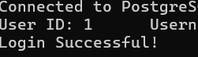

The return value is a server-side generated token that is given back to the client. This way the client can access the personal session via the singleton object BLL_SessionManager which stores all accompanying sessions (individually stored in the session object). Two helper methods provide the username (which is sometimes needed for database queries) when the token is provided and the token when username is provided. (GetSessionByToken and GetSessionByUsername). Later I also added a GetUserID Method to save/get the corresponding user_id, this allowed me to insert history entries with the correct foreign key.

## Endpoint STATS

After fully implementing the session functionality, it is now possible to run a query against an previously logged-in client which only provides the token. It accesses a

## Endpoint SCORE

Similar to Endpoint STATS, this simply accesses a view (get_score) in the DatabaseGetScore Object and packs it into a UserStats-List. This then gets serialized.

## Endpoint History

### POST – History Entry

I reused a lot of code from the Endpoint /User/ POST method to create an entry in the history table. The biggest difference was the user_id which I saved in the session data and was used to create a foreign key reference in the history table for the corresponding user (see data modeling). A new object was required to deserialize the JSON-string called UserHistory.

### GET – Get a list of all history entries for the user

I reused the UserHistory object to store the query return, which then was stored in a list of returns. This list in turn got serialized and returned to the user.

## Endpoint Tournament