int* x[3]; Here x is an array of 3 pointers to int.
int (*x)[3]; Here x is a pointer to an array of three ints.
Here's a usage example of both:
int* arrayOfPointers[3];
int x, y, z;
arrayOfPointers[0] = &x;
arrayOfPointers[1] = &y;
arrayOfPointers[2] = &z;

int (*pointerToArray)[3];
int array[3];
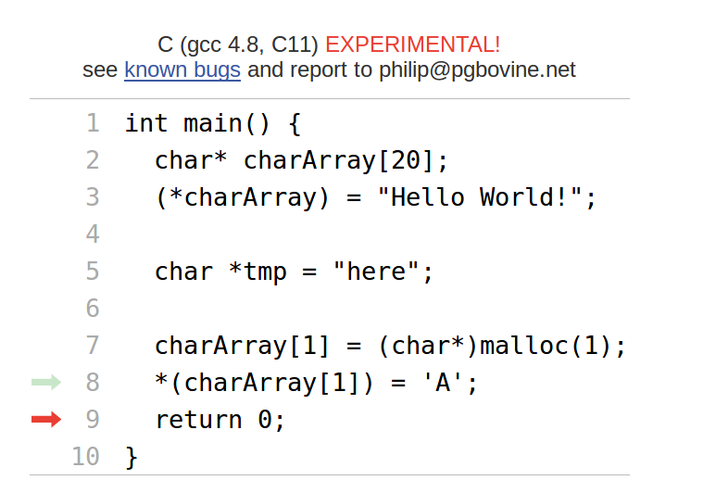
pointerToArray = &array;
