Chapter 2
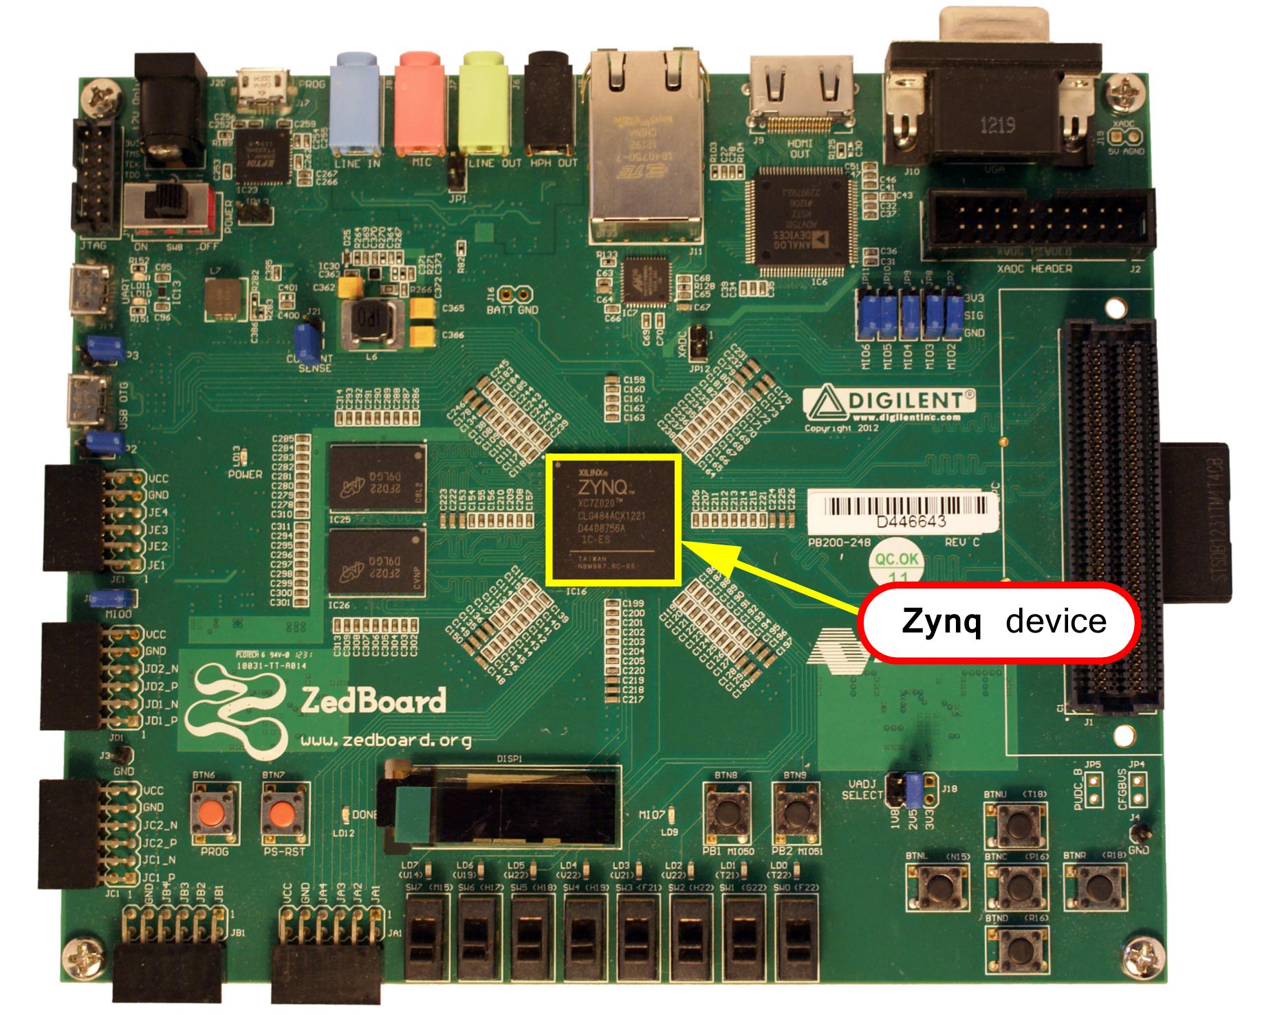

The Zynq comprises of Processing System (PS) and Programming Logic (PL). These can be used independently or together, and in fact the power circuitry is configured with separate domains for each, enabling either the PS or PL to be powered down if not in use.

All Zynq devices have the same basic architecture , and all of them contain , a dual-core ARM Cortex-A9 processor. This is the ‘hard’ processor – it exists as a dedicated and optimized silicon element on the device.

The advantage of soft processors is that the number and precise implementation of processor instances is flexible. The hard processors can achieve considerably higher performance , as is true of Zynq’s ARM processors.

The Zync’s Processing System is not just the ARM processor, but a set of associated processing resources forming an Application Processing Unit(APU)

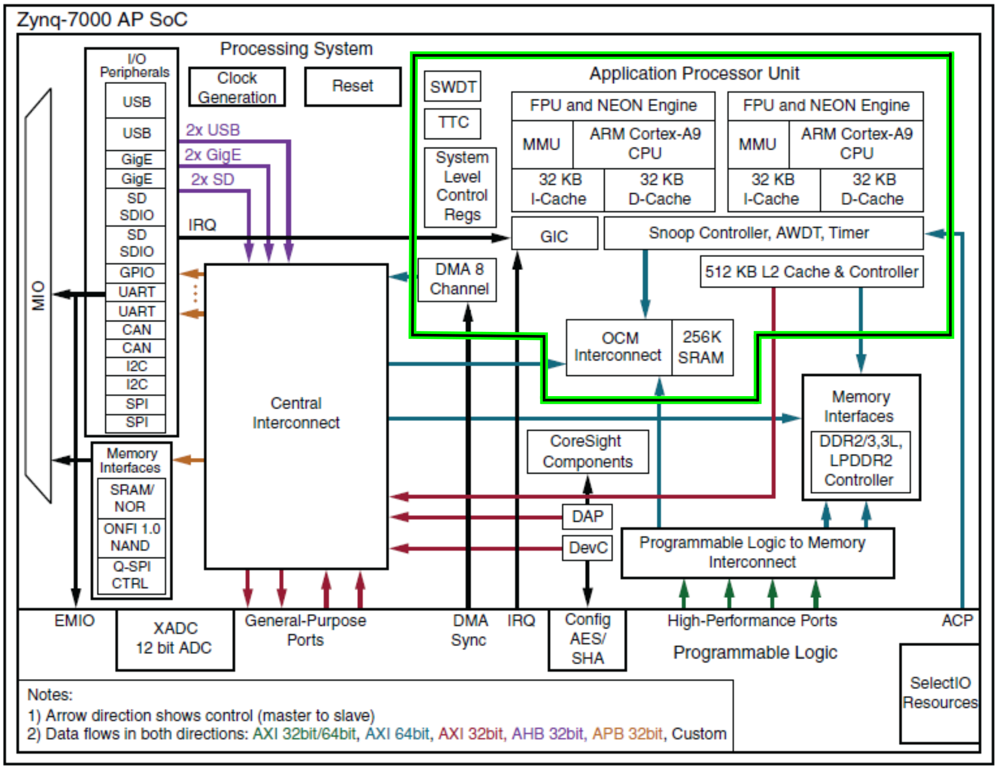

Application Processing Unit(APU)

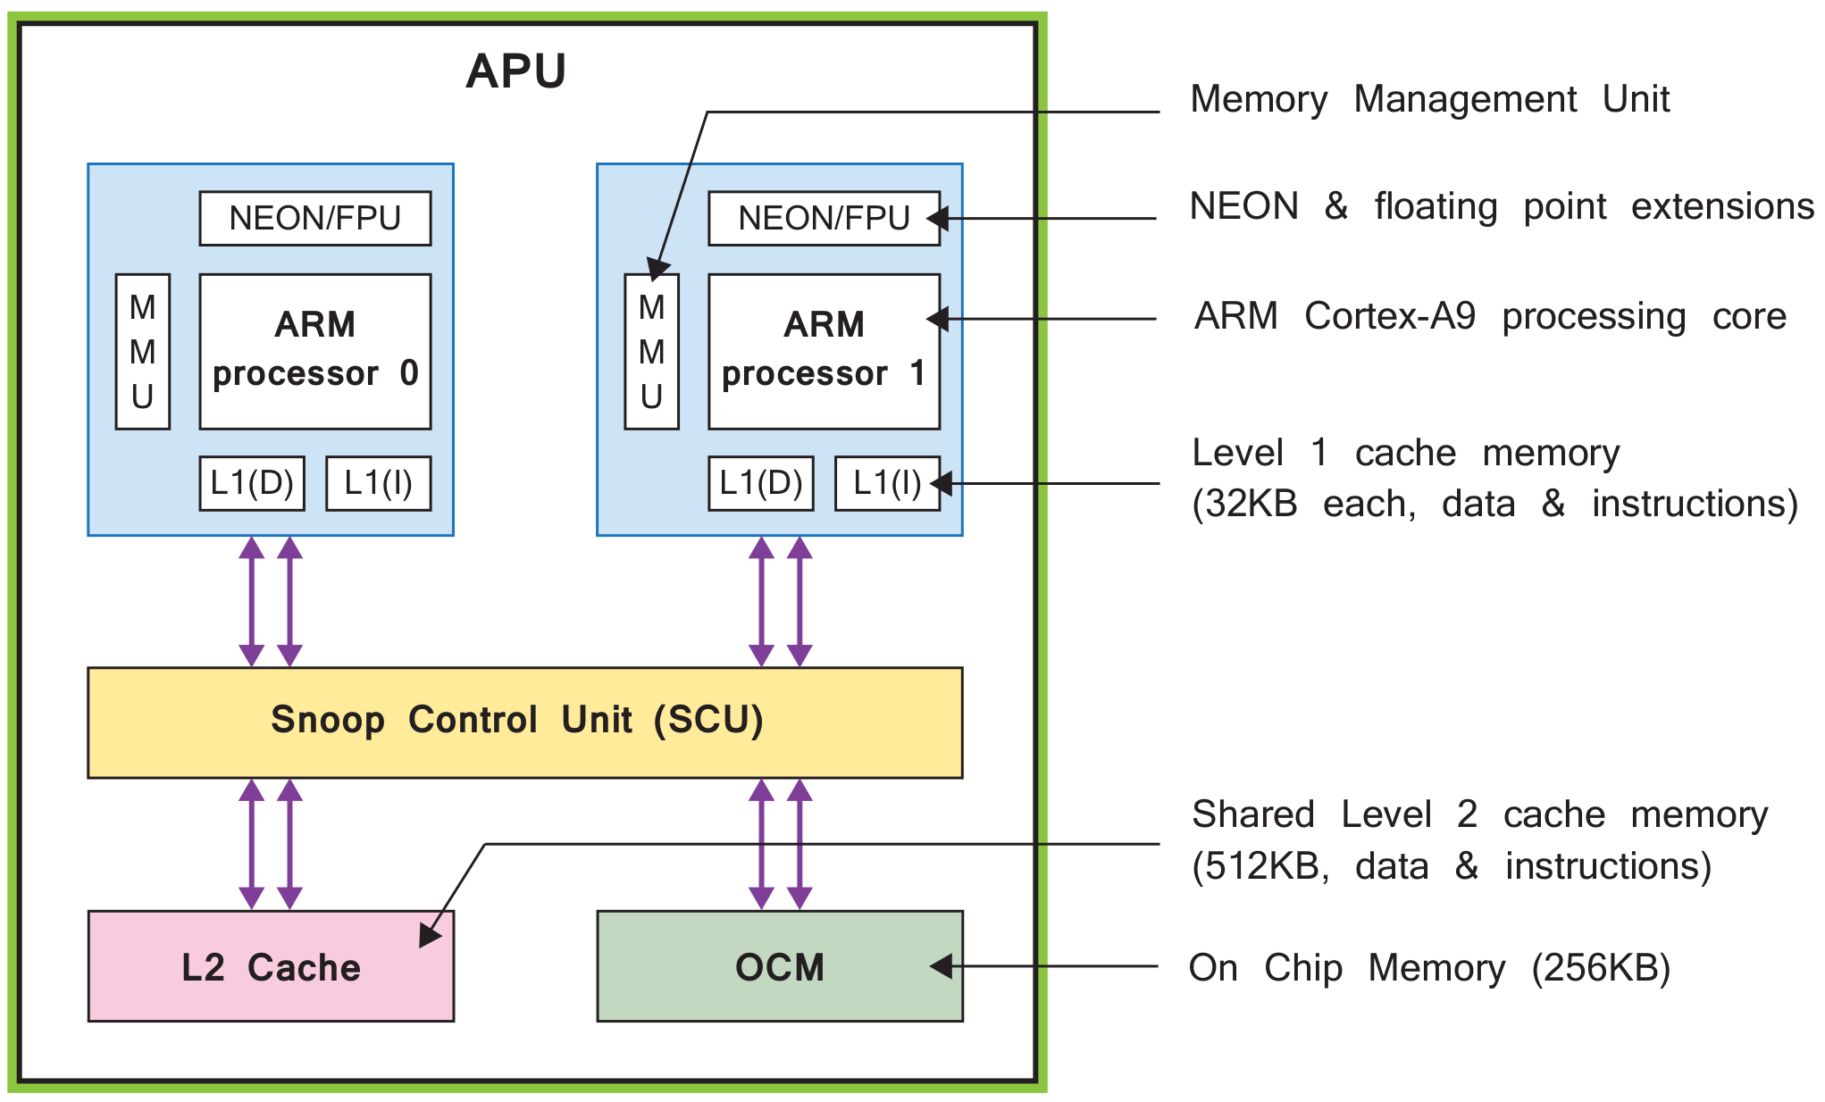

The APU is primarily comprised of 2 ARM processing cores, each with associated computational units: a NEON Media Processing Engine(MPE) and Floating Point Unit(FPU), a Memory Management Unit(MMU) , and a Level 1 Cache memory.

The APU also contains a Level 2 cache memory , and a further On Chip Memory Memory (OCM). Finally the Snoop Control Unit (SCU) forms a bridge between the ARM cores and the Level 2 cache and the OCM memories; SCU has also the responsibility for interfacing with the PL.

The ARM Cortex-A9 can operate up to 1GHZ. Each of the two cores has separate Level 1 caches for data and instructions, both of which are 32KB. The 2 cores also share a larger Level 2 cache of 512KB for instructions and data, and there is a further 256KB of On Chip Memory Memory (OCM)

The Primary role of the MMU is to translate between virtual and physical address.

The Snoop Control Unit undertakes several tasks relating to interfacing between the
processors and Level 1 and 2 cache memories (‘snooping’ is one of several mechanisms for
ensuring cache coherency, i.e. managing the consistency of data across shared cache
resources )

The Snoop Control Unit additionally manages transactions that take place between the PS and PL via the Accelerator Coherency Port (ACP).

Timers and an interrupt controller are further functional blocks located in the APU.

The computation of the NEON engine is depicted as follows :
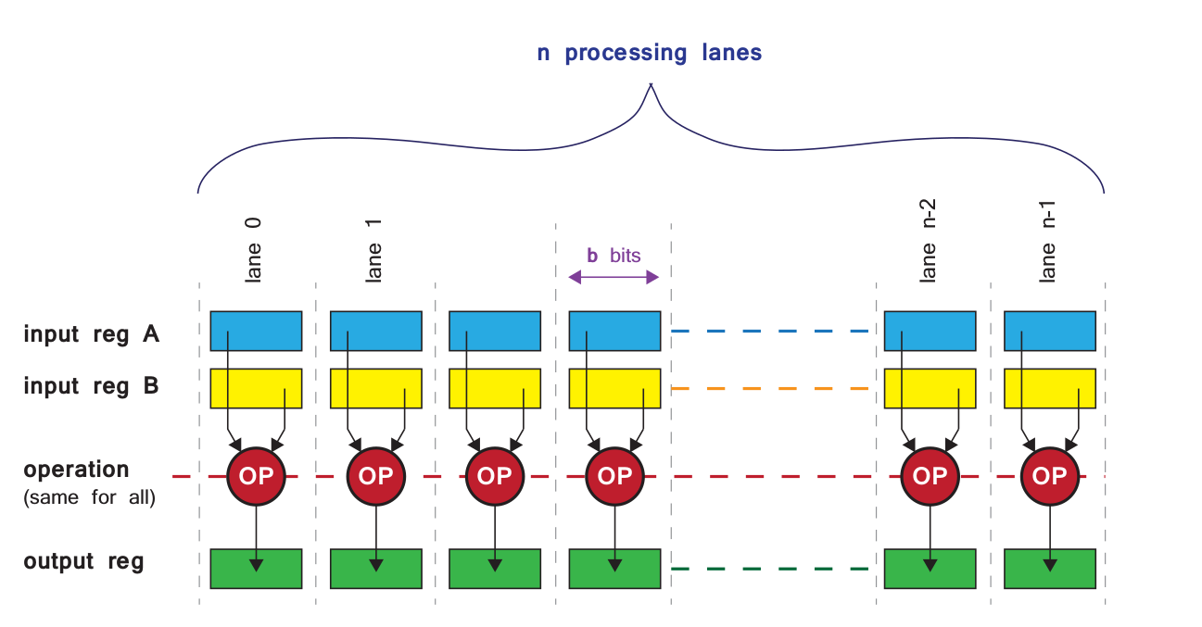
There are two input registers, A and B, each of which contain a set of N individual input vectors. A single defined operation is performed between the N sets of input vectors to produce a corresponding set of output vectors which are written to the output register. The size of the vectors can vary, as can the number of vectors comprising each register; the important feature is that each ‘lane’ produces results arising from the same operation, which is performed on several different sets of inputs at the same time; hence the term single instruction multiple data.

NEON supports a variety of data types including signed and unsigned integers, single
precision floating point, and half-precision floating point; however, double precision is not
supported.

Processing System External Interfaces
The Zynq PS features a variety of interfaces, both between the PS and PL, and between
the PS and external components

Communication between the PS and external interfaces is achieved primarily via the
Multiplexed Input/Output (MIO), which provides 54 pins of flexible connectivity, meaning
that the mapping between peripherals and pins can be defined as required.

Certain connections can also be made via the Extended MIO (EMIO), which is not a direct path from the PS to external connections, but instead passes through and shares the I/O resources of the PL

The available I/O includes standard communications interfaces, and General Purpose
Input/Output (GPIO) which can be used for a variety of purposes including simple
buttons, switches, and LEDs.


