Chapter 1
System On Chip(SOC)
is lower cost , enables faster and more secure data transfers between the various system elements, has higher overall system speed , lower power consumption , smaller physical size , and better reliability.

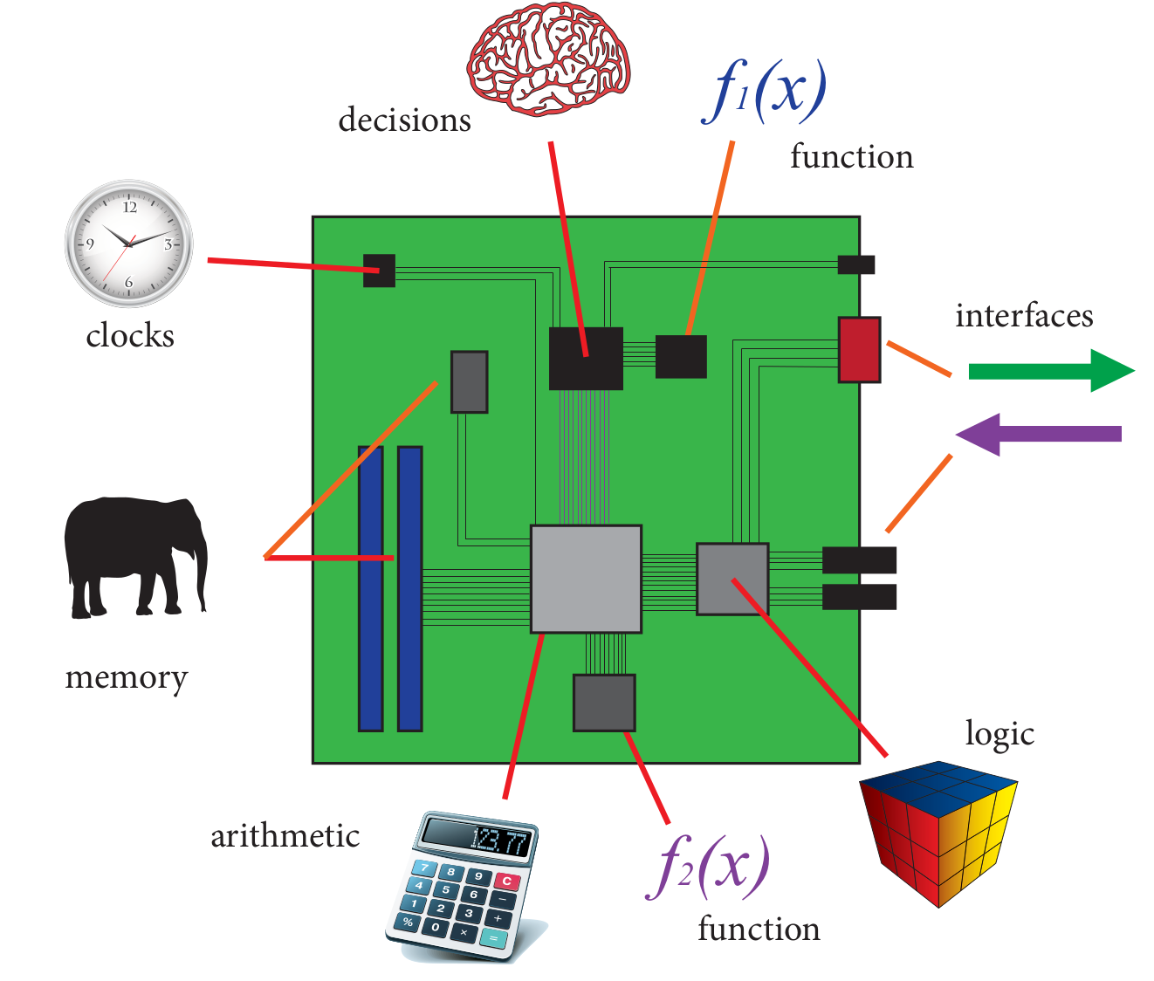
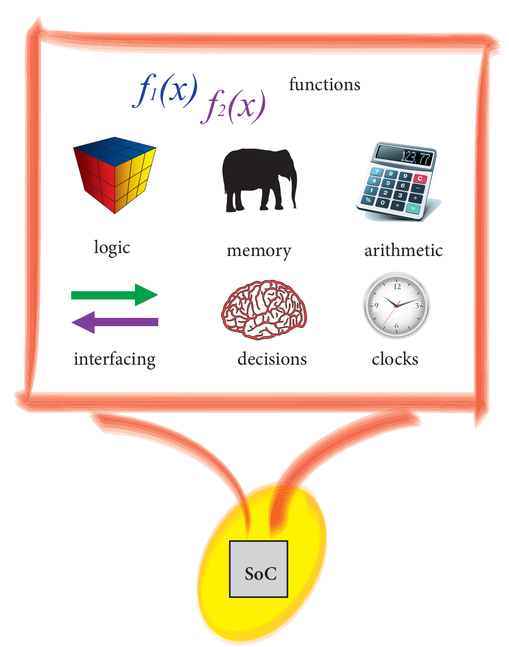
System-On-A-Board System On Chip(SOC)

For ASIC( Application Specific Integrated Circuits) SOC major disadvantages are :
- Development time and cost
- lack of flexibility

This type of SOC is suitable only for high-volume markets where there is no requirements for future upgrades.

FPGA’s (Field Programmable Gate Array’s) are inherently flexible devices that can be configured to implement any arbitrary system, including embedded processors if needed.

ZYNQ is comprised of two main parts:
- Progressing System (PS) , formed around a dual-core ARM Cortex-A9 processor
- Programming Logic (PL) , which is equivalent to that of an FPGA
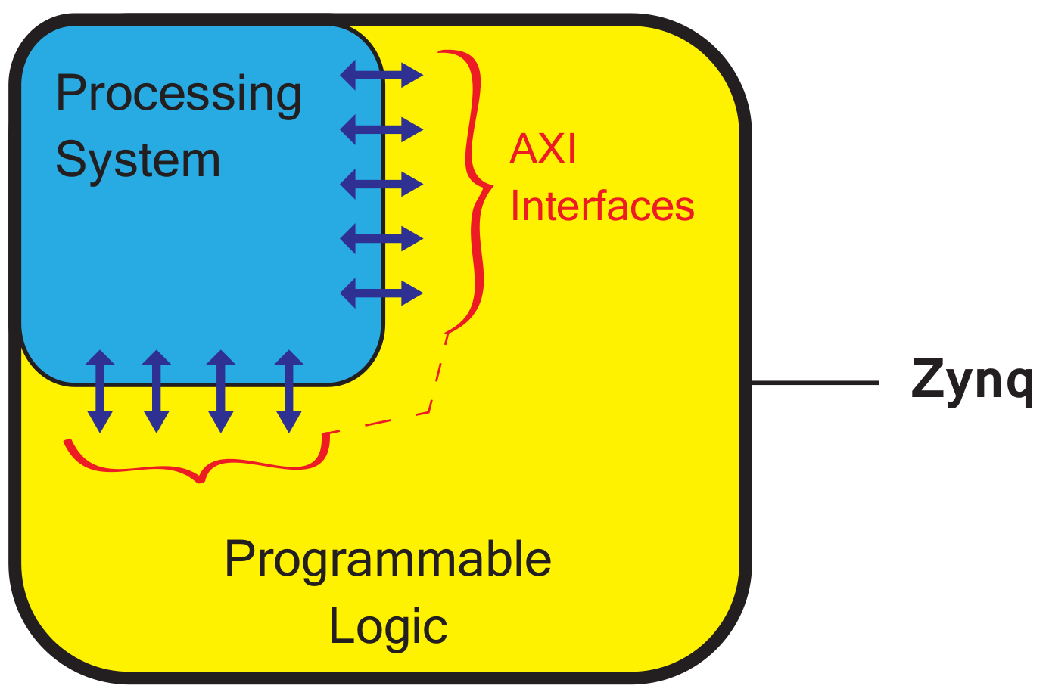

The Programming Logic (PL) section is used for implementing high-speed logic , arithmetic and data flow subsystems.
The Programming System (PS) supports software routines and/or operating systems, meaning that the overall functionality of any designed system can be appropriately partitioned between hardware and software.

Links between the Programming Logic and Programming System are made using INDUSTRY STANDARD ADVANCE EXTENSIBLE INTERFACE (AXI) connections.

Basic model for the types of digital systems incorporate a processor , memories , and peripherals, along with buses connecting the various elements together. That represents the hardware system)
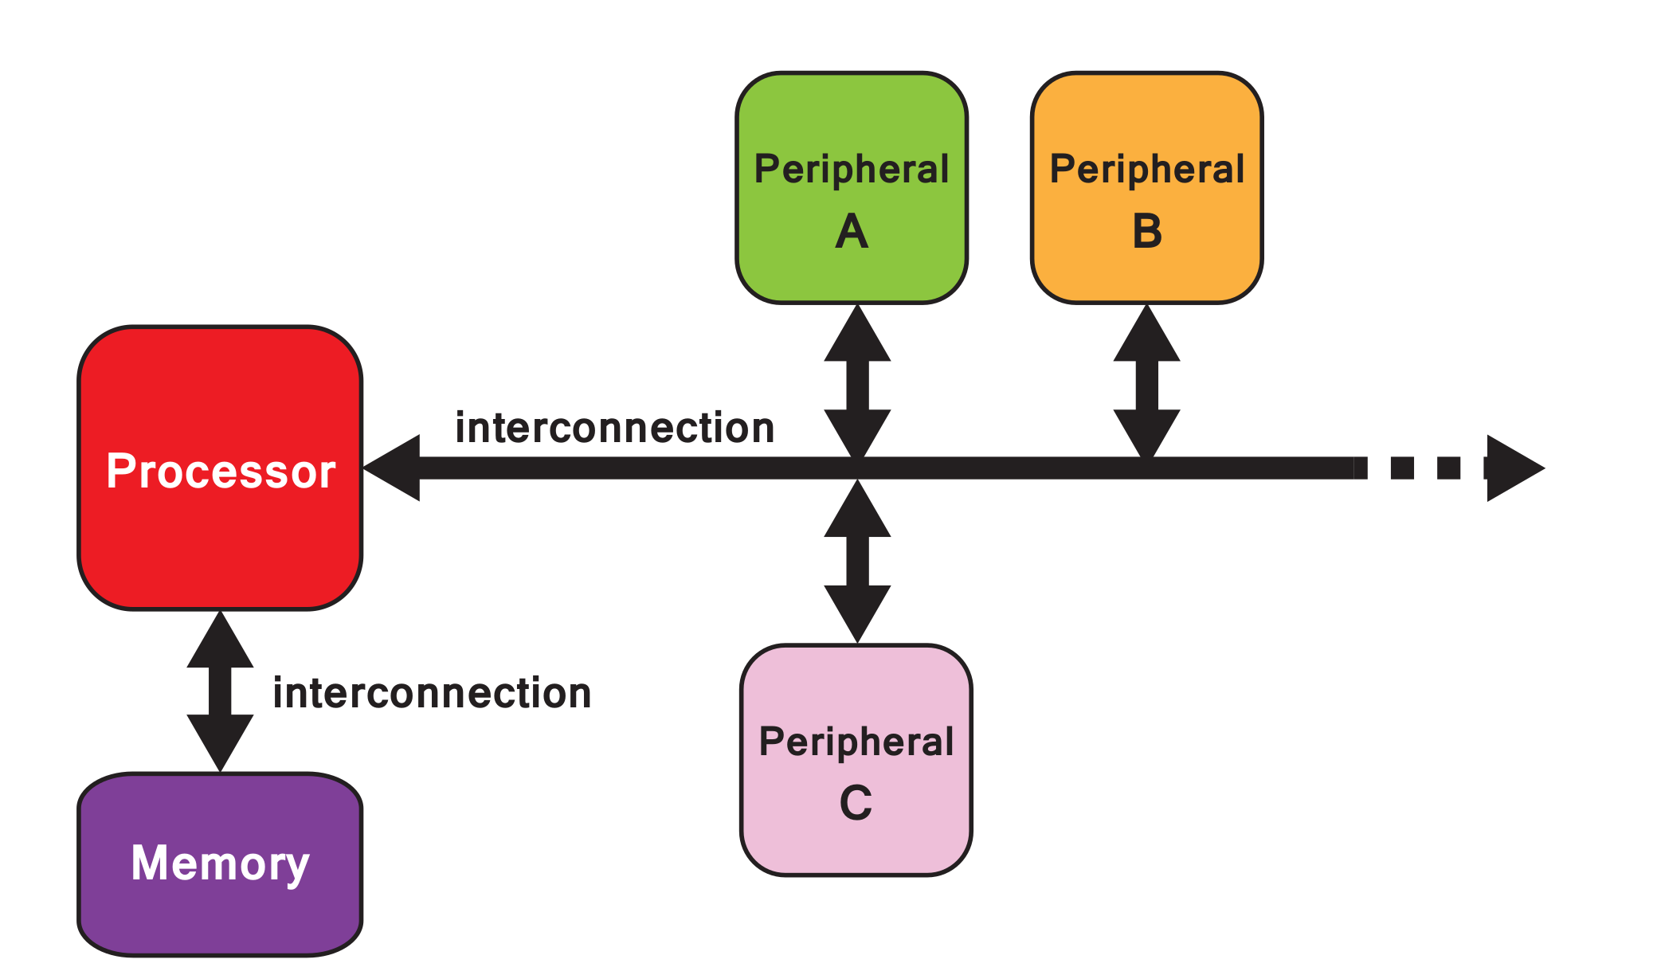

The processor can be regraded as the central element of the hardware system. The software system( a software ‘stack’) runs on the processor, comprising applications ( usually based on an Operating System(OS)), and with the lower layer of software functionality for interfacing with the hardware system.

Commutations between system elements takes place via interconnections.

Peripherals
are functional components residing away from the processor, and in general perform one of three functions:
- Co-processor : elements that supplement the primary processor, usually optimized for a certain task.
- Cores for interacting with external interfaces , eg. connection to LEDs, switches , codecs, and etc.
- Additional memory elemnts

