**Persona of 5 usability text pariticpants**

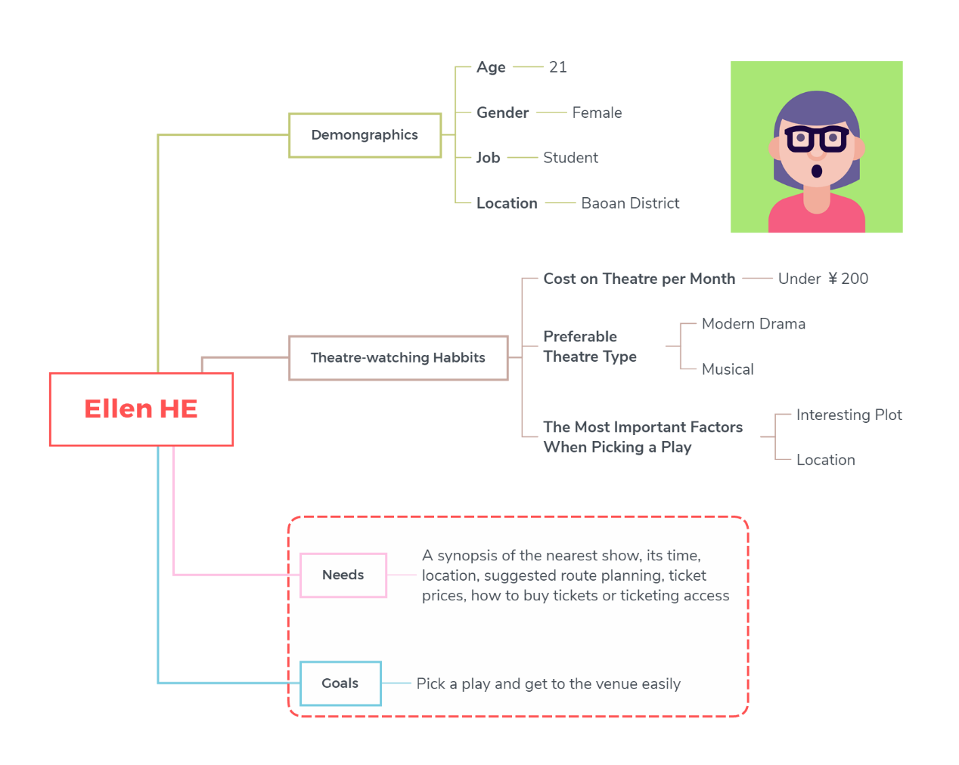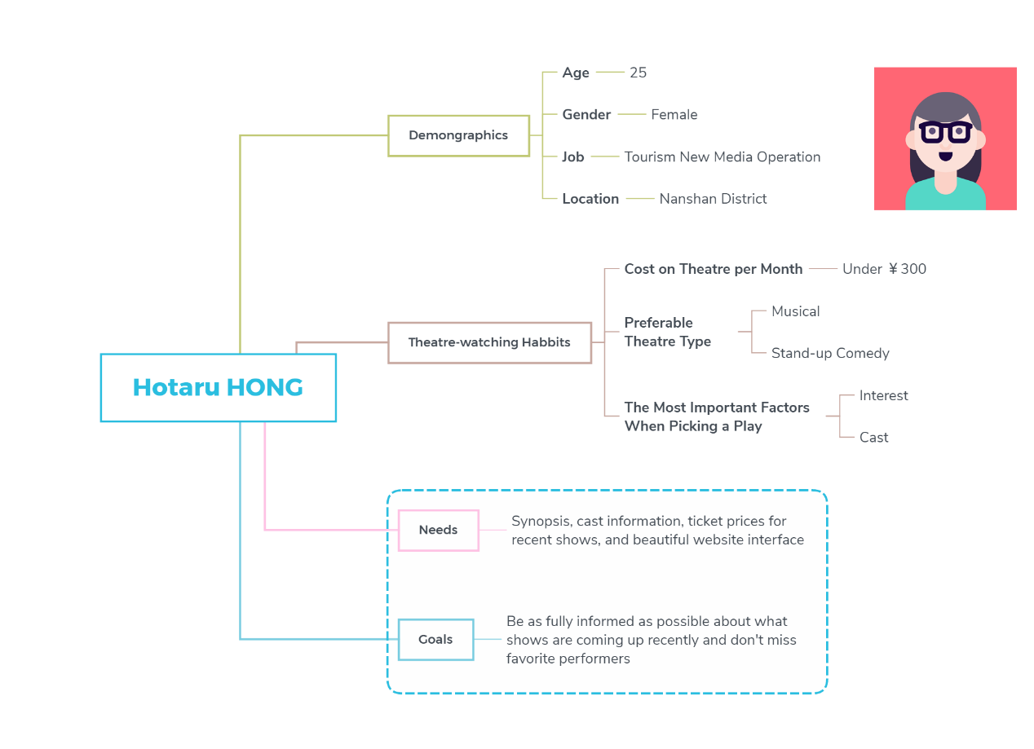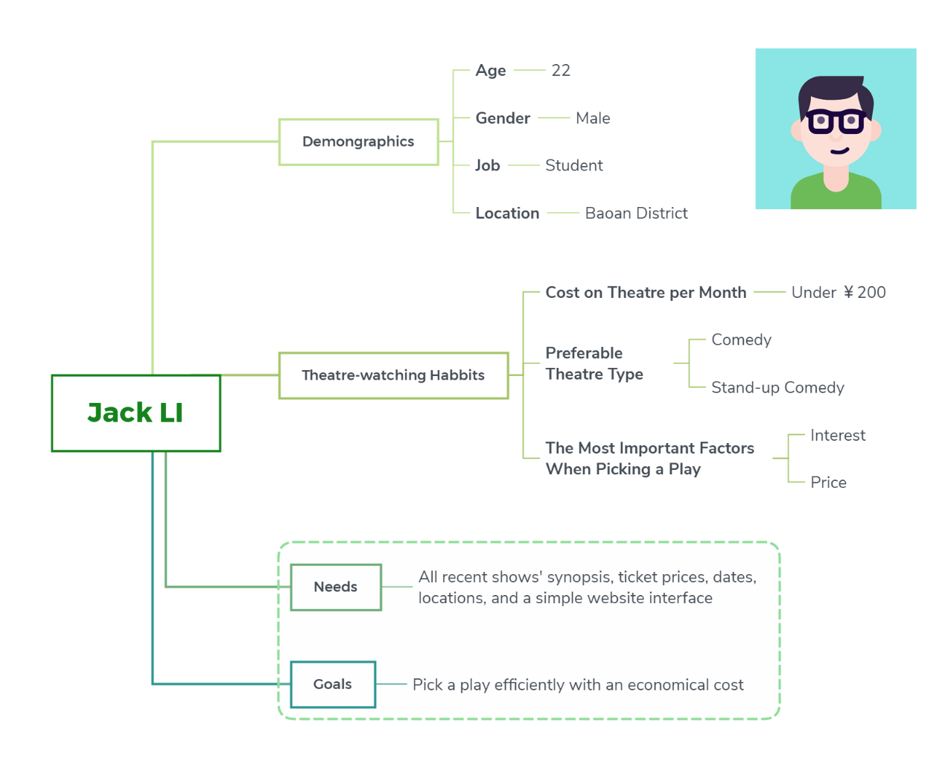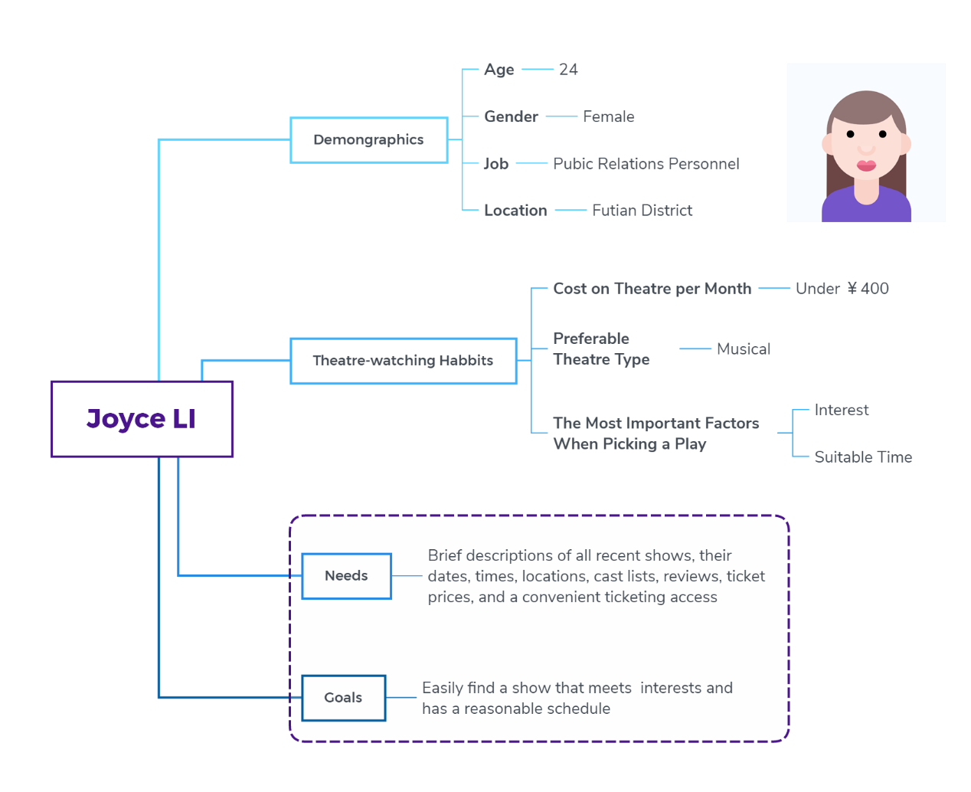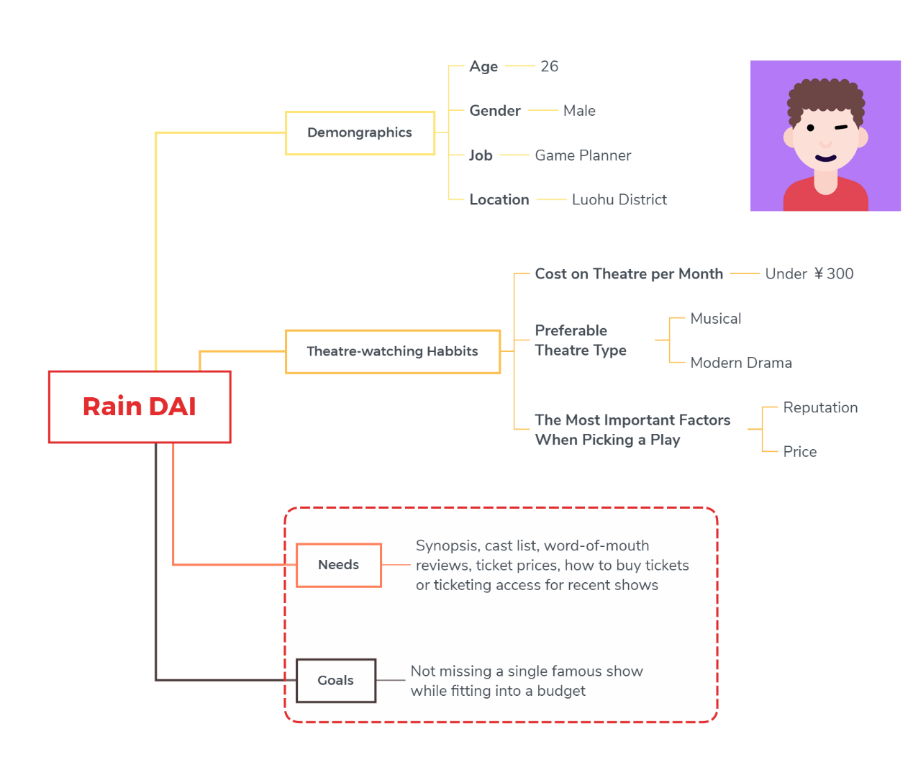

**The usability report on MoreTickest.com**

In terms of effectiveness, the completion rate of 5 participants is 100%.

The efficiency is shown in the table below.

|  |  |  |
| --- | --- | --- |
| Participant | Time on tasks 1 (seconds) | Time on tasks 2 (seconds) |
| Ellen HE | 75 | 52 |
| Hotaru HONG | 88 | 35 |
| Jack LI | 58 | 26 |
| Joyce LI | 73 | 44 |
| Rain DAI | 102 | 67 |

In general, everyone agreed that the whole process is easy, logical and straightforward. But according to the post-interview, it still has some pitfalls

First of all, MoreTickets doesn't have the option to sort by districts in its site navigation. So users have to check the location carefully of each event. Also, there is no option to sort by theater type. So users cannot directly pick an event according to their preferable genres. In addition, a text participant said that compared to sorting by ticket discount, he expects a more straightforward sorting by price, which makes it easier for him to choose activities within his budget. The participant who is focus on the reputation of the show looks forward to seeing what other audiences have said about the show directly on the website, and is willing to post a brief review of the show for other viewers as well. Last but not least, participant who lives in remote areas requests more detailed information on how to get to the venue.

**Problem statement**

How might I help young theatre lovers in Shenzhen who are accustomed to using the internet to obtain information on theatre activities to conveniently acquire a general overview of the upcoming plays including time, venues, ticket prices, audience comments so that they can select the activities meeting their interests and goals then enjoy it better?

**Pain points**

Gain a general overview of what theatre activities will be held in the near future.

Read a synopsis of the play.

Learn basic information about the theatre activities, such as time, venues and ticket prices.

View what other audiences have said about the play.

Select theatre activities that meet target users’ interests.

Confirm that target users’ schedules are suitable.

Find out if the activities destinations are easily accessible and plan transportation to the venues.

Purchase theatre tickets or reserve seats for shows.

Write post-viewing notes and share them with other theatre lovers.

**Needs**

Show sufficient information on recent theatre activities including brief description, synopsis, cast list, dates, times, venues, suggested route planning, ticket price and reviews.

Convenient and direct access to buying ticket.

Beautiful and simple website interface which can be used easily.